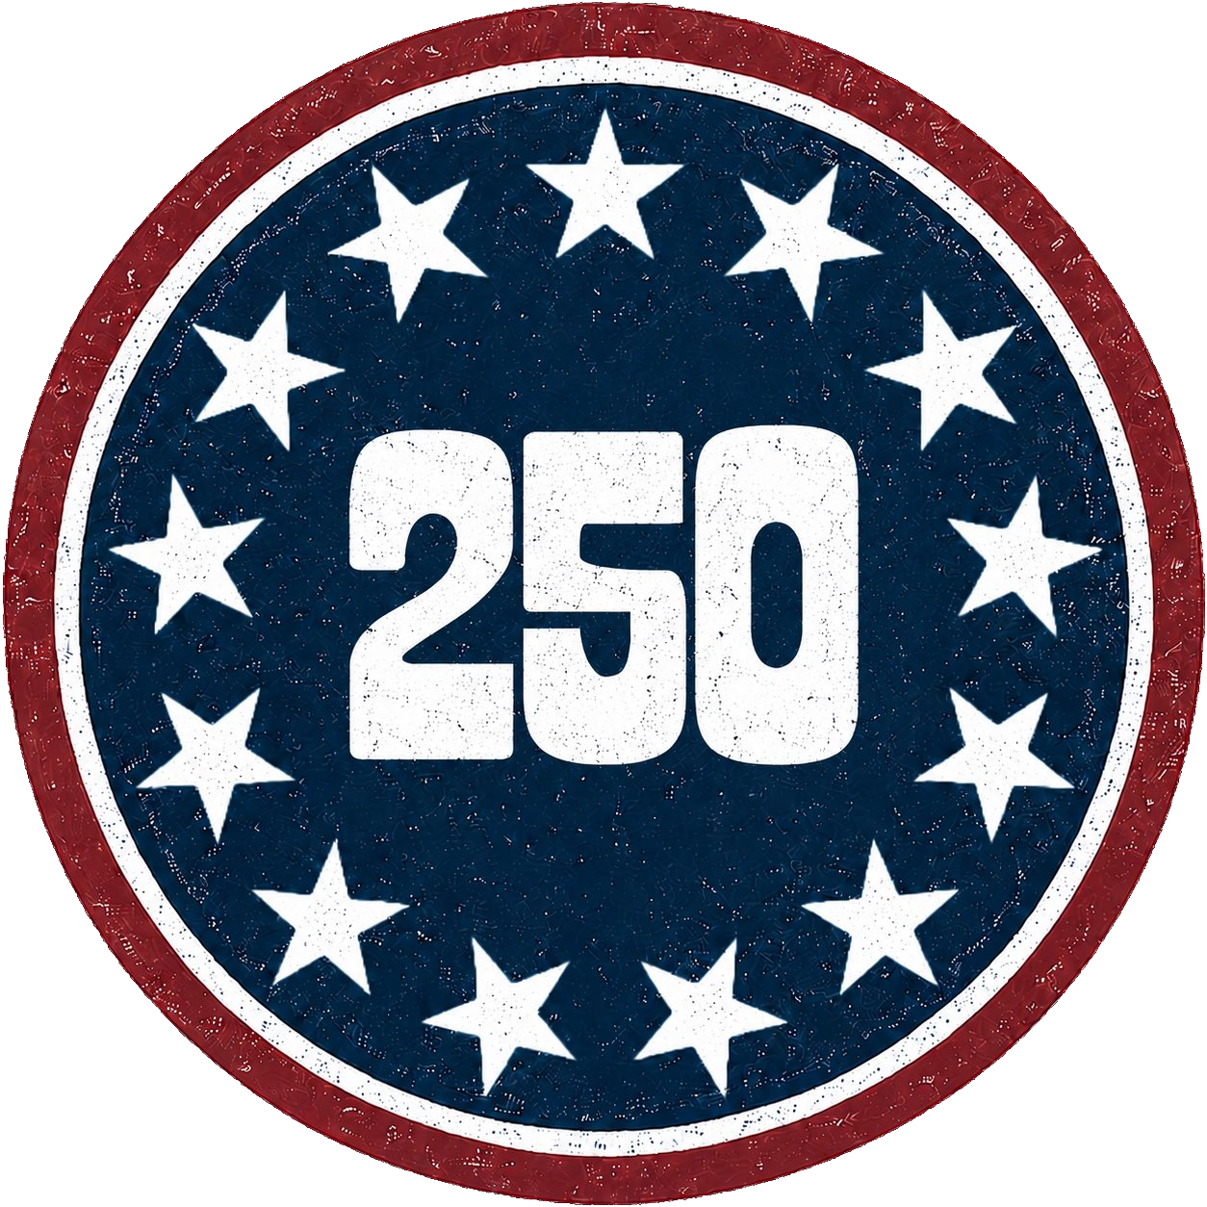
Zero and 1st
Teacher
Renan Grossi
(51) 98135 3067

Conditionals

Quick Reminder
- Zero Conditional: General truths / facts → If + Present Simple, Present Simple
- First Conditional: Real possibility in the future → If + Present Simple, will + infinitive

Exercise 1: Fill in the Blanks
Complete the sentences with the correct form of the verbs in parentheses.
- If you _________ (heat) water to 100 degrees Celsius, it _________ (boil). [Zero]
- If it _________ (rain) tomorrow, we _________ (stay) at home. [First]
- If she _________ (study) hard, she always _________ (get) good grades. [Zero]
- If they _________ (finish) their work on time, they _________ (go) to the party. [First]
- If you _________ (mix) red and blue, you _________ (get) purple. [Zero]
- If he _________ (be) late again, the teacher _________ (get) angry. [First]
- If you _________ (freeze) water, it _________ (turn) into ice. [Zero]
- If we _________ (not / hurry), we _________ (miss) the bus. [First]
- If you _________ (not / water) plants, they _________ (die). [Zero]
- If I _________ (find) your keys, I _________ (call) you. [First]

Exercise 2: Multiple Choice
Choose the correct option.
1. If you _________ the button, the machine _________.
(a) will press, starts (b) press, will start (c) press, starts [Zero]
2. If he _________ late again, he _________ his job.
(a) is, will lose (b) will be, lose (c) is, loses [First]
3. If they _________ the exam, they always _________ happy.
(a) pass, will be (b) pass, are (c) will pass, are [Zero]
4. If it _________ this evening, we _________ the barbecue inside.
(a) will rain, have (b) rain, will have (c) rains, will have [First]
5. If you _________ too much sugar, it _________ your teeth.
(a) eat, damages (b) will eat, damages (c) eat, will damage [Zero]
6. If she _________ her homework, she _________ TV.
(a) will finish, watches (b) finishes, will watch (c) finishes, watches [First]
7. If you _________ water with oil, it _________ mix.
(a) mix, won’t (b) will mix, doesn’t (c) mix, doesn’t [Zero]
8. If we _________ now, we _________ on time.
(a) leave, will be (b) will leave, are (c) leave, are [First]
9. If you _________ fire, it _________.
(a) touch, will burn (b) touch, burns (c) will touch, burns [Zero]
10. If they _________ a dog, they _________ it for a walk every day.
(a) will get, take (b) get, take (c) get, will take [First]

Exercise 3: Sentence Formation
- (will / get / wet / if / it / rains / you) → _________________________________ [First]
- (melts / ice / if / you / heat / it) → _________________________________ [Zero]
- (come / will / I / if / she / calls) → _________________________________ [First]
- (hungry / be / will / you / don’t / eat / if / you) → _________________________________ [First]
- (burns / fire / touch / you / if / it) → _________________________________ [Zero]
- (the / bus / miss / will / you / don’t / run / if / you) → _________________________________ [First]
- (floats / water / on / wood / put / you / if / it) → _________________________________ [Zero]
- (TV / watch / will / you / homework / your / finish / if / you) → _________________________________ [First]
- (spoils / out / food / leave / you / if / it) → _________________________________ [Zero]
- (late / be / will / you / don’t / come / if / you) → _________________________________ [First]

Exercise 4: Error Correction
Some of these sentences have mistakes. Correct the mistakes if there are any.
- If you will heat water, it boils. → _________________________________
- If it rains tomorrow, we will stays at home. → _________________________________
- If you mix red and blue, you will get purple. → _________________________________
- If she studies hard, she always will get good grades. → _________________________________
- If they finish their work, they will went to the party. → _________________________________
- If you not water plants, they die. → _________________________________
- If he is late again, the teacher gets angry. → _________________________________
- If we not hurry, we will miss the bus. → _________________________________
- If you eat too much sugar, it will damages your teeth. → _________________________________
- If she finish her homework, she can watch TV. → _________________________________

Exercise 5: Context-Based Text
Complete the text with Zero or First Conditional.
If you _________ (put) a metal object in the microwave, it _________ (cause) sparks. This is a basic rule that everyone should know. If you _________ (forget) this rule, you _________ (risk) damaging your microwave.
Tomorrow, if it _________ (rain), we _________ (cancel) the picnic. However, if the weather _________ (be) nice, we _________ (go) to the park as planned.
If you _________ (eat) too much junk food, it _________ (affect) your health. If you _________ (want) to stay healthy, you _________ (need) to eat a balanced diet.

