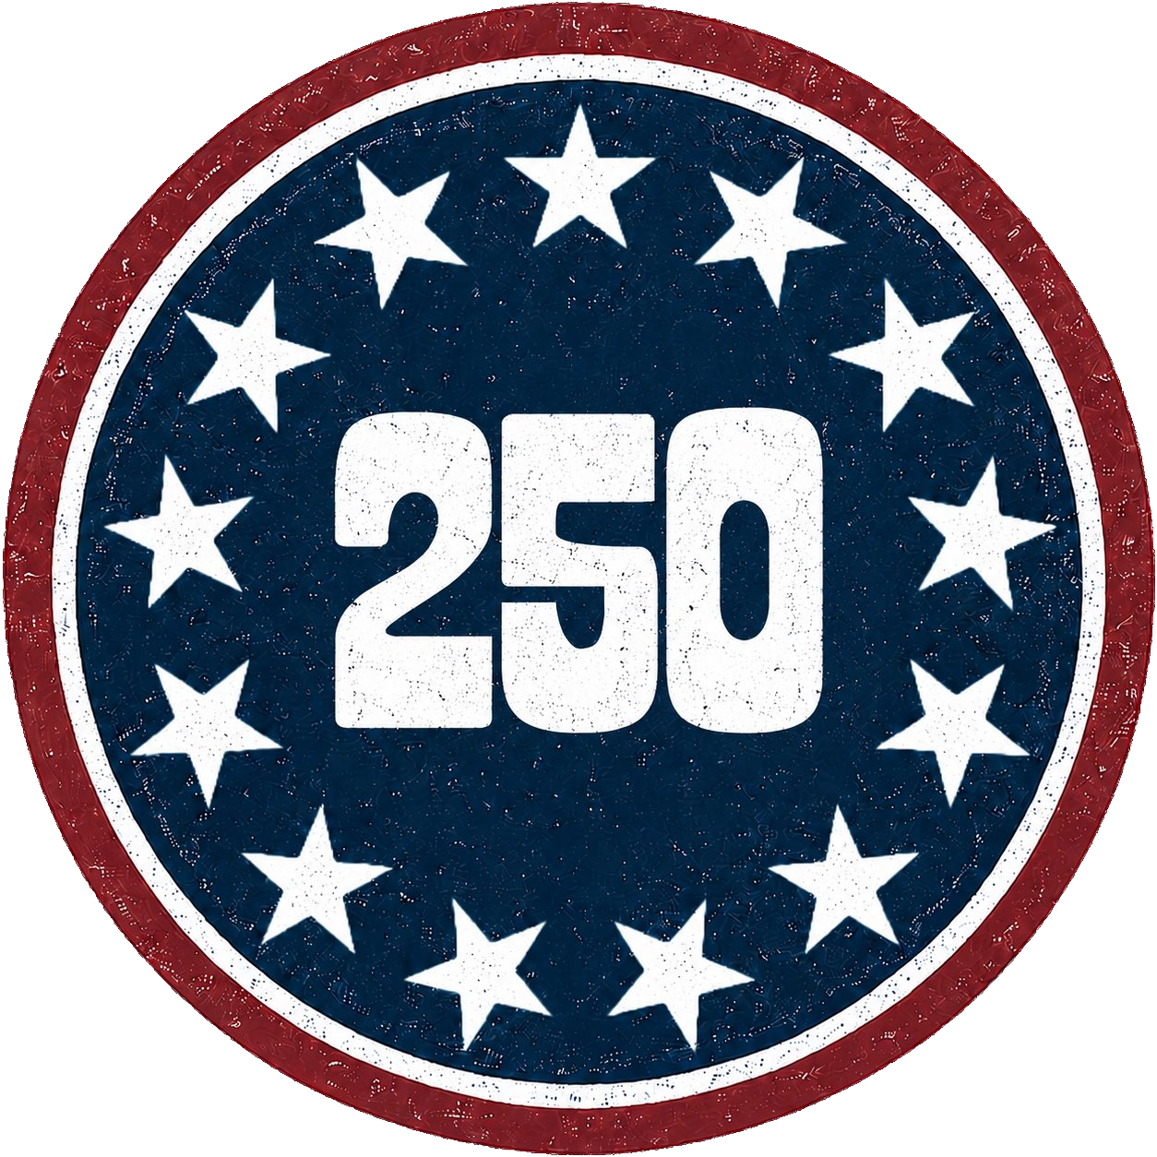
Must, Might, Should
Teacher
Renan Grossi
(51) 98135 3067

Quick Reminder
- Must = strong obligation / logical certainty
- Might = possibility
- Should = advice / recommendation / expectation

Exercise 1: Fill in the Blanks (Mixed Forms)
Complete with must, might, or should + the correct form of the verb.
- He ______ (be) very tired. He has been working all day.
- You ______ (see) a doctor if you’re feeling ill.
- They ______ (be) at home. The lights are on.
- She ______ (not / stay) up so late. It’s not good for her health.
- He ______ (forget) about the meeting. He isn’t answering his phone.
- You ______ (apologize) to her for being rude.
- It ______ (rain) later, so take an umbrella.
- They ______ (be) lost. They’ve been driving around for hours.
- We ______ (leave) now if we want to catch the bus.
- She ______ (not / eat) so much junk food. It’s bad for her.

Exercise 2: Multiple Choice
Choose the best modal.
- You ______ be very careful with this delicate vase.
(a) must (b) might (c) should
- He ______ be the one who broke the window. He was playing outside.
(a) must (b) might (c) should
- If you want to improve, you ______ practice more.
(a) must (b) might (c) should
- They ______ be at the park now. They usually go there in the afternoon.
(a) must (b) might (c) should
- You ______ finish your homework before playing games.
(a) must (b) might (c) should
- She ______ be on her way. She left an hour ago.
(a) must (b) might (c) should
- You ______ check the weather before you go hiking.
(a) must (b) might (c) should
- He ______ be late. He called to say he was stuck in traffic.
(a) must (b) might (c) should
- You ______ wear a helmet when riding a bike.
(a) must (b) might (c) should
- She ______ be studying in the library. She goes there every afternoon.
(a) must (b) might (c) should

Exercise 3: Forming Sentences
Rearrange the words to form correct sentences.
- (homework / you / finish / must) → _________________________________.
- (we / protect / the / environment / must) → _________________________________?
- (not / they / leave / early / should) → _________________________________.
- (call / she / later / might) → _________________________________?
- (cooking / I / should / start / dinner) → _________________________________?
- (you / not / eat / so / much / sugar / should) → _________________________________.
- (he / be / tired / must) → _________________________________.
- (rain / it / might / later) → _________________________________.
- (apologize / you / should) → _________________________________?
- (they / be / lost / might) → _________________________________.

Exercise 4: Error Correction
Correct the mistakes.
- You must to be careful when handling glass. → __________________________________
- She shoulds go to the doctor if she feels sick. → __________________________________
- He might be to late for the meeting. → __________________________________
- They mustn’t have arrive yet. → __________________________________
- You should apologizes for your mistake. → __________________________________
- It might rains tomorrow. → __________________________________
- We must leaving now. → __________________________________
- She should not to eat so much junk food. → __________________________________
- He must be tired after work, mustn’t he? → __________________________________
- You might to call her later. → _________________________________?

Exercise 5: Context-Based Dialogue
Complete the dialogue with appropriate modals.
Mom: It’s getting late. You ______ (be) tired. You ______ (go) to bed soon.
Child: But Mom, I ______ (not / finish) my homework yet.
Mom: You ______ (finish) it tomorrow morning. You really ______ (not / stay) up so late.
Child: Okay. ______ I (read) one more chapter first?
Mom: Yes, but only one. And you ______ (not / forget) to brush your teeth.

