
Arriving in
Teacher
Renan Grossi
(51) 98135 3067

Johannesburg

OR Tambo International Airport, Johannesburg
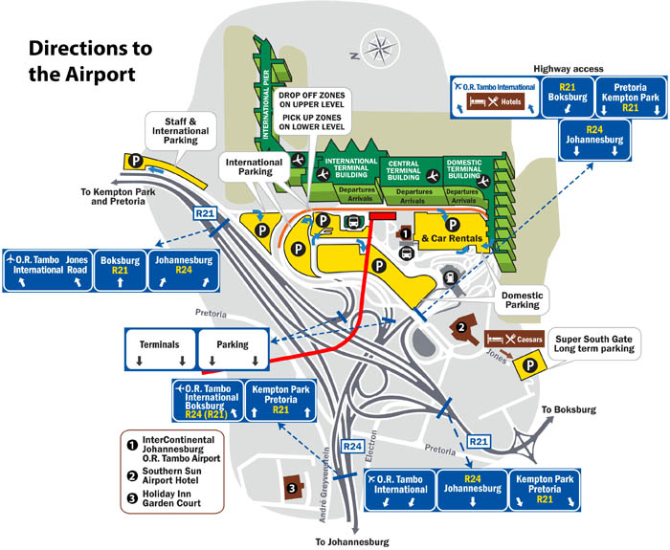

Mauro (Traveler from Brazil): [Approaching the information desk] Hi, can you help me? I just arrived from Brazil and need to find the best way to get to my hotel.
Information Desk Attendant: Hello! Welcome to Johannesburg. Certainly, I can help with that. Which hotel are you staying at?
Mauro: It's the Radisson Blu Hotel in Sandton, the financial district and suburb located in the city of Johannesburg.
Information Desk Attendant: Great choice! For transportation, you have options like taxis, airport shuttles, or ride-sharing apps such as Bolt or Uber.
Mauro: Could you tell me about the price range for these options?
Information Desk Attendant: Sure! A taxi could cost around 600 to 800 South African Rand (ZAR), whereas an Uber might range from 350 to 500 ZAR, depending on traffic. The shuttle services are usually priced per person, typically around 200 ZAR.
Mauro: That’s helpful, thank you. How about the schedule? Are taxis and Uber available any time?
Information Desk Attendant: Yes, both taxis and Uber are available 24/7. The airport shuttle services, however, often run on a fixed schedule, so it’s best to check the specific timing at the shuttle counter just over there.
Mauro: And how long does the trip usually take?
Information Desk Attendant: The drive to Sandton should take around 30 to 45 minutes, but it can vary depending on the traffic, especially during rush hour.
Mauro: I see. What more can you tell me about the shuttle services?
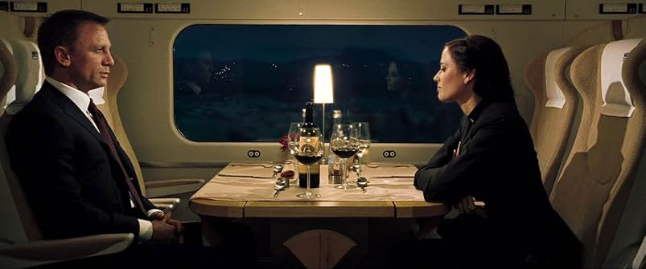
Information Desk Attendant: The shuttle services operate at regular intervals and are a good option if you don't mind sharing a ride with other travelers. They run on a fixed schedule, with trips every hour or so, depending on how busy the day is. The shuttle will drop you off at major hotels and central locations in the city.
Mauro: Are there any specific advantages or disadvantages to taking the shuttle?
Information Desk Attendant: The shuttles are a cost-effective choice, especially if you're traveling alone and not in a hurry. However, travel time might be slightly longer compared to a taxi or Uber since shuttles might stop at multiple hotels along the way to drop off other passengers.
Mauro: That makes sense. Where would I catch the shuttle?
Information Desk Attendant: You can book and board the shuttle right outside this terminal. Look for the shuttle services counter in the 'Public Transport' area, and they’ll provide you with the exact timing and ticketing details.
Mauro: Great, that sounds like a decent option. I think I’ll decide between the Uber and the shuttle. Thanks for all the help!
Information Desk Attendant: You're welcome! Have a wonderful stay in Johannesburg.

══════════════════════════════════════════════════════════════════════════════════
♦ ♣ ♥ ♠
══════════════════════════════════════════════════════════════════════════════════

Scene: Arriving at Radisson Blu Hotel, Sandton
As the airport shuttle bus pulls to a smooth stop at the Radisson Blu Hotel in Sandton, Mauro and Lara Croft gather their belongings and prepare to disembark. The shuttle, a comfortable and modern bus designed for airport hotel transfers, has provided them with a pleasant journey through Johannesburg.
Mauro: [Standing up and gently calling Lara Croft] We're here, Lara Croft. Let's make sure we have everything.
Lara Croft: [Smiling and checking her bag] All set! It was nice to see a bit of the city from the road.
They step off the shuttle bus, the driver kindly holding the door for them as they exit. The hotel’s impressive entrance looms ahead, welcoming after their long journey.
Shuttle Driver: [With a friendly wave] Enjoy your stay in Sandton, and feel free to ask the hotel staff for any local tips!
Mauro: Thanks a lot! [Nods appreciatively] That was a really smooth ride.
They make their way towards the hotel entrance, their footsteps echoing slightly on the polished stone pathway. The air is filled with the faint scent of flowers from the landscaped gardens around the hotel.
Lara Croft: This hotel looks beautiful. I’m glad we chose it.
Mauro: Absolutely. Let’s head inside and check in. Can’t wait to relax for a bit.
They enter the lobby, where the friendly ambiance and elegant decor greet them warmly. Mauro leads the way to the reception desk, ready to begin their stay.
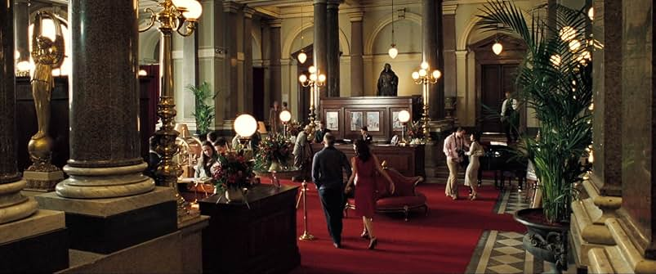
Hotel Receptionist: [As Mauro and Lara Croft approach] Good afternoon, and welcome to the Radisson Blu Hotel. Do you have a reservation?
Mauro: Hello. Yes, we have a reservation under Mauro Policarpo Augusto Quaresma.
The receptionist checks the system as Mauro hands over his passport, eager to finalize the check-in.
Hotel Receptionist: Great, I see your reservation here. We have prepared everything for your arrival. Breakfast is included with your stay. It's served in our main dining area, located on the second floor, from 6:30 AM to 10:00 AM on weekdays, and until 11:00 AM on weekends.
Mauro: That sounds perfect. What kind of facilities do you have here?
Hotel Receptionist: We have a variety of amenities to enhance your stay. Our fitness center is open 24/7, and it's located on the third floor. We also have a rooftop pool with a bar where you can relax and enjoy the views of the city.
Lara: Sounds lovely. Do you offer any services for getting around the city or tours?
Hotel Receptionist: Yes, we offer a concierge service that can help arrange city tours, transport, and provide recommendations for local attractions and dining options. Just visit the concierge desk in the lobby.
Mauro: Excellent. Is there a business center or place to work if I need to?
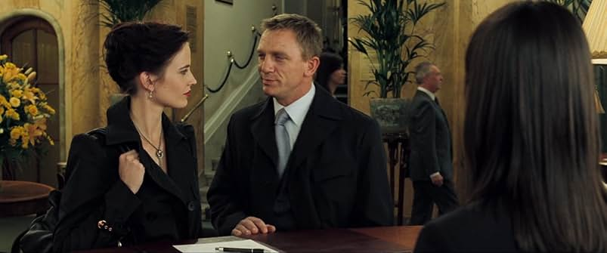
Hotel Receptionist: Absolutely, we have a fully equipped business center on the ground floor that's open 24 hours. It includes meeting rooms and workstations with complimentary Wi-Fi.
Lara: And if we want to have dinner at the hotel, do you have a restaurant?
Hotel Receptionist: We do. Our signature restaurant, located on the first floor, offers a variety of international and local dishes for dinner from 6:00 PM to 10:00 PM. We recommend booking a reservation, especially on weekends.
Mauro: Sounds great. Thank you for all the information.
Hotel Receptionist: You’re welcome. Here’s your room key. If you need any more assistance during your stay, feel free to contact the front desk. Enjoy your stay with us!
Mauro and Lara take the room key and head towards the elevators, looking forward to settling into their room and starting their Johannesburg adventure.

══════════════════════════════════════════════════════════════════════════════════
♦ ♣ ♥ ♠
══════════════════════════════════════════════════════════════════════════════════

Scene: Outside their hotel room at the Radisson Blu Hotel, Sandton
Mauro tries the key card several times, but the door won't open.
Mauro: [Frowning slightly] Hmm, that's odd. The key isn't working.
Lara: Maybe try it one more time, just to be sure.
Mauro tries again, but the door remains locked.
Mauro: No luck. Let's head back to the front desk and see if they can help us out.
They return to the reception desk.
Mauro: [Approaching the receptionist] Hi, sorry to bother you. We just tried to access our room, but the key card isn’t working.
Hotel Receptionist: I’m sorry about that! Let me check the details for you. Could you please confirm your room number?
Mauro: It’s room 405.
Hotel Receptionist: [Checking the system] Thank you. Sometimes the electronic keys occasionally need reactivating. Let me reprogram it for you.
Lara: Thanks, we appreciate that.
Hotel Receptionist: [Reprogramming the key] There you go. This should work now. Please try it again, and if you have any further issues, feel free to contact us.
Mauro: Thank you very much. We'll give it another try.
Mauro and Lara return to their room and try the card again, which now works smoothly, allowing them into the room.
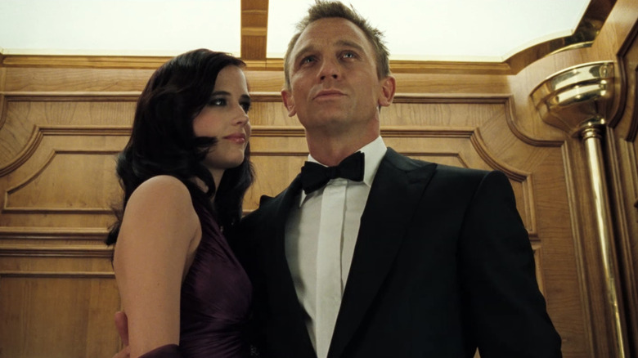
Lara: Great, it worked this time! Glad we got that sorted out quickly.
Mauro: Definitely. Let’s get settled and start enjoying our trip.
Both enter the room, relieved and ready to relax.

══════════════════════════════════════════════════════════════════════════════════
♦ ♣ ♥ ♠
══════════════════════════════════════════════════════════════════════════════════

