St. Nicholas, Krampus, and the Grinch
Teacher
Renan Grossi
Tel.: 98135 3067

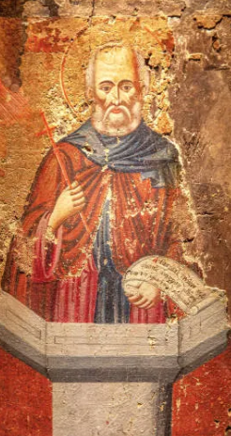
St. Nicholas of Myra (the real root of Santa Claus) was a kind 4th-century bishop from the Eastern Roman Empire.
He was famous for secretly giving gifts to the poor — especially to children and young women in need.
Here is some classic depiction of the saint:

Over the centuries, this gentle, generous saint slowly transformed into the cheerful, red-suited Santa Claus we know today: a magical, gift-bringing figure who rewards good children.

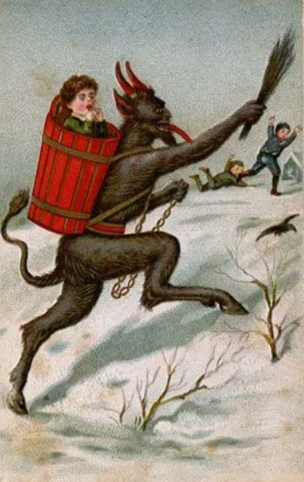
Krampus, on the other hand, is the dark companion from Alpine folklore (especially Austria, southern Germany, and parts of Central Europe).
While St. Nicholas brings presents to good children on December 5th/6th, Krampus comes for the naughty ones.
Half-goat, half-demon, with horns, fangs, and a long red tongue, he carries chains, birch rods, and sometimes a sack or basket to carry particularly bad children away for punishment.
Here is a chilling traditional image of Krampus:
In many regions, people still celebrate "Krampusnacht" (December 5th) with wild parades, scary costumes, and lots of noise — a perfect balance to all the sweetness of Christmas.


The Grinch is the newest (and most fictional) of the trio.
Created by Dr. Seuss in 1957, the Grinch is a green, grumpy creature who lives on Mount Crumpit above the cheerful town of Whoville.
He hates Christmas — the singing, the gifts, the happiness — so much that he decides to steal it all.

