The Cachaca

Case
Teacher
Renan Grossi
Tel.: 98135 3067

Activity I. Read the following text and discuss:

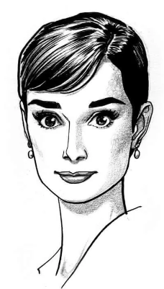
It was a dreary Monday morning when Detective Julia Kendall was called to the scene of a burglary. The owner of the house, a wealthy businessman, had reported that his safe had been broken into and a significant amount of money and jewelry had been stolen.
Dreary: gloomy, dull, or uninspiring
Burglary: the act of illegally entering a building and removing valuable objects
Wealthy: having a large amount of money
Safe: made of metal with a lock or combination, used for storing valuable items documents

As she inspected the crime scene, Detective Kendall noticed a piece of paper on the ground near the safe. It was torn and crumpled, but she could make out a few words: "Meet at the park. Richard."
Crumpled: wrinkled or crushed, as a result of being folded, compressed
She didn't think much about it at first, assuming it was just a note between two partners. But as she delved deeper into the investigation, things started to fall into place.
Delved: to investigate or explore something thoroughly
Fall into place: to happen as expected
She discovered that the businessman had recently fired his assistant, a man named Richard, for embezzlement. Richard had been furious about losing his job and had been overheard making threats to "get revenge" over his former boss.
Fired: to be dismissed or terminated from a job
Embezzlement: the act of stealing money or property
Overheard: to hear something that was not meant for one's ears
Threats: statements or actions that express an intention to harm, damage, or cause trouble
Detective Kendall became convinced that Richard was the culprit, but she didn't have enough evidence to prove it. That is, until she received a tip from Richard’s ex-coworker Douglas, saying that Richard had been seen wearing one of the stolen pieces of jewelry.
Culprit: a person responsible for a crime or wrongdoing.
Tip: a piece of information or advice that is given to someone
With a search warrant in hand, Detective Kendall and her team went to Richard's apartment. They found the missing money and jewelry hidden in a false wall, behind a cupboard of cachaça bottles, along with the torn note that had led Kendall to suspect Richard in the first place.
Search warrant: a legal document that authorizes law enforcement
Cupboard: a piece of furniture with shelves or drawers used for storing items
When Richard was brought in for questioning, he initially denied everything. But as Detective Kendall presented her evidence, he broke down and confessed to the crime. It had been a shock to everyone who knew him, as Richard had always been considered a trustworthy and decent member of the community.
Broke down: to lose emotional control and become very upset
Trustworthy: deserving of trust or confidence
As the news spread, people were stunned that someone they had known for years had committed such a heinous act. But Detective Kendall knew that it was just another day on the job, and she was already onto the next case.
Heinous: shockingly evil or wicked; abominable or atrocious

