Egyptian UFos

Teacher
Renan Grossi
Tel.: 98135 3067

Activity I. Read the following text:

Let's delve into the ancient Egyptian UFO sighting with utmost detail, as if you were a doctoral student researching this topic.
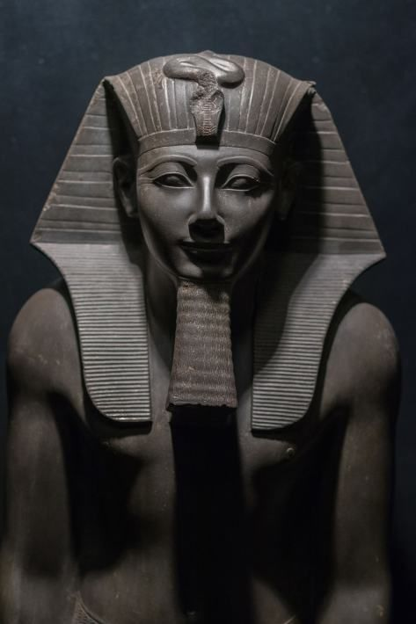
Around 1450 BCE, during the reign of Pharaoh Thutmose III, an intriguing event unfolded in the region of Megiddo, located in what is now modern-day Israel. The Egyptian army, led by Pharaoh Thutmose III himself, was preparing for battle when they witnessed a remarkable phenomenon in the sky—an unidentified flying object (UFO).
According to historical accounts, the object appeared as a shining disk or circle with an intense radiance surpassing the brilliance of the sun. The soldiers and Pharaoh Thutmose III were astonished and captivated by this extraordinary sight. Notably, this event was documented in ancient Egyptian hieroglyphics that can still be observed today on the walls of the temple of Karnak.
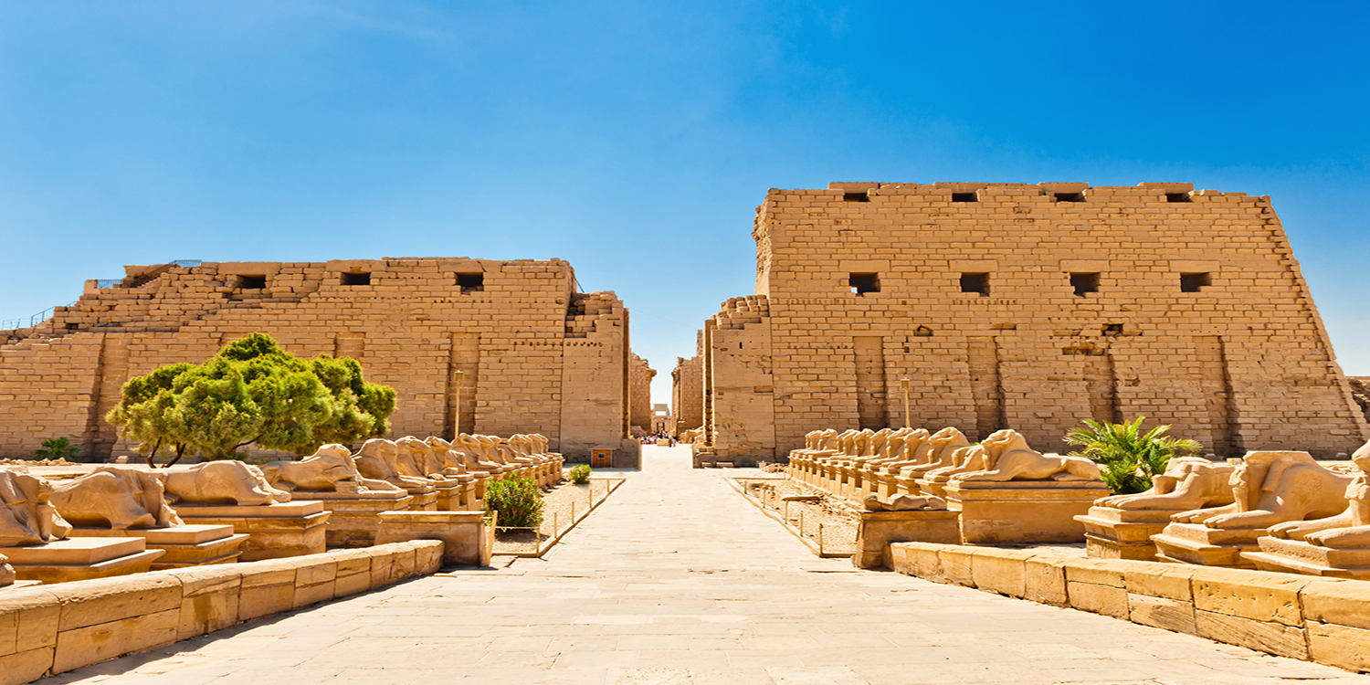
What distinguishes this ancient UFO sighting from other encounters is the presence of what the soldiers described as strange, otherworldly beings accompanying the luminous disk. Although the details surrounding these beings are scarce, their presence adds an extra layer of mystery to the account.
The sighting lasted for several hours, during which the UFO moved across the sky in a seemingly effortless and controlled manner. This extraordinary display of aerial movement left the soldiers both fearful and awestruck, as they grappled with the inexplicable nature of the event. The encounter was of such significance that it warranted documentation in the hieroglyphics of Karnak, allowing us to gain insights into this ancient phenomenon.

It is crucial to note that this account of a UFO sighting in ancient Egypt is not an isolated incident. Numerous civilizations throughout history have documented similar encounters with unidentified flying objects. While the descriptions may vary, these accounts share the common thread of witnessing perplexing aerial phenomena that challenge conventional explanations.
The ancient Egyptian story of Pharaoh Thutmose III's encounter with a radiant disk and enigmatic beings serves as a reminder of humanity's enduring fascination with UFOs. This historical event sparks curiosity about the possibility of extraterrestrial visitations and raises thought-provoking questions about our place in the universe and the unexplored frontiers of outer space.
By studying and analyzing accounts like these, we gain valuable insights into the long-standing human fascination with UFOs, providing a deeper understanding of our collective history and the enduring mysteries that have captivated civilizations throughout the ages.
