A super El Niño is forming in the Pacific - the biggest since the recorded history

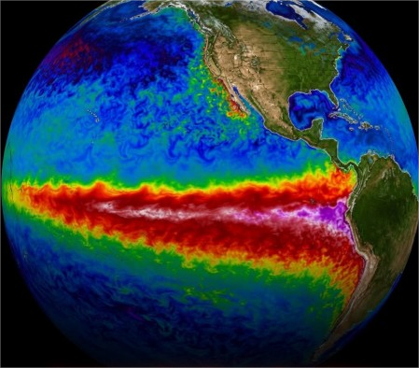
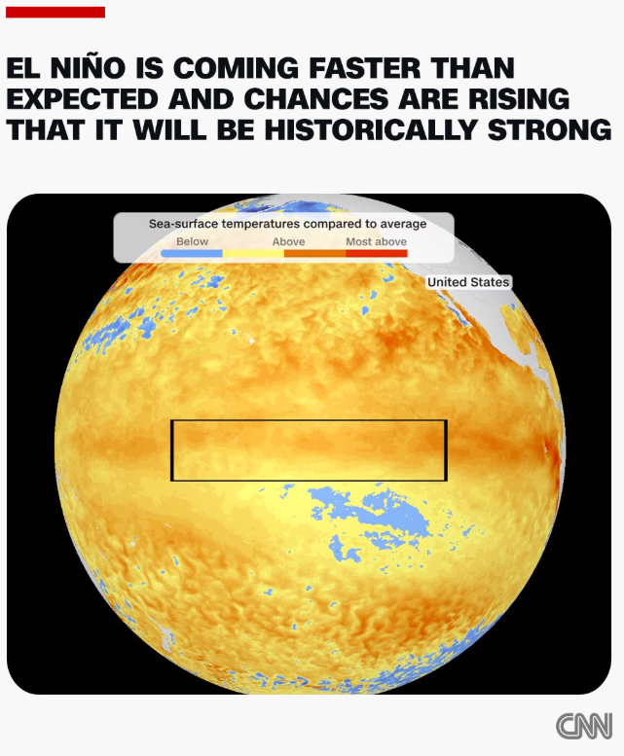

What does it mean for someone who lives in porto alegre? When and how will it affect us?

For someone in Porto Alegre, a developing/strong El Niño generally means a higher risk of above-average rainfall, heavy storms, and flooding. This is the opposite of its effects in northern Brazil (drier conditions).

Why This Happens

El Niño alters global atmospheric circulation, often leading to a persistent high-pressure system over central Brazil. This blocks or slows cold fronts, concentrating moisture and instability over southern Brazil (Rio Grande do Sul, Santa Catarina, Paraná). Combined with warmer air holding more moisture, it increases the chance of intense, prolonged rain events—especially in fall and winter (April–August in the Southern Hemisphere).

- Recent example: The devastating 2024 floods, which hit Porto Alegre hard, were strongly amplified by the previous El Niño. El Niño roughly doubled the likelihood and added ~9% intensity to the extreme rainfall.

Timeline for the Current Developing El Niño

- Emergence: Likely May–July 2026 (high probability, already showing rapid warming signs).
- Strengthening/Peak: Often strongest in the second half of 2026, especially September–November (spring) through the Southern Hemisphere summer. A "Super" El Niño would amplify effects.
- When effects hit southern Brazil: Can start as early as mid-2026 but typically become more pronounced in the second half of 2026 into early 2027, with elevated flood risk during the cooler/wetter seasons (fall/winter/spring). September–November is often flagged as a high-risk window for extreme events.

How It Could Affect Porto Alegre and the Region
- Increased flooding risk — Higher rainfall totals, more frequent heavy downpours, thunderstorms, and stalled weather systems. Porto Alegre is especially vulnerable due to its location on the Guaíba River/Lake system and low-lying areas. The 2024 floods showed how quickly rivers can overflow, disrupting the airport, roads, water supply, and homes.
- Agriculture and economy — Excess rain can damage crops (e.g., soy planting season), livestock, and infrastructure. It may contribute to food price pressures nationally.
- Other impacts — Stronger storms, possible cyclones, landslides in hilly areas, and disruptions to daily life/transport. Warmer-than-average temperatures overall.
- Compounding factors — Climate change is making extreme rain events more likely and intense on top of El Niño. Urbanization, deforestation, and infrastructure issues (as seen in 2024) can worsen outcomes.

What You Can Do
- Stay informed via local authorities (e.g., INMET, MetSul, Rio Grande do Sul civil defense alerts).
- Prepare emergency kits, review flood insurance/home protections, especially if you live in low-lying or river-adjacent neighborhoods.
- Follow seasonal forecasts as the event evolves (intensity and exact impacts can vary).

