FORMAL VS INFORMAL
Teacher
Renan Grossi
Tel.: 98135 3067

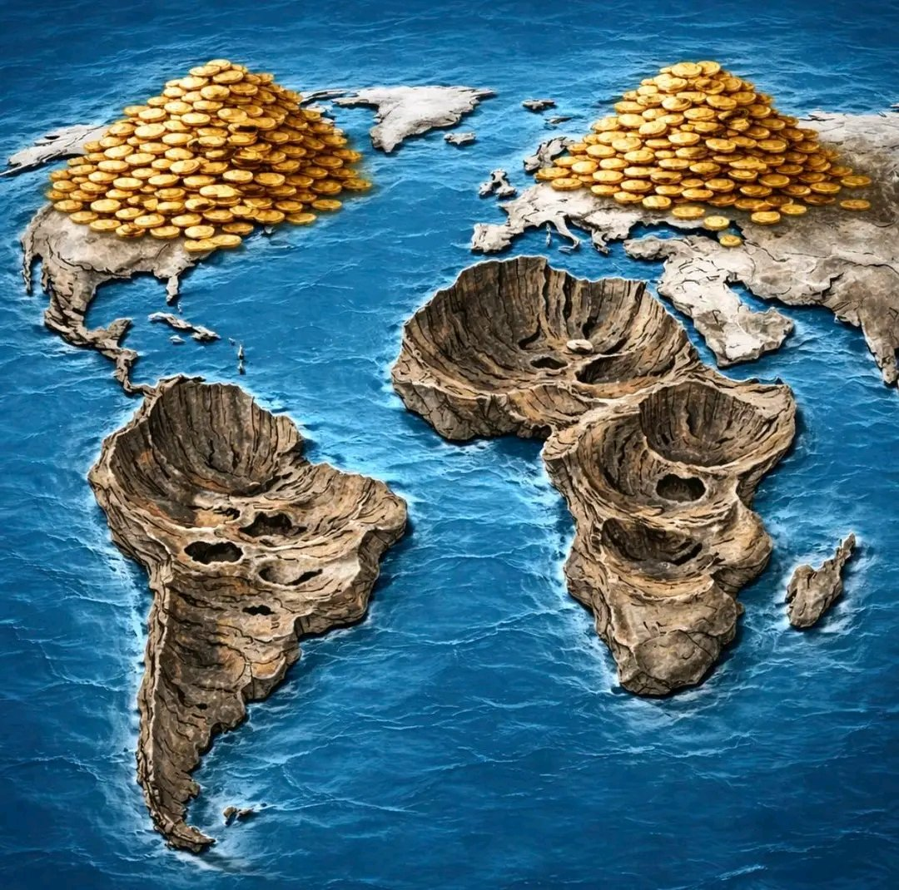
INFORMAL TEXT | FORMAL TEXT
Yo, a lot of folks love saying the developing world is broke ’cause the West colonized ’em and jacked all their resources. But nah, the real deal is that over the last hundred years or so, most of these places have straight-up shown they can’t handle their own stuff. They ain’t poor ’cause we stole everything… they’re poor ’cause they suck at running their countries, resources or not. | It is often argued that the developing world remains poor because Western nations colonized these regions and extracted their resources. However, over the past century, many developing countries have demonstrated significant difficulty in effectively managing and utilizing their own resources. Their poverty, according to this view, is not primarily the result of external theft, but rather of weak governance, poor administration, and institutional failure.
Look at Venezuela: biggest oil reserves on the planet, but with a corrupt commie in charge, people are starving and eating zoo animals while sitting on trillions in black gold. | Venezuela serves as a frequently cited example: despite possessing the largest proven oil reserves in the world, chronic corruption and ideological mismanagement have contributed to widespread shortages and severe poverty among the population.
Africa’s the same vibe. Europeans left behind farms, trains, roads, mines… all that good infrastructure... What happened? | Africa is often presented as a similar case. European colonial powers left behind extensive infrastructure, including farmland, railways, roads, and mining operations.
It all fell apart quick, got stripped for parts or just looted. They got handed full-on working systems for pulling out resources and basically unlimited cash potential, but couldn’t even keep up basic maintenance. | Following decolonization, much of this infrastructure deteriorated, was dismantled, or looted, and many previously functioning supply chains collapsed due to inadequate maintenance and governance.
People might say, “Yo, Europeans didn’t train ’em how to run it! Not their fault!” But bro, they did try to train locals for management roles—it would’ve been easier than shipping in a whole workforce. Just didn’t find much talent, I guess. | A common defense is that colonial powers failed to train local populations to manage these systems independently. However, historical records indicate that efforts were made to involve and train local administrators, partly out of practical necessity, though with limited success in many regions.
Don’t buy it? Check Hong Kong and Singapore. There, Euros worked with locals in admin and management. When colonialism ended, those spots ran themselves just fine. Africa? Not so much. | Comparisons are frequently drawn with Hong Kong and Singapore, where colonial administrations worked more closely with local elites in governance and management. After the end of colonial rule, these societies were able to govern themselves effectively, in contrast to many African states.
Look, I’m not saying colonialism was awesome… people got a right to self-rule and deciding their own fate. But blaming ongoing poverty in the developing world on colonialism and resource extraction? That’s straight-up bull. | None of this implies an endorsement of colonialism, as the right to self-rule and self-determination is fundamental. Nevertheless, attributing the developing world’s persistent poverty solely to colonialism and resource extraction is, from this perspective, an overly simplistic and unconvincing explanation.

