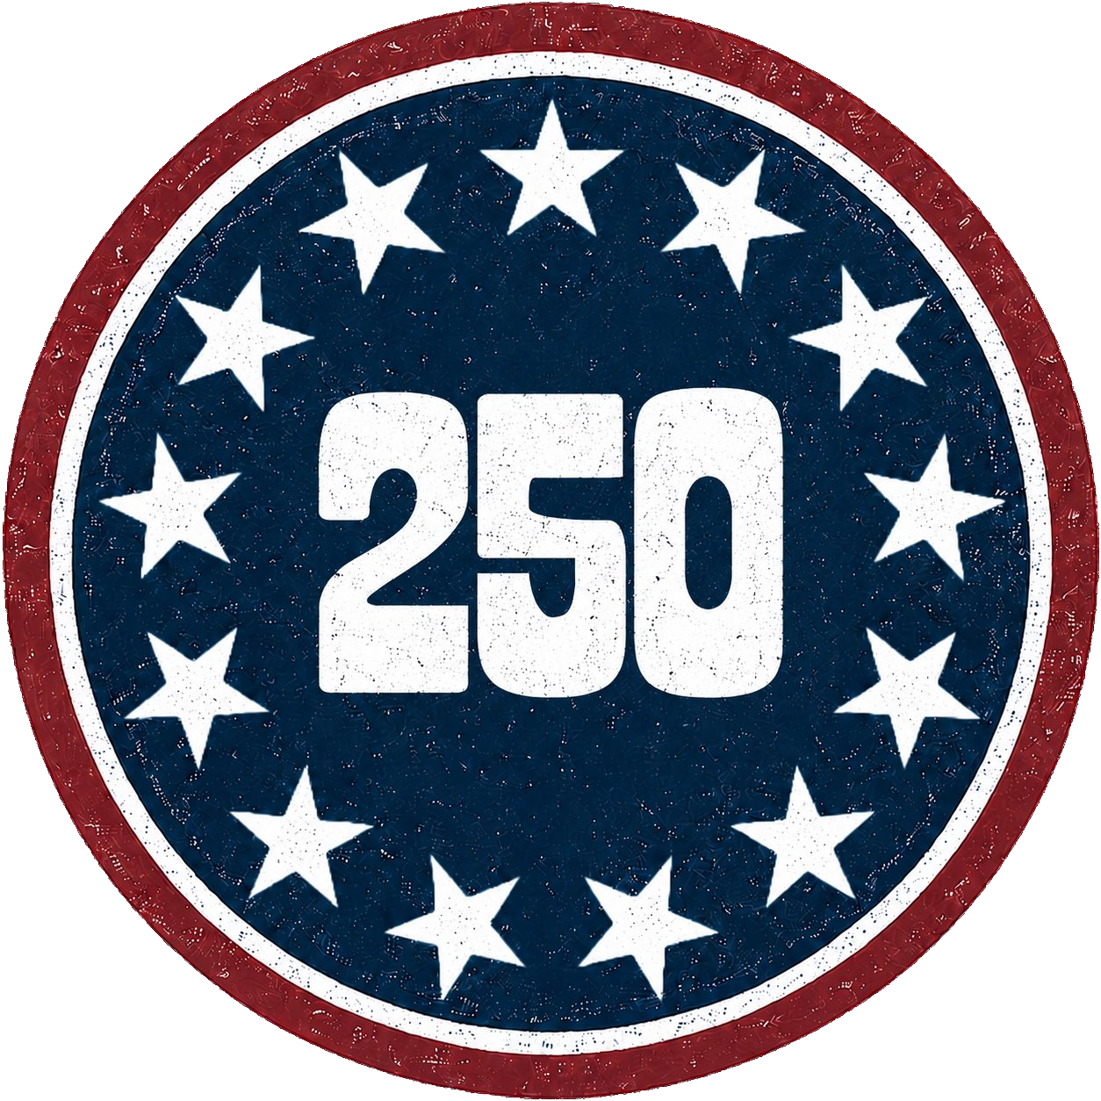
IT Interview
Teacher
Renan Grossi
(51) 98135 3067

Interviewer: Good morning, thank you for coming in for this interview. Can you please introduce yourself and tell us about your previous experience in the field?
Candidate: Good morning, my name is Douglas and I have been working as a software developer for the past 7 years. My previous experience has been focused on web development using JavaScript, React, and Node.js. I have also worked with databases such as MongoDB and MySQL.
Interviewer: Great, can you give us an example of a project you have worked on that you are particularly proud of?
Candidate: Sure, I worked on a project where I was responsible for building a web application that allowed users to book appointments with doctors. I used React for the frontend and Node.js for the backend. The application had to handle a lot of traffic, so I had to optimize the code to ensure that it was scalable and fast. I also integrated it with a payment gateway to allow users to pay for their appointments.
Interviewer: That sounds impressive. Can you tell us about a challenging technical problem you faced and how you solved it?
Candidate: One of the most challenging problems I faced was when I was working on a project that involved real-time data streaming. The data was coming in at a very high rate, and we needed to process it in real-time. I had to use technologies like Apache Kafka and Apache Spark to handle the data stream and process it efficiently. It was a complex problem, but I was able to find a solution that met the project's requirements.
Interviewer: Excellent. How do you keep yourself up-to-date with the latest trends and technologies in the field?
Candidate: I am constantly learning and keeping up-to-date with the latest trends and technologies. I read technical blogs and attend conferences and meetups. I also participate in online communities and forums where developers share their knowledge and expertise. Additionally, I experiment with new technologies and build personal projects to gain practical experience.
Interviewer: Finally, can you tell us about your experience working in a team environment?
Candidate: I have experience working in both small and large teams. I believe that communication is key in a team environment, so I make sure to communicate clearly and frequently with my team members. I also value collaboration and teamwork, and I'm always willing to help my colleagues when needed. In my previous jobs, I have used tools like Git and JIRA to manage and track tasks, and I am comfortable working with agile methodologies like Scrum.
Interviewer: Thank you for your time and for sharing your experience with us. We will be in touch soon.

