Kitchen chaos
Teacher
Renan Grossi
Tel.: 98135 3067

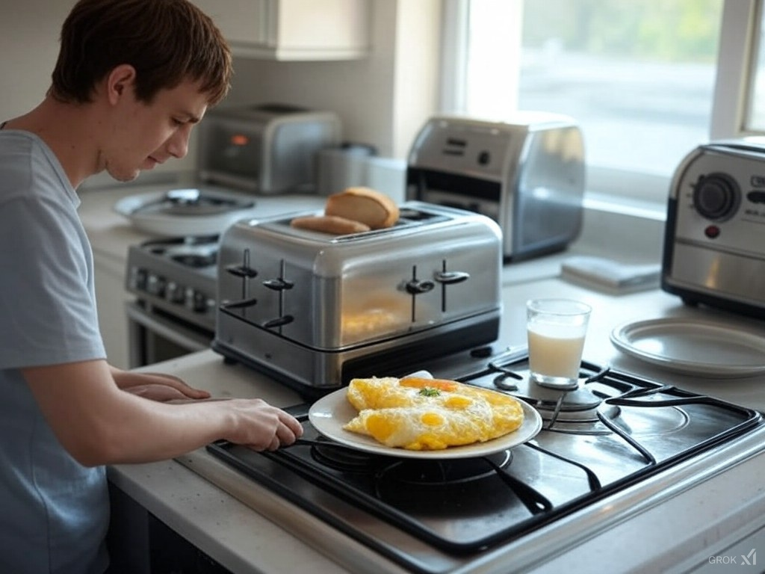
In the kitchen, I find solace from my daily IT tasks. I start my day by grabbing a spoon and a plate to make breakfast. I pull milk from the fridge and eggs for an omelet. The toaster pops up bread while the kettle boils for a nice cup of tea or a strong coffee from the coffee maker to fuel my coding sessions.

When it's time for dinner, I chop vegetables like carrots and onions with my knife, preparing a healthy meal. The microwave is handy for heating leftovers, especially when I'm debugging late into the night. My blender has become a staple for making smoothies packed with fruits and spinach, aligning with my new health-conscious lifestyle.

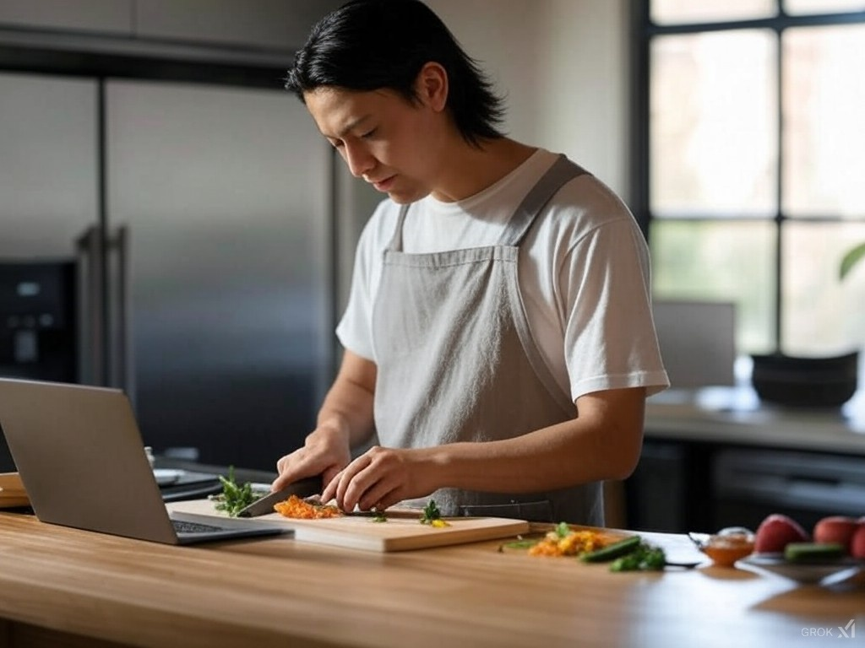
I've ventured into gourmet cooking recently, mastering sushi with rice, and raw fish from the freezer. Precision in cooking, much like in coding, is key, and I've learned to appreciate the nuances of each utensil, from the peeler to the mortar and pestle. The dishwasher has been a relief, allowing me more time to focus on my algorithms rather than cleaning up after meals.

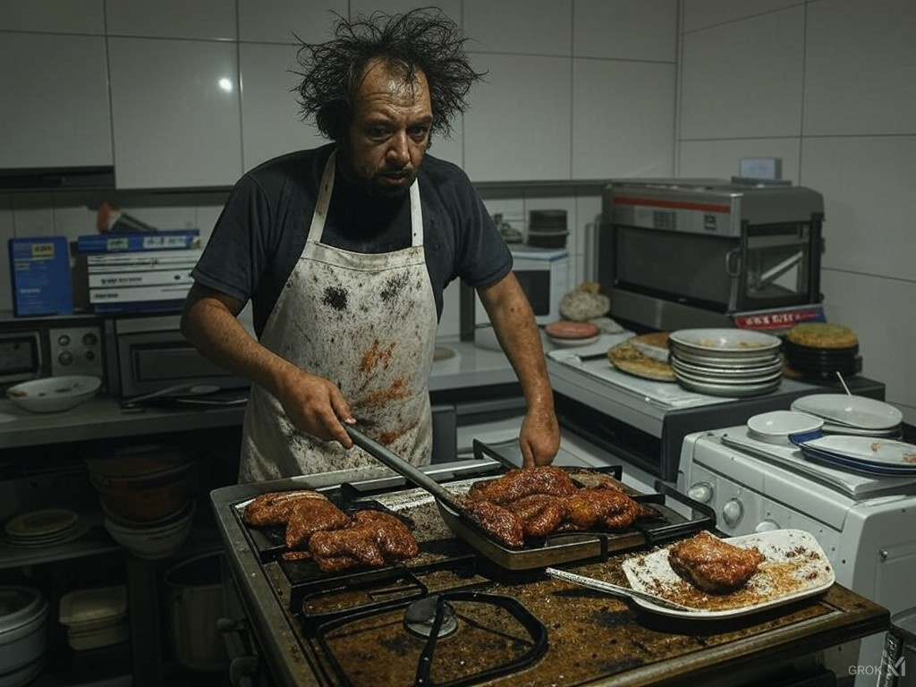
This kitchen journey has taught me that both cooking and coding require creativity, precision, and a deep understanding of the tools at hand. Whether I'm using the sous-vide to perfect a dish or debugging a complex program, the parallels are striking.

