Romania
Teacher
Renan Grossi
Tel.: 98135 3067

Activity I. Read the text:
Romania is a captivating country located in Southeastern Europe. It is known for its rich history, diverse landscapes, vibrant culture, and warm hospitality. Let's delve into various aspects of Romania:
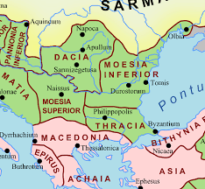
- History: Romania has a fascinating history that spans over 2,000 years. The region was inhabited by Dacians, a Thracian tribe, before it was conquered by the Romans in the 2nd century AD. Over the centuries, the territory of present-day Romania witnessed various influences, including Roman, Ottoman, and Austro-Hungarian rule. In 1918, Romania unified its territories and became a modern nation-state.
- Landscapes: Romania has breathtaking natural landscapes. The Carpathian Mountains traverse the country, offering stunning peaks, deep gorges, and lush forests. The region is popular for outdoor activities like hiking, skiing, and wildlife observation. The Danube River forms Romania's southern border, providing picturesque landscapes and opportunities for river cruises. The country is also home to the Danube Delta, a UNESCO World Heritage site and one of Europe's most bio-diverse regions.
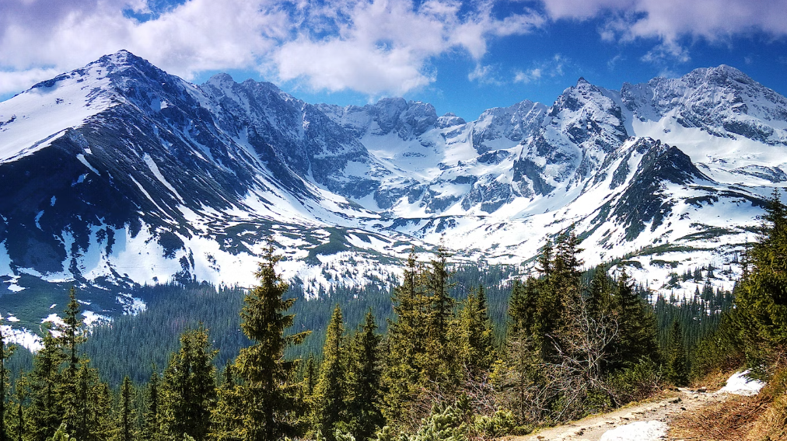
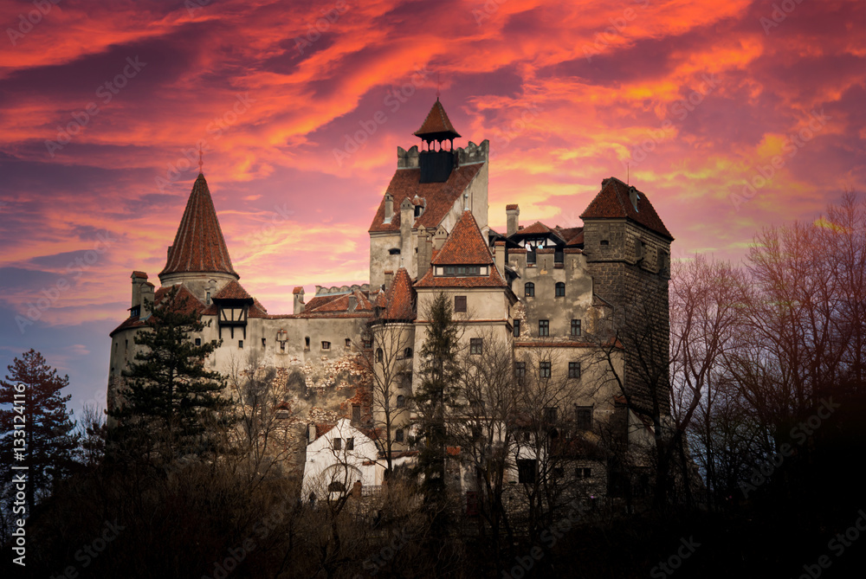
- Transylvania: Transylvania is a historical region in central Romania that holds a certain mystique. It is often associated with the legend of Count Dracula, inspired by the novel by Bram Stoker. The region is renowned for its medieval towns and castles, such as Bran Castle and Peleș Castle. The city of Sibiu, with its well-preserved old town, is a cultural hub and was designated as the European Capital of Culture in 2007.
- Bucharest: As the capital and largest city of Romania, Bucharest offers a mix of old-world charm and modern vibrancy. It features impressive architecture, including the massive Palace of the Parliament, the second-largest administrative building in the world. The city also boasts numerous museums, beautiful parks, and a thriving nightlife scene.
- Cultural Heritage: Romanian culture is a fusion of various influences, combining elements from the Roman, Byzantine, Ottoman, and Western European traditions. Folklore plays a significant role, with traditional music, dance, and intricate handicrafts showcasing the country's heritage. The Romanian language is a Romance language and has similarities with Italian, Spanish, and French.
- Traditional Cuisine: Romanian cuisine is hearty and flavorful. Popular dishes include sarmale (cabbage rolls stuffed with seasoned meat and rice), mămăligă (a cornmeal dish similar to polenta), and mici (grilled minced meat rolls). Locally produced wines, such as Fetească Neagră and Grasă de Cotnari, are also well-regarded.
- Festivals and Traditions: Romania celebrates various cultural and religious festivals throughout the year. One of the most prominent is Easter, which features unique customs like painted eggs and traditional dances. The Mărțișor festival in March marks the arrival of spring, and the colorful winter holiday of Christmas is widely celebrated.
- Famous Personalities: Romania has produced many notable figures across different fields. Some renowned personalities include the sculptor Constantin Brâncuși, gymnast Nadia Comăneci, Nobel laureate writer Herta Müller, and musician George Enescu.
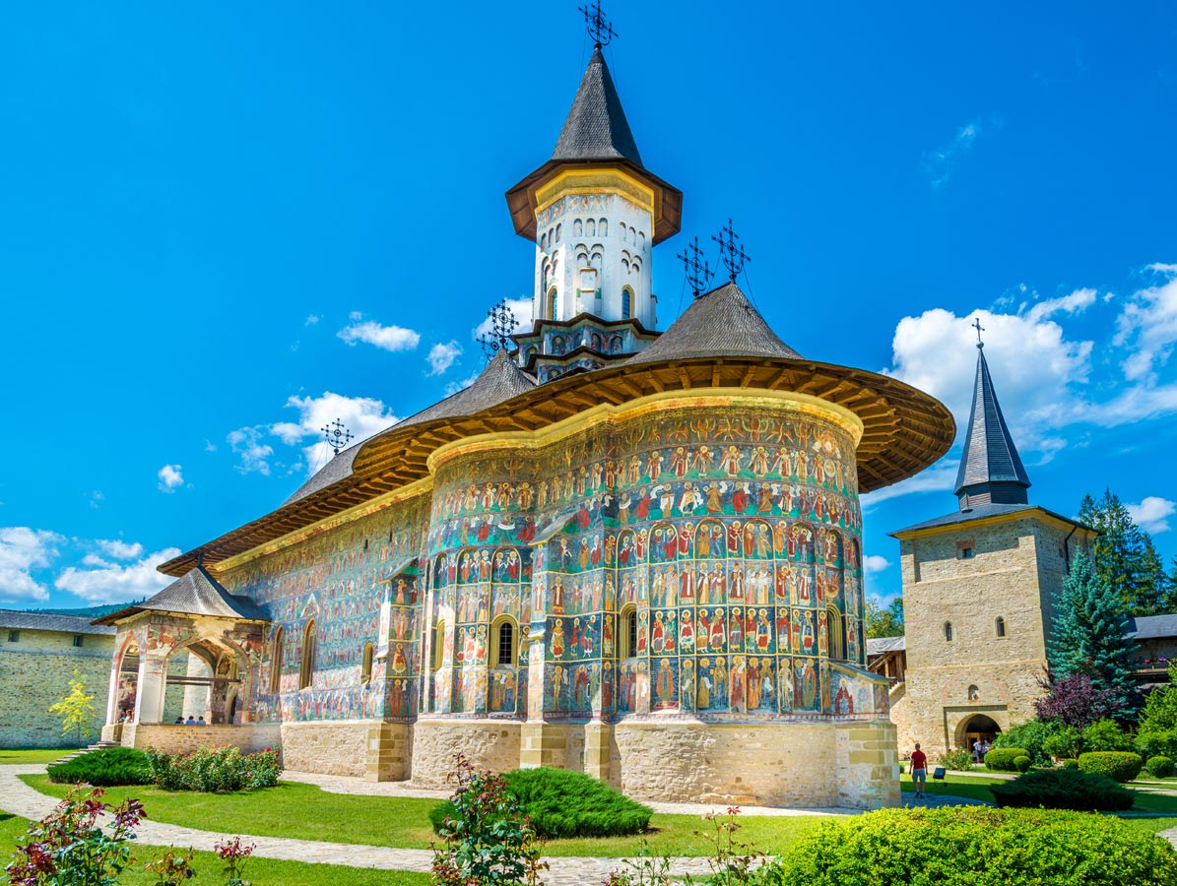
- Tourism Gems: Besides Transylvania and Bucharest, Romania is dotted with numerous hidden gems. The painted monasteries of Bucovina, the fortified churches of Transylvania (a UNESCO World Heritage site), the enchanting city of Cluj-Napoca, and the picturesque village of Sighișoara (birthplace of Vlad the Impaler, often associated with Dracula) are just a few examples.
Romania is a country that offers a wealth of experiences, from exploring its historical landmarks and stunning landscapes to immersing oneself in its vibrant culture. It continues to enchant visitors with its unique blend of traditions, natural beauty, and warm hospitality.

