
St. Patrick's Day

Teacher
Renan Grossi
Tel.: 98135 3067

Read this story and do the following exercises:

"Oh no!" Erica exclaimed when she walked into school. Everyone was wearing green. Well, everyone except her. She had forgotten it was St. Patrick's Day.
"No green? You get a pinch," Erica's best friend, Sarah, said to her as she walked up and pinched her.
"Ouch!" Erica shrieked. She knew this was going to be a horrible day if she didn't find some green fast.
Erica walked outside to look for a shamrock, but she didn't find anything. Erica sat down on the steps and started to cry. Suddenly, a leprechaun appeared.
"What's the matter, young Lassie?" he said.
"Who are you?" Erica asked.
"Why I'm a leprechaun and I'm here to cheer ye up on this St. Patty's Day," he replied.
"I forgot to wear green today," Erica said. "If I go in there, everyone will pinch me all day long!"
"No worries, lass. I'll help you with some green," the leprechaun replied.
Suddenly, a pot of gold appeared. "Let me just work my magic and you'll have plenty of green to wear," he said.
Erica watched as he worked his magic. He sprinkled some of the gold from the pot of gold. Then, he took off his hat and, from it, produced the most perfect shamrock she had ever seen.
"Here ya go lass," he said.
Erica thanked the leprechaun and headed back into school to enjoy her day pinch-free.
- What was the main problem in the story?
a. Erica is a dog called “Lassie”.
b. Erica forgot to wear green.
c. Erica met a weird man.
d. Erica had a mean best friend.
- How was Erica's problem solved?
a. She met a friendly leprechaun.
b. She left school.
c. She went home to change.
d. She ate dubious medicinal plants.
- Who helped Erica?
a. Her best friend, Sarah.
b. An underpaid teacher.
c. An Irish leprechaun.
d. Her single mother
- Why did Erica need to wear green?
a. It was Pinch Day.
b. It was School Spirit Day.
c. It was St. Patrick's Day.
d. It was a popular color in school.
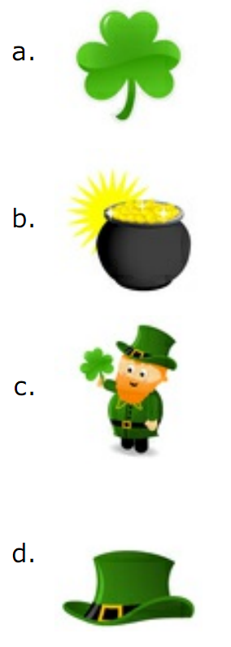
- What did Erica end up wearing?


