Text Interpretation
Aesop's Fables
Teacher
Renan Grossi
Tel.: 98135 3067

Putting the Bell on the Cat
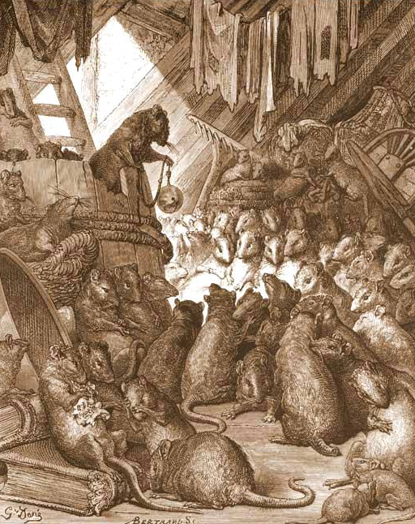
The mice once called a meeting to decide on a plan to free themselves of their enemy, the cat. At least they wished to find some way of knowing when she was coming, so they might have time to run away. Indeed, something had to be done, for they lived in such constant fear of her claws that they hardly dared stir from their dens by night or day.
Many plans were discussed, but none of them was thought good enough. At last a very young mouse got up and said:
"I have a plan that seems very simple, but I know it will be successful. All we have to do is to hang a bell about the cat's neck. When we hear the bell ringing we will know immediately that our enemy is coming."
All the mice were much surprised that they had not thought of such a plan before. But in the midst of the rejoicing over their good fortune, an old mouse arose and said:
"I will say that the plan of the young mouse is very good. But let me ask one question: Who will bell the cat?"
It is one thing to say that something should be done, but quite a different matter to do it.

Comprehension Questions

Q1 – The mice were afraid of the cat.
Right Wrong Doesn't say
Q2 – They immediately found out a solution.
Right Wrong Doesn't say
Q3 – Some mice didn’t like the plan and maybe were jealous.
Right Wrong Doesn't say

Q4 – One mouse will need to sacrifice itself to bell the cat.
Right Wrong Doesn't say
Q5 – The mice had discarded the plan before.
Right Wrong Doesn't say
Q6 – The last sentence tells us how discourse and action are different.
Right Wrong Doesn't say

The Dog and His Reflection
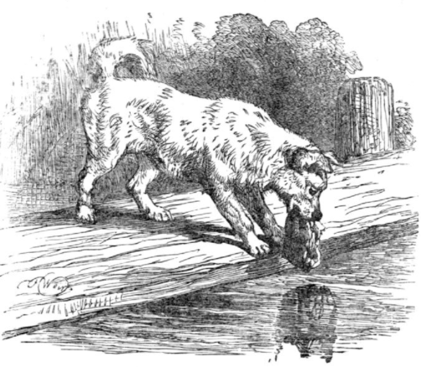
A dog, to whom the butcher had thrown a piece of meat, was hurrying home with his prize as fast as he could go. As he crossed a narrow footbridge, he happened to look down and saw himself reflected in the quiet water as if in a mirror. But the greedy dog thought he saw a real dog carrying a meat much bigger than his own.
If he had stopped to think he would have known better. But instead of thinking, he dropped his meat and sprang at the dog in the river, only to find himself swimming for his life to reach the shore. At last he managed to scramble out, and as he stood sadly thinking about the good meat he had lost, he realized what a stupid dog he had been.
It is very foolish to be greedy.

Comprehension Questions

Q1 – The butcher had thrown lots of meat to the dog in previous times.
Right Wrong Doesn't say
Q2 – The dog casually strolled home with his meat.
Right Wrong Doesn't say
Q3 – The dog envied his own reflection on the water.
Right Wrong Doesn't say

Q4 – The reflection actually had a bigger piece of meat.
Right Wrong Doesn't say
Q5 – The dog slowly entered the river.
Right Wrong Doesn't say
Q6 – The dog got out of the river with good composure.
Right Wrong Doesn't say
Q7 – The dog regretted having jumped into the river.
Right Wrong Doesn't say

The Father and His Sons
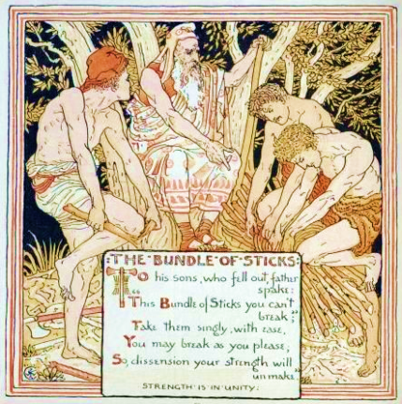
A certain man had several sons who were always quarreling with one another, and, try as he might, he could not get them to live together in harmony. So he was determined to convince them of their folly by the following means: bidding them to fetch a bundle of sticks, he invited each in turn to break it across his knee.
All tried and all failed: and then he undid the bundle, and handed them the sticks one by one, when they had no difficulty at all in breaking them. "There, my boys," said he, "united you will be more than a match for your enemies: but if you quarrel and separate, your weakness will put you at the mercy of those who attack you."
Union is strength.

Comprehension Questions

Q1 – The relationship between the siblings was good.
Right Wrong Doesn't say
Q2 – Father never tried to improve his sons’ relationship.
Right Wrong Doesn't say
Q3 – The father already had lots of sticks in the house.
Right Wrong Doesn't say
Q4 – They broke the bundle of sticks with difficulty.
Right Wrong Doesn't say

Q5 – It was easy to break individual sticks.
Right Wrong Doesn't say
Q6 – United they’ll be dangerous to their enemies.
Right Wrong Doesn't say
Q7 – If they fight among each other, the enemies will have an easier time attacking them.
- Right Wrong Doesn't say

The Fox and the Grapes
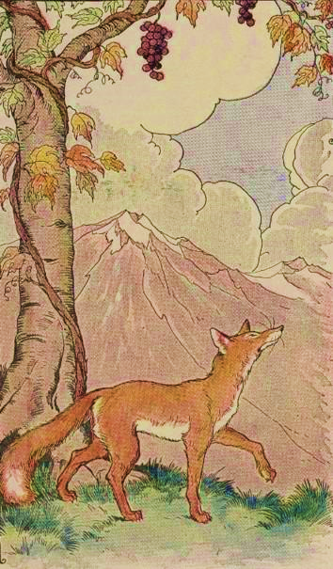
A Fox one day spied a beautiful bunch of ripe grapes hanging from a vine trained along the branches of a tree. The grapes seemed ready to burst with juice, and the Fox's mouth watered as he gazed longingly at them.
The bunch hung from a high branch, and the Fox had to jump for it. The first time he jumped he missed it by a long way. So he walked off a short distance and took a running leap at it, only to fall short once more. Again and again he tried, but in vain.
Now he sat down and looked at the grapes in disgust.
"What a fool I am," he said. "Here I am wearing myself out to get a bunch of sour grapes that are not worth the effort."
And off he walked very, very scornfully.
There are many who pretend to despise and belittle that which is beyond their reach.

Comprehension Questions

Q1 – The fox saw one grape hanging from a vine.
Right Wrong Doesn't say
Q2 – The grapes were not ready to eat.
Right Wrong Doesn't say
Q3 – The juice was coming out of the grapes.
Right Wrong Doesn't say
Q4 – The fox fell close to the tree after its second leap.
Right Wrong Doesn't say

Q5 –The fox tasted the grapes and didn’t like them.
Right Wrong Doesn't say
Q6 – The fox realized the grapes were actually sour.
Right Wrong Doesn't say
Q7 – The fox scorned the grapes only because they were out of his reach.
Right Wrong Doesn't say

Two Travelers and a Bear
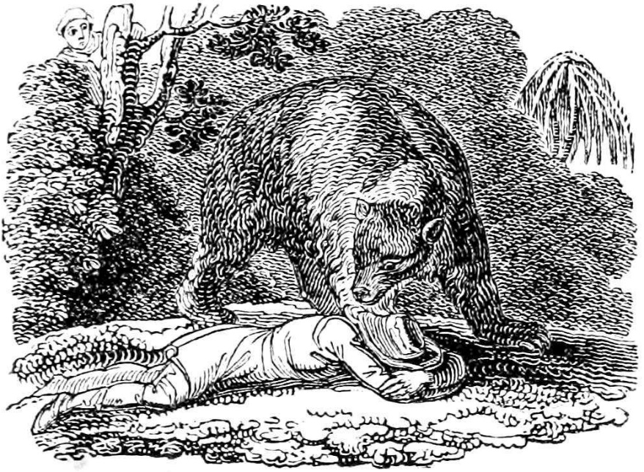
Two men were traveling in company through a forest, when, all at once, a huge bear crashed out of the brush near them.
One of the men, thinking of his own safety, climbed a tree.
The other, unable to fight the savage beast alone, threw himself on the ground and lay still, as if he were dead. He had heard that a bear will not touch a dead body.
It must have been true, for the bear snuffed at the man's head awhile, and then, seeming to be satisfied that he was dead, walked away.
The man in the tree climbed down. "It looked just as if that bear whispered in your ear," he said. "What did he tell you?"
"He said," answered the other, "that it was not at all wise to keep company with a fellow who would desert his friend in a moment of danger."
Misfortune is the test of true friendship.

Comprehension Questions

Q1 – The men were travelling with a big group.
Right Wrong Doesn't say
Q2 – The bear slowly appeared from a bush.
Right Wrong Doesn't say
Q3 – One man tried to kill himself to escape the bear.
Right Wrong Doesn't say
Q4 – The bear killed one of the men.
Right Wrong Doesn't say

Q5 –The bear spoke in a low voice in the man’s ear.
Right Wrong Doesn't say
Q6 – One man saw that the other should not be trusted.
Right Wrong Doesn't say
Q7 – One of the men thinks it’s wise to keep company with a trustworthy fellow.
Right Wrong Doesn't say

The Grasshopper and the Ant
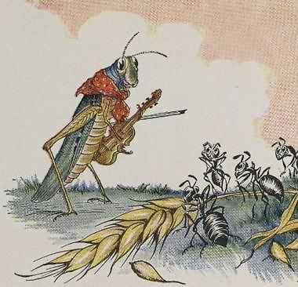
One bright day in late autumn a family of Ants were bustling about in the warm sunshine, drying out the grain they had stored up during the summer, when a starving Grasshopper, his fiddle under his arm, came up and humbly begged for a bite to eat.
"What!" cried the Ants in surprise, "haven't you stored anything away for the winter? What in the world were you doing all last summer?"
"I didn't have time to store up any food," whined the Grasshopper; "I was so busy making music that before I knew it the summer was gone."
The Ants shrugged their shoulders in disgust.
"Making music, were you?" they cried. "Very well; now dance!" and they turned their backs on the Grasshopper and went on with their work.
There's a time for work and a time for play.

Comprehension Questions

Q1 – The grasshopper was a little hungry.
Right Wrong Doesn't say
Q2 – The ants were so sad that they started to cry.
Right Wrong Doesn't say
Q3 – The grasshopper behaved differently than the ants.
Right Wrong Doesn't say
Q4 – The grasshopper didn’t worry about his future.
Right Wrong Doesn't say

Q5 – The ants didn’t care much about the grasshopper.
Right Wrong Doesn't say
Q6 – The grasshopper played the lute as well.
Right Wrong Doesn't say
Q7 – Even though he begged, the grasshopper was not helped by the ants.
Right Wrong Doesn't say
Q8 – There needs to be a good balance between work and play.
Right Wrong Doesn't say

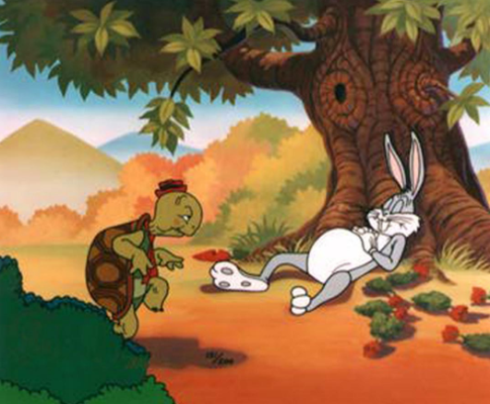
The Tortoise and the Hare
A hare was making fun of the tortoise one day for being so slow.
"Do you ever get anywhere?" he asked with a mocking laugh.
"Yes," replied the tortoise, "and I get there sooner than you think. I'll run you a race and prove it."
The hare was much amused at the idea of running a race with the tortoise, but for the fun of the thing he agreed. So the fox, who had consented to act as judge, marked the distance and started the runners off.
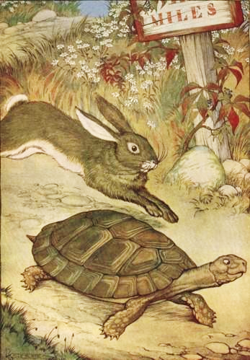
The hare was soon far out of sight, and to make the tortoise feel very deeply how ridiculous it was for him to try a race with a hare, he lay down beside the course to take a nap until the tortoise could catch up.
The tortoise meanwhile kept going slowly but steadily, and, after a time, passed the place where the hare was sleeping. But the hare slept on very peacefully; and when at last he did wake up, the tortoise was near the goal. The hare now ran his fastest, but he could not overtake the tortoise in time.
Slow and steady wins the race.

Comprehension Questions

Q1 – The hare and the tortoise had fun together.
Right Wrong Doesn't say
Q2 – The hare didn’t care much about the race.
Right Wrong Doesn't say
Q3 – The fox told the hare and the tortoise to start running.
Right Wrong Doesn't say
Q4 – In fact, the hare ran very slowly.
Right Wrong Doesn't say

Q5 –The tortoise was running fast.
Right Wrong Doesn't say
Q6 – The hare woke up after the race had finished.
Right Wrong Doesn't say
Q7 – When the hare woke up, it saw the race was over and did not even try to finish it.
Right Wrong Doesn't say

