Text Interpretation
Teacher
Renan Grossi
Tel.: 98135 3067

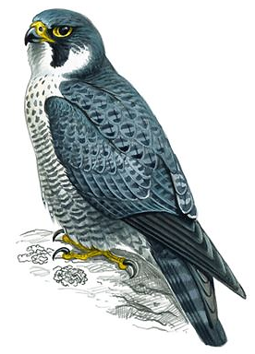
Robot Birds
Liverpool city council wants to clear the city of fat pigeons. They say that people feed the birds, which makes them fat. The pigeons get big because their normal diet consists of seeds and insects, not high-fat junk food they eat in the city center.
The council wants people to know that everyone who feeds the pigeons is responsible for the streets being so crowded with these birds. They hope to encourage the birds to move away from the city center and into parks and open spaces.
Ten robotic birds have been brought into the city center to scare the pigeons away and the government asks visitors not to give the pigeons any food. The mechanical birds - known as 'robops' - sit on the roofs of buildings. They move around to different locations. They look like a peregrine falcon, which is a bird that kills pigeons. They even make noises and flap their wings to scare the pigeons. They hope that the pigeons will go away before the city becomes the European Capital of Culture in two years.
Peregrine Falcon
Falco peregrinus

Comprehension Questions:

Q1 - Pigeons are fat in Liverpool, more than in other cities.
Right Wrong Doesn't say
Q2 - Pigeons get fat because they eat seeds and insects.
Right Wrong Doesn't say
Q3 - According to the council, everyone is to blame for the numbers of pigeons.
Right Wrong Doesn't say

Q4 - They want the pigeons to move out of the city center.
Right Wrong Doesn't say
Q5 - They recommend visitors not to feed the pigeons.
Right Wrong Doesn't say
Q6 - The robotic birds can move around the city center.
Right Wrong Doesn't say
Q7 - Liverpool is the European Capital of Culture.
Right Wrong Doesn't say

Intelligence pills
Some scientists predict that healthy adults and children may one day in the future take drugs to improve their intelligence and intellectual performance. A research group suggests that such drugs might become as common as coffee or tea in the next couple of decades.
To counter this, students that take exams might have to take drugs tests like athletes. There are already drugs that are known to improve mental performance, like Ritalin, which is given to children with problems concentrating. A drug given to people with trouble to sleep also helps people remember numbers.
These drugs raise serious legal and moral questions, but people already take vitamins to help them remember things better, so it is not a simple problem to solve. It probably is very difficult to decide at what point a food supplement becomes an unfair drug in an examination.

Comprehension Questions:

Q1 - Only children will take pills to improve their intellectual performance.
Right Wrong Doesn't say
Q2 - Intelligence pills are already as common as coffee or tea.
Right Wrong Doesn't say
Q3 - Coffee is as common as tea.
Right Wrong Doesn't say
Q4 - Students could have to take intelligence drugs tests.
Right Wrong Doesn't say
Q5 - A pill to sleep helps people remember numbers.
Right Wrong Doesn't say
Q6 - Vitamins to help people study are illegal.
Right Wrong Doesn't say
Q7 - Food supplements are unfair.
Right Wrong Doesn't say

Japan's most famous dog
In front of the enormous Shibuya train station in Tokyo, there is a life-size bronze statue of a dog. Even though the statue is very small when compared to the huge neon signs flashing, it isn't difficult to find. It is used as a meeting point since 1934 and today you find hundreds of people waiting there for their friends to arrive... just look for the crowds.
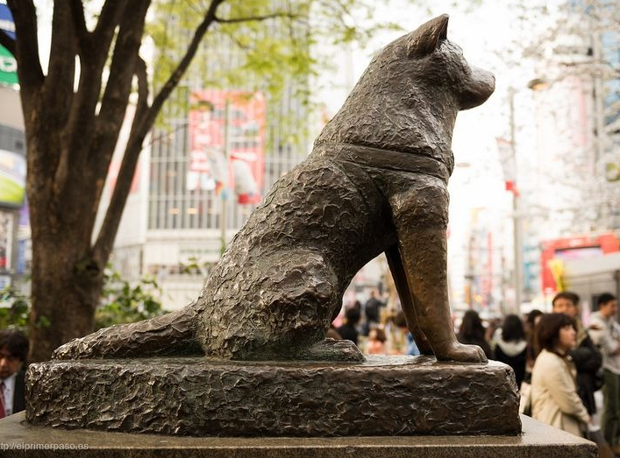
Hachiko, an Akita dog, was born in 1923 and brought to Tokyo in 1924. His owner, Professor Eisaburo Uyeno and he were inseparable friends right from the start. Each day Hachiko would accompany his owner, a professor at the Imperial University, to Shibuya train station when he left for work. When he came back, the professor would always find the dog patiently waiting for him. Sadly, the professor died suddenly at work in 1925 before he could return home.
Although Hachiko was still a young dog, the bond between him and his owner was very strong and he continued to wait at the station every day. Sometimes, he would stay there for days at a time, though some believe that he kept returning because of the food he was given by street vendors. He became a familiar sight to commuters over time. In 1934, a statue of him was put outside the station. In 1935, Hachiko died at the place he last saw his friend alive.

Comprehension Questions:

Q1 - The statue of Hachiko is small.
Right Wrong Doesn't say
Q2 - The statue isn't difficult to find because there are so many people there.
Right Wrong Doesn't say
Q3 - The professor worked in a school.
Right Wrong Doesn't say
Q4 - The professor died at work.
Right Wrong Doesn't say

Q5 - The dog waited every day at the station.
Right Wrong Doesn't say
Q6 - Nobody gave the dog any food.
Right Wrong Doesn't say
Q7 - The dog died before the statue was put outside the station.
- Right Wrong Doesn't say

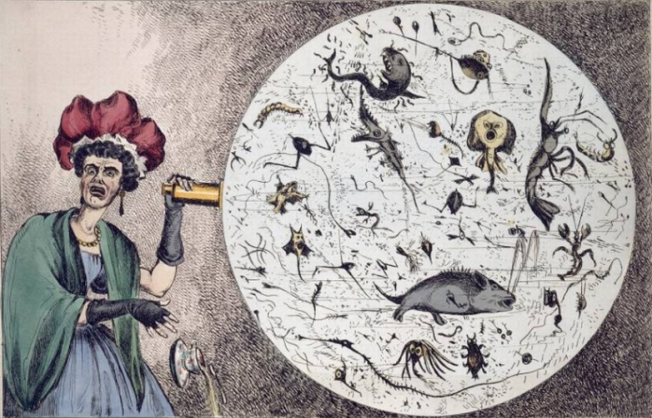
John Snow
John Snow 1) __________ born in 1813 in York, England and was the eldest of nine children. When he 2) __________ fourteen, he started working for a surgeon and went on to study medicine.
In 1855, a lot of people started dying in an area of London of the illness cholera and John Snow went there to study what was 3) __________. He discovered that the people who had died were drinking 4) __________ same water.
Before this study, no one 5) __________ how people got the illness. The results of his study 6) __________ important because they 7) __________ how the illness spread and also 8) __________ to start the science of public health.

Comprehension Questions:

Q1
is was had
Q2
has had was
Q3
happen happened happening
Q4
a as the
Q5
knew was knowing knowing
Q6
is was were
Q7
explaining explained to explain
Q8
help helping helped

