Московский государственный технический университет им. Н.Э. Баумана Факультет «Информатика и системы управления»

Кафедра «Системы обработки информации и управления»



**Лабораторная работа №3**

**«Обработка признаков часть 2»**

**ИСПОЛНИТЕЛЬ:**

Ханмагомедов Ренат Маувзудинович

Группа ИУ5-21М

" " 2021 г.

Москва 2021

**Целью работы** является: изучение продвинутых способов предварительной обработки данных для дальнейшего формирования моделей.

**Задание:**

Для выбранного датасета (датасетов) на основе материалов лекций решить следующие задачи:

* масштабирование признаков (не менее чем тремя способами);
* обработку выбросов для числовых признаков (по одному способу для удаления выбросов и для замены выбросов);
* обработку по крайней мере одного нестандартного признака (который не является числовым или категориальным);
* отбор признаков:
  + один метод из группы методов фильтрации (filter methods);
  + один метод из группы методов обертывания (wrapper methods);
  + один метод из группы методов вложений (embedded methods).

In [1]:

**import** numpy **as** np **import** pandas **as** pd **import** seaborn **as** sns

**import** matplotlib.pyplot **as** plt

**%**matplotlib inline sns.set(style**=**"ticks")

**from** sklearn.impute **import** SimpleImputer **from** sklearn.impute **import** MissingIndicator **import** scipy.stats **as** stats

**from** sklearn.model_selection **import** train_test_split **from** sklearn.preprocessing **import** StandardScaler **from** sklearn.preprocessing **import** MinMaxScaler

**from** sklearn.preprocessing **import** RobustScaler

Для выбранного датасета (датасетов) на основе материалов лекций решить следующие задачи:

масштабирование признаков (не менее чем тремя способами); обработку выбросов для числовых признаков (по одному способу для удаления выбросов и для замены выбросов);

обработку по крайней мере одного нестандартного признака (который не является числовым или категориальным);

отбор признаков:

один метод из группы методов фильтрации (filter methods); один метод из группы методов обертывания (wrapper methods); один метод из группы методов вложений (embedded methods).

In [2]:

data **=** pd.read_csv('/Users/a.fedorova/Desktop/учеба/Великолепная ма

In [3]:

data.head()

|  |  |  |  |  |  |  |  |  |
| --- | --- | --- | --- | --- | --- | --- | --- | --- |
| Out[3]: |  | | | | | | | |
|  | **artists** | **danceability** | **energy** | **key** | **loudness** | **mode** | **speechiness** | **acousticness instrum** |
|  | Drake | 0.754 | 0.449 | 7.0 | -9.211 | 1.0 | 0.1090 | 0.0332 |
|  | XTENTACION | 0.740 | 0.613 | 8.0 | -4.880 | 1.0 | 0.1450 | 0.2580 |
|  | Post Malone | 0.587 | 0.535 | 5.0 | -6.090 | 0.0 | 0.0898 | 0.1170 |
|  | Post Malone | 0.739 | 0.559 | 8.0 | -8.011 | 1.0 | 0.1170 | 0.5800 |
|  | Drake | 0.835 | 0.626 | 1.0 | -5.833 | 1.0 | 0.1250 | 0.0589 |

|  |  |  |  |  |  |  |  |
| --- | --- | --- | --- | --- | --- | --- | --- |
| In [4]:  Out[4]: | data.describe() |  | | | | | |
|  | **danceability** | **energy** | **key** | **loudness** | **mode** | **speechiness** | **acoustic** |
|  | count 100.00000 | 100.000000 | 100.000000 | 100.000000 | 100.000000 | 100.000000 | 100.00 |
|  | mean 0.71646 | 0.659060 | 5.330000 | -5.677640 | 0.590000 | 0.115569 | 0.19 |
|  | std 0.13107 | 0.145067 | 3.676447 | 1.777577 | 0.494311 | 0.104527 | 0.22 |
|  | min 0.25800 | 0.296000 | 0.000000 | -10.109000 | 0.000000 | 0.023200 | 0.00 |
|  | 25% 0.63550 | 0.562000 | 1.750000 | -6.650500 | 0.000000 | 0.045350 | 0.04 |
|  | 50% 0.73300 | 0.678000 | 5.000000 | -5.566500 | 1.000000 | 0.074950 | 0.10 |
|  | 75% 0.79825 | 0.772250 | 8.250000 | -4.363750 | 1.000000 | 0.137000 | 0.24 |
|  | max 0.96400 | 0.909000 | 11.000000 | -2.384000 | 1.000000 | 0.530000 | 0.93 |

In [5]:

X_ALL **=** data.drop(['id', 'name', 'artists', 'liveness'], axis**=**1)

In [6]:

**def** arr_to_df(arr_scaled):

res **=** pd.DataFrame(arr_scaled, columns**=**X_ALL.columns)

**return** res

# Масштабирование признаков

## StandardScaler

In [7]:

*# Обучаем StandardScaler на всей выборке и масштабируем*

cs11 **=** StandardScaler()

data_cs11_scaled_temp **=** cs11.fit_transform(X_ALL)

*# формируем DataFrame на основе массива* data_cs11_scaled **=** arr_to_df(data_cs11_scaled_temp) data_cs11_scaled

|  |  |  |  |  |  |  |  |  |  |
| --- | --- | --- | --- | --- | --- | --- | --- | --- | --- |
| Out[7]: |  | | | | | | | | |
|  |  | **danceability** | **energy** | **key** | **loudness** | **mode** | **speechiness** | **acousticness** | **ins** |
|  | 0 | 0.287854 | -1.455314 | 0.456531 | -1.997753 | 0.833616 | -0.063162 | -0.739184 |  |
|  | 1 | 0.180503 | -0.319108 | 0.729903 | 0.450984 | 0.833616 | 0.282982 | 0.283383 |  |
|  | 2 | -0.992691 | -0.859498 | -0.090213 | -0.233147 | -1.199593 | -0.247772 | -0.357995 |  |
|  | 3 | 0.172835 | -0.693224 | 0.729903 | -1.319276 | 0.833616 | 0.013759 | 1.748092 |  |
|  | 4 | 0.908957 | -0.229043 | -1.183701 | -0.087840 | 0.833616 | 0.090680 | -0.622280 |  |
|  | ... | ... | ... | ... | ... | ... | ... | ... |  |
|  | 95 | -0.248901 | -0.277539 | 1.276647 | -0.750486 | 0.833616 | -0.740065 | -0.564510 |  |
|  | 96 | -0.601626 | -0.007344 | -0.636957 | -0.362058 | 0.833616 | -0.672759 | 0.224249 |  |
|  | 97 | -1.261069 | 0.699321 | -1.457073 | 0.549363 | 0.833616 | 2.177157 | -0.556777 |  |
|  | 98 | -3.515443 | -1.538451 | 1.550019 | -0.517542 | -1.199593 | -0.736219 | -0.430776 |  |
|  | 99 | -1.253401 | -0.506166 | 1.550019 | -0.362623 | 0.833616 | -0.763141 | 2.280300 |  |

100 rows × 12 columns

In [8]:

*# Построение плотности распределения*

**def** draw_kde(col_list, df1, df2, label1, label2):

fig, (ax1, ax2) **=** plt.subplots(ncols**=**2, figsize**=**(12, 5))

*# первый график*

ax1.set_title(label1) sns.kdeplot(data**=**df1[col_list], ax**=**ax1) *# второй график*

ax2.set_title(label2) sns.kdeplot(data**=**df2[col_list], ax**=**ax2) plt.show()

In [9]:

draw_kde(['tempo', 'duration_ms'], data, data_cs11_scaled, 'до масш

/Users/a.fedorova/opt/anaconda3/lib/python3.7/site-packages/seabor n/distributions.py:679: UserWarning: Passing a 2D dataset for a bi variate plot is deprecated in favor of kdeplot(x, y), and it will cause an error in future versions. Please update your code.

warnings.warn(warn_msg, UserWarning)

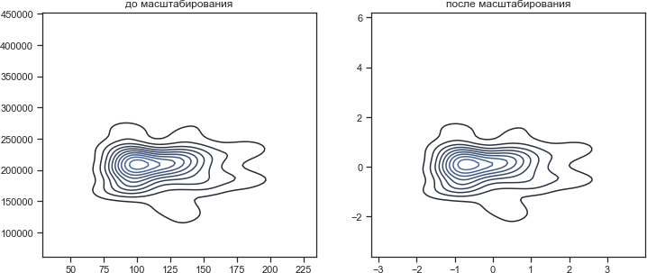

## Масштабирование "Mean Normalisation"

In [10]:

*# Разделим выборку на обучающую и тестовую*

X_train, X_test, y_train, y_test **=** train_test_split(X_ALL, data['li

test_size**=**0.2, random_state**=**1)

*# Преобразуем массивы в DataFrame* X_train_df **=** arr_to_df(X_train) X_test_df **=** arr_to_df(X_test)

X_train_df.shape, X_test_df.shape

Out[10]: ((80, 12), (20, 12))

In [11]:

**class** MeanNormalisation:

**def** fit(self, param_df):

self.means **=** X_train.mean(axis**=**0) maxs **=** X_train.max(axis**=**0)

mins **=** X_train.min(axis**=**0) self.ranges **=** maxs **-** mins

**def** transform(self, param_df):

param_df_scaled **=** (param_df **-** self.means) **/** self.ranges

**return** param_df_scaled

**def** fit_transform(self, param_df): self.fit(param_df)

**return** self.transform(param_df)

In [12]:

sc21 **=** MeanNormalisation()

data_cs21_scaled **=** sc21.fit_transform(X_ALL) data_cs21_scaled.describe()

|  |  |  |  |  |  |  |  |  |
| --- | --- | --- | --- | --- | --- | --- | --- | --- |
| Out[12]: |  | | | | | | | |
|  |  | **danceability** | **energy** | **key** | **loudness** | **mode** | **speechiness** | **acousticnes** |
|  | ount | 100.000000 | 100.000000 | 100.000000 | 100.000000 | 100.000000 | 100.000000 | 100.00000 |
|  | ean | -0.016824 | -0.006161 | -0.030227 | -0.002058 | 0.002500 | -0.007142 | 0.00878 |
|  | std | 0.185652 | 0.241376 | 0.334222 | 0.231335 | 0.494311 | 0.206249 | 0.25051 |
|  | min | -0.666200 | -0.610254 | -0.514773 | -0.578758 | -0.587500 | -0.189402 | -0.21278 |
|  | 25% | -0.131498 | -0.167658 | -0.355682 | -0.128667 | -0.587500 | -0.145696 | -0.16749 |
|  | 50% | 0.006604 | 0.025354 | -0.060227 | 0.012406 | 0.412500 | -0.087290 | -0.08951 |
|  | 75% | 0.099026 | 0.182176 | 0.235227 | 0.168932 | 0.412500 | 0.035145 | 0.06780 |
|  | max | 0.333800 | 0.409713 | 0.485227 | 0.426578 | 0.412500 | 0.810598 | 0.84590 |

In [13]:

cs22 **=** MeanNormalisation() cs22.fit(X_train)

data_cs22_scaled_train **=** cs22.transform(X_train) data_cs22_scaled_test **=** cs22.transform(X_test)

In [14]:

data_cs22_scaled_train.describe()

Out[14]:

**danceability energy key loudness mode speechines**

|  |  |  |  |  |  |
| --- | --- | --- | --- | --- | --- |
| count 8.000000e+01 | 8.000000e+01 | 8.000000e+01 | 8.000000e+01 | 8.000000e+01 | 8.000000e+0 |
| mean -1.161181e- | -2.223915e- | 1.457168e-17 | -7.736867e- | 1.942890e-17 | 4.128642e-1 |

std min

|  |  |  |  |  |  |
| --- | --- | --- | --- | --- | --- |
| 16  1.742082e-01  -6.662004e- | 16  2.318961e-01  -5.902870e- | 3.348639e-01  -5.147727e- | 17  2.281019e-01  -5.734220e- | 4.953901e-01  -5.875000e- | 2.164278e-0  -1.894016e |
| 01 | 01 | 01 | 01 | 01 | 0 |
| -1.106055e- | -1.622504e- | -3.329545e- | -1.217367e- | -5.875000e- | -1.440188e |
| 01 | 01 | 01 | 01 | 01 | 0 |

25%

50% 1.226983e-02 2.202579e-02 3.068182e-02 -4.187272e-

03

4.125000e-01 -7.860843e

0

75% 1.007967e-01 1.701123e-01 3.034091e-01 1.692575e-01 4.125000e-01 2.823846e-0 max 3.337996e-01 4.097130e-01 4.852273e-01 4.265780e-01 4.125000e-01 8.105984e-0

In [15]:

draw_kde(['tempo', 'duration_ms'], data, data_cs21_scaled, 'до масш

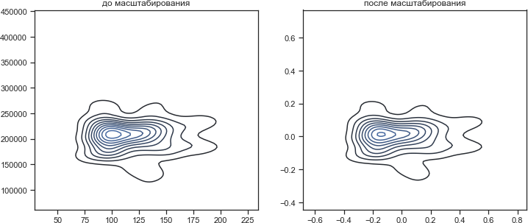

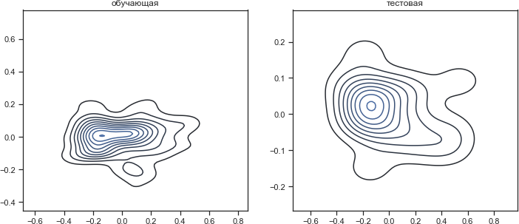

## MinMax-масштабирование

In [17]:

*# Обучаем StandardScaler на всей выборке и масштабируем*

cs31 **=** MinMaxScaler()

data_cs31_scaled_temp **=** cs31.fit_transform(X_ALL)

*# формируем DataFrame на основе массива* data_cs31_scaled **=** arr_to_df(data_cs31_scaled_temp) data_cs31_scaled.describe()

|  |  |  |  |  |  |  |  |  |
| --- | --- | --- | --- | --- | --- | --- | --- | --- |
| Out[17]: |  | | | | | | | |
|  |  | **danceability** | **energy** | **key** | **loudness** | **mode** | **speechiness** | **acoustic** |
|  | count | 100.000000 | 100.000000 | 100.000000 | 100.000000 | 100.000000 | 100.000000 | 100.00 |
|  | mean | 0.649377 | 0.592268 | 0.484545 | 0.573639 | 0.590000 | 0.182259 | 0.20 |
|  | std | 0.185652 | 0.236651 | 0.334222 | 0.230107 | 0.494311 | 0.206249 | 0.23 |
|  | min | 0.000000 | 0.000000 | 0.000000 | 0.000000 | 0.000000 | 0.000000 | 0.00 |
|  | 25% | 0.534703 | 0.433931 | 0.159091 | 0.447702 | 0.000000 | 0.043706 | 0.04 |
|  | 50% | 0.672805 | 0.623165 | 0.454545 | 0.588026 | 1.000000 | 0.102111 | 0.11 |
|  | 75% | 0.765227 | 0.776917 | 0.750000 | 0.743722 | 1.000000 | 0.224546 | 0.26 |
|  | max | 1.000000 | 1.000000 | 1.000000 | 1.000000 | 1.000000 | 1.000000 | 1.00 |

In [18]:

cs32 **=** MinMaxScaler() cs32.fit(X_train)

data_cs32_scaled_train_temp **=** cs32.transform(X_train) data_cs32_scaled_test_temp **=** cs32.transform(X_test)

*# формируем DataFrame на основе массива*

data_cs32_scaled_train **=** arr_to_df(data_cs32_scaled_train_temp) data_cs32_scaled_test **=** arr_to_df(data_cs32_scaled_test_temp)

In [19]:

In [20]:

draw_kde(['tempo', 'duration_ms'], data, data_cs31_scaled, 'до масш

/Users/a.fedorova/opt/anaconda3/lib/python3.7/site-packages/seabor n/distributions.py:679: UserWarning: Passing a 2D dataset for a bi variate plot is deprecated in favor of kdeplot(x, y), and it will cause an error in future versions. Please update your code.

warnings.warn(warn_msg, UserWarning)

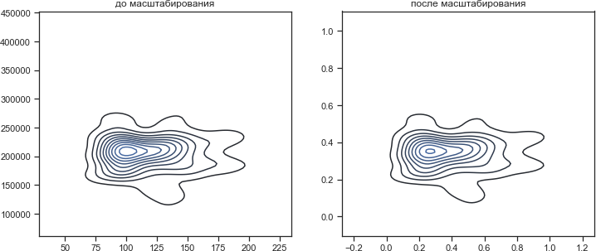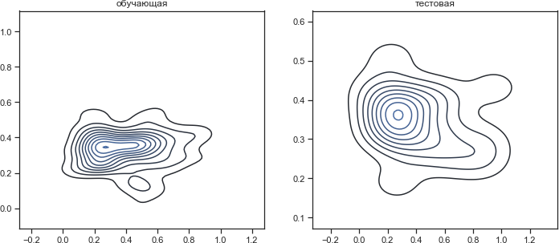

draw_kde(['tempo', 'duration_ms'], data_cs32_scaled_train, data_cs3

# Обработка выбросов для числовых признаков

In [21]:

data2 **=** pd.read_csv('/Users/a.fedorova/Desktop/учеба/Великолепная м

In [22]:

Out[22]:

data2.head()

**ood latitude longitude room_type price minimum_nights number_of_reviews last_review**

Private room

|  |  |  |  |
| --- | --- | --- | --- |
| 149 | 1 | 9 | 2018-10-19 |
| 225 | 1 | 45 | 2019-05-21 |
| 150 | 3 | 0 | NaN |

|  |  |  |
| --- | --- | --- |
| ton | 40.64749 | -73.97237 |
| wn | 40.75362 | -73.98377 |
| lem | 40.80902 | -73.94190 |

Entire home/apt

Private room

Hill 40.68514 -73.95976 Entire

home/apt

89 1 270 2019-07-05

lem 40.79851 -73.94399 Entire

home/apt

80 10 9 2018-11-19

In [23]:

data2.describe()

Out[23]:

|  |  |  |  |  |  |
| --- | --- | --- | --- | --- | --- |
| **host_id** | **latitude** | **longitude** | **price** | **minimum_nights** | **number_of_reviews** |
| .889500e+04 | 48895.000000 | 48895.000000 | 48895.000000 | 48895.000000 | 48895.000000 |
| .762001e+07 | 40.728949 | -73.952170 | 152.720687 | 7.029962 | 23.274466 |
| .861097e+07 | 0.054530 | 0.046157 | 240.154170 | 20.510550 | 44.550582 |
| .438000e+03 | 40.499790 | -74.244420 | 0.000000 | 1.000000 | 0.000000 |
| .822033e+06 | 40.690100 | -73.983070 | 69.000000 | 1.000000 | 1.000000 |
| .079382e+07 | 40.723070 | -73.955680 | 106.000000 | 3.000000 | 5.000000 |
| .074344e+08 | 40.763115 | -73.936275 | 175.000000 | 5.000000 | 24.000000 |
| .743213e+08 | 40.913060 | -73.712990 | 10000.000000 | 1250.000000 | 629.000000 |

In [35]:

**def** diagnostic_plots(df, variable, title): fig, ax **=** plt.subplots(figsize**=**(10,7)) *# гистограмма*

plt.subplot(2, 2, 1) df[variable].hist(bins**=**30) *## Q-Q plot* plt.subplot(2, 2, 2)

stats.probplot(df[variable], dist**=**"norm", plot**=**plt)

*# ящик с усами*

plt.subplot(2, 2, 3) sns.violinplot(x**=**df[variable]) *# ящик с усами*

plt.subplot(2, 2, 4) sns.boxplot(x**=**df[variable]) fig.suptitle(title) plt.show()

In [39]:

diagnostic_plots(data2, 'price', 'price - original')

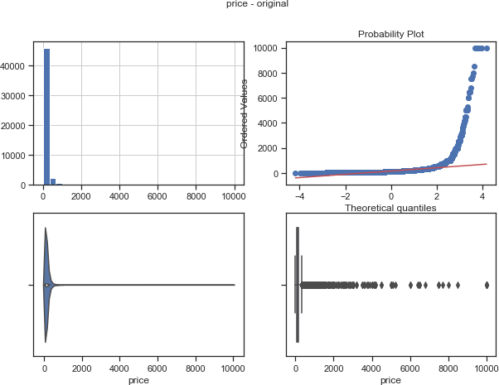

In [40]:

diagnostic_plots(data2, 'number_of_reviews', 'number_of_reviews - o

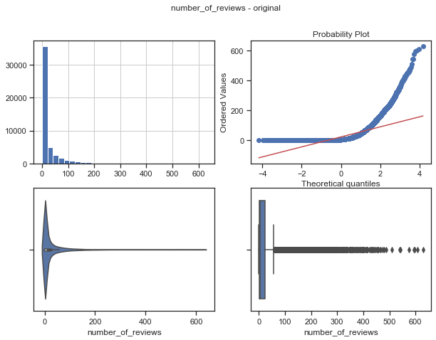

In [41]:

diagnostic_plots(data2, 'reviews_per_month', 'reviews_per_month - o

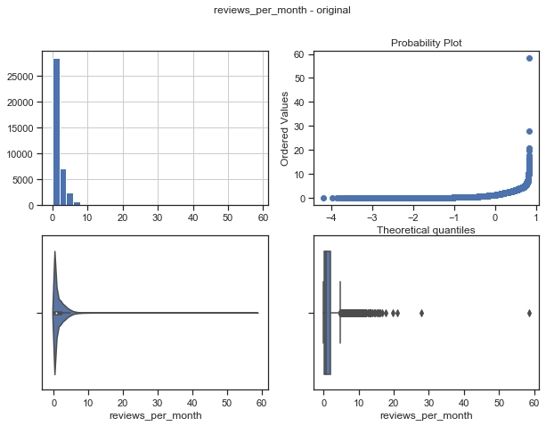

*Явно заметны выбросы на полях:* ***number_of_reviews, reviews_per_month, price***

In [24]:

*# Тип вычисления верхней и нижней границы выбросов*

**from** enum **import** Enum

**class** OutlierBoundaryType(Enum): SIGMA **=** 1

QUANTILE **=** 2

IRQ **=** 3

In [26]:

*# Функция вычисления верхней и нижней границы выбросов*

**def** get_outlier_boundaries(df, col): lower_boundary **=** df[col].quantile(0.05) upper_boundary **=** df[col].quantile(0.95) **return** lower_boundary, upper_boundary

## Удаление выбросов (number_of_reviews)

In [38]:

*# Вычисление верхней и нижней границы*

lower_boundary, upper_boundary **=** get_outlier_boundaries(data2, "pri

*# Флаги для удаления выбросов*

outliers_temp **=** np.where(data2["price"] **>** upper_boundary, **True**,

np.where(data2["price"] **<** lower_boundary,

*# Удаление данных на основе флага*

data_trimmed **=** data2.loc[**~**(outliers_temp), ]

title **=** 'Поле-{}, метод-{}, строк-{}'.format("price", "QUANTILE", d diagnostic_plots(data_trimmed, "price", title)

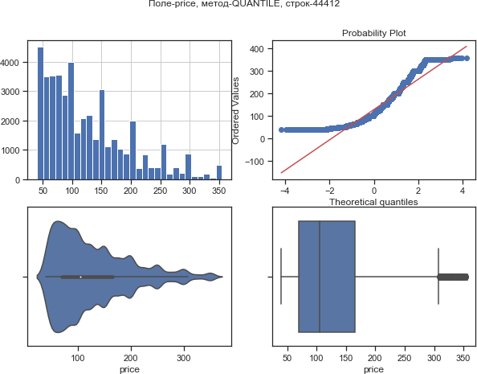

## Замена выбросов

In [43]:

*# Вычисление верхней и нижней границы*

lower_boundary, upper_boundary **=** get_outlier_boundaries(data2, "rev

*# Изменение данных*

data2["reviews_per_month"] **=** np.where(data2["reviews_per_month"] **>**

np.where(data2["reviews_per_month"] **<** lower_bo title **=** 'Поле-{}, метод-{}'.format("reviews_per_month", "QUANTILE") diagnostic_plots(data2, "reviews_per_month", title)

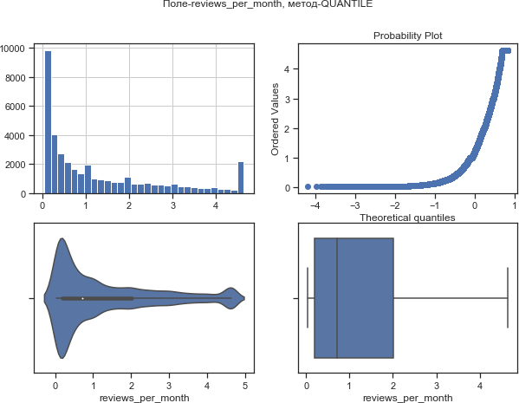

# Обработка нестандартного признака

|  |  |  |
| --- | --- | --- |
| Out[45]: | id | int64 |
|  | name | object |
|  | host_id | int64 |
|  | host_name | object |
|  | neighbourhood_group | object |
|  | neighbourhood | object |
|  | latitude | float64 |
|  | longitude | float64 |
|  | room_type | object |
|  | price | int64 |
|  | minimum_nights | int64 |
|  | number_of_reviews | int64 |
|  | last_review | object |
|  | reviews_per_month | float64 |
|  | calculated_host_listings_count | int64 |
|  | availability_365 | int64 |
|  | dtype: object |  |

In [52]:

*# Сконвертируем дату и время в нужный формат*

data2["last_review_date"] **=** data2.apply(**lambda** x: pd.to_datetime(x[

In [53]:

Out[53]:

data2.head(5)

room

|  |  |  |  |  |
| --- | --- | --- | --- | --- |
| **ngitude room_type price** | **minimum_nights** | **number_of_reviews** | **last_review** | **reviews_per_mon** |
| 3.97237 Private 149 | 1 | 9 | 2018-10-19 | 0. |
| 3.98377 Entire 225 | 1 | 45 | 2019-05-21 | 0. |
| 3.94190 Private 150 | 3 | 0 | NaN | N |
| 3.95976 Entire 89 | 1 | 270 | 2019-07-05 | 4. |
| 3.94399 Entire 80 | 10 | 9 | 2018-11-19 | 0. |

home/apt

room

home/apt

home/apt

Out[54]: id int64

name object

host_id int64

host_name object

neighbourhood_group object

neighbourhood object

latitude float64

longitude float64

room_type object

price int64

minimum_nights int64

number_of_reviews int64

last_review object

reviews_per_month float64

calculated_host_listings_count int64

availability_365 int64

last_review_date datetime64[ns] dtype: object

In [55]:

*# День*

data2['last_review_day'] **=** data2['last_review_date'].dt.day

*# Месяц*

data2['last_review_month'] **=** data2['last_review_date'].dt.month

*# Год*

data2['last_review_year'] **=** data2['last_review_date'].dt.year

In [56]:

data2.head(5)

Out[56]:

|  |  |  |  |  |  |
| --- | --- | --- | --- | --- | --- |
| **f_reviews** | **last_review** | **reviews_per_month** | **calculated_host_listings_count** | **availability_365** | **las** |
| 9 | 2018-10-19 | 0.21 | 6 | 365 |  |
| 45 | 2019-05-21 | 0.38 | 2 | 355 |  |
| 0 | NaN | NaN | 1 | 365 |  |
| 270 | 2019-07-05 | 4.64 | 1 | 194 |  |
| 9 | 2018-11-19 | 0.10 | 1 | 0 |  |