

EPSG

EPSG4326 == WGS84

CRS("+init=epsg:3857") == CRS("+init=epsg:900913")

'+proj=merc +a=6378137 +b=6378137 +lat_ts=0 +lon_0=0 +x_0=0 +y_0=0 +k=1 +units=m +nadgrids=@null +wktext +no_defs'

Got the rasters for the study region (WGS84 from globcover)

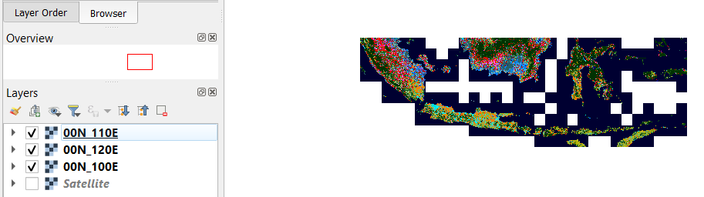

Then GDSAL merge with no compression in QGIS with high compression. (Low compression failed).

-Mosaic in R

-Warp to 3857 in QGIS. Export (SLOW)

-Read in eRIDE_1 adapted script: define forest/habitat

-Run eRIDE 1

-Load eRIDE 1,

-Crop for Java only

-Aggregate

-Correlate with eRIDE 2

-Summarize stats, Think