The genetic basis of a colorful signal: The polymorphic dewlap of the slender anole (Anolis apletophallus)

Supplementary Material

Supporting Information Captions

Table S1. Breeding experiment for the slender anole individuals (excel table).

Table S2. Geographic coordinates of slender anole individuals for the Pool-seq analyses (excel table).

Table S3. List of candidate genes from De Mello, P. L. H., Hime, P. M., & Glor, R. E. (2021) (excel table).

Table S4. List of the closest annotated genes and their distance to the main peak of differentiation.

Table S5. List of recovered genes from the Pool-seq method.

Figure S1. PoolParty pipeline PPstats results.

Figure S2. Pool sequencing plot illustrating small regions of the genome that may be associated with the slender anole dewlap polymorphism.

Figure S3. Nucleotide diversity (Tajima's D) density graphic across the slender anole genome.
Table S1. Results of breeding experiment for the slender anole. The table provides details on the parents including dam and sire origin, sire dewlap morphology, assumed genotypes (see methods), if females were mated in the lab (Lab-cross) or wild-mated, and if we can predict the dewlap morph of the male offspring (informative) and what we predict, and on the eggs and hatchlings produced in captivity (sex and male dewlap morph). (excel table)

Table S2. Geographic coordinates of slender anole individuals from each dewlap morph used for the Pooled population sequencing (Pool-seq) experiment. (excel table)
Table S3. List of candidate genes from De Mello, P. L. H., Hime, P. M., & Glor, R. E. (2021). Transcriptomic analysis of skin color in anole lizards. Genome Biology and Evolution, 13(7), evab110 that were queried from our Pool-seq experiment. Note that some genes do not have an ENSEMBL annotation and are instead listed by gene abbreviation. (excel table)

Table S4. List of the closest annotated genes and their distance to the main peak of differentiation.

Gene Symbol | Gene Name | Scaffold | Start | End | Distance (bp) | Putative function
GM-Ann9784 | Putative Gene model | 3 | 117706233 | 117701849 | 152849 | NA
Prdm13 | PR/SET Domain 13 | 3 | 117596157 | 117563730 | 266506 | transcriptional regulation
Ccnc | Cyclin C | 3 | 117469049 | 117478885 | 382123 | regulation of transcription by RNA polymerase II
Tstd3 | Thiosulfate Sulfurtransferase Like Domain Containing 3 | 3 | 117462633 | 117465282 | 396248 | Transferase activity
Usp45 | Ubiquitin Specific Peptidase 45 | 3 | 117356846 | 117431638 | 428500 | regulator of DNA repair processes
Pnisr | PNN Interacting Serine And Arginine Rich Protein | 3 | 117310059 | 117334368 | 527134 | RNA binding activity
Coq3 | Coenzyme Q3, Methyltransferase | 3 | 117281487 | 117295572 | 565020 | electron transport pathways, methyltransferase activity
Faxc | Failed Axon Connections Homolog | 3 | 117240887 | 117275020 | 585922 | integral component of membrane, axonal development
SIM1 | single-minded 1 | 3 | 117881371 | 117984039 | 0 (Peak at intron 2, 175 SNPs) | development of the neural system midline cells
Ascc3 | Activating Signal Cointegrator 1 Complex Subunit 3 | 3 | 118012635 | 118305674 | 48990 | DNA repair and resistance to alkylation damage
GM-Ann24855 | Putative Gene model | 3 | 118385449 | 118387643 | 419355 | NA
GM-Ann24955 | Putative Gene model | 3 | 118428027 | 118425009 | 457241 | NA
GM-Ann30225 | Putative Gene model | 17 | 25637969 | 25654910 | 53197 | NA
Cldn19 | Claudin 19 | 17 | 25603999 | 25622878 | 19227 | tight junction-specific obliteration of the intercellular space
Cldn16 | Claudin 16 | 17 | 25573504 | 25584772 | 0 (Peak exon 1, 7 SNPs) | tight junction-specific obliteration of the intercellular space
Cldn16 | Claudin 16 | 17 | 25545825 | 25569234 | 4270 | tight junction-specific obliteration of the intercellular space
Slc45A1 | Solute carrier family 45, | 17 | 25516579 | 25536272 | 37232 | transport of sugars and other molecules across cell membranes
LOC114602599 | uncharacterized oxidoreductase YjhC-like | 17 | 25476714 | 25510275 | 63229 | oxidation-reduction reactions
Mrps16 | MRPS16 | 17 | 25466348 | 25470974 | 102530 | assembly of the mitochondrial ribosome
GM-Ann22174 | Putative Gene model | 1822 | 10025 | 13095 | 3171 | NA
LOC100565998 | zinc finger protein 658B-like | 1822 | 14558 | 15724 | 540 | DNA-binding transcription activator activity
LOC100557322 | zinc finger protein 135 | 1822 | 15812 | 16925 | 0 (Peak exon 1, 5 SNPs) | DNA-binding transcription activator activity

Table S4. List of recovered genes or parts of these genes from the Pool-seq experiment.

Gene | Protein Name | General Function | Scaffold No. | No. SNPs recovered
SIM1 | Single-minded 1 | Development of the neural system midline cells | 3 | 175
Cldn16 | Claudin-16 | Physical barrier to prevent solutes and water from passing freely through the paracellular space | 17 | 7
ZFP2 | ZFP2 Zinc Finger | Predicted to enable DNA-binding transcription factor activity and to be involved in regulation of transcription by RNA polymerase II | 1822 | 13

Figure S1. PoolParty pipeline PPstats results from the slender anole genome presenting the Proportion of the Genome Covered after Coverage filters for the Pool-seq samples. Library 1 (solid morph) and Library 2 (bicolor morph).
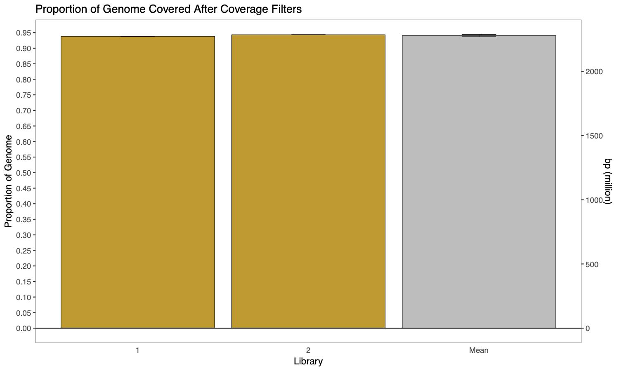

Figure S2. Pool sequencing plot illustrating small regions of the genome that may be associated with the slender anole dewlap polymorphism. (A) Manhattan plot illustrating genomic differentiation between the dewlap morphs using the pairwise F_{ST} values, and (B) Fisher Exact Test. Subsequently we highlight few SNPs from the (C) Scaffold 6; (D) Scaffold 10; (E) Scaffold 17 including the candidate gene CLDN16; (F) Scaffold 138, and (G) Scaffold 1822 including the candidate gene ZFP2. The green bars on top of the graphics (E) and (G) represent the exons and the arrow the direction of the annotation genome. The red line represents the Bonferroni Correction (p-value = 8.9).

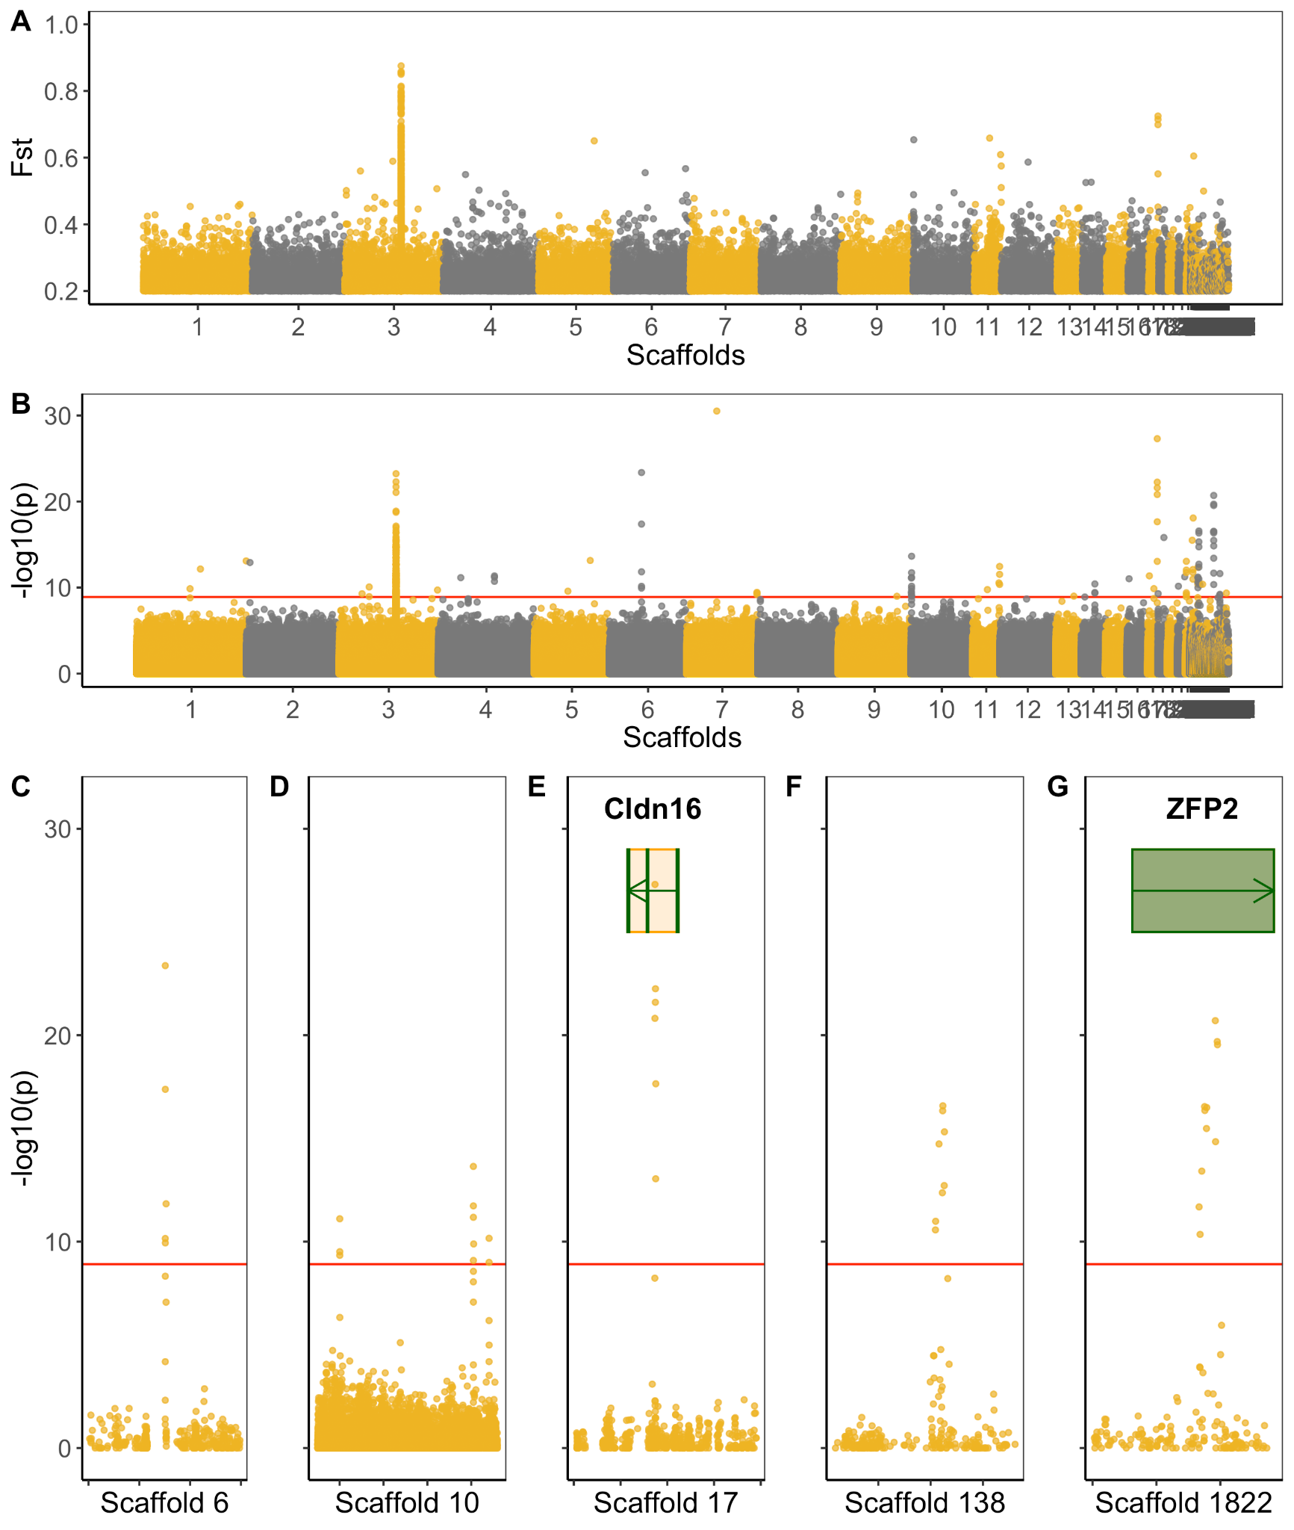

Figure S3. Nucleotide diversity (Tajima's D) density graphic across the slender anole genome presenting the (A) morph divided in 3 graphics showing the density of nucleotide diversity in different angles, and (B) bicolor morph between a sliding window of a 1000 bp. The red dots represent the candidate regions across the entire slender anole genome.

