|  |
| --- |
| **Laporan Praktikum**  **Implementasi Rancangan Prototype** |
|  |
| **Dibuat oleh:**  **Nama : Kevin Hutajulu**  **NIM : 11422034**  **Program Studi: DIV TEKNOLOGI REKAYASA PERANGKAT LUNAK** |
| **INSTITUT TEKNOLOGI DEL**  **FAKULTAS VOKASI** |

**Source code :**

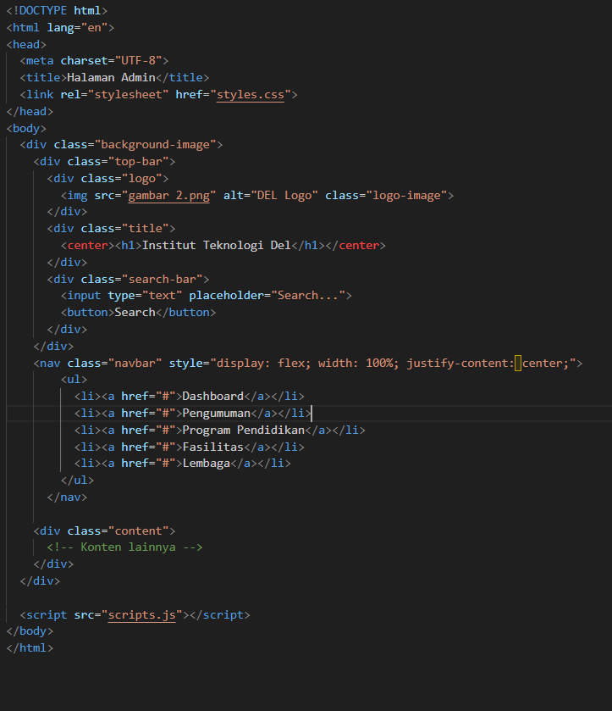

**CSS :** 