# AZ-203T01A-03 Demo #10 Deploying to AKS by using Azure CLI

Demo Script

## Before delivery:

* For next demo you ne have Docker installed.
* Update value and run the script ***demo.azcli*** before delivery
* Make sure it works with out exceptions.
* After successful run you will be able to connect to the NodePort and request ngnix welcome page.
* Clean up by deleting resource group and clean up file from c:\users\user_name\.kube\config

## In class:

* Run the script
* Demonstrate cluster form Azure portal

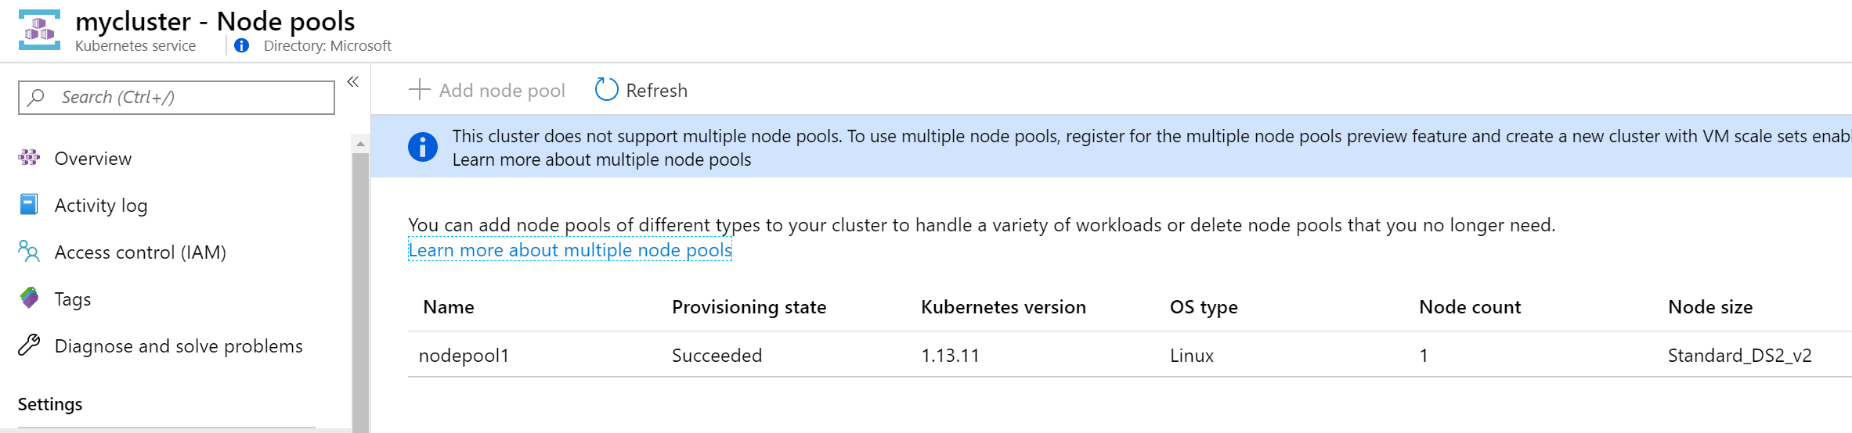

* Demonstrate yaml file.
* Connect to the “curl” container.
* Update and request nodeport url from previous output

