
Asbru Ltd.

Asbru Ltd.
www.asbrusoft.com
info@asbrusoft.com

Asbru Web Content Management System
Getting Started
Easily & Inexpensively
Create, Publish & Manage Your Websites

9. August 2012 Copyright © 2012 Asbru Ltd. Version 8.1.1

Table of Contents

1 Table of Contents 2
2 Introduction 3
3 Login 4
4 Web Pages 5
5 Homepage 6
6 Template 7
7 Navigation 9
8 Contact Form 12
9 Restricted Area 15
10 Search 17
11 Offers, Banners and News 20
12 Style Sheets 23

Asbru Web Content
Management System
Easily & Inexpensively
Create, Publish & Manage Your Websites

Introduction
The Asbru Web Content Management System is a web solution allowing you easy access to create and update the content of your Internet website as well as your Intranet and Extranet websites. This document describes in easy steps how to get started with the Asbru Web Content Management system. We go through the creation of a website as the one displayed below containing common functionality such as menus, contact forms, pages with restricted access, search, banners and special offers.
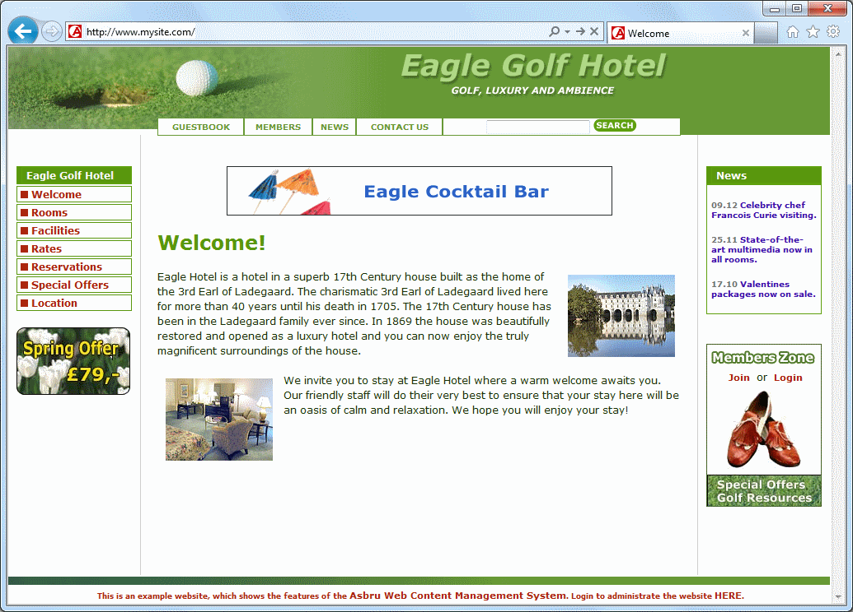
If you are using one of our online trials you can go to the Login chapter below and start with the creation of the website.
If the system has been installed on your own servers you should ensure that it has been installed and configured correctly. Before you start you should also ensure that one of the trial databases or the “basic” database has been imported. If you login to the system and a Quickstart Configuration page is displayed the system has not been configured and you should go to the Quickstart Configuration section in the Asbru Web Content Management System Installation Guide and follow the directions.

Login
To create and update your website you need to login to the administration pages of the Asbru Web Content Management system. The login procedure is described below.
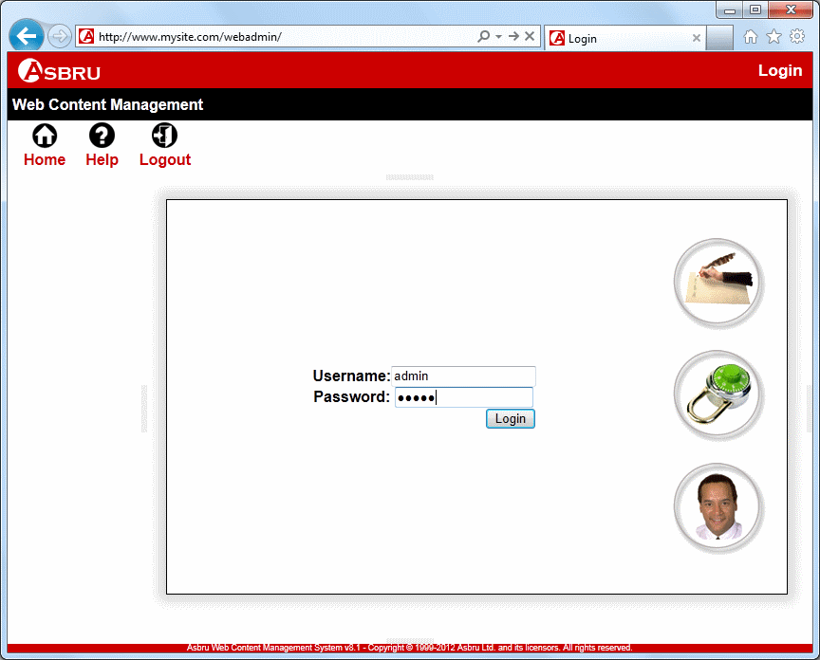     |  | Login
 |  | ◆ | Enter the address of your website followed by “/webadmin/” in the address field of your web browser. For example:  https://www.mysite.com/webadmin/
 |  | ❖ | Enter your username and password. The default username and password are:  Username: admin  Password: admin  Click on the Login button.
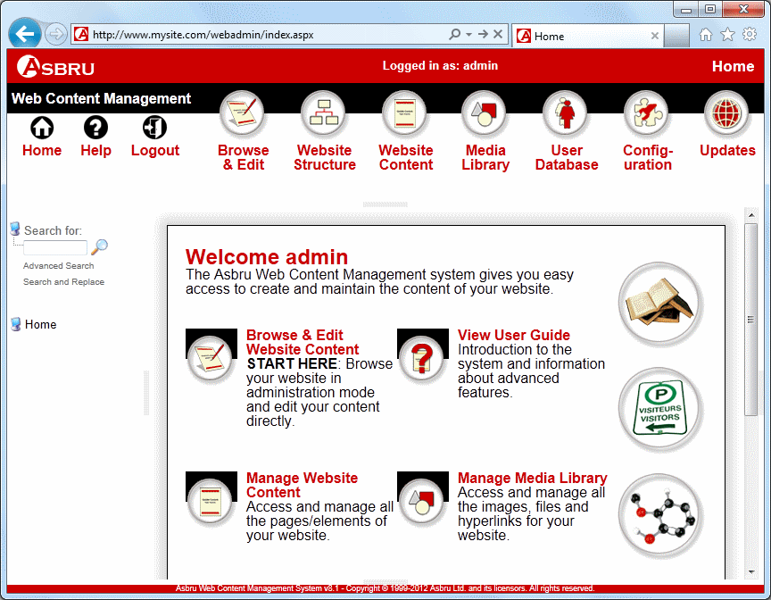   |  |  | After successful login the front page of the Asbru Web Content Management system appears. The menus displayed depend on your edition and your available add-on modules.  ☹ If you cannot login ensure that you are entering your exact username and password with upper and lower case letters and without any leading/trailing blanks.

Web Pages
In this section we describe how to create and update web pages. Pages like Rooms, Facilities, Rates, Special Offers, Location, Members and News from our example website can all be created this way. We will explain how to create special pages like Contact Forms and Reservations in subsequent sections.

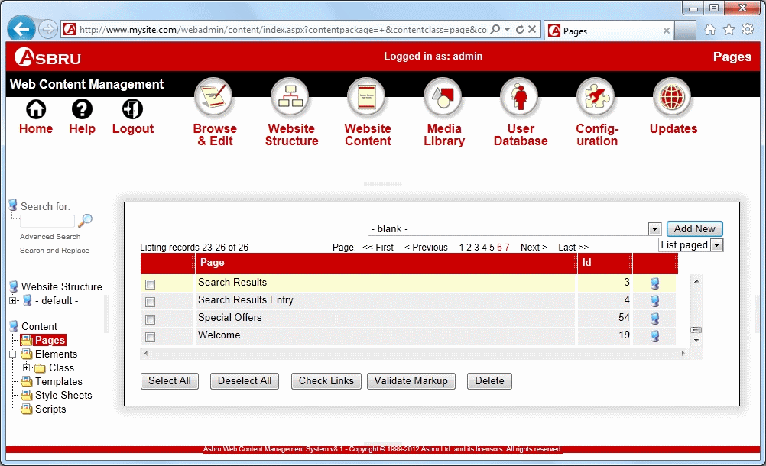         |  | Create/Update a Web Page
 |  | ◆ | Select Website Content in the toolbar.
 |  | ❖ | Select Pages.
 |  | ⬥ | To create a new web page, click the Add New button.  -or-  To update an existing web page click on the title of the web page.

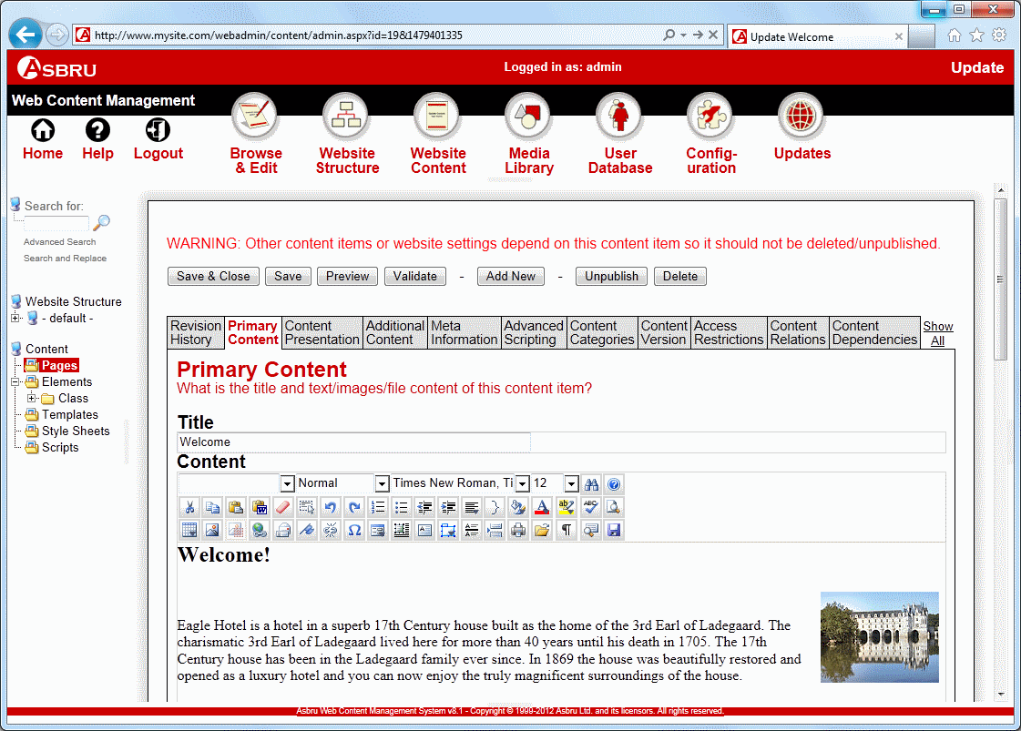       |  |  | A new screen appears. Any existing web page content is displayed in the Content field.
 |  |  | Enter or update the title of your web page in the Title field.
 |  |  | Add or change the content of your web page in the Content field.
 |  |  | Click the Save & Close button.  You will return to the Pages screen. If you created a new web page it will now be displayed on the page list  ☹ For more information on how to add or change content in the Content field please refer to the Content Editor section of the Asbru Web Content Management Website Editor Guide.

Homepage
To setup your homepage you need to create a web page as described in the section above and then configure the web page so that it becomes the homepage. The homepage will then appear when a website visitor accesses your website URL, for example http://www.mysite.com.

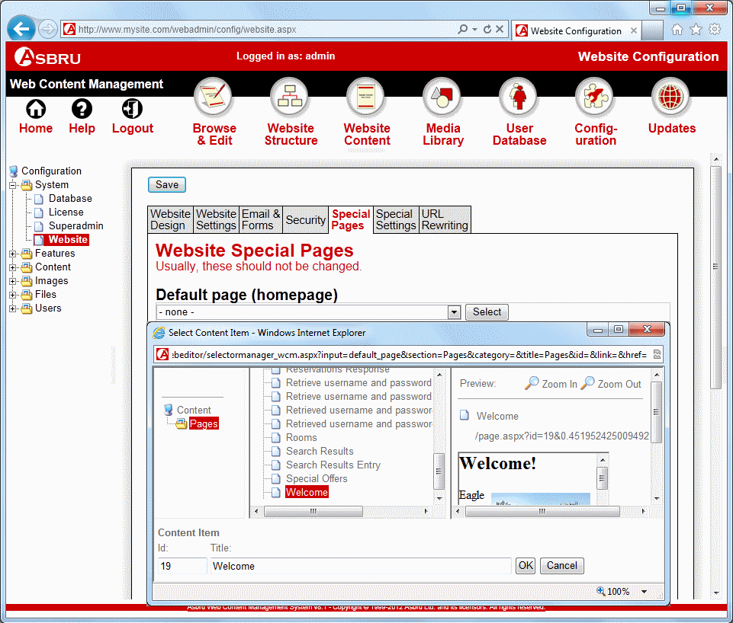                 |  | Setup a Homepage
 |  | ◆ | Select Configuration in the toolbar.
 |  |  | The Configuration screen appears.
 |  | ❖ | Click the plus icon in front of the System menu item to expand and select Website in the submenu.
 |  | ⬥ | Select the Special Pages tab.
 |  |  | Click on Select under Default page (homepage).  A popup appears.
 |  |  | Click on Pages.
 |  |  | Select the page you wish to be the homepage.
 |  |  | Click OK.
 |  |  | Click Save.

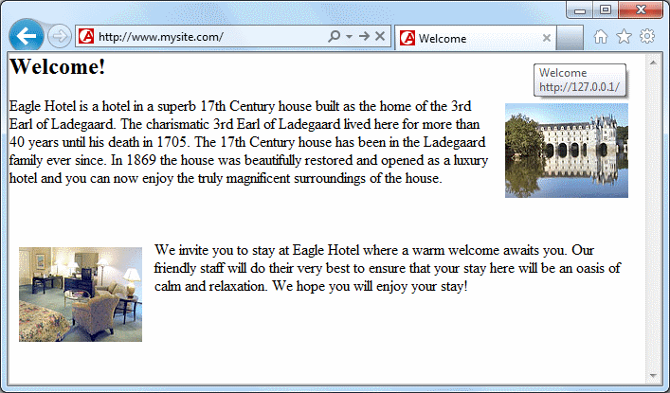 |  |  | When website visitors access your website URL, for example http://www.mysite.com, they will now see your configured homepage.

Template
To achieve a unified layout for all the pages on your website you need to create a template. The template can contain for example a footer, a header with your logo and other elements and design features. Below we show you how to create a simple template with a header and a footer. We also show you how to setup the template to be used throughout your entire website. The template will later be extended to include a menu and other elements.

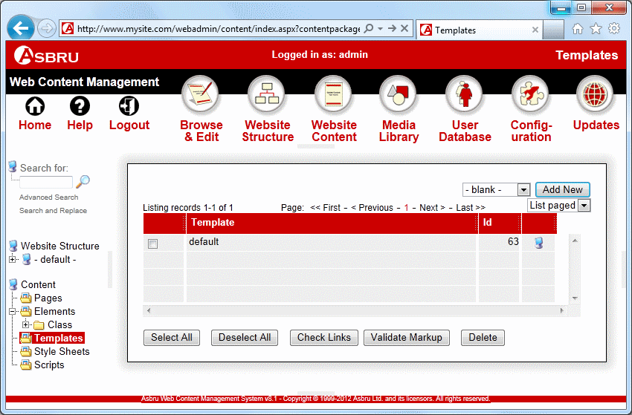       |  | Create a Template
 |  | ◆ | Select Website Content in the toolbar.
 |  | ❖ | Select Templates in the left hand side menu.
 |  | ⬥ | Click the Add New button.

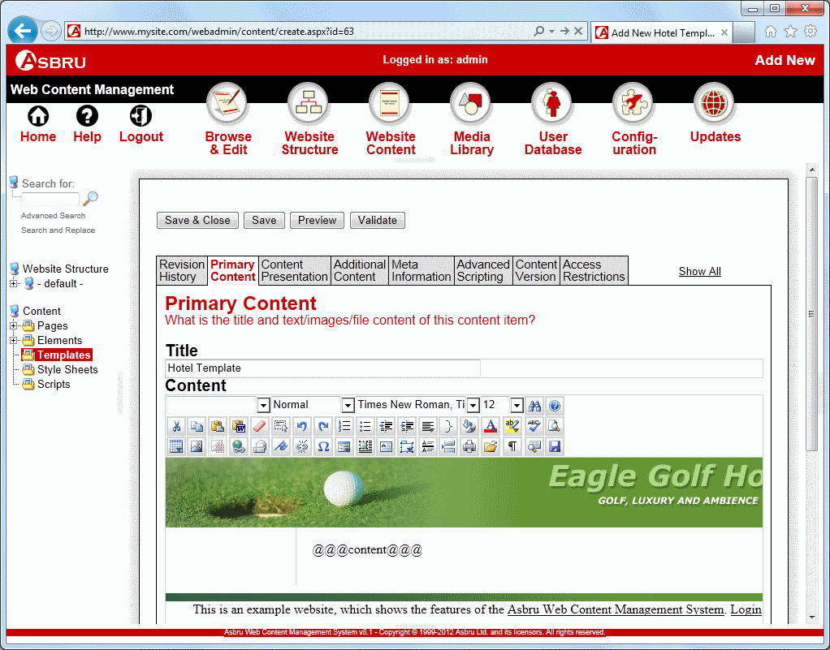         |  |  | A blank Add New template screen appears.
 |  |  | Enter a template Title.
 |  |  | Add the header, footer and other design features you wish to include in your template in the large input area.
 |  |  | Enter the code  @@@content@@@  where you wish the page content to appear.
 |  |  | Click Save and Close.  ☹ Templates are often constructed as tables with no borders. Click the Show WYSIWYG/Plain editor button to turn on table outlines.

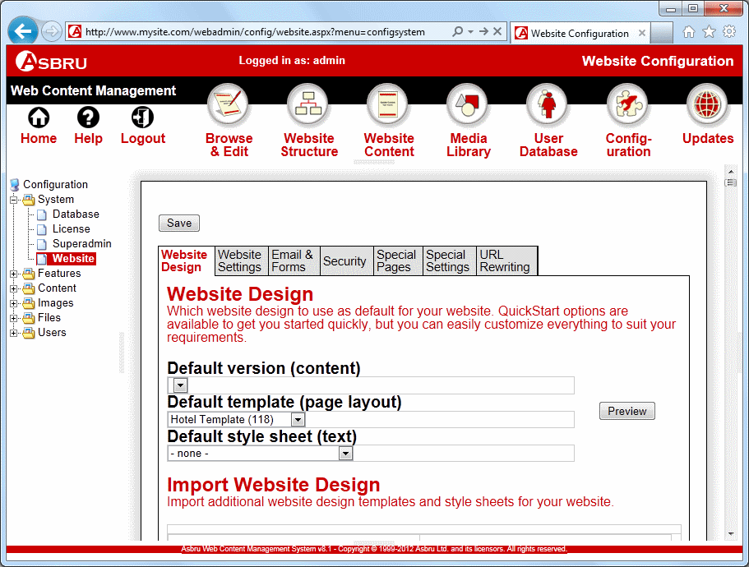         |  | Apply the Template
 |  | ◆ | Select Configuration in the toolbar.
 |  | ❖ | Click the plus icon in front of System to expand the System menu and select Website in the submenu.
 |  | ⬥ | Select the template you created in previous steps.
 |  |  | Click Save.

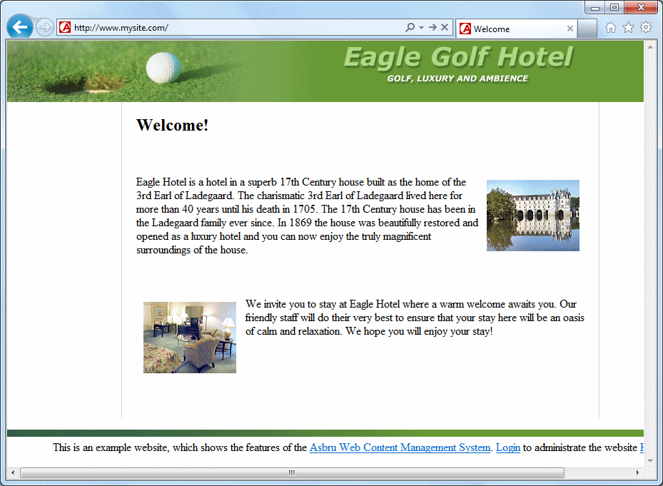 |  |  | When visitors access your website URL, for example http://www.mysite.com, your configured homepage should now appear within your configured template as displayed here.

Navigation
To add a menu or toolbar to your website create a menu or toolbar element with links to your web pages and insert the menu and/or toolbar into your template. Below we illustrate how to do this for a menu. The procedure for creating a toolbar is similar.

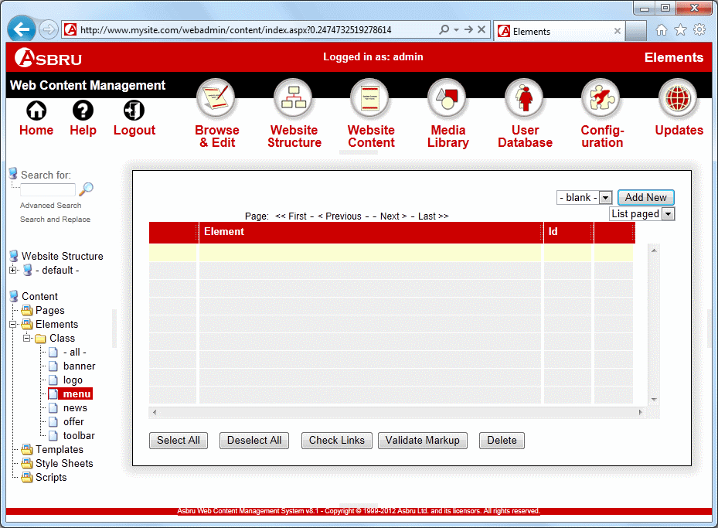       |  | Create a Menu Element
 |  | ◆ | Select Website Content in the toolbar.
 |  | ❖ | Click the plus icon in front of the Class menu item to expand the Class menu and select menu in the submenu.
 |  | ⬥ | Click the Add New button.

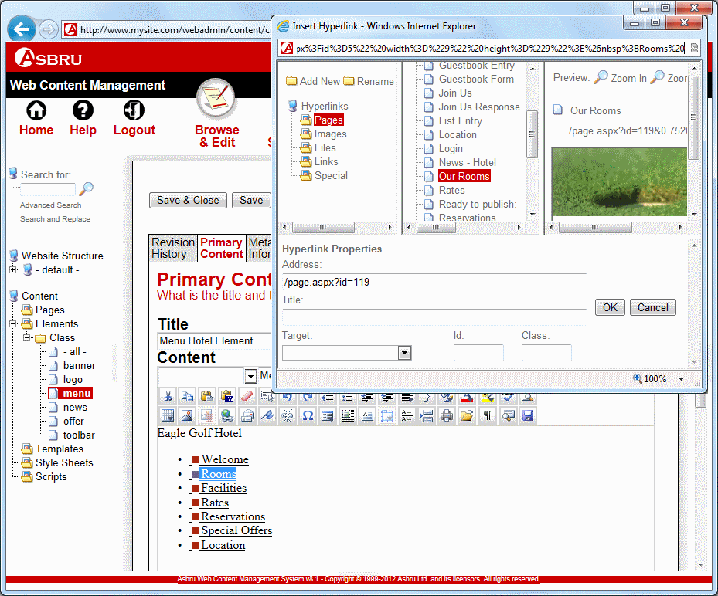               |  |  | A blank Add New element screen appears.
 |  |  | Enter a menu Title.
 |  |  | Create your menu in the Content field. Select each of the menu items in turn and follow step 6 to 9 below to insert hyperlinks to web pages.
 |  |  | Click on the Insert Hyperlink button in the editor toolbar.  A popup screen appears.
 |  |  | Select Pages.
 |  |  | Select the web page you wish to link to.
 |  |  | Click OK.
 |  |  | Click the Save & Close button.
 |  |  | ☹ You can create new pages through the web content editor’s hyperlink manager.

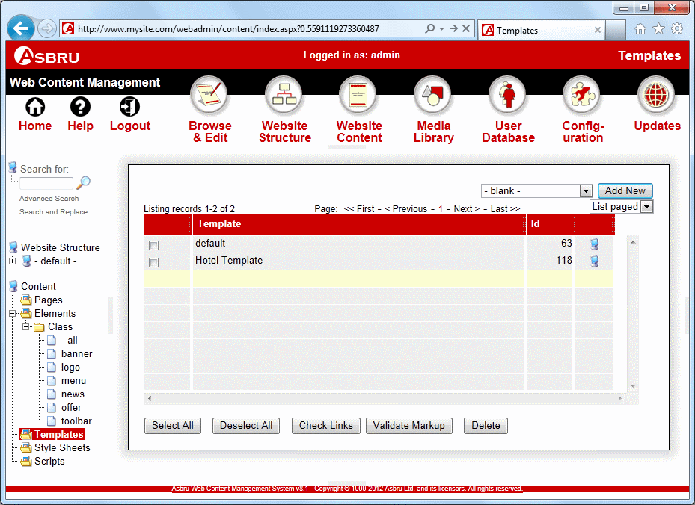       |  | Assign Menu to Template
 |  | ◆ | Select Website Content in the toolbar.
 |  | ❖ | Select Templates in the menu.
 |  | ⬥ | Find the template created in previous steps and click on the title of the template.

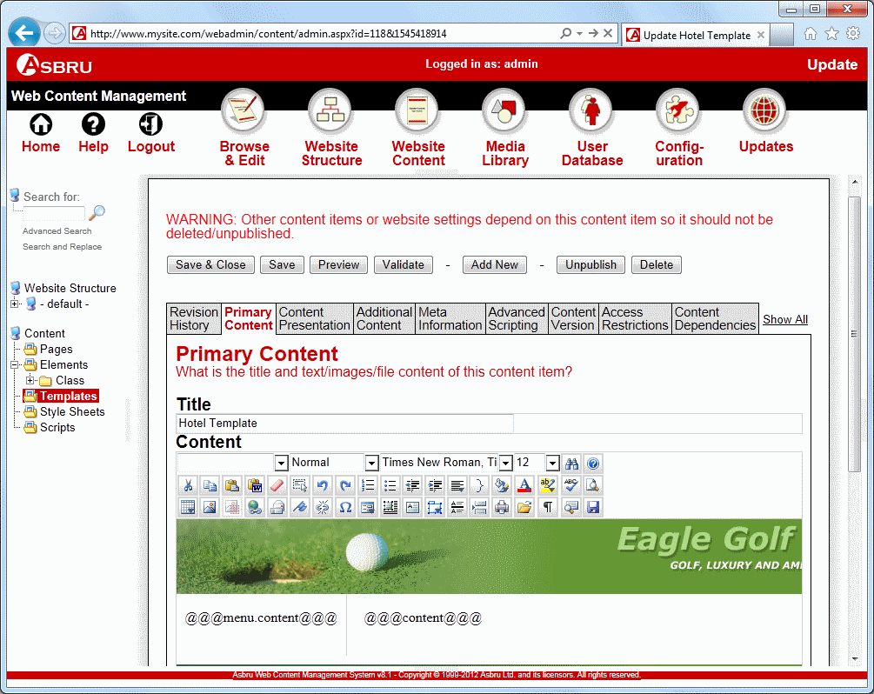     |  |  | The Update screen will now appear.
 |  |  | Add the code  @@@menu.content@@@  where you wish the menu to appear.
 |  |  | Click on the Additional Content tab.

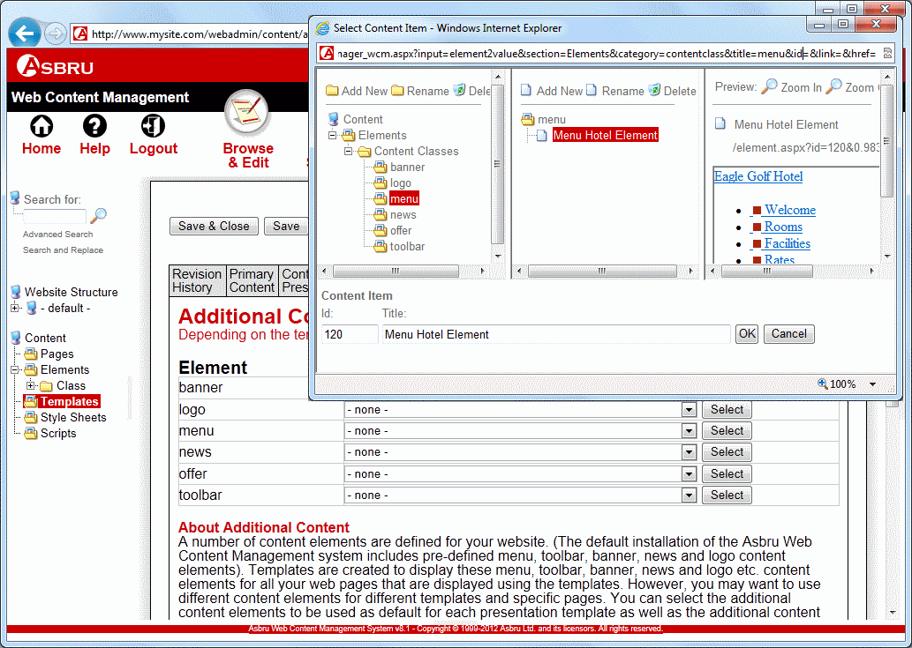           |  |  | The Additional Content tab appears.
 |  |  | Click on the Select button for menu.
 |  |  | Click on menu.
 |  |  | Select the menu element created in previous steps on the menu list.
 |  |  | Click OK.
 |  |  | Click the Save & Close button.

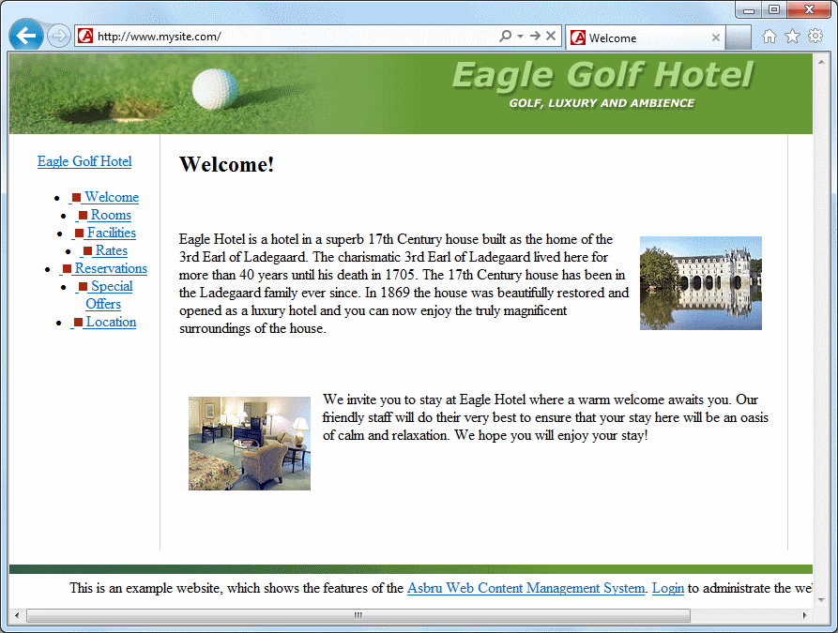 |  |  | Repeat the steps above to create a toolbar menu.  The resulting website looks like this.

Contact Form
A contact form enables your website visitors to send messages to your configured administrator email address through your website. To create a contact form, you have to add special form elements to a regular web page. The elements that must be inserted for a form to function correctly include a form container with general information about the contact form, form fields inside the form container, a Send button inside the form container and a special hidden field that specifies the landing page after the user has clicked on the Send button in the contact form. The creation of a contact form is illustrated in detail below. A reservations form is created in the same way.
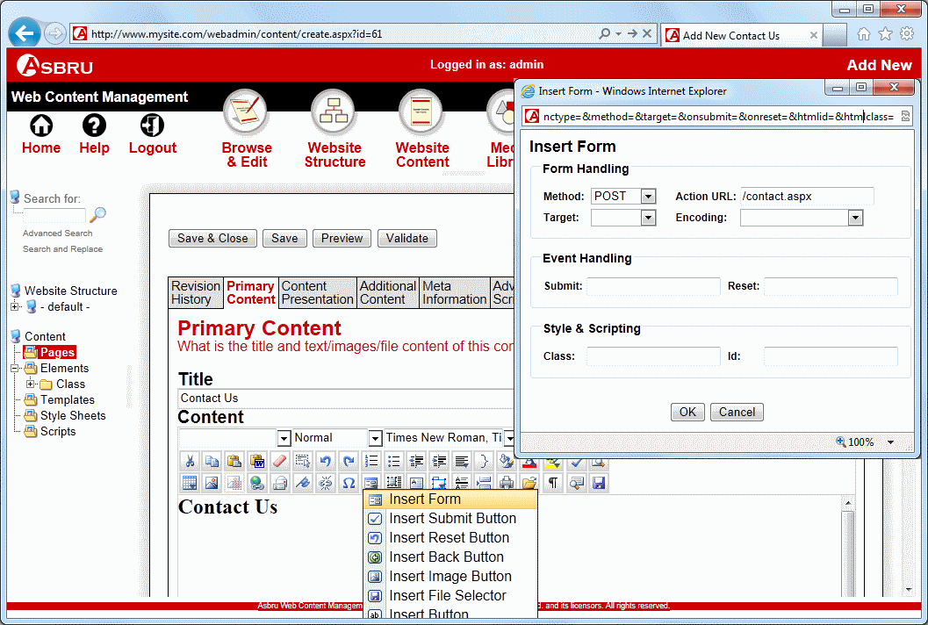             |  | Insert Form Container
 |  | ◆ | Create or open a web page as illustrated in the Web Pages section above. (Not displayed on this screenshot.)
 |  | ❖ | Place the cursor in the Content field where you wish the form container to be placed.
 |  | ⬥ | Hold the mouse over the Insert Form button and select Insert Form from the drop down list.  A popup appears.
 |  |  | Select POST in the Method drop down.
 |  |  | Enter /contact.jsp in the Action URL field (or /contact.aspx or /contact.jsp).
 |  |  | Click OK.
 |  |  | Click the Show WYSIWYG/Plain button to display a red dashed form container outline.
 |  |  | If you wish you can now add tables, text, images and other objects inside the form container.

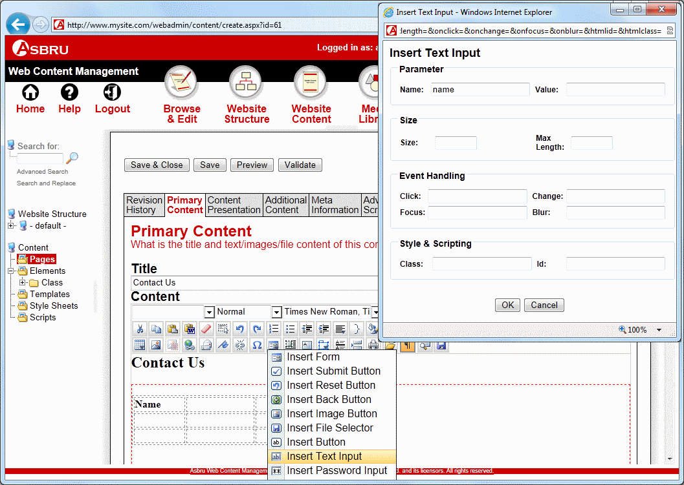         |  | Insert Form Fields
 |  | ◆ | Place the cursor inside the form outline where you wish to insert a form field.
 |  | ❖ | Hold the mouse over the Insert Form button and click on Insert Text Input.  A popup appears.
 |  | ⬥ | Enter name to create a field where website visitors can enter their name.
 |  |  | Click the OK button to insert the field in the Content area.
 |  |  | Repeat step 1 to step 3 above to insert other fields. One of your field names should be subject as this will be used as the subject of the email that will be sent to the configured website administrator.

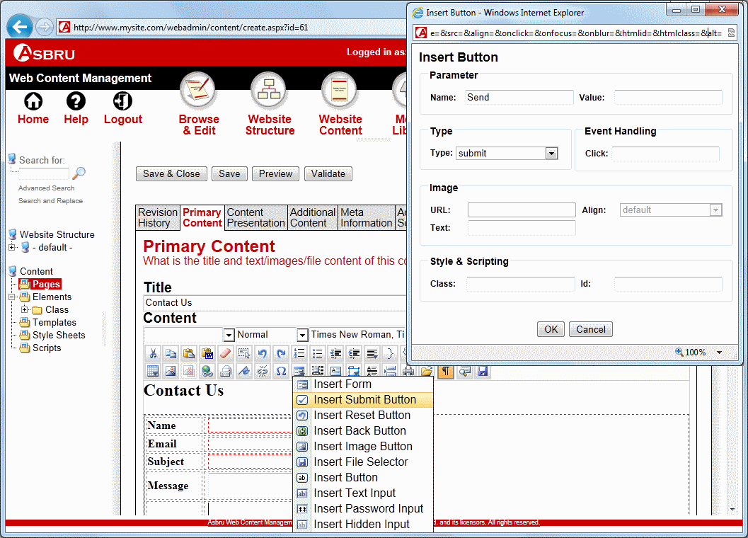         |  | Insert Send button
 |  | ◆ | Place the cursor inside the form outline where you wish the Send button to appear.
 |  | ❖ | Hold the mouse over the Insert Form button in the content editor toolbar and click on Insert Submit Button.  A popup appears.
 |  | ⬥ | Enter Send.
 |  |  | Click the OK button to insert the Send button.

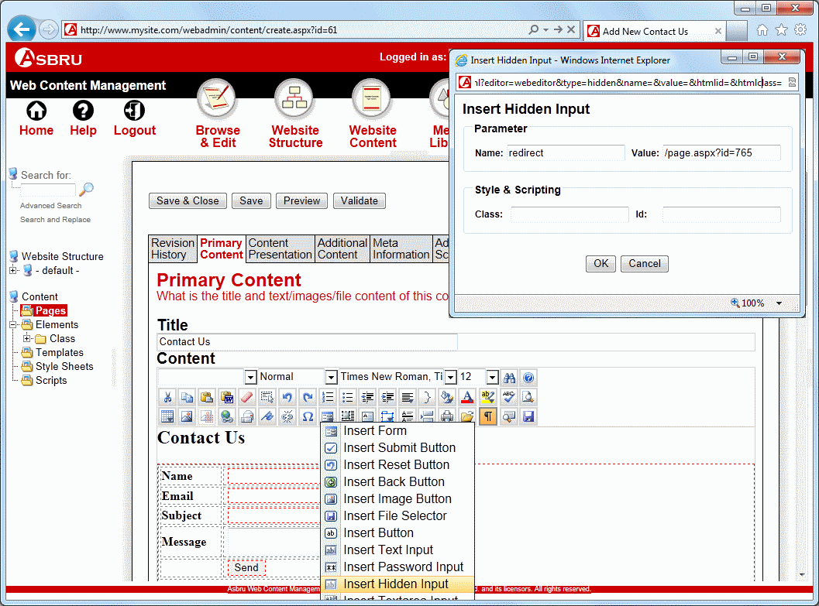             |  | Specify a Landing Page
 |  | ◆ | Place the cursor somewhere inside the form outline.
 |  | ❖ | Hold the mouse over the Insert Form button in the content editor toolbar and click on Insert Hidden Input.  A popup appears.
 |  | ⬥ | Enter redirect in the Name field.
 |  |  | Enter /page.jsp?id=xx (or /page.aspx?id=xx) in the Value field where you replace xx with the page number for the page you wish to redirect the website visitor to when the visitor clicks the Send button in your form.
 |  |  | Click the OK button to insert the hidden input field button.
 |  |  | Click Save & Close.

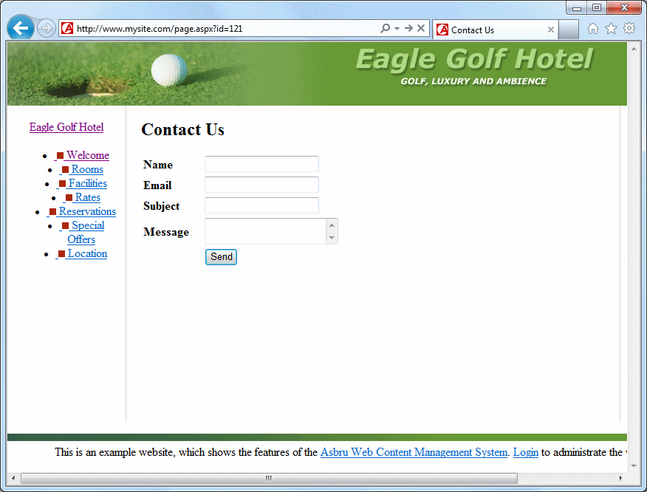
The Contact Us page will now look similar to the one displayed here.

Website visitors can fill in the form and when he/she clicks the Send button the administrator configured to receive contact emails will receive an email with the details entered in the form.

Restricted Area
It is possible to create an area of your website where only registered website visitors have access. You can setup these access restrictions for one or several individual web pages or for entire page types or page groups. Below we illustrate how to setup access restrictions for individual pages and how to add registered website visitors. Please refer to the User Access Restrictions section in the Asbru Web Content Management User Guide for more information about setting access restrictions for page types and page groups.

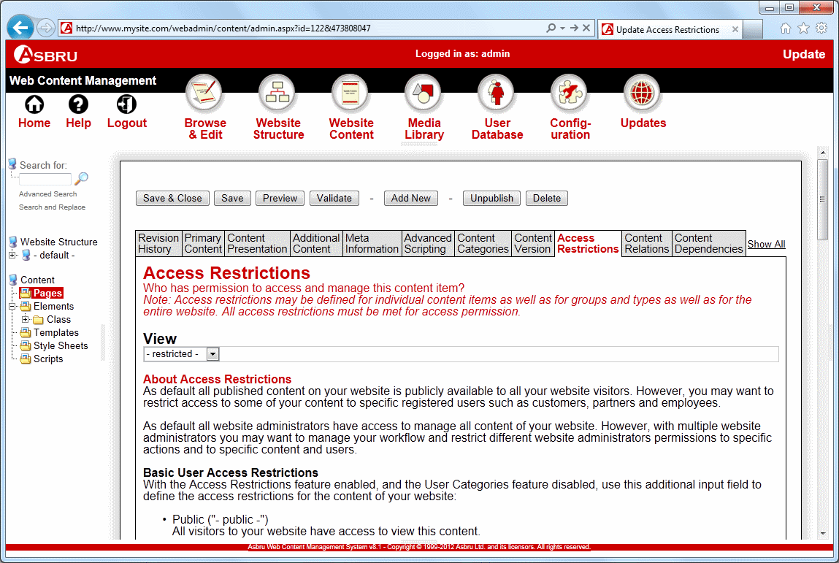       |  | Restrict Access to a Web Page
 |  |  | For each of the pages where restricted access is required follow steps 1 to 4 below.
 |  | ◆ | Create or open the relevant web page as illustrated in the Web Pages section above. (Not displayed on this screenshot.)
 |  | ❖ | Click on the Access Restrictions tab.
 |  | ⬥ | Select –restricted- on the View list.
 |  |  | Click Save & Close.

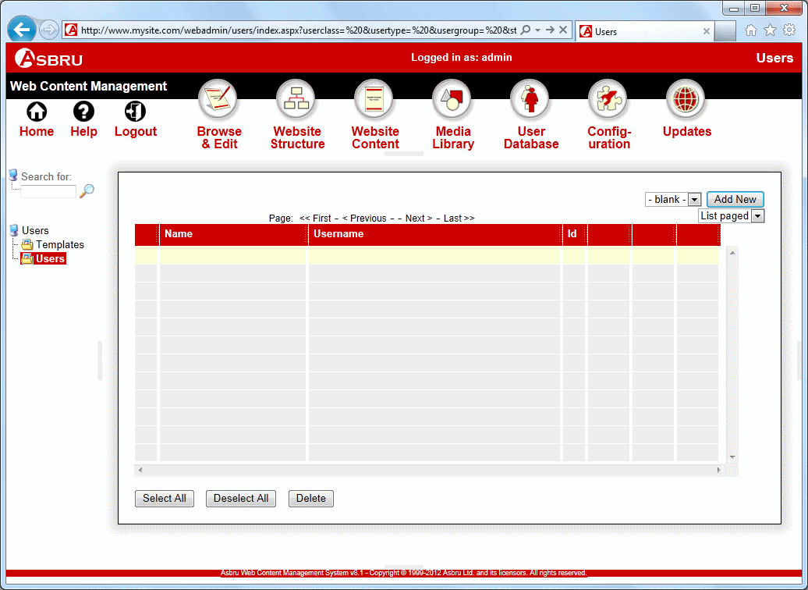       |  | Register a User
 |  | ◆ | Select User Database.
 |  | ❖ | Click Users.
 |  | ⬥ | Click on the Add New button.

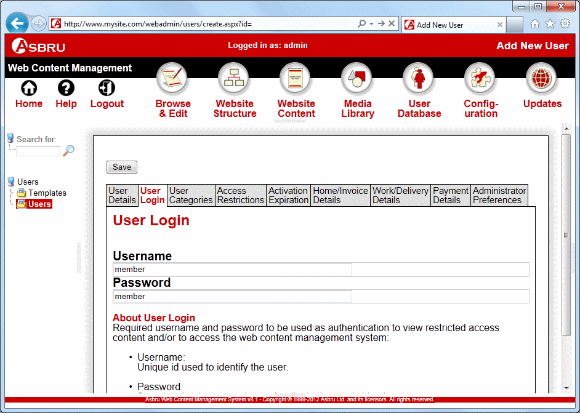       |  |  | Enter a username for example member in the Username field.
 |  |  | Enter a password for example member in the Password field.
 |  |  | Click the Save button.

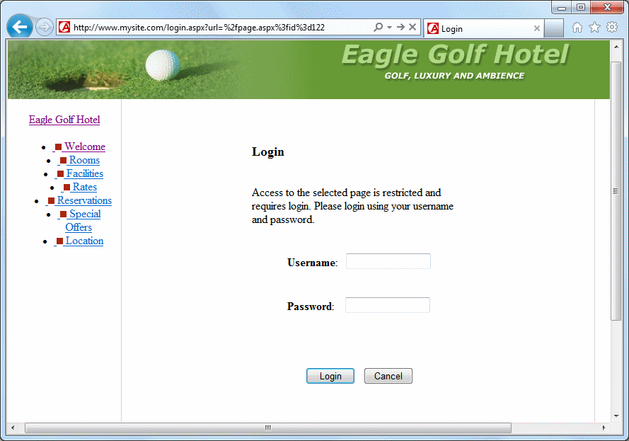
If a website visitor accesses a page with restricted access the visitor will be prompted to login. When the visitor has provided a valid username and password and clicked the Login button the visitor will see the page with restricted access.

Search
You can add a search field to your website that will enable visitors to search for content containing any key phrase. Search fields can be inserted into pages, templates or elements like toolbars or menus. In this example we illustrate how to insert a search field into your toolbar. To insert a search field you have to insert a form container, the search field itself and a search button. All of these three must be present for the search functionality to function correctly.

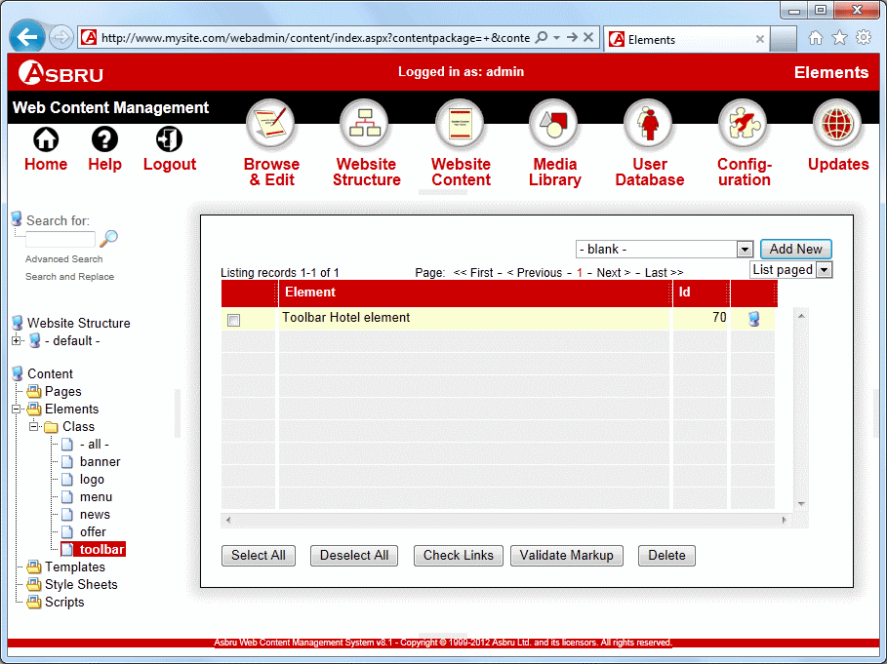       |  | Open Toolbar
 |  | ◆ | Select Website Content.
 |  | ❖ | Select the plus icon in front of Class to expand the class menu and click toolbar.
 |  | ⬥ | Click on the Toolbar Hotel element title.

⬥


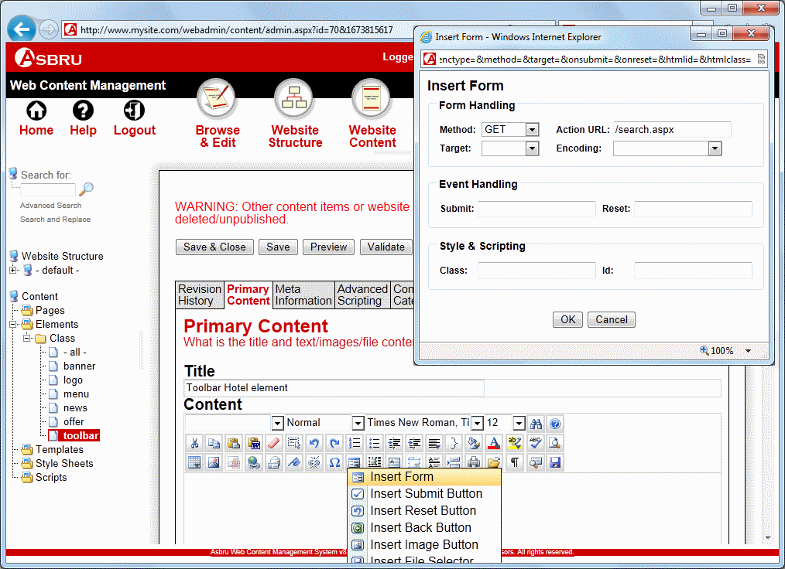       |  | Insert Form Container
 |  | ◆ | Place the cursor in the web content editor input field.
 |  | ❖ | Hold the mouse over the Insert Form button in the editor toolbar and click on Insert Form.  A popup appears.
 |  | ⬥ | Select GET in the Method list.
 |  |  | Enter /search.jsp (or /search.aspx) in the Action URL field.
 |  |  | Click the OK button.
 |  |  | Click the Show WYSIWYG/Plain button to display form outlines for the form container you have just inserted.
 |  |  | If you wish you can now add tables, text, images and other objects inside the form container.

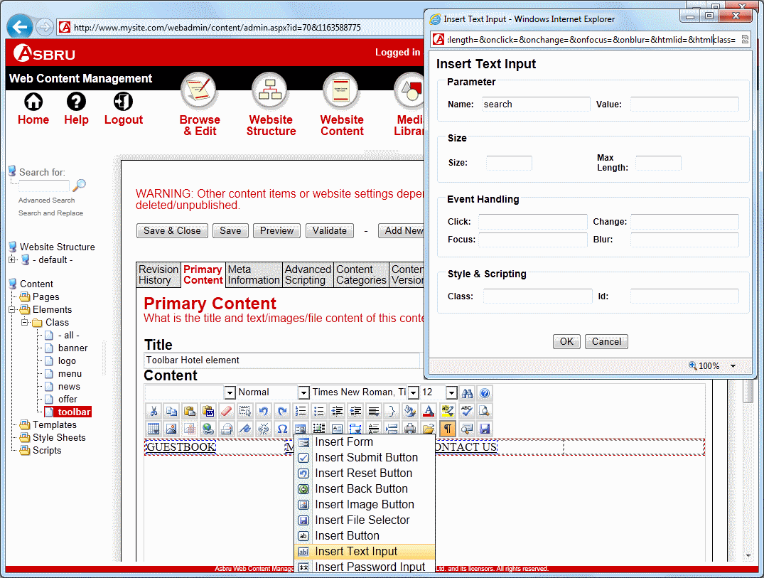         |  | Insert Search Field
 |  | ◆ | Place the cursor where you wish the Search field to appear.
 |  | ❖ | Hold the mouse over the Insert Form button in the editor toolbar and click on Insert Text Input.  A popup screen appears.
 |  | ⬥ | Enter search in the Name field.
 |  |  | Click the Ok button.

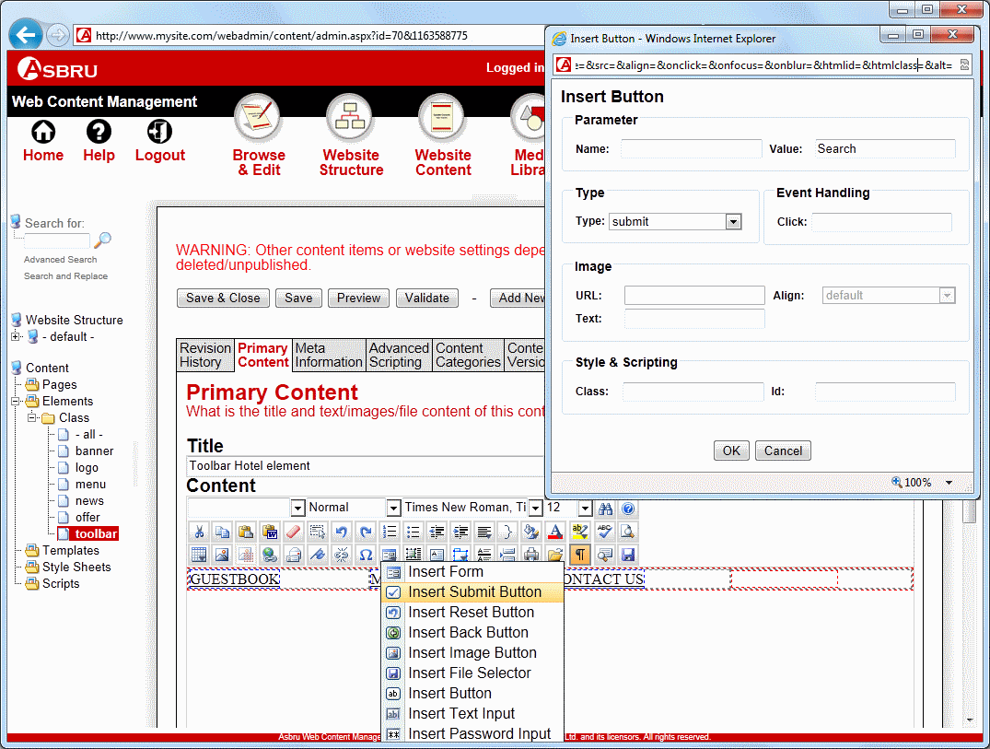           |  | Insert Search button
 |  | ◆ | Place the cursor where you wish the Search button to appear.
 |  | ❖ | Hold the mouse over the Insert Form button in the editor toolbar and click on Insert Submit Button.  A popup screen appears.
 |  | ⬥ | Enter the text you wish to appear on your button in the Value field. For example Search.
 |  |  | Click Ok.
 |  |  | Click Save & Close.

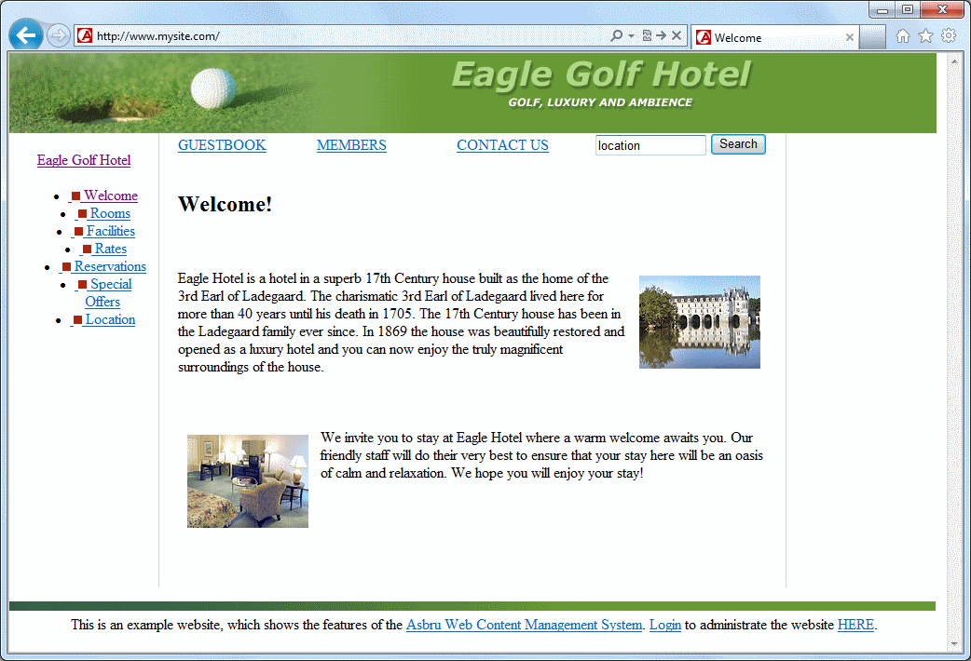
Your website should now look similar to this.
Enter a search term, for example location in the search box and click on the Search button.

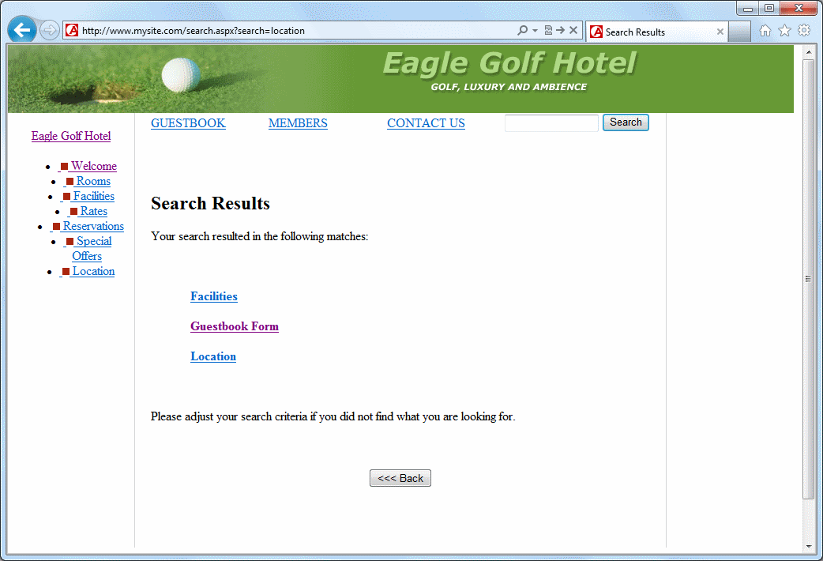
A page now shows all the pages, which contain the word location.
If a visitor clicks on one of the search results links the visitor is redirected to the page.

Offers, Banners and News
You can add offers, banners and news to your website using the Asbru Web Content Management system. To do this, create the banner, offer or news as an Element and insert it into your template. Below we illustrate how to create an offer element and insert it into the template. The procedure to include banners and news on your website is similar.

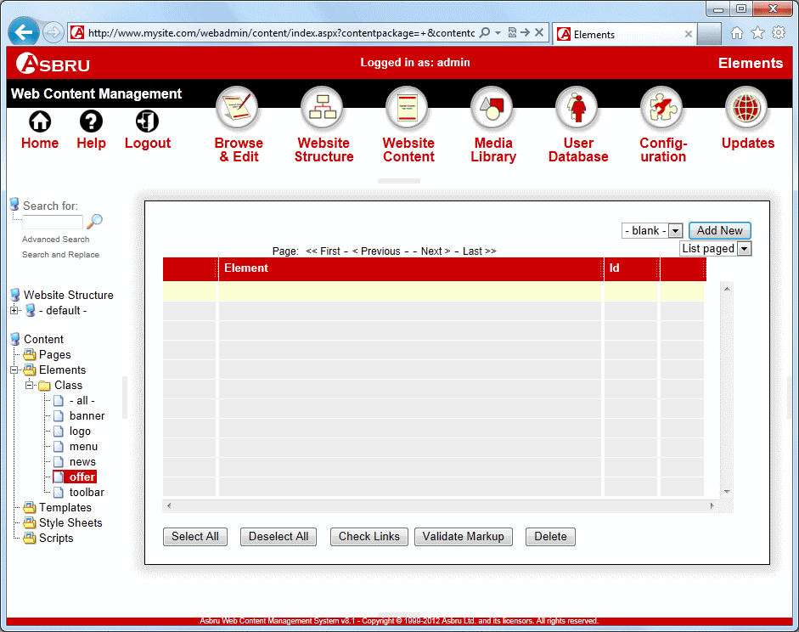       |  | Create an Offer Element
 |  | ◆ | Select Website Content in the toolbar.
 |  | ❖ | Click the plus icon in front of the Class menu item to expand the Class menu and select offer in the submenu.
 |  | ⬥ | Click the Add New button.

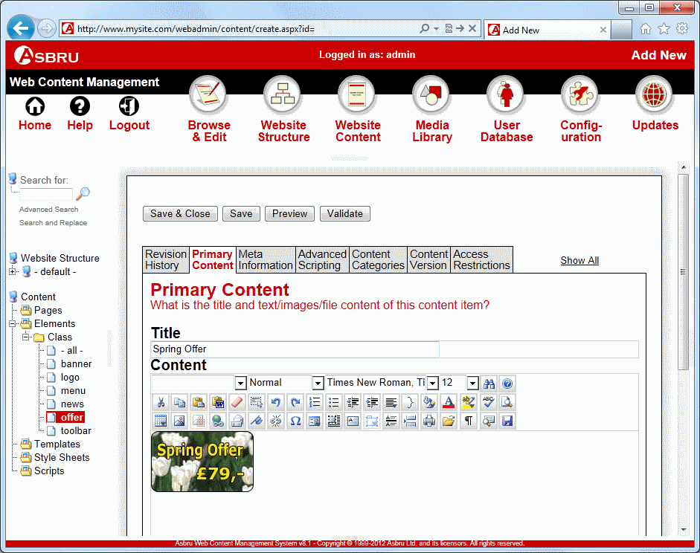       |  |  | A blank Add New element screen appears.
 |  |  | Enter an offer Title.
 |  |  | Add the content of the offer in the Content field. The content can be for example images or text.
 |  |  | Click Save & Close.
 |  |  | Repeat step 3 to step 6 to create other offers.
 |  |  | ☹ You can add images through the web content editor’s media manager. For more information please see the Asbru Web Content Management Web Content Editor Guide.

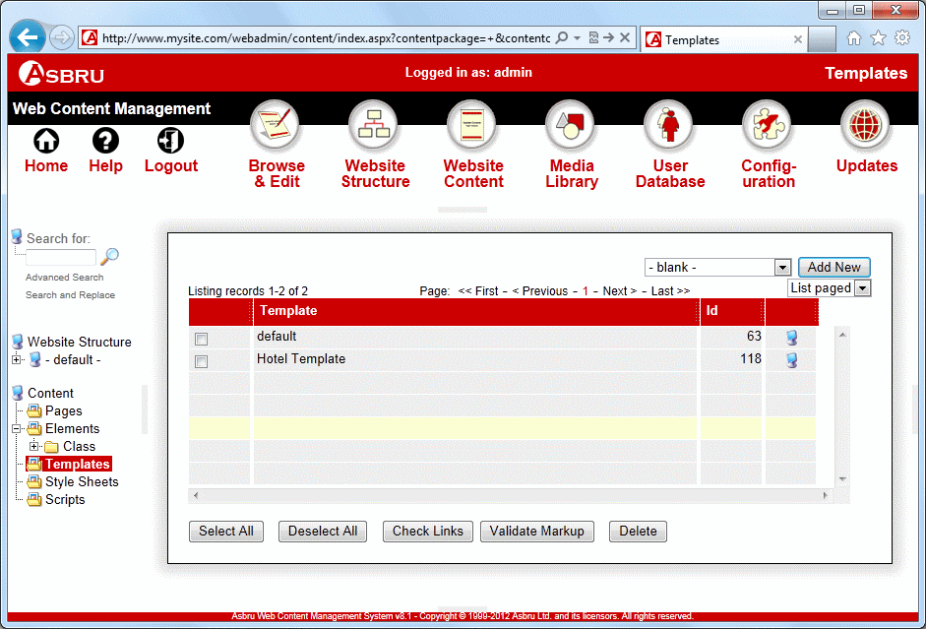       |  | Assign Offer to Template
 |  | ◆ | Select Website Content in the toolbar.
 |  | ❖ | Select Templates in the menu.
 |  | ⬥ | Find the template created in previous steps and click on the title.

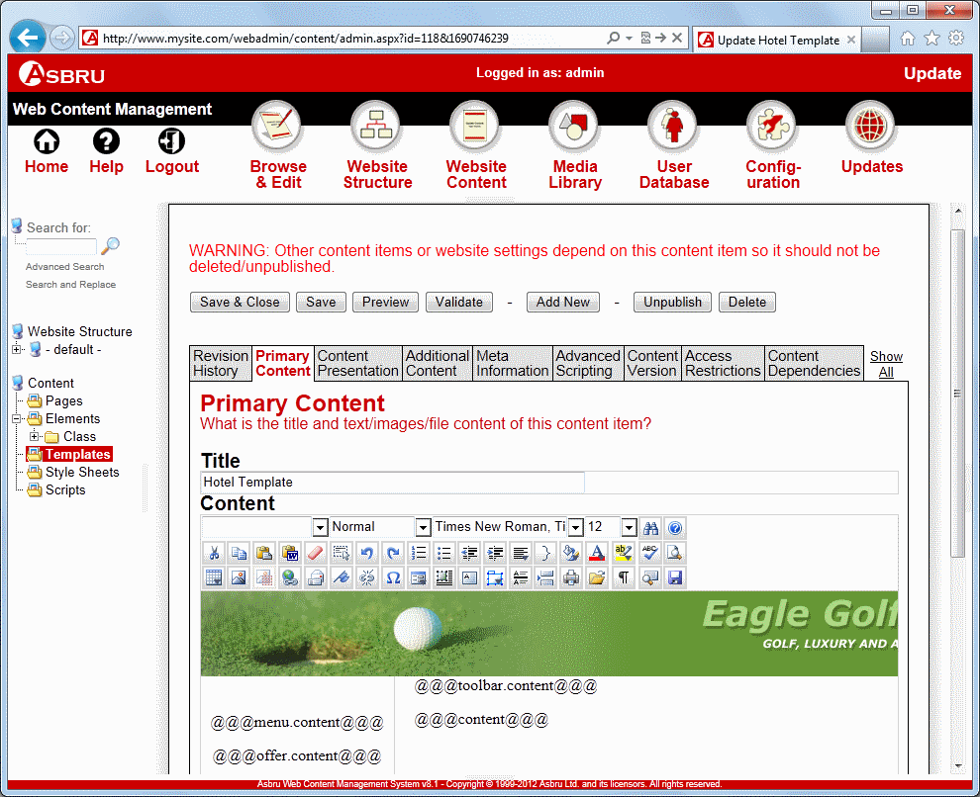     |  |  | The Update screen will now appear.
 |  |  | Add the code  @@@offer.content@@@  where you wish the offer to appear.
 |  |  | Click on the Additional Content tab.

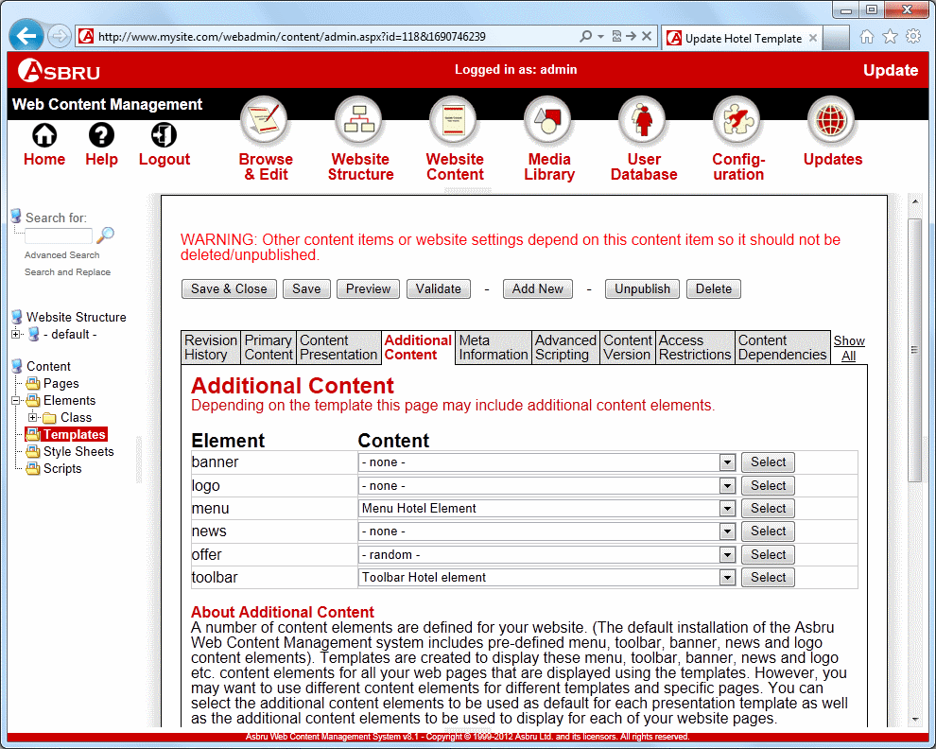     |  |  | The Additional Content tab appears.
 |  |  | On the offer list select the offer element created in previous steps or alternatively select –random-. If you select –random- every time the template is displayed one of the offer elements will be displayed randomly.
 |  |  | Click the Save & Close button.

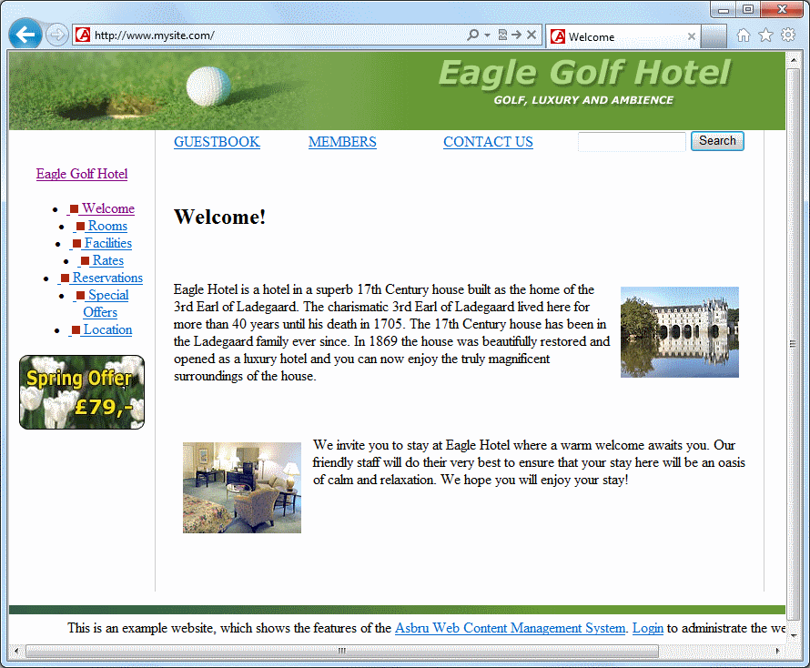 |  |  | After insertion of both offers, banner and news elements into the template your website will look similar to this.

Style Sheets
A CSS (Cascading Style Sheet) lets you define colours, fonts, layout, and other aspects of the presentation of your web pages. A Style Sheet is not necessary to create a website as you can define colours, fonts and layout on your web pages, but it does give you more options and enables you to control the formatting on your website in one place. You can create a Style Sheet in the Asbru Web Content Management system and then configure it to be used for all the web pages on your website. Below we illustrate how to do this.

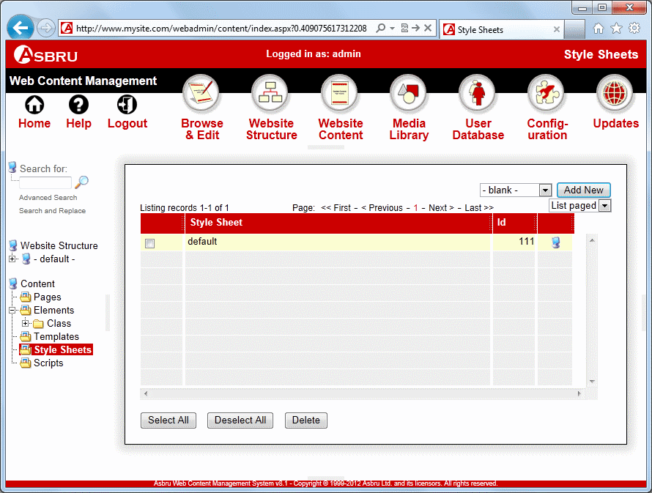       |  | Create a Style Sheet
 |  | ◆ | Select Website Content in the toolbar.
 |  | ❖ | Select Style Sheets.
 |  | ⬥ | Click the Add New button.

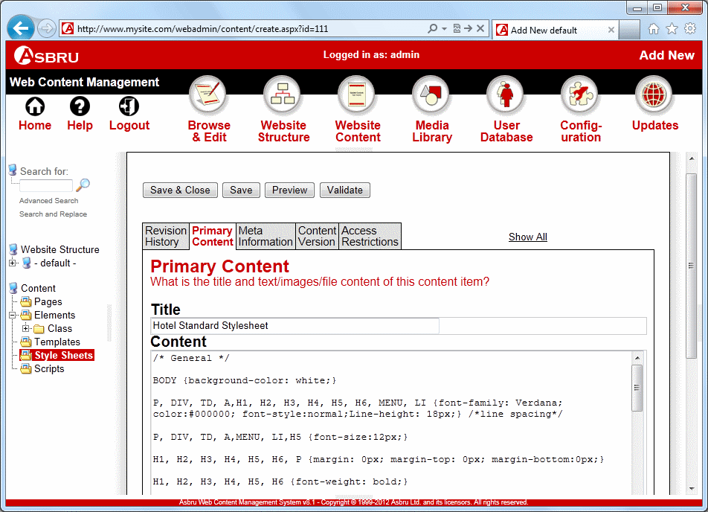       |  |  | Enter a Style Sheet Title.
 |  |  | Add your Style Sheet content in the Content field.
 |  |  | Click Save & Close.

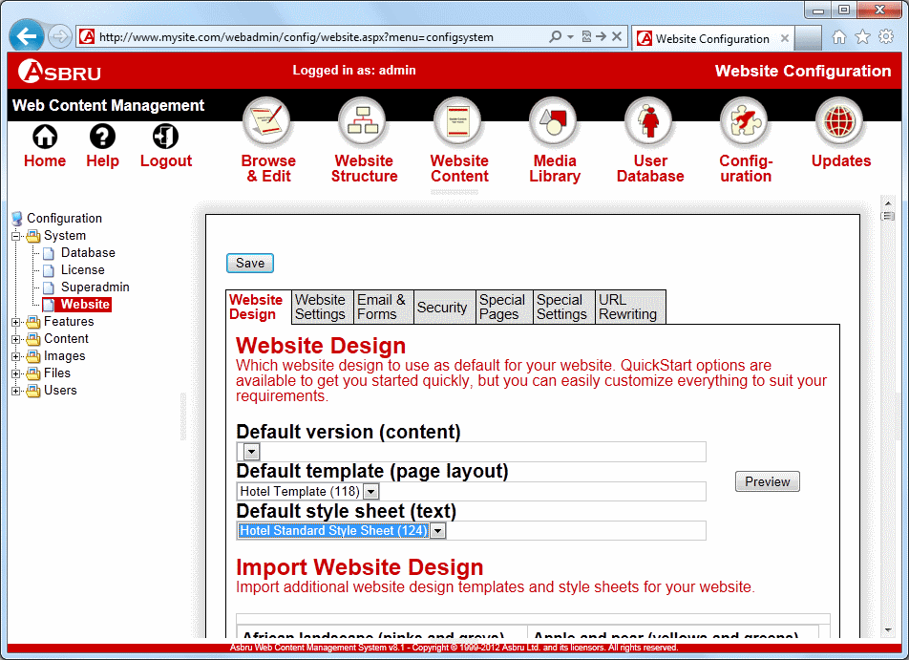         |  | Apply the Style Sheet
 |  | ◆ | Select Configuration in the toolbar.
 |  | ❖ | Click on the plus icon in front of System to expand and select Website in the submenu.
 |  | ⬥ | Select the Style Sheet created in previous steps on the Default style sheet (text) list.
 |  |  | Click Save.

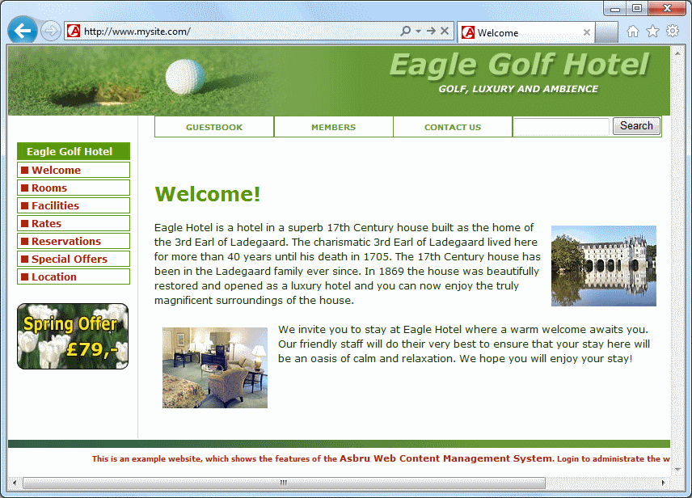 |  |  | After creation of a style sheet your website will look similar to this. As you can see the font and line height as well as other layout features have changed.

