Asbru Ltd.

Asbru Ltd.
www.asbrusoft.com
info@asbrusoft.com

Asbru
Web Content Editor
User Guide
Easily & Inexpensively
Create, Edit & Post Your Website Content

20. October 2008 Version 7.0.19

Copyright and Proprietary Information
Copyright Asbru Ltd 2002–2008. This user guide constitutes proprietary information of Asbru Ltd. No part of this user guide may be reproduced, transmitted, transcribed, stored in a retrieval system or translated into any language in any form, by any means, without the written permission of Asbru Ltd.

Notice
Asbru Ltd. reserves the right to make changes in this user guide at any time and without notice. Asbru Ltd. makes no warranties, express or implied, in this user guide. In no event shall Asbru Ltd. be liable for any indirect, special, incidental or consequential damages arising out of purchase or use of this user guide or the information contained herein.

Licenses and Trademarks
Asbru Web Content Editor and the Asbru logo are trademarks or registered trademarks of Asbru Ltd. in the United Kingdom and other countries. All other company, product, or trade names are trademarks or registered trademarks of their respective holders.
Asbru Web Content Editor includes and uses the wz_dragdrop.js library, Copyright (c) 2002-2003 Walter Zorn (www.walterzorn.com), licensed under the terms of the GNU Lesser General Public License (LGPL) (www.gnu.org/copyleft/lesser.html)
Asbru Web Content Editor includes and uses the wz_jsgraphics.js library, Copyright (c) 2002-2004 Walter Zorn (www.walterzorn.com), licensed under the terms of the GNU Lesser General Public License (LGPL) (www.gnu.org/copyleft/lesser.html)

Asbru Ltd.
Asbru Ltd. provides Internet/Web services, consultancy and solutions for businesses and individuals. Registered in England - Company Registration No. 3865324 - www.asbrusoft.com

Asbru
Web Content Editor
Easily & Inexpensively
Create, Edit & Post Your Website Content

Introduction
This document is the user guide for the Asbru Web Content Editor. The user guide describes how you, the end-user, use the Asbru Web Content Editor to create, edit and post your website content.
The Asbru Web Content Editor is a web solution allowing you easy access to create and edit the content of your websites as well as any web-based applications and services. The system is full-featured but very easy to use and highly flexible.

Table of Contents
Introduction 3
Table of Contents 4
1 Installation and Configuration 7
1.1 System Requirements 7
1.2 Download and Installation 7
1.3 Internationalisation 7
1.3.1 User Language Preferences 8
2 Asbru Web Content Editor 9
2.1 Text Formatting and Style 10
2.1.1 Style 10
2.1.2 Format 11
2.1.3 Font Name 11
2.1.4 Font Size 12
2.1.5 Bold 12
2.1.6 Italic 12
2.1.7 Underline 12
2.1.8 Font Formatting 12
2.1.9 Text Colour 13
2.1.10 Background Colour 14
2.1.11 Superscript 14
2.1.12 Subscript 14
2.1.13 Strikethrough 14
2.1.14 Remove Format 15
2.2 Indentation and Alignment 15
2.2.1 Decrease Indent 15
2.2.2 Indent 15
2.2.3 Align Left 15
2.2.4 Align Center 15
2.2.5 Align Right 15
2.2.6 Align Full 15
2.2.7 Do Not Break 16
2.2.8 Numbered List 16
2.2.9 Bullet List 16
2.3 Editing 16
2.3.1 Cut 16
2.3.2 Copy 16
2.3.3 Paste 17
2.3.4 Clean HTML Code 17
2.3.5 Delete 18
2.3.6 Select All 19
2.3.7 Redo 19
2.3.8 Undo 19
2.4 Web Content 19
2.4.1 Insert Special Characters & Codes 19
2.4.2 Insert Media (Image / Flash / Java Applet) 19
2.4.3 Define Imagemap 22
2.4.4 Insert Link 23
2.4.5 Insert Frame 25
2.4.6 Insert Mail To Link 26
2.4.7 Insert Anchor/ Bookmark 27
2.4.8 Unlink 28
2.4.9 Insert Horizontal Rule 28
2.5 Table Editing 28
2.5.1 Insert Table 28
2.5.2 Table Properties 30
2.5.3 Insert Caption 31
2.5.4 Insert Header Row 31
2.5.5 Insert Footer Row 31
2.5.6 Row Properties 31
2.5.7 Insert Row Above 33
2.5.8 Insert Row Below 33
2.5.9 Delete Row 33
2.5.10 Split Cell Rows 33
2.5.11 Column Properties 33
2.5.12 Insert Column Left 35
2.5.13 Insert Column Right 35
2.5.14 Delete Column 35
2.5.15 Split Cell Columns 35
2.5.16 Cell Properties 35
2.5.17 Insert Cell Left 37
2.5.18 Insert Cell Right 37
2.5.19 Delete Cell 37
2.5.20 Split Cell 37
2.5.21 Merge Cells 38
2.6 Form Editing 38
2.6.1 Insert Form 38
2.6.2 Insert Button 39
2.6.3 Insert File Input 41
2.6.4 Insert Text Input 42
2.6.5 Insert Password Input 43
2.6.6 Insert Hidden Input 44
2.6.7 Insert Text Area Input 45
2.6.8 Insert Checkbox 46
2.6.9 Insert Radio Button 47
2.6.10 Insert Select List 48
2.7 Positioning 50
2.7.1 Absolute Positioning 50
2.7.2 Bring Forwards 50
2.7.3 Send Backwards 50
2.7.4 Bring To Front 51
2.7.5 Send To Back 51
2.7.6 Bring Above Text 51
2.7.7 Send Below Text 51
2.7.8 Insert Box 51
2.8 Special 53
2.8.1 Help 53
2.8.2 Import File 53
2.8.3 Find 53
2.8.4 Insert Print Page Break 54
2.8.5 Print 54
2.8.6 Preview 54
2.8.7 Save / Submit 55
2.8.8 Show Details 55
2.8.9 Show Hidden Details 55
2.8.10 Show HTML 56
2.8.11 Check Spelling 56
2.9 HTML DOM Inspector 58

Installation and Configuration
No installation and configuration of end-user, client-side software is required. The Asbru Web Content Editor is a web application which runs on a website in your standard web browser.

System Requirements
The Asbru Web Content Editor is very flexible in that it runs on most major operating systems and web browsers.

The Asbru Web Content Editor runs on the following website platforms:

Website Platform Component | Supported Products
Operating System | Microsoft Windows  Macintosh  Linux  Unix  (+ other operating systems)
Web Browser  (web content editors) | Microsoft Windows Internet Explorer (v4.0 or newer)  Mozilla (v1.3 or newer)  Mozilla Firefox (v0.7 or newer)  Netscape (v7.1 or newer)  Safari (v2.0.1 or newer)  (+ any standard compliant web browser for standard HTML form textarea content editing)
Web Browser  (web content viewers) | Any standard compliant web browser

Please note that only recent versions of the website platform software are supported by the Asbru Web Content Editor. You should always make sure to keep your website platform software updated to the latest or at least a recent version to avoid functionality and security problems.

Before installing the Asbru Web Content Editor you should make sure that:

- Your operating system and web browser are installed and working correctly.

Download and Installation
The Asbru Web Content Editor is downloaded automatically as part of the web page it is used on. Your web browser must simply be configured to allow Javascript programs (which it should be as default). Your web browser may also need to be configured to allow “cookies” (which it should be as default) for internationalisation support.

Internationalisation
The Asbru Web Content Editor supports internationalisation with translations of all text to other languages than the default (English) and automatic detection of each user’s language preferences. The Asbru Web Content Editor also supports right to left editing for Arabic and Hebrew languages.
Your web browser may need to be configured to allow “cookies” (which it should be as default) for internationalisation support.

User Language Preferences
Each individual user can select the language used by the Asbru Web Content Editor through his/her web browser’s language preferences settings.
In Microsoft Internet Explorer language preferences can be selected through the Tools – Internet Options – General – Languages menu/window. Please see the Microsoft Internet Explorer documentation for details.
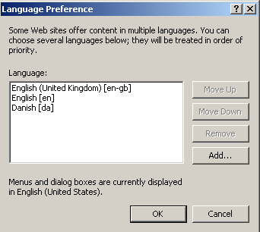
In Mozilla language preferences can be selected through the Edit – Preferences – Navigator – Languages menu/window. Please see the Mozilla documentation for details.
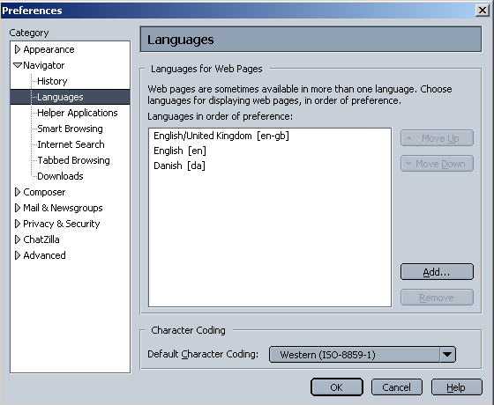
The Asbru Web Content Editor will detect the selected web browser language preferences and use one of the selected languages if available. If none of the selected languages are available the default language will be used.

Asbru Web Content Editor
Due to differences in supported web browser technologies, there are different versions of the Asbru Web Content Editor for different web browsers. Some web editor functionality varies between the different Asbru Web Content Editor versions and some web content editor functionality is not available in all Asbru Web Content Editor versions. See the following sections for details.

As default the Asbru Web Content Editor auto-detects the web browser you are using and automatically selects the best Asbru Web Content Editor version for your web browser.

The Asbru Web Content Editor can be used for creating and editing text, images, hyperlinks or HTML code for your website and web-based applications and databases. The Asbru Web Content Editor screens are displayed below.

Asbru Web Content Editor v1 (for Microsoft Internet Explorer 4.0-5.0):
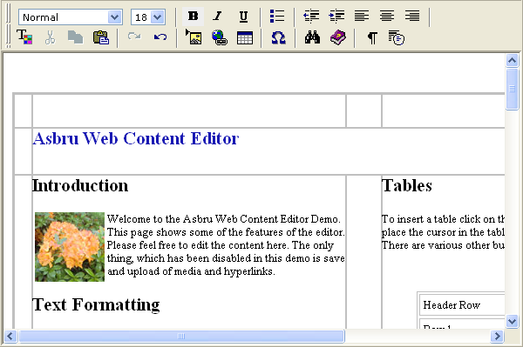

Asbru Web Content Editor v2+ (for Microsoft Internet Explorer v5.5 and newer as well as Netscape 7.1 and Mozilla 1.3 and newer):

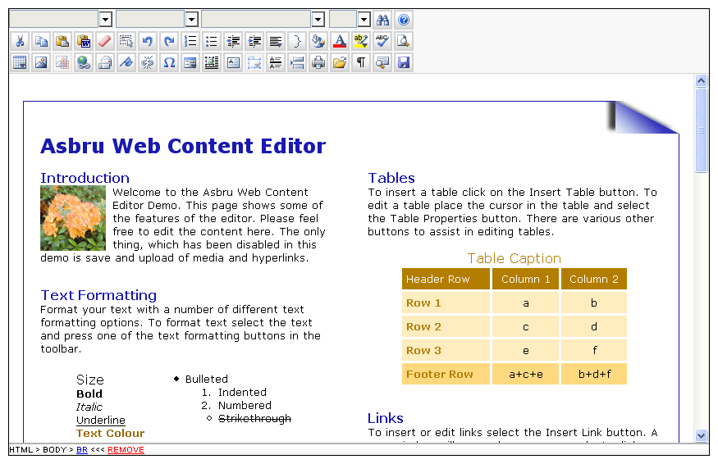

Write text in the work area in the middle and select the toolbar buttons to format the text and insert images, hyperlinks and HTML code. Optionally, the HTML DOM Inspector located below the editable content displays details about the currently selected content. The toolbar buttons and the HTML DOM Inspector are described in the following sections.

Text Formatting and Style

Style
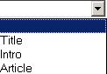
Asbru Web Content Editor v2+ only.

The Asbru Web Content Editor offers support for Cascading Style Sheets. Defined styles/classes are extracted automatically from any Style Sheet assigned to the content.
To apply a style select the text you want to change and then select the style from the Style list in the toolbar. The actual formatting for the styles can be defined in the Style Sheet assigned to the content.

Format
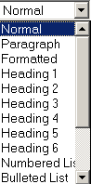

The Asbru Web Content Editor offers standard predefined HTML text formats.
- Normal
- Formatted
- Address
- Heading 1
- Heading 2
- Heading 3
- Heading 4
- Heading 5
- Heading 6
- Numbered List
- Bulleted List
- Directory List
- Menu List
- Definition Term
- Definition
- Paragraph

To apply a format select the text you want to change and then select the format from the Format list in the toolbar. The actual formatting for the format can be defined in the Style Sheet assigned to the content.

Font Name
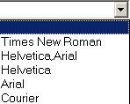

Asbru Web Content Editor v2+ only. See Font Formatting for Asbru Web Content Editor v1.

To change the Font Name select the text you want to change and then select a Font Name from the Font Name list in the toolbar.

Font Size
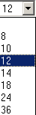

To change the Font Size select the text you want to change and then select a Font Size from the Font Size list in the toolbar.

Bold

To apply bold formatting to text select the text you want to change and then select the Bold toolbar button.

Italic

Apply italic formatting to text by selecting the text you want to change and then select the Italic toolbar button.

Underline

Apply underline formatting to text by selecting the text you want to change and then select the Underline toolbar button.

Font Formatting

Asbru Web Content Editor v1 only. See Text Colour for Asbru Web Content Editor v2+.

The Font toolbar button provides several formatting options that will override the formatting styles defined by your Style and Style Sheet selection. To format text select the text you want to change and then select the Font toolbar button. The following screen will appear:

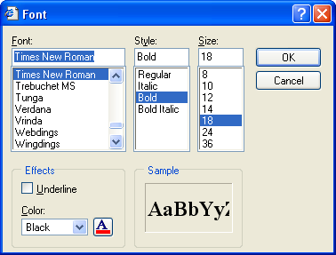

- Font - Select the font you want to apply to the selected text.
- Style - Select the style you want to apply to the selected text.
- Size - Select the Font Size you want to apply to the selected text.
- Underline - If you want to underline the selected text check the Underline checkbox.
- Color - Select the Font Color from the color list or select the button and select the Font Color.

Select OK when the Sample box displays the formatting you want to apply to the selected text or select Cancel.

Text Colour
Asbru Web Content Editor v2+ only.

Apply text colour formatting to text by selecting the text you want to change and then select the Text Colour toolbar button. The following screen will appear:

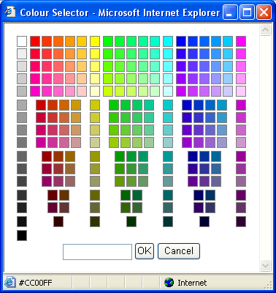

Select a colour from the palette or enter a HTML colour code. Select OK to apply to the selected text or select Cancel.

Background Colour
Asbru Web Content Editor v2+ only.

Apply background colour formatting to text by selecting the text you want to change and then select the Background Colour toolbar button. The following screen will appear:

Select a colour from the palette or enter a HTML colour code. Select OK to apply to the selected text or select Cancel.

Superscript

Asbru Web Content Editor v2+ only.

Apply superscript formatting to text by selecting the text you want to change and then select the Superscript toolbar button.

Subscript

Asbru Web Content Editor v2+ only.

Apply subscript formatting to text by selecting the text you want to change and then select the Subscript toolbar button.

Strikethrough

Asbru Web Content Editor v2+ only.

Apply strikethrough formatting to text by selecting the text you want to change and then select the Strikethrough toolbar button.

Remove Format

Asbru Web Content Editor v2+ only.

Remove formatting from text by selecting the text you want to change and then select the Remove Format toolbar button.

Indentation and Alignment

Decrease Indent

To decrease the indent of a paragraph select the text you want to change and then select the Decrease Indent toolbar button.

Indent

To apply indent to a paragraph select the text you want to change and then select the Indent toolbar button.

Align Left

To align left select the text you want to align left and then select the Align Left toolbar button.

Align Center

To center text select the text you want to center and then select the Align Center toolbar button.

Align Right

To align right select the text you want to align and then select the Align Right toolbar button.

Align Full

Asbru Web Content Editor v2+ only.

To align left and right select the text you want to align and then select the Align Full toolbar button.

Do Not Break

Asbru Web Content Editor v2+ only.

To prevent text from being broken by automatic line breaks select the text you want to keep together and then select the Do Not Break toolbar button.

Numbered List

Asbru Web Content Editor v2+ only.

To apply numbers select the items you want to add numbers to. Then select the Numbered List toolbar button.

Bullet List

To apply bullets select the items you want to add bullets to. Then select the Bullet List toolbar button.

Editing

Cut

To remove selected content from the Asbru Web Content Editor and place it on the clipboard select the Cut toolbar button.

Your web browser may not support this functionality, in which case you will be prompted to use your web browser’s menu/keyboard functionality for this instead.

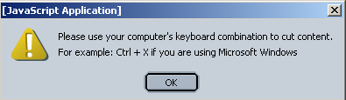

Copy

To copy selected content from the Asbru Web Content Editor and place it on the clipboard select the Copy toolbar button.

Your web browser may not support this functionality, in which case you will be prompted to use your web browser’s menu/keyboard functionality for this instead.

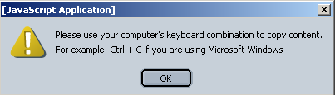

Paste

To paste content from the clipboard into the Asbru Web Content Editor select the Paste toolbar button.

Your web browser may not support this functionality, in which case you will be prompted to use your web browser’s menu/keyboard functionality for this instead.

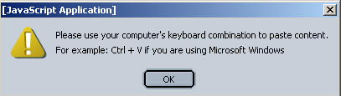

Clean HTML Code
Asbru Web Content Editor v2+ only.

Content pasted from other applications such as Microsoft Word may contain unneeded/unwanted HTML codes. Select the Clean HTML Code toolbar button to clean the content for such unneeded/unwanted HTML codes. The following screen will appear:
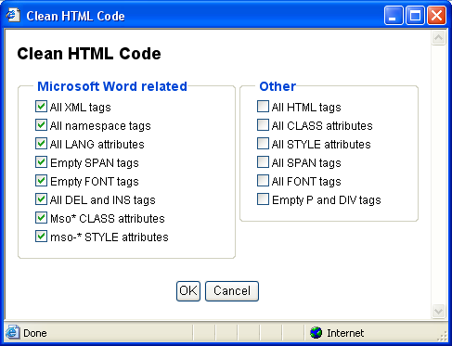
- Microsoft Word related (selected by default and “safe” to clean):
  - All XML tags
Delete all XML tags from content.
  - All namespace tags
Delete all XML namespace tags from content.
  - All LANG attributes
Delete all LANG attributes from content.
  - Empty SPAN tags
Delete empty and double SPAN tags.
  - Empty FONT tags
Delete empty and double FONT tags.
  - All DEL and INS tags
Delete all DEL and INS tags.
  - Mso* CLASS attributes
Delete all CLASS attributes named Mso* from content.
  - mso- STYLE attributes
Delete all STYLE attributes named mso-* from content.

- Other (only select these if you are sure you want to delete these HTML tags and attributes or your content may be altered significantly):
  - All HTML tags
Delete all HTML tags from content.
  - All CLASS attributes
Delete all CLASS attributes from content.
  - All STYLE attributes
Delete all STYLE attributes from content.
  - All SPAN tags
Delete all SPAN tags.
  - All FONT tags
Delete all FONT tags.
  - Empty P and DIV
Delete all empty P and DIV tags.

Select OK to clean the content in the web editor work area.

Delete

Asbru Web Content Editor v2+ only.

To delete content from the Asbru Web Content Editor select the content to be deleted and select the Delete toolbar button.

Select All

Asbru Web Content Editor v2+ only.

To select all content in the Asbru Web Content Editor select the Select All toolbar button.

Redo

Select the Redo toolbar button to reverse an action of the Undo command.

Undo

Select the Undo toolbar button to reverse the last command or delete the last entry you typed.

Web Content

Insert Special Characters & Codes

To insert special characters and codes into the web editor work area select the Insert Special Characters & Codes toolbar button. The following screen will appear:

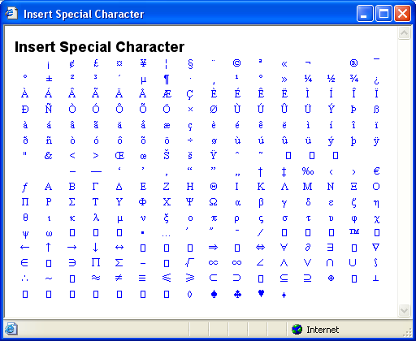

Select the special character you want to insert and the special character will be inserted into the web editor work area.

Insert Media (Image / Flash / Java Applet)

To insert an image (or Flash animation or Java Applet) into the Asbru Web Content Editor select the Insert Media toolbar button. One of the following windows will appear:

Basic dialog window:
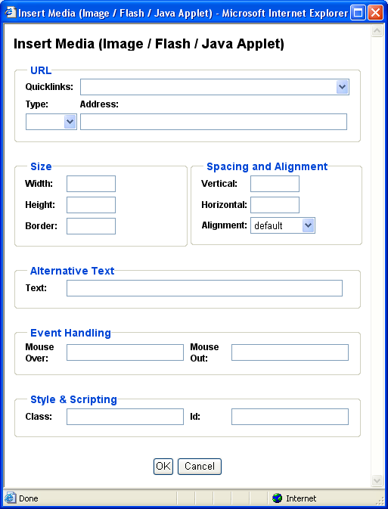
Advanced dialog window:
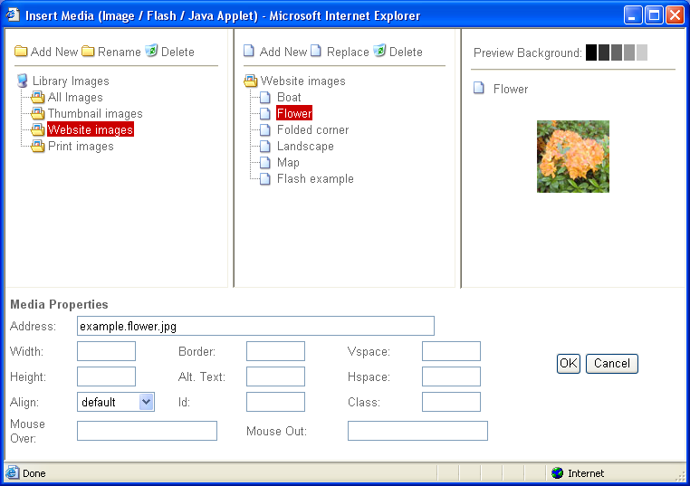

The first window shows the basic media dialog. The second window shows the advanced media manager dialog. Please see the Developers Guide for details on how to configure which dialog window to use.

- Quicklinks
List of pre-defined images, which you can select from.
- URL Type
Type of URL address (“http://”, “https://”).
- URL Address
Web address domain, path and file name.
- Address
Full web address including Type and URL domain, path and file name.
- Width
Number of pixels or percentage for how the image is to be displayed.
- Height
Number of pixels or percentage for how the image is to be displayed.
- Border
Number of pixels for border to be displayed around the image.
- Alignment / Align
Defines the image alignment in relation to surrounding text.
  - Left
  - Right
  - Top
  - Bottom
  - Middle
  - Absmiddle
- Vertical spacing / Vspace
Number of blank pixels to be displayed above and below the image.
- Horizontal spacing / Hspace
Number of blank pixels to be displayed to the left and right of the image.
- Text
Alternative text description to be displayed instead of the image.
- Id
Unique HTML code id for use with Javascript.
- Class
HTML class name for use with CSS style sheet.
- Mouse Over
Javascript event handler triggered when the caret/cursor is moved over the image.
- Mouse Out
Javascript event handler triggered when the caret/cursor is moved away from image.

Select OK to insert the image (or Flash animation or Java Applet) into the Content Editor or select Cancel to return to the Content Editor without inserting the image (or Flash animation or Java Applet) into the Content Editor.

Whether an image, Flash animation or Java Applet is selected and inserted into the Content Editor is detected automatically based on the URL/filename extension where “.swf” identifies a Flash animation and “.class” identifies a Java Applet. All other extensions are handled as an image.

Define Imagemap
To define an imagemap for an image select the image and then the Define Imagemap toolbar button. The following window will appear:

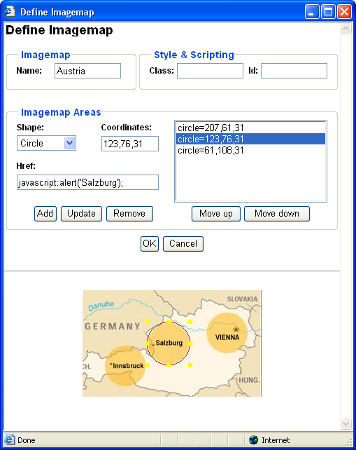

- Name
Name of the imagemap used internally to link the image and the imagemap (required).
- Class
HTML class name for use with CSS style sheet.
- Id
Unique HTML code id for use with Javascript.
- Imagemap Areas
Define the imagemap areas which users can select:
  - Shape
The supported imagemap shapes are circle and rectangle.
  - Coordinates
The coordinates which define the imagemap area position and size (Circle: centerX, centerY, radius) (Rectangle: left, top, right, bottom).
Enter the coordinates manually, or Drag & Drop the imagemap area outline and handles displayed on the image at the bottom of the imagemap window.
  - Href
The web address URL to which the image map area links.
  - Add
Add entered Shape, Coordinates and Href as imagemap area.
  - Update
Change selected imagemap area to entered Shape, Coordinates and Href.
  - Delete
Delete selected imagemap area.
  - Move Up
Move selected imagemap area up.
  - Move Down
Move selected imagemap down.

Select OK to define the imagemap for the selected image in the web editor work area.

Insert Link

Select the Insert Link toolbar button to insert a link into the work area. One of the following windows appears:

Basic dialog window:
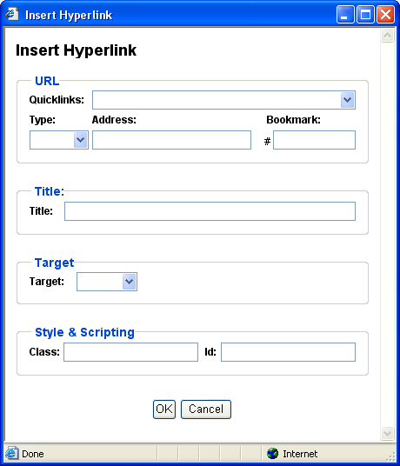

Advanced dialog window:
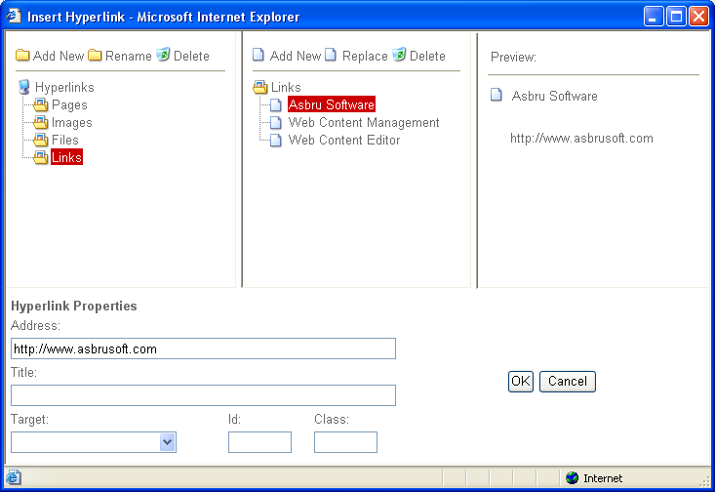

The first window shows the standard hyperlink dialog. The second window shows the advanced hyperlink manager dialog. Please see the Developers Guide for details on how to configure which dialog window to use.

- Quicklinks
List of pre-defined hyperlinks, which you can select from.
- URL Type
Type of URL address (“http://”, “https://”).
- URL Address
Web address domain, path and file name.
- URL Bookmark
Web page bookmark name.
- Address
Full web address including Type, URL and Bookmark
- Title
Hyperlink title which web browsers may display for the link (on mouse over etc).
- Target
Defines how the hyperlink is to be opened.
  - Same Window (_self)
The link will be opened in the current window.
  - Parent Window (_parent)
The link will be opened in the parent window.
  - Browser Window (_top)
The link will be opened on the top level of the window.
  - New Window (_blank)
The link will be opened in a new window.
- Id
Unique HTML code id for use with Javascript.
- Class
HTML class name for use with CSS style sheet.

When you are done, select OK to insert the link into your web editor.

Insert Frame
Asbru Web Content Editor v2+ only.

Select the Insert Frame toolbar button to insert a content frame containing another web page in the work area. The following screen will appear:
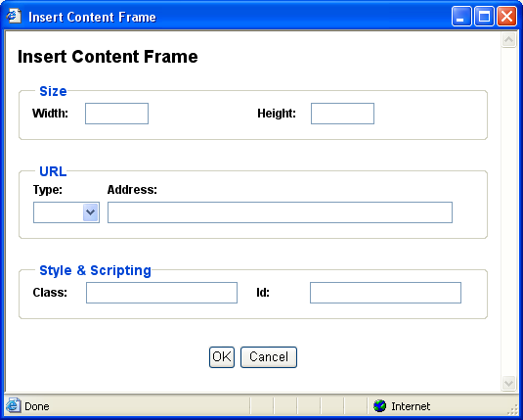
- Width
Enter the width of the box as a percentage (for example “100%”) or in pixels (for example “100” pixels).
- Height
Enter the height of the box as a percentage (for example “100%”) or in pixels (for example “100” pixels.
- URL Type
Type of URL address (“http://”, “https://”).
- URL Address
Web address domain, path and page name.
- Id
Unique HTML code id for use with Javascript.
- Class
HTML class name for use with CSS style sheet.

Select OK to insert the content frame into the web editor work area.

Insert Mail To Link

Asbru Web Content Editor v2+ only.

Select the Insert Mail To Link toolbar button to insert a link into the work area. The following screen will appear:

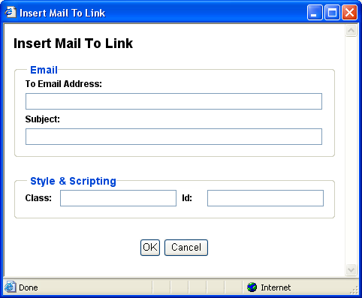

- To Email Address
Default email address to which the email should be sent.
- Subject
Default subject for the email to be sent.
- Id
Unique HTML code id for use with Javascript.
- Class
HTML class name for use with CSS style sheet.

When you are done, select OK to insert the link into your web editor.

Insert Anchor/ Bookmark

Asbru Web Content Editor v2+ only.

Select the Insert Anchor / Bookmark toolbar button to insert an anchor/bookmark into the work area. The following screen will appear:

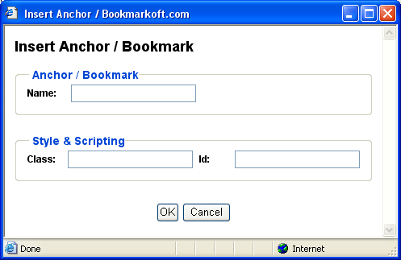

- Name
Name of the anchor/bookmark.
- Id
Unique HTML code id for use with JavaScript.
- Class
HTML class name for use with CSS style sheet.

When you are done, select OK to insert the anchor/bookmark into your web editor.

Unlink

Asbru Web Content Editor v2+ only.

To remove a link (without deleting the content) select the link and select the Unlink toolbar button.

Insert Horizontal Rule

Asbru Web Content Editor v2+ only.

To insert a horizontal rule select the Insert Horizontal Rule toolbar button.

Table Editing

Insert Table

Select the Insert Table toolbar button to insert a table in the work area. The following screen will appear:

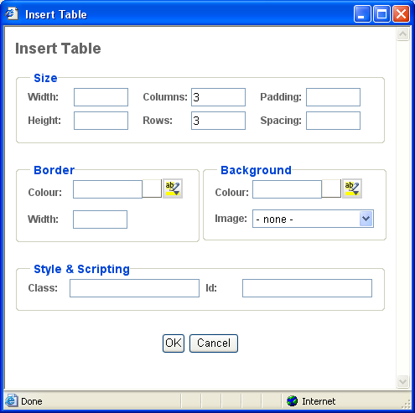

- Width
Enter the width of the table as a percentage (for example “100%”) or in pixels (for example “100” pixels). You can leave the field blank and the browser will determine the width.
- Height
Enter the height of the table as a percentage (for example “100%”) or in pixels (for example “100” pixels. You can leave the field blank and the browser will determine the height.
- Columns
Enter the number of columns in the table.
- Rows
Enter the number of rows in the table.
- Cell padding
Enter the distance between the border and content of the table in pixels (for example “2” pixels). You can leave the field blank and the browser will determine the cell padding.
- Cell spacing
Enter the distance between the cells in pixels (for example “2” pixels). You can leave the field blank and the browser will determine the cell spacing.
- Border Width
Select the border width of the table in pixels from the list. If you select 0 there will be no border. If you select “- default -“ the browser will determine the border width.
- Border Colour
Enter the border colour as an html colour name or as an html colour code. The actual colour is displayed in the square next to the input field. Select the colour square for access to the colour selector.
- Background Colour
Enter the background colour as an html colour name or as an html colour code. The actual colour is displayed in the square next to the input field. Select the colour square for access to the colour selector.
- Background Image
In the Background image section of the screen select “- none -“ if no background image is required or select a background image from the list of background images.
- Id
Unique HTML code id for use with Javascript.
- Class
HTML class name for use with CSS style sheet.

When all the details for the table have been entered, select OK to insert the table into the content editor.

Table Properties

Asbru Web Content Editor v2+ only.

Select or position the claret/cursor inside a table and select the Table Properties toolbar button to edit the table’s properties. The following screen will appear:

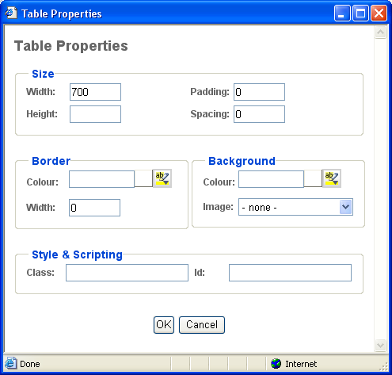

- Width
Enter the width of the table as a percentage (for example “100%”) or in pixels (for example “100” pixels). You can leave the field blank and the web browser will determine the width.
- Height
Enter the height of the table as a percentage (for example “100%”) or in pixels (for example “100” pixels. You can leave the field blank and the web browser will determine the height.
- Cell padding
Enter the distance between the border and content of the table in pixels (for example “2” pixels). You can leave the field blank and the browser will determine the cell padding.
- Cell spacing
Enter the distance between the cells in pixels (for example “2” pixels). You can leave the field blank and the browser will determine the cell spacing.
- Border Width
Enter the border width of the table in pixels. If you enter 0 there will be no border. If you leave it blank the browser will determine the border width.

- Border Colour
Enter the border colour as an html colour name or as an html colour code. The actual colour is displayed in the square next to the input field. Select the colour square for access to the colour selector.
- Background Colour
Enter the background colour as an html colour name or as an html colour code. The actual colour is displayed in the square next to the input field. Select the colour square for access to the colour selector.
- Background Image
In the Background image section of the screen select “- none -“ if no background image is required or select a background image from the list of background images.
- Id
Unique HTML code id for use with Javascript.
- Class
HTML class name for use with CSS style sheet.

When all the details for the table have been entered, select OK to update the table in the content editor.

Insert Caption

Asbru Web Content Editor v2+ only.

Select or position the claret/cursor inside a table and select the Insert Caption toolbar button to insert a caption for the table. As default the caption is displayed above the table.

Insert Header Row

Asbru Web Content Editor v2+ only.

Select or position the claret/cursor inside a table and select the Insert Header Row toolbar button to insert a new table header row at the top of the table.

Insert Footer Row

Asbru Web Content Editor v2+ only.

Select or position the claret/cursor inside a table and select the Insert Footer Row toolbar button to insert a new table footer row at the bottom of the table.

Row Properties

Asbru Web Content Editor v2+ only.

Select or position the claret/cursor inside a table row and select the Row Properties toolbar button to edit the row’s properties. The following screen will appear:

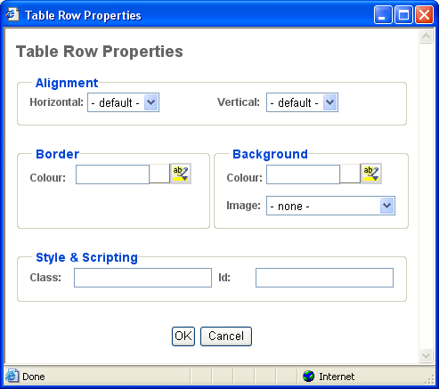

- Horizontal Alignment
Select default, left, center or right to horizontally align the row’s cell’s contents. This row alignment is overruled by any defined column and cell horizontal alignment.
- Vertical Alignment
Select default, top, middle, baseline or bottom to vertically align the row’s cell’s contents. This row alignment is overruled by any defined column and cell vertical alignment.
- Border Colour
Enter the border colour as an html colour name or as an html colour code. The actual colour is displayed in the square next to the input field. Select the colour square for access to the colour selector.
- Background Colour
Enter the background colour as an html colour name or as an html colour code. The actual colour is displayed in the square next to the input field. Select the colour square for access to the colour selector.
- Background Image
In the Background image section of the screen select “- none -“ if no background image is required or select a background image from the list of background images.
- Id
Unique HTML code id for use with Javascript.
- Class
HTML class name for use with CSS style sheet.

When all the details for the table row have been entered, select OK to update the table row in the content editor.

Insert Row Above

Asbru Web Content Editor v2+ only.

Select or position the claret/cursor inside a table row and select the Insert Row Above toolbar button to insert a new row above the selected row.

Insert Row Below

Asbru Web Content Editor v2+ only.

Select or position the claret/cursor inside a table row and select the Insert Row Below toolbar button to insert a new row below the selected row.

Delete Row

Asbru Web Content Editor v2+ only.

Select or position the claret/cursor inside a table row and select the Delete Row toolbar button to delete the selected row.

Split Cell Rows

Asbru Web Content Editor v2+ only.

Position the claret/cursor inside a merged table cell and select the Split Cell Rows toolbar button to split the cell back into rows again.

Column Properties

Asbru Web Content Editor v2+ only.

Position the claret/cursor inside a table cell and select the Column Properties toolbar button to edit the column’s properties. The following screen will appear:

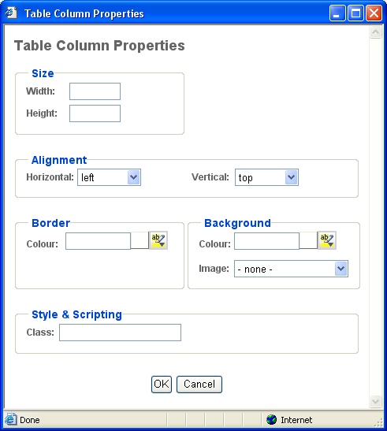

- Width
Enter the width of the column as a percentage (for example “100%”) or in pixels (for example “100” pixels). You can leave the field blank and the web browser will determine the width.
- Height
Enter the height of the column as a percentage (for example “100%”) or in pixels (for example “100” pixels. You can leave the field blank and the web browser will determine the height.

- Horizontal Alignment
Select default, left, center or right to horizontally align the column’s cell’s contents. This column alignment overrules/overwrites any defined row/cell horizontal alignment.
- Vertical Alignment
Select default, top, middle, baseline or bottom to vertically align the column’s cell’s contents. This column alignment overrules/overwrites any defined row/cell vertical alignment.
- Border Colour
Enter the border colour as an html colour name or as an html colour code. The actual colour is displayed in the square next to the input field. Select the colour square for access to the colour selector.
- Background Colour
Enter the background colour as an html colour name or as an html colour code. The actual colour is displayed in the square next to the input field. Select the colour square for access to the colour selector.
- Background Image
In the Background image section of the screen select “- none -“ if no background image is required or select a background image from the list of background images.

- Class
HTML class name for use with CSS style sheet.

When all the details for the table column have been entered, select OK to update the table column in the content editor.

Insert Column Left

Asbru Web Content Editor v2+ only.

Position the claret/cursor inside a table cell and select the Insert Column Left toolbar button to insert a new column to the left of the selected column.

Insert Column Right

Asbru Web Content Editor v2+ only.

Position the claret/cursor inside a table cell and select the Insert Column Right toolbar button to insert a new column to the right of the selected column.

Delete Column

Asbru Web Content Editor v2+ only.

Position the claret/cursor inside a table cell and select the Delete Column toolbar button to delete the selected column.

Split Cell Columns

Asbru Web Content Editor v2+ only.

Position the claret/cursor inside a merged table cell and select the Split Cell Columns toolbar button to split the cell back into columns again.

Cell Properties

Asbru Web Content Editor v2+ only.

Position the claret/cursor inside a table cell and select the Cell Properties toolbar button to edit the cell’s properties. The following screen will appear:

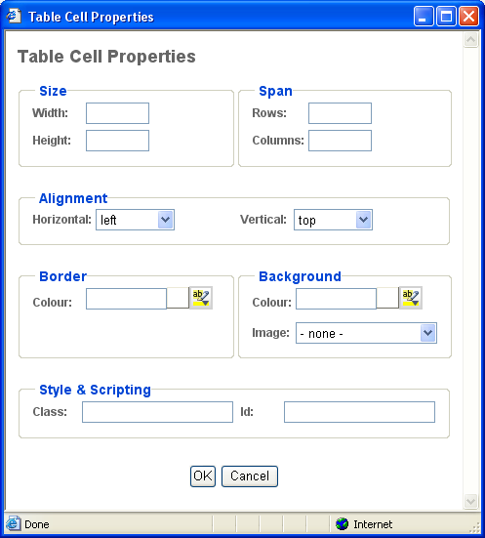

- Width
Enter the width of the cell as a percentage (for example “100%”) or in pixels (for example “100” pixels). You can leave the field blank and the web browser will determine the width.
- Height
Enter the height of the cell as a percentage (for example “100%”) or in pixels (for example “100” pixels. You can leave the field blank and the web browser will determine the height.
- Span Rows
Enter the number of rows the (merged) cell spans. Changing this row span will not actually merge/split the cell, but only change how it is displayed.
- Span Columns
Enter the number of columns the (merged) cell spans. Changing this column span will not actually merge/split the cell, but only change how it is displayed.

- Horizontal Alignment
Select default, left, center or right to horizontally align the cell’s contents. This cell alignment overrules/overwrites any defined row/column horizontal alignment.
- Vertical Alignment
Select default, top, middle, baseline or bottom to vertically align the cell’s contents. This cell alignment overrules/overwrites any defined row/column vertical alignment.

- Border Colour
Enter the border colour as an html colour name or as an html colour code. The actual colour is displayed in the square next to the input field. Select the colour square for access to the colour selector.
- Background Colour
Enter the background colour as an html colour name or as an html colour code. The actual colour is displayed in the square next to the input field. Select the colour square for access to the colour selector.
- Background Image
In the Background image section of the screen select “- none -“ if no background image is required or select a background image from the list of background images.

- Id
Unique HTML code id for use with Javascript.
- Class
HTML class name for use with CSS style sheet.

When all the details for the table cell have been entered, select OK to update the table cell in the content editor.

Insert Cell Left

Asbru Web Content Editor v2+ only.

Position the claret/cursor inside a table cell and select the Insert Cell Left toolbar button to insert a new cell to the left of the selected cell.

Insert Cell Right

Asbru Web Content Editor v2+ only.

Position the claret/cursor inside a table cell and select the Insert Cell Right toolbar button to insert a new cell to the right of the selected cell.

Delete Cell

Asbru Web Content Editor v2+ only.

Position the claret/cursor inside a table cell and select the Delete Cell toolbar button to delete the selected cell.

Split Cell

Asbru Web Content Editor v2+ only.

Position the claret/cursor inside a merged table cell and select the Split Cell toolbar button to split the cell back into rows and columns again.

Merge Cells

Asbru Web Content Editor v2+ only.

Select a number of table cells across rows and/or columns and select the Merge Cells toolbar button to merge the cells into a single cell.

Your web browser may not support selection of cells across rows properly as a square of selected cells. Some additional cells to the left and right of the intended square of cells selection may be selected as well. The Asbru Web Content Editor adjusts this non-square cell selection by ignoring any selected cells outside the square of selected cells defined by the top-left and the bottom-right selected cells.

Form Editing

Insert Form

Asbru Web Content Editor v2+ only.

Select the Insert Form toolbar button to insert a form in the work area. The following screen will appear:

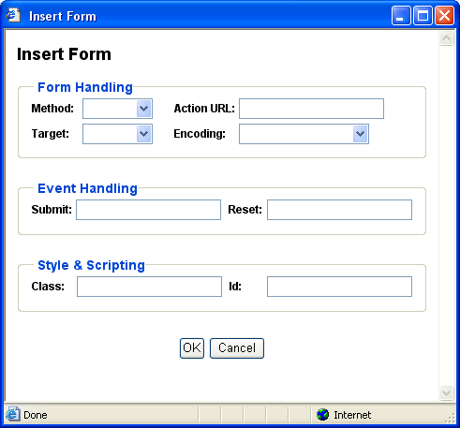

- Method
Method used to submit form data to the web server. GET (default) submits data as part of the URL web address. POST submits data as attachments and is required for file upload and larger amounts of data.
- Action URL
Website address to which the form data is submitted.
- Encoding
Encoding format for form data when submitted to the web server. The default encoding is “URL encoded”. “Multi-part form-data” encoding is required for file upload.
- Target
Defines how the submitted form is to be opened.
  - Same Window (_self)
The form will be opened in the current window.
  - Parent Window (_parent)
The form will be opened in the parent window.
  - Browser Window (_top)
The form will be opened on the top level of the window.
  - New Window (_blank)
The form will be opened in a new window.
- Submit
Javascript event handler triggered when the form is submitted.
- Reset
Javascript event handler triggered when the form is reset.
- Id
Unique HTML code id for use with Javascript.
- Class
HTML class name for use with CSS style sheet.

Select OK to insert the form into the web editor work area.

Insert Button

Asbru Web Content Editor v2+ only.

Select one of the Insert Button toolbar buttons to insert a button of that type in the work area. The following screen will appear:

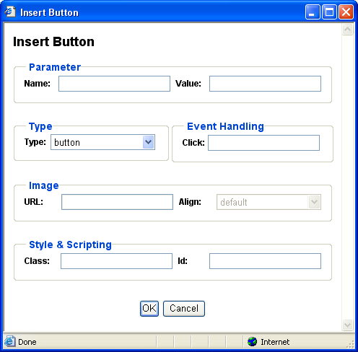

- Name
Name of parameter submitted to the web server.
- Value
Value of parameter submitted to the web server.
- Type
Type of button to be inserted:
  - Submit
Submits the form to the web server.
  - Button
Does not do anything unless used with Javascript event handler.
  - Reset
Resets the form to the default values.
  - Image
Submits the form to the web server.
- Click
Javascript event handler triggered when the button is clicked.
- Image URL
Website address for image to be used for image button.
- Image Align
Alignment of image in relation to surrounding text.
- Id
Unique HTML code id for use with Javascript.
- Class
HTML class name for use with CSS style sheet.

Select OK to insert the button into the web editor work area.

Insert File Input

Asbru Web Content Editor v2+ only.

Select the Insert File Input toolbar button to insert a file selector button for file upload to the web server in the work area. The following screen will appear:

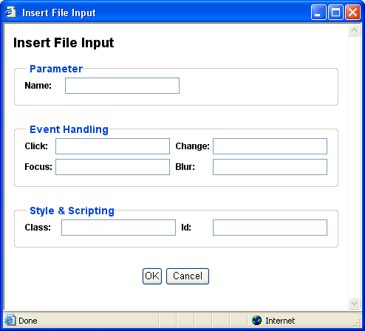

- Name
Name of parameter submitted to the web server.
- Value
Default value of parameter submitted to the web server.
- Click
Javascript event handler triggered when the file input field/button is clicked.
- Change
Javascript event handler triggered when the file input is changed.
- Focus
Javascript event handler triggered when the file input is focused.
- Blur
Javascript event handler triggered when focus is removed from the file input.
- Id
Unique HTML code id for use with Javascript.
- Class
HTML class name for use with CSS style sheet.

Select OK to insert the file input field/button into the web editor work area.

Insert Text Input

Asbru Web Content Editor v2+ only.

Select the Insert Text Input toolbar button to insert a text input field in the work area. The following screen will appear:

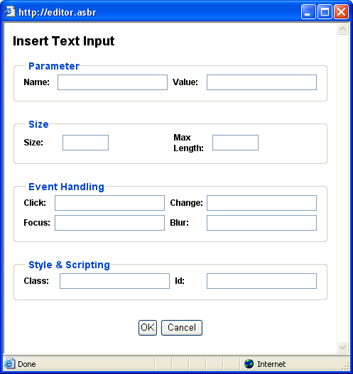

- Name
Name of parameter submitted to the web server.
- Value
Default value of parameter submitted to the web server.
- Size
Display size of input field.
- Max Length
Maximum number of characters to be entered into the input field.
- Click
Javascript event handler triggered when the input field is clicked.
- Change
Javascript event handler triggered when the input field is changed.
- Focus
Javascript event handler triggered when the input field is focused.
- Blur
Javascript event handler triggered when focus is removed from the input field.
- Id
Unique HTML code id for use with Javascript.
- Class
HTML class name for use with CSS style sheet.

Select OK to insert the input field into the web editor work area.

Insert Password Input

Asbru Web Content Editor v2+ only.

Select the Insert Password Input toolbar button to insert a password input field in the work area. The following screen will appear:

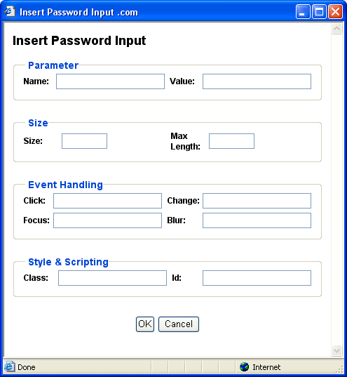

- Name
Name of parameter submitted to the web server.
- Value
Default value of parameter submitted to the web server.
- Size
Display size of input field.
- Max Length
Maximum number of characters to be entered into the input field.
- Click
Javascript event handler triggered when the input field is clicked.
- Change
Javascript event handler triggered when the input field is changed.
- Focus
Javascript event handler triggered when the input field is focused.
- Blur
Javascript event handler triggered when focus is removed from the input field.
- Id
Unique HTML code id for use with Javascript.
- Class
HTML class name for use with CSS style sheet.

Select OK to insert the input field into the web editor work area.

Insert Hidden Input

Asbru Web Content Editor v2+ only.

Select the Insert Hidden Input toolbar button to insert a hidden input field in the work area. The following screen will appear:

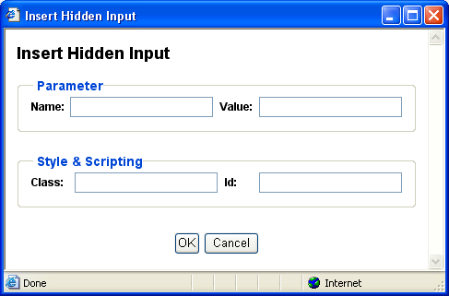

- Name
Name of parameter submitted to the web server.
- Value
Default value of parameter submitted to the web server.
- Id
Unique HTML code id for use with Javascript.
- Class
HTML class name for use with CSS style sheet.

Select OK to insert the input field into the web editor work area.

Insert Text Area Input

Asbru Web Content Editor v2+ only.

Select the Insert Text Area Input toolbar button to insert a text area input field in the work area. The following screen will appear:

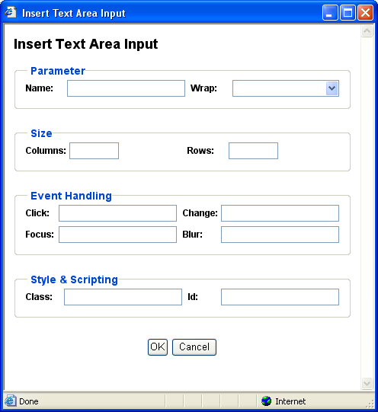

- Name
Name of parameter submitted to the web server.
- Wrap
Defines if and how content entered into the text area input should be word wrapped with automatic insertion of line breaks:
  - Off
Do not wrap.
  - Soft / Virtual
Display automatic word wrapping but do not submit automatic word wrapping to the web server.
  - Hard / Physical
Display and submit automatic word wrapping to the web server.
- Columns
Width of the input field.
- Rows
Height the input field.
- Click
Javascript event handler triggered when the input field is clicked.
- Change
Javascript event handler triggered when the input field is changed.
- Focus
Javascript event handler triggered when the input field is focused.
- Blur
Javascript event handler triggered when focus is removed from the input field.
- Id
Unique HTML code id for use with Javascript.
- Class
HTML class name for use with CSS style sheet.

Select OK to insert the input field into the web editor work area.

Insert Checkbox

Asbru Web Content Editor v2+ only.

Select the Insert Checkbox toolbar button to insert a checkbox input field in the work area. The following screen will appear:

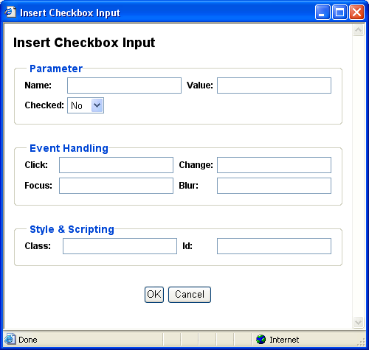

- Name
Name of parameter submitted to the web server.
- Value
Default value of parameter submitted to the web server.
- Checked
Default state of input field.
- Click
Javascript event handler triggered when the input field is clicked.
- Change
Javascript event handler triggered when the input field is changed.
- Focus
Javascript event handler triggered when the input field is focused.
- Blur
Javascript event handler triggered when focus is removed from the input field.
- Id
Unique HTML code id for use with Javascript.
- Class
HTML class name for use with CSS style sheet.

Select OK to insert the input field into the web editor work area.

Insert Radio Button

Asbru Web Content Editor v2+ only.

Select the Insert Radio Button toolbar button to insert a radio button input field in the work area. The following screen will appear:

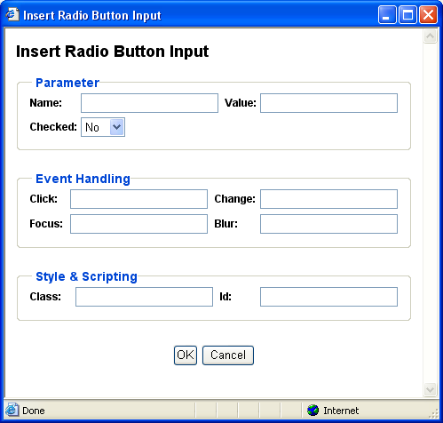

- Name
Name of parameter submitted to the web server.
- Value
Default value of parameter submitted to the web server.
- Checked
Default state of input field.
- Click
Javascript event handler triggered when the input field is clicked.
- Change
Javascript event handler triggered when the input field is changed.
- Focus
Javascript event handler triggered when the input field is focused.
- Blur
Javascript event handler triggered when focus is removed from the input field.
- Id
Unique HTML code id for use with Javascript.
- Class
HTML class name for use with CSS style sheet.

Select OK to insert the input field into the web editor work area.

Insert Select List

Asbru Web Content Editor v2+ only.

Select the Insert Select List toolbar button to insert a select list input field in the work area. The following screen will appear:

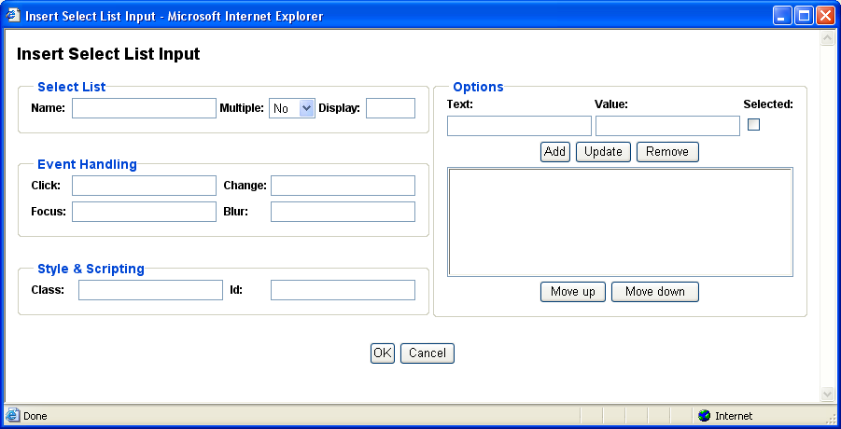

- Name
Name of parameter submitted to the web server.
- Multiple
Define if users can select multiple options or only a single option.
- Display
Number of options to be displayed (default 1).
- Options
Define the options which users can select from:
  - Text
Label to be displayed for option.
  - Value
Value submitted to the web server if selected.
  - Selected
Define if option should be selected as default.
  - Add
Add entered Text and Value as option.
  - Update
Change selected option to entered Text and Value
  - Delete
Delete selected option.
  - Move Up
Move selected option up.
  - Move Down
Move selected option down.
- Click
Javascript event handler triggered when the input field is clicked.
- Change
Javascript event handler triggered when the input field is changed.
- Focus
Javascript event handler triggered when the input field is focused.
- Blur
Javascript event handler triggered when focus is removed from the input field.
- Id
Unique HTML code id for use with Javascript.
- Class
HTML class name for use with CSS style sheet.

Select OK to insert the input field into the web editor work area.

Positioning

Absolute Positioning
Asbru Web Content Editor v2+ only.

Select a positionable content element or place the caret/cursor inside a positionable content element and select the Absolute Positioning toolbar button to toggle absolute positioning for the selected content element.
Positionable content elements include images, tables, P and DIV tags, IFRAMEs, form input fields and OBJECTs (Flash and Java applets).

Bring Forwards
Asbru Web Content Editor v2+ only.

Bring the currently selected absolute positioning enabled content element further forwards in front of other absolute positioning content elements.

Send Backwards
Asbru Web Content Editor v2+ only.

Send the currently selected absolute positioning enabled content element further backwards behind of other absolute positioning content elements.

Bring To Front
Asbru Web Content Editor v2+ only.

Bring the currently selected absolute positioning enabled content element in front of all other absolute positioning content elements.

Send To Back
Asbru Web Content Editor v2+ only.

Send the currently selected absolute positioning enabled content element behind of all other absolute positioning content elements.

Bring Above Text
Asbru Web Content Editor v2+ only.

Bring the currently selected absolute positioning enabled content element in front of the general page content.
Microsoft Internet Explorer for Windows only. Mozilla/Netscape content is always above text or invisible.

Send Below Text
Asbru Web Content Editor v2+ only.

Send the currently selected absolute positioning enabled content element behind of the general page content.
Microsoft Internet Explorer for Windows only. Mozilla/Netscape content is always above text or invisible.

Insert Box
Asbru Web Content Editor v2+ only.

Select the Insert Box toolbar button to insert an absolute positioning content box in the work area. The following screen will appear:

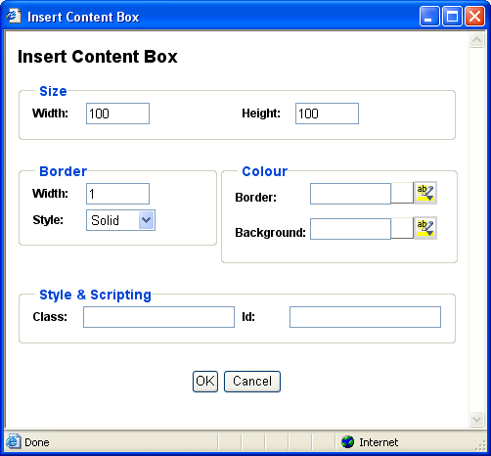

- Width
Enter the width of the box as a percentage (for example “100%”) or in pixels (for example “100” pixels).
- Height
Enter the height of the box as a percentage (for example “100%”) or in pixels (for example “100” pixels.
- Border Width
Enter the border width in pixels. If you enter 0 there will be no border. If you leave it blank the browser will determine the border width.

- Border Style
Select the border style to be used for the box.

- Border Colour
Enter the border colour as an html colour name or as an html colour code. The actual colour is displayed in the square next to the input field. Select the colour square for access to the colour selector.
- Background Colour
Enter the background colour as an html colour name or as an html colour code. The actual colour is displayed in the square next to the input field. Select the colour square for access to the colour selector.
- Id
Unique HTML code id for use with Javascript.
- Class
HTML class name for use with CSS style sheet.

Select OK to insert the content box into the web editor work area.

Special

Help

Select the Help toolbar button when you need help and a help screen will open.

Import File
Asbru Web Content Editor v2+ only.

Select the Import File toolbar button to upload and import a text or HTML format file from your local computer to the web editor work area. The imported file will replace the current content in the web editor work area.
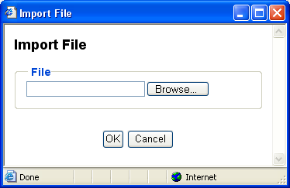

Find

To search for characters in the work area select the Find toolbar button. The following sub-session will appear. Type the characters in the Find what field and select additional search criteria.

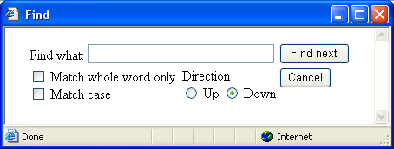

Select the Find Next button to search the work area or select Cancel.

Your web browser may not support this functionality, in which case you will be prompted to use your web browser’s menu/keyboard functionality for this instead.

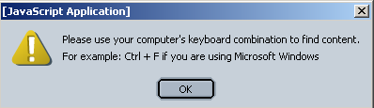

Insert Print Page Break

Asbru Web Content Editor v2+ only.

Position the claret/cursor where you want to define a page break (when the content is printed) and select the Insert Print Page Break button to insert a (hidden) print page break code into the web editor work area.

Print

Asbru Web Content Editor v2+ only.

To print the content in the work area select the Print toolbar button. This will open your web browser’s Print dialog window. Please see your web browser and operating system documentation for details on the Print dialog window.

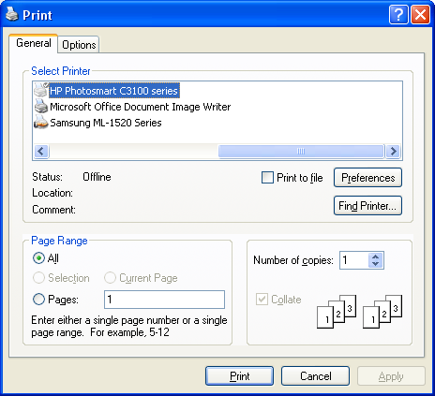

Preview

Asbru Web Content Editor v2+ only.

To preview the content in the work area select the Preview toolbar button. This will open a new web browser window with the content from the web editor work area.

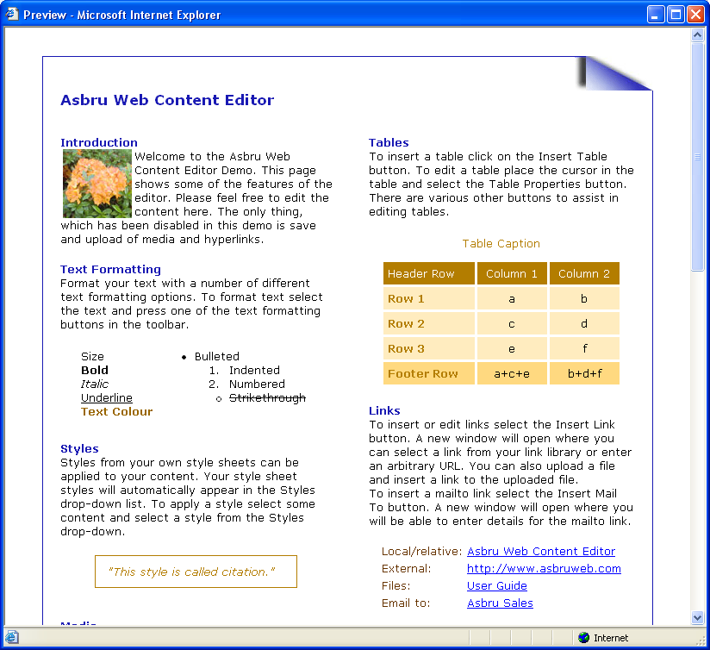

Save / Submit

Asbru Web Content Editor v2+ only.

To save the content in the work area, select the Save toolbar button. This will submit the web page form, which the web editor work area is part of, to the web server.

Show Details

Asbru Web Content Editor v1 only.

Select the Show Details toolbar button to see formatting marks and hidden text.

Show Hidden Details

Asbru Web Content Editor v2+ only.

Select the Show WYSIWYG / Plain toolbar button to see toggle between displaying the content in WYSIWYG (What-You-See-Is-What-You-Get) and Plain modes.

- WYSIWYG mode - displays content (approximately) as it will be displayed on your websites including application of Style Sheet formatting.
- Plain mode – displays content with table border, image and form outlines and without application of Style Sheet formatting.

Show HTML

Select the Show HTML toolbar button to see and edit the content as HTML code in the work area.

Check Spelling

Asbru Web Content Editor v2+ only.

Select the Check Spelling toolbar button to check the spelling of the content in the currently selected web content editor input field. This will open a new web browser window.
Depending on how your system has been configured, you may have access to select which dictionary to use for the spell checking. Alternatively, your system may have been configured to always use a specific dictionary.
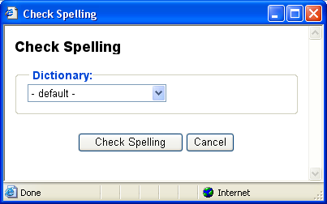
Spell checking your web content may take a little while depending on the size of your content and the size of the dictionary used for the spell checking.
When you web content has been spell checked any identified misspellings would be displayed with a number of suggestions for corrections. Please note that any identified misspellings and suggestions may be wrong. You should never simply accept all spell checking suggestions.
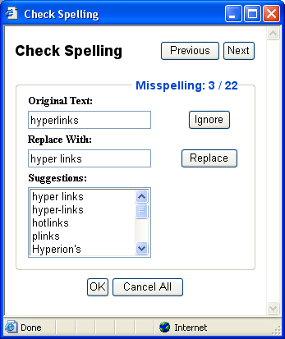
The total number of identified misspellings and details of the currently select misspelling are displayed.
- Previous
Displays the details of the previous identified misspelling.
- Next
Displays the details of the next identified misspelling.
The misspelling is also highlighted and focused in the web content editor input field if possible – i.e. if the misspelling is not in hidden text in the web content.
A number of suggestions for replacements of the original text may be listed. As default the best suggestion is selected automatically or you can select any of the other listed suggestions or enter your own correction manually.
- Ignore
Skips the current misspelling without making any changes to your web content and displays the next misspelling.
- Replace
Replaces the identified misspelling in your web content with the selected/entered correction and displays the next misspelling.
When done with the spell checking please select “OK” or “Cancel” to return to the web content editor input field.
- OK
Applies your spell checking corrections to your web content.
- Cancel All
Undo all your spell checking corrections.
Please note that you should not simply close the spell checking window as this may leave some of your web content highlighted.

HTML DOM Inspector
Asbru Web Content Editor v2+ only.

Optionally, a HTML DOM Inspector may be displayed below your editable web content.

The HTML DOM Inspector displays the hierarchy of HTML codes the currently selected content is located within. The HTML attributes of the innermost surrounding HTML code are also displayed. In the example graphic above, the currently selected content is enclosed by a FONT code with the attribute “size=4”, which in turn is enclosed by a STRONG code etc.

Each of the displayed surrounding HTML codes may be clicked to make that content block the currently selected content in the web content editor. In the example graphic above, the TABLE link may be clicked to make the entire table the currently selected content.

The HTML DOM Inspector may also display a “REMOVE” link, which deletes the innermost HTML code surrounding the currently selected content. In the example graphic above, “REMOVE” will delete the FONT code, which encloses the currently selected content.

