Web Services Contract First
WSCF v1 Walkthrough
A guided tour around the WSCF toolset.
17-09-10
Document Version
Version | Date | Description
1.0 | 17/09/2010 | WSCFblue 1.0.10. Written for VS 2008 but the same also applies to VS2010.
Table of Contents
Introduction 3
Objectives 3
Schema-First Development 3
Scenario Overview 4
Artifacts Provided 4
Organizing the Visual Studio 2008 Solution 5
Modeling Data and Messages 6
Modeling Data 6
Modeling Messages 8
Modeling the Interface Contract 9
Code Generation 16
Deploying/Distributing the Contract Metadata 16
Service-side Code Generation 17
Code Style Options 18
Service Behavior Options 21
Service Method Implementation 22
Files and Namespaces 25
Final Output 25
Service Configuration Generation 25
Client-side Code Generation 26
Data Contract Generation 27
Iterating the Contract and Code 28
Summary 28

Introduction
WSCFBlue is a toolset that facilitates the development of web services using a contract first (specifically, a schema first) approach. This document is a walkthrough of the main features of the toolset. To understand more about schema first development and how it compares to code-first development, please refer to this MSDN Magazine article.

Objectives
In this walkthrough, you will learn:
  - The steps involved in Schema First Development
  - How to model your data
  - How to model your messages
  - How to model your interface (build a WSDL from a set of XSD files)
  - How to use advanced options such as Fault Contracts as part of your interface
  - How to generate a service side stub from the WSDL
  - How to generate client ‘proxies’ from a WSDL
  - How to work with the auto-generated code and fill out your implementation
  - How to generate data contracts from a WSDL

Schema-First Development
The schema-first approach has five discrete steps as depicted in the following figure.
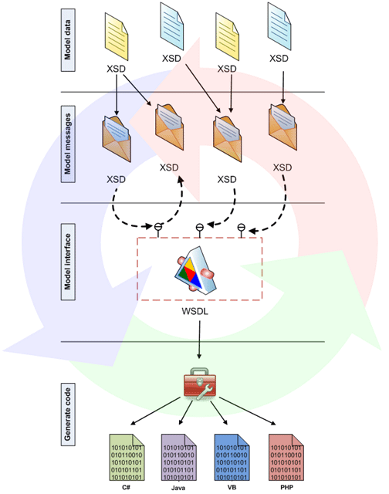

Step 1 Model data: You model the data structures used to transfer data between your service and clients using XML Schema. You may use the Visual Studio XSD editor or a similar tool like Altova XmlSpy or Liquid XML Studio.
Step 2 Model messages: As we explained earlier, in this step you model the structure of your message body using XML schema. You will probably use the data structures you modeled in Step 1 here.
Step 3 Model interface: In this step, you model your interface contract by defining its operations. However, unlike the earlier steps, here you have to use WSDL instead of XML schema. WSDL editing is not available in Visual Studio but is available in certain products like Altova XmlSpy. WSCFblue provides a wizard interface to step you through the creation of a WSDL from the XSDs that represent the data and messages
Step 4 Generate code: Once you have modeled your data, messages and operations, it's time to generate code to represent those artifacts in your favorite programming language. A common tool used for this purpose is svcutil.exe which is a purely command-line interface and has some limitations when compared to WSCFblue (but also has some extra features / options that WSCFblue doesn’t currently have.)
Step 5 Iterate contract design and code generation: It's extremely hard to reach perfection in one attempt. Once you design your contract, you may want to refactor it several times until you find the optimal structures you need. When dealing with generated code the physical organization of the implemented contract is also very important and WSCFblue provides some options that can help you deal with implementation and round-tripping.

Scenario Overview
For this walkthrough we are going to create a Web service for browsing restaurants in your area. It also allows administrators to add new restaurants to the service. It is based on WSCFblue version 1.0.10. We will use Visual Studio 2008 for this walkthrough although the same concepts apply to Visual Studio 2010 (the only changes being the area of service configuration in the web.config file).

Artifacts Provided
We have provided the Restaurant Schemas that are used in the walkthrough. You can use these as you build up the solution.

Organizing the Visual Studio 2008 Solution
First let’s create a blank Visual Studio 2008 solution. We will add our projects into this solution afterwards. The recommended practice in WCF services is to keep the service implementation in a separate project from the host but for this walkthrough, to keep things simple, we will just use the out of the box WCF Service Application template to host the web service.
The following table shows the projects to add to the solution, the project type and their purposes.
Project | Type | Description
ContractMetadata | C# Class Library | Contains the metadata definitions for data, messages, and interfaces
RestaurantService | WCF Service Application | Restaurant Web service implementation
RestaurantClient | C# Console Application | Restaurant Web service client implementation

As soon as you have added the projects from the corresponding templates, do the following steps
- Delete the Class1.cs file from the ContractMetadata Project.
- Delete the IService1.cs, Service1.svc files and remove entries corresponding to Service1 from the web.config file (serviceModel section) in the RestaurantService project.
When all three projects are added to the solution your solution explorer window will look like the following screenshot.
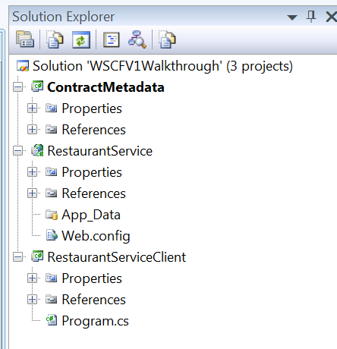

Modeling Data and Messages

Modeling Data
Now that we have organized our Visual Studio 2008 environment, we can start defining our contract. According to the steps we discussed above, our first step is to create an XML Schema which represents the data we want to use. For our RestaurantService Web service, we need two data structures to represent the Restaurant information and a collection of Restaurant information.
The following code snippet is our XML schema data defined in a newly added RestaurantData.xsd file to the ContractMetadata project.
<?xml version="1.0" encoding="utf-8" ?>
<xs:schema id="RestaurantData" targetNamespace="urn:thinktecture-com:demos:restaurantservice:data:v1"
elementFormDefault="qualified" xmlns="urn:thinktecture-com:demos:restaurantservice:data:v1"
xmlns:mstns="urn:thinktecture-com:demos:restaurantservice:data:v1" xmlns:xs="http://www.w3.org/2001/XMLSchema">
<xs:complexType name="restaurantInfo">
<xs:sequence>
<xs:element name="restaurantID" type="xs:int" />
<xs:element name="name" type="xs:string" />
<xs:element name="address" type="xs:string" />
<xs:element name="city" type="xs:string" />
<xs:element name="state" type="xs:string" />
<xs:element name="zip" type="xs:string" />
<xs:element name="openFrom" type="xs:time" />
<xs:element name="openTo" type="xs:time" />
</xs:sequence>
</xs:complexType>
<xs:complexType name="restaurantsList">
<xs:sequence>
<xs:element name="restaurant" type="restaurantInfo"
maxOccurs="unbounded" minOccurs="0" />
</xs:sequence>
</xs:complexType>
<xs:simpleType name="ratingInfo">
<xs:restriction base="xs:string">
<xs:enumeration value="poor" />
<xs:enumeration value="good" />
<xs:enumeration value="veryGood" />
<xs:enumeration value="excellent" />
</xs:restriction>
</xs:simpleType>

<xs:complexType name="customFault">
<xs:sequence>
<xs:element name="errorCode" type="xs:string"/>
<xs:element name="message" type="xs:string"/>
<xs:element maxOccurs="unbounded" minOccurs="0" name="messages"
type="xs:string" />
</xs:sequence>
</xs:complexType>
</xs:schema>

As stated in the scenario overview, our service allows administrators to add new restaurants to the service. However, we want to allow access only to administrators we trust. Therefore it would be necessary for RestaurantService administrators to submit their credentials for authentication before adding a new restaurant. We want to use SOAP headers to transport the authentication credentials (hopefully over an SSL connection). Thus we need another data structure to carry our user credentials.
Let’s define the user credentials in a new XSD file called RestaurantHeaderData.xsd. Although a separate XSD file for this SOAP Header definition is not strictly necessary, it helps to keep these data structures separate (it makes it easier to see the different structures involved in the contract and could also help with reuse later).
The following code snippet is the header data structure.
<?xml version="1.0" encoding="utf-8" ?>
<xs:schema id="RestaurantHeaderData" targetNamespace="urn:thinktecture-com:demos:restaurantservice:headerdata:v1"
elementFormDefault="qualified" xmlns="urn:thinktecture-com:demos:restaurantservice:headerdata:v1"
xmlns:mstns="urn:thinktecture-com:demos:restaurantservice:headerdata:v1" xmlns:xs="http://www.w3.org/2001/XMLSchema">
<xs:complexType name="credentials">
<xs:sequence>
<xs:element name="username" type="xs:string" />
<xs:element name="password" type="xs:string" />
</xs:sequence>
</xs:complexType>
<xs:element name="userCredentials" type="credentials">
</xs:element>
</xs:schema>

Modeling Messages
Next, we are defining the messages to exchange our data. Let’s start by adding a new XSD file called RestaurantMessages.xsd. So far, we have three messages for our RestaurantService Web service. It is very important to note that we have to <import> the XSD file which defines our data structure (RestaurantData.xsd in this case) into RestaurantMessages.xsd. This way we are reusing the XML types we modeled before. In real world projects your data type schemas might already exist in some other context, and you can just add it to your project and reference in the message schema. In our example we simply use the xsd:import mechanism.
The following figure shows the schema import mechanism
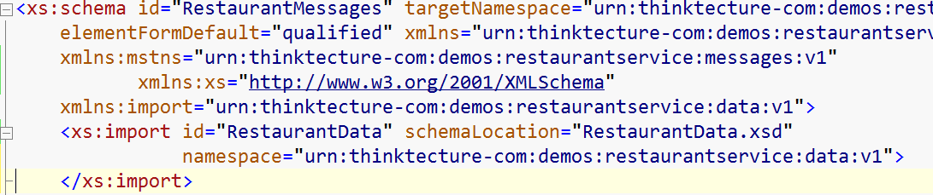
The following code snippet shows the definition of the messages.
<?xml version="1.0" encoding="utf-8" ?>
<xs:schema id="RestaurantMessages" targetNamespace="urn:thinktecture-com:demos:restaurantservice:messages:v1"
elementFormDefault="qualified" xmlns="urn:thinktecture-com:demos:restaurantservice:messages:v1"
xmlns:mstns="urn:thinktecture-com:demos:restaurantservice:messages:v1"
xmlns:xs="http://www.w3.org/2001/XMLSchema"
xmlns:import="urn:thinktecture-com:demos:restaurantservice:data:v1">
<xs:import id="RestaurantData" schemaLocation="RestaurantData.xsd"
namespace="urn:thinktecture-com:demos:restaurantservice:data:v1">
</xs:import>
<xs:element name="getRestaurants">
<xs:complexType>
<xs:sequence>
<xs:element name="zip" type="xs:string" />
</xs:sequence>
</xs:complexType>
</xs:element>
<xs:element name="getRestaurantsResponse">
<xs:complexType>
<xs:sequence>
<xs:element name="restaurants" type="import:restaurantsList" />
</xs:sequence>
</xs:complexType>
</xs:element>
<xs:element name="addRestaurant">
<xs:complexType>
<xs:sequence>
<xs:element name="restaurant" type="import:restaurantInfo" />
</xs:sequence>
</xs:complexType>
</xs:element>
<xs:element name="rateRestaurant">
<xs:complexType>
<xs:sequence>
<xs:element name="restaurantID" type="xs:int" />
<xs:element name="rate" type="import:ratingInfo" />
</xs:sequence>
</xs:complexType>
</xs:element>

<xs:element name="customFault" type="import:customFault" />

</xs:schema>

This approach to splitting up the schemas is also aligned with the WCF programming model. In this example, the RestaurantData schema represents the Data Contracts and the RestaurantMessages schema represents the Message Contracts. The Operation Contracts and Service Contract will be defined in the actual WSDL which will be built next.
Side Note: Driving the code from the WSDL in this manner also gives us the freedom in naming operations logically (with the suffixes of ‘Request’ and ‘Response’). When taking a code-first approach with the Data Contract Serializer, those suffixes are ‘reserved’ by the framework for generating the WSDL.

Modeling the Interface Contract
WSDL is very complex and the specification allows for some very complicated constructs (which also makes interoperability a challenge). Even though there are several WSDL editors available, those editors just try to focus too much on the actual WSDL specification. What we need is a higher-level, a more abstracted view on the interface contract.
WSCF comes with its own WSDL generation wizard that tries to hide any suspicious details of the WSDL specification from the developer or architect. This wizard allows you to do all your interface contract creation work just inside the Visual Studio 2008 IDE. It hides all the complex details of the specification and generates a WSDL document, which is totally compliant with the interoperability recommendations of WSI BP (Basic Profile) 1.1.
WSCF also allows the user to import multiple schema files to create a WSDL document. Not only that, it also provides a feature to automatically infer operations from your message schema definition. This saves a lot of time you might otherwise spend manually adding operations, even though they could be guessed from the message names.
The following table shows the currently supported string patterns for operation inference.
Input Message Name Element | Output Message Name Element | Inferred Operation Name
XYZ | XYZResponse | XYZ
XYZRequest | XYZResponse | XYZ
XYZRequestMessage | XYZResponseMessage | XYZ
Table 2: Supported string patterns for operation inference
WSCF is also armed with a feature which you can use to generate the SOAP 1.2 binding. Last but not least, the wizard enables a simple kind of WSDL round-tripping, which means you can generate a WSDL, review it, and later modify it using the wizard.
Let’s take a look at how the WSDL wizard generates the interface contract for the RestaurantService.
To start the WSDL wizard right click on your messages schema file (RestaurantMessages.xsd in this case) in the Visual Studio Solution Explorer and select the WSCF.blue →Create WSDL Interface Description menu item from the context menu.
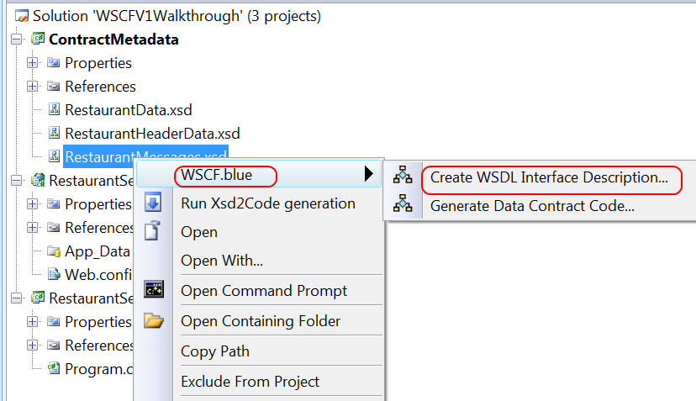
The wizard starts with a welcome message. Click on the Next button to collect some basic metadata for our Web service description. This includes the service name, the Web services XML namespace and an optional description.
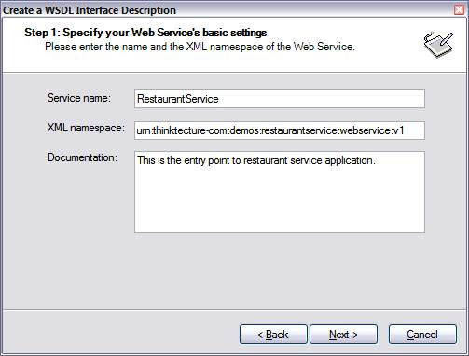
The next step allows you to import additional schema files into the WSDL. In our example we have to import the schema file with the type definitions for our message headers, RestaurantHeaderData.xsd. It’s important to keep in mind that you cannot import two schema files which have the same target namespace.
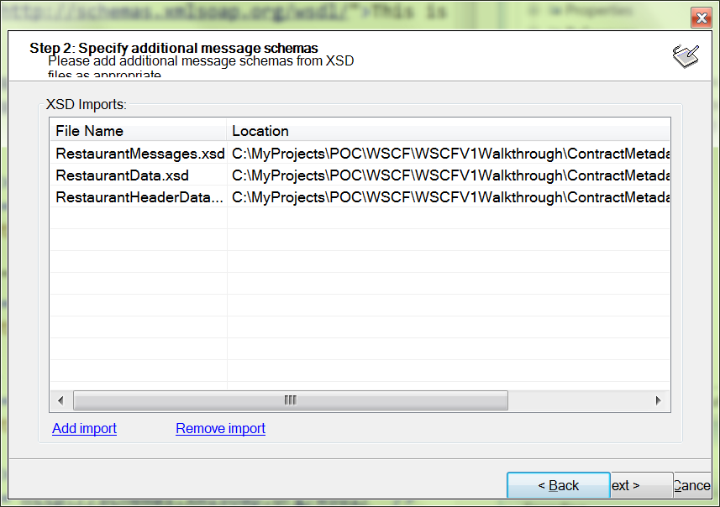
In step 3 you define the operations in your contract the meat of this process. However, WSCFs WSDL wizard is intelligent enough to infer the operations according to message name patterns in your message schemas.
Click on the Infer Operations checkbox to automatically infer the operations. (If you are working along with this sample, when you click Infer Operations you will notice that the system automatically brings in the “userCredentials” and customFault structures as well although there are no operations for them. Just highlight those entries and click Remove Operation leaving the remaining operations as shown in the following screenshot.
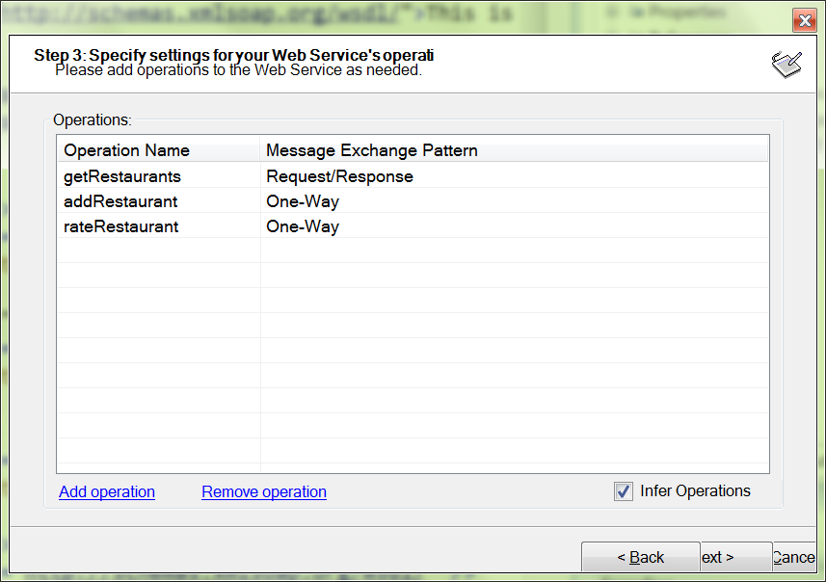

The following step allows you to optionally configure inbound and outbound messages in your operations. In this step you can select the message element for your message body from the schema. However, if you inferred the service operations, message body elements are automatically and hopefully correctly - configured for you. Optionally you can customize the name for your inbound/outbound message.
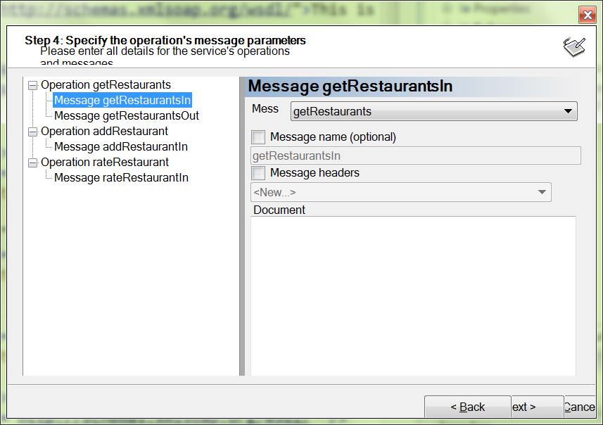
An interesting feature on Step 4 is the Message headers checkbox. When you check that box, you can select schema types for one or more message headers for your inbound/outbound messages from the drop-down underneath the checkbox. In this case we create a message header for addRestaurantIn inbound message to carry our user credentials. Check the Message headers checkbox and select Credentials from the dropdown.
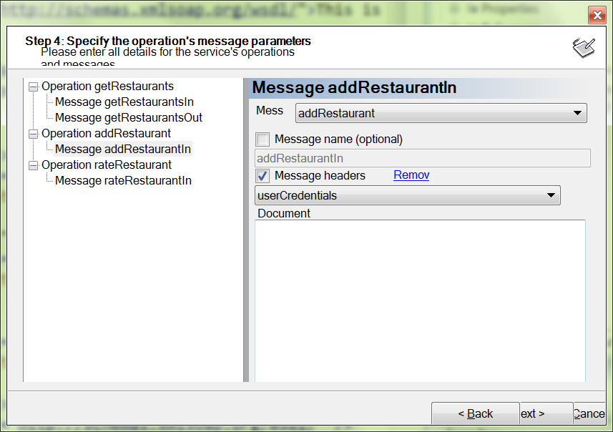
In this same step you can also select whether you want to throw custom faults. Defining fault messages in your WSDL can be a little different to defining your input and output messages. For example, you can have multiple fault messages for a single operation and the same fault message is often reused for different operations. The message mapping page of the WSDL Wizard is a reasonable place to put the configuration for your fault contract.
When you select an operation in the tree control a link label is displayed in the properties pane. Clicking the link will add a new fault message to the operation.
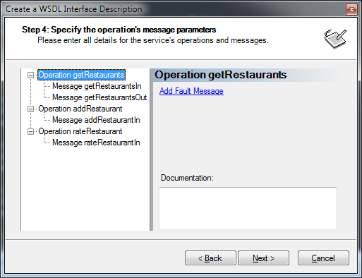
When you select the fault message in the tree control you can then select a type from your schema to be used as the message body. In the RestaurantsData.xsd we have the following complex type that defines the structure of the fault.
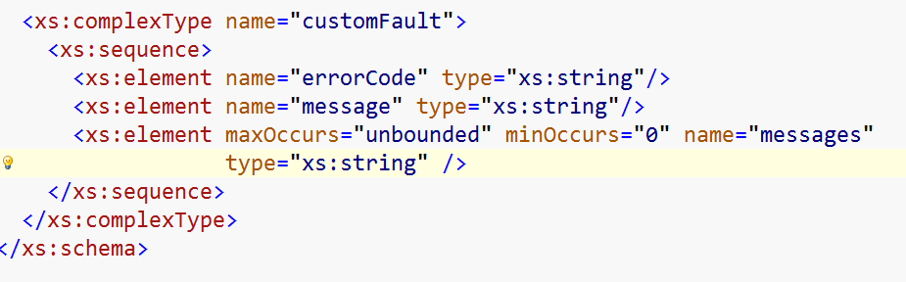
In the RestaurantMessages XSD we have the following element definition for the fault message related to the operation.
The separate element is very important. Do not create your fault type as an anonymous type definition directly under the element for the message. Doing so will result in an error about a missing data type during code generation.
In the WSDL Wizard, you must provide a name for the message and that name must be unique to the operation. It does not have to be unique to the entire contract though. This means that you can reuse the same message name for a different operation and only a single message will be added to the WSDL. There is also a link label that allows you to remove the fault message if required. (Note that when you select the type and name it, the title (in bold) will still be “Fault1”. To refresh the name (to “customFaultMessage” as in the example below) click on some other node in the tree and then come back to the Fault node and the name will be refreshed.
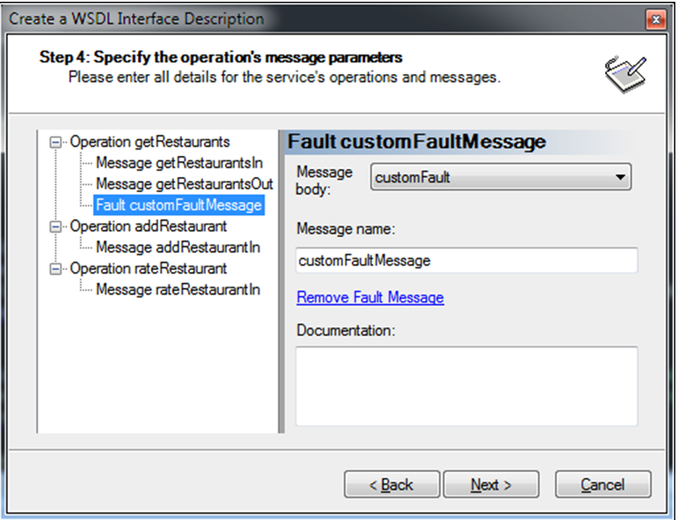
In the next step you can select whether you want to have the <service> tag in your WSDL. <service> allows you to specify a default location of a Web service that implements the abstract interface you are currently modeling. Also, you can select whether you want to start the code generation immediately after the wizard finishes.
The WSDL specification defines <service> as optional, but some Web services frameworks don’t work correctly unless the <service> element is present in the WSDL document. In addition to the above features WSCF gives you an option to generate the SOAP 1.2 binding in the generated WSDL.
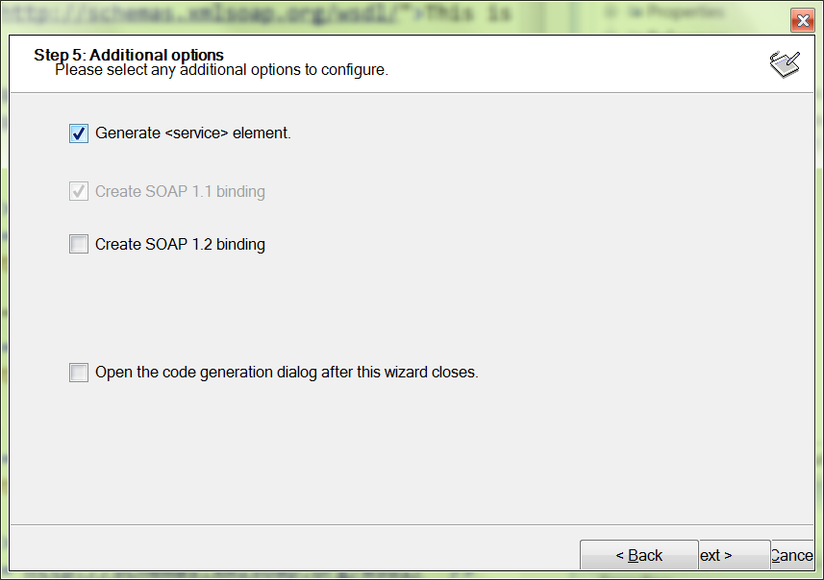
Step number 6 allows you to modify the relative paths of your imported schema files. This may be needed if you have the real XSD files (e.g. for production use) at a different location, e.g. at a URL on a web server (and if you have some custom schema validation routines that access the schemas at that location).
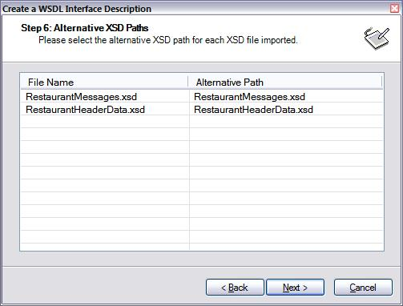
Click the Finish button on the last screen and you will see the generated WSDL file in your solution explorer.
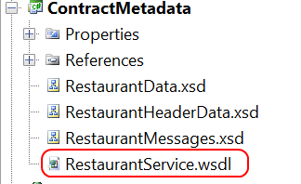

Code Generation

Deploying/Distributing the Contract Metadata
For this walkthrough we want to focus on the .NET platform and Visual Studio 2008 as our IDE. Thus, we now need to distribute or deploy - the contract metadata to both the client and the Web service developer. Before proceeding into the rest of the section it is important to understand some of the rationale around this distribution
- First, we are not talking about sharing binaries like we used to do with .NET Remoting between the client and server. (Even so, in pure .NET client & service scenarios it is very common for a service provider and consumer to share a types library when they want to avoid any issues with auto-generated WSDLs and metadata inference in Visual Studio’s out of the box tooling).
- Secondly, the WSDL and the XSD’s are the contract and we already have these so there is no need to rely on the auto-generated WSDL from the Service when generating the client proxy. (Of course, there are scenarios when you do not have the WSDL readily available, or if it is your typical multi-part WSDL then there is no single file to refer to anyway, or you can only point to an existing WSDL/MEX endpoint to generate the consumer. WSCF supports generating the consumer proxy for these scenarios, but in general, we would recommend that if you have full control over the service and consumer and you are creating the WSDL using the WSCF tooling, then do avail of this contract.
In the following screenshot we can see the ContractMetadata copied out to the client and the service after which we will be ready to dive into code generation.
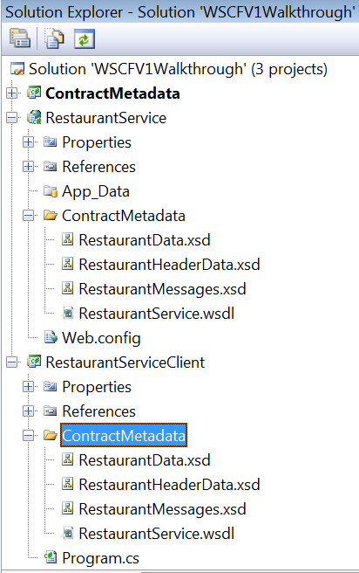

Service-side Code Generation
Now that we have our service contract in place we can start building our service implementation. WSCF comes with a code generation engine for C# and Visual Basic.NET. Let’s start by generating the service-side code first. To start the code generation, we have to right click on the WSDL file in our RestaurantService project and select the WSCF.blue → Generate Web Service Code menu item from the context menu
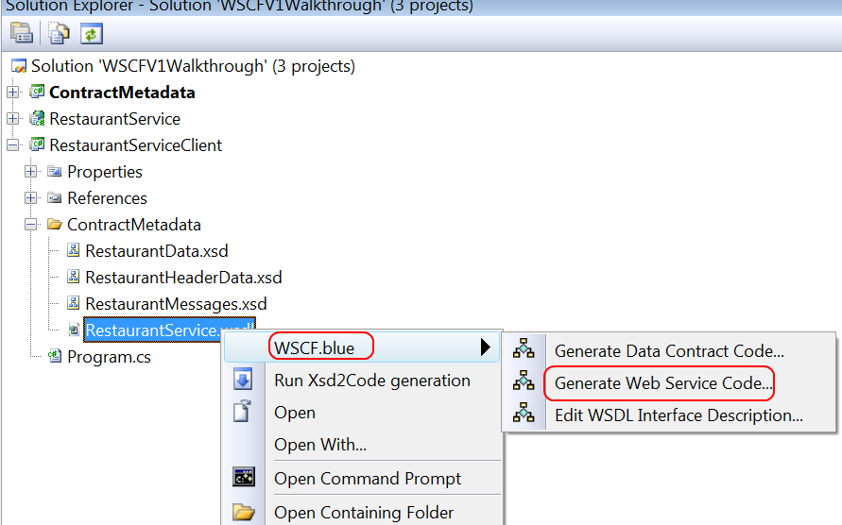

This action will bring up the Code Generation Options dialog box which allows you to control the code generation.
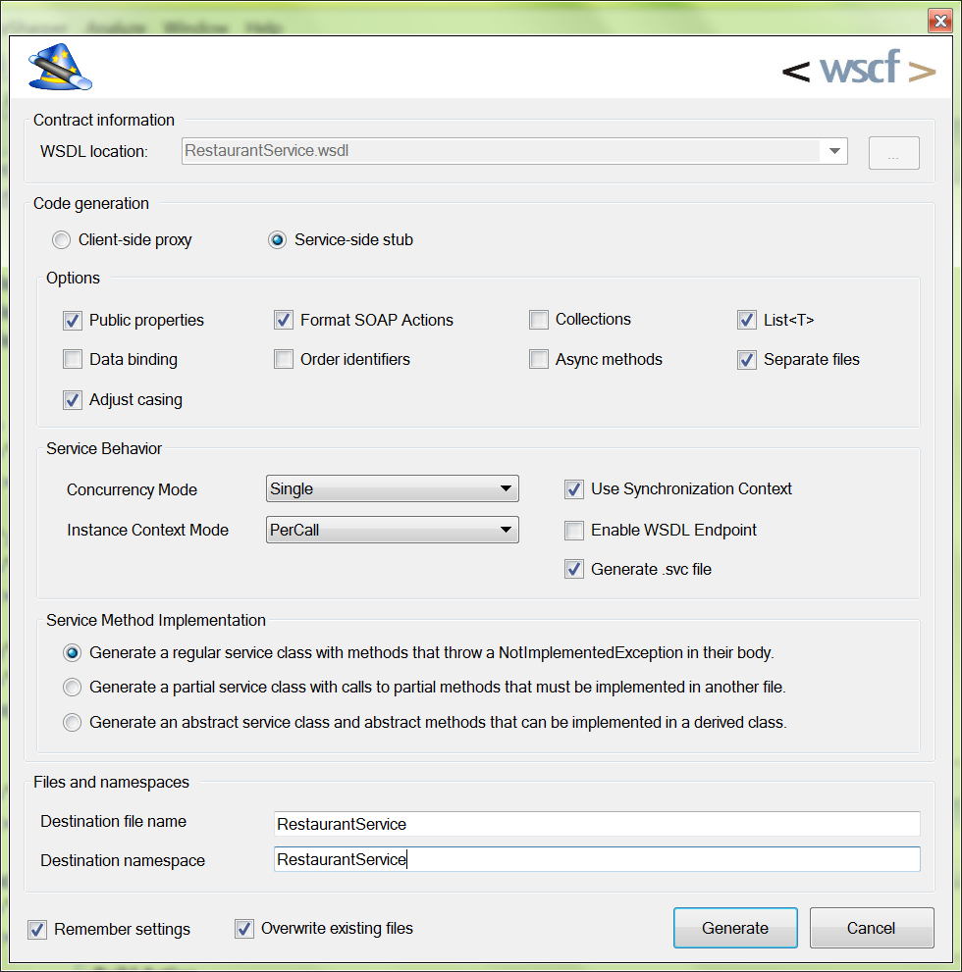
Since we generate the code for the service, we select the Service-side stub radio button. Various checkboxes in the Options group box let you generate the code according to what you actually need. We will take a look at each of those options in a moment. Now it is important to notice that some options are available for both client-side and service-side code generation, whereas some others are only available for client-side or service-side.

Code Style Options
Option | Description
Public Properties | Clicking the Public properties checkbox commands the code generator to generate property getters and setters for our data fields.
Format Soap Actions | Force the SOAP actions (Action and ReplyAction) applied to each operation contract follow the standard WCF format: <namespace>/<service>/<operation>[Response]
Collections | The Collections option instructs the code generator to generate a .NET collection type instead of arrays where necessary. For example, the GetRestaurantResponse class could contain a list of RestaurantInfo objects as an array. By default WSCF would generate an array of RestaurantInfo objects  // Collection type generated.  public class RestaurantInfoCollection : System.Collections.CollectionBase  {  }  public class GetRestaurantsResponse  {  // Array declaration is modified to use the newly created  // collection type.  public RestaurantInfoCollection restaurants;  }
List<T> | (This option is mutually exclusive with Collections (i.e.) you can choose either Collections or List<T> and if you don’t select either, then the system defaults to using arrays.  The snippet below demonstrates the code generated instead of an array of RestaurantInfo type.  public System.Collections.Generic.List<RestaurantInfo> restaurants;
Data Binding | WSCF also supports generating the data binding code if necessary. The resulting types will automatically include the implementation of INotifyPropertyChanged interface (Listing 7). This feature could be primarily used by the client applications. However you could also use it in the service side implementation as well.  public partial class RestaurantInfo :  object, System.ComponentModel.INotifyPropertyChanged  {  public int RestaurantID  {  get  {  return this.restaurantID;  }  set  {  if ((this.restaurantID != value))  {  this.restaurantID = value;  this.RaisePropertyChanged("RestaurantID");  }  }  }  }
Order Identifiers | The Order Identifiers option will cause the code generator to emit the order identifiers for the public fields and properties. These order identifiers will control the order of the elements generated by the XmlSerializer.  [System.Xml.Serialization.XmlElementAttribute(Order=0, ElementName="restaurantID")]  public int RestaurantID;  [System.Xml.Serialization.XmlElementAttribute(Order=1, ElementName="name")]  public string Name;
Adjust Casing | Typically the programming languages (.NET) and XML follow different naming convention patterns. More specifically, the XML world mostly tend to use the Camel case naming convention whereas the programming languages tend to use the Pascal case naming convention. WSCF has the Adjust Casing option to easily switch between these two worlds. If you select this option the resulting code will convert all the type names and public field names to Pascal case if necessary. For instance, if we take a look at the RestaurantInfo complex type in RestaurantData.xsd and the respective .NET type generated to represent it you can easily notice the difference.  <xs:complexType name="restaurantInfo">  <xs:sequence>  <xs:element name="restaurantID" type="xs:int" />  <xs:element name="name" type="xs:string" />  </xs:sequence>  </xs:complexType>  public partial class RestaurantInfo  {  public int RestaurantID;  public string Name;  }
Separate files | The Separate Files option, generates types into individual .cs/.vb files. In many situations this will make code organization easier as it generates a separate file for each type
Async Methods | Async Methods are useful for client side proxy generation where this option creates a Begin/End method pair for each operation  public virtual System.IAsyncResult BeginAddRestaurant(AddRestaurant request, System.AsyncCallback callback, object asyncState)  {  throw new System.NotImplementedException();  }  public virtual void EndAddRestaurant(System.IAsyncResult result)  {  throw new System.NotImplementedException();  }

Service Behavior Options
Option | Description
Concurrency Mode | Specifies whether a service class supports single-threaded or multi-threaded modes of operation.  The options are Single, Multiple & Re-entrant.  From the MSDN documentation  - Single: The service instance is single-threaded and does not accept reentrant calls. If the InstanceContextMode property is Single, and additional messages arrive while the instance services a call, these messages must wait until the service is available or until the messages time out.  - Re-entrant: The service instance is single-threaded and accepts reentrant calls. The reentrant service accepts calls when you call another service; it is therefore your responsibility to leave your object state consistent before callouts and you must confirm that operation-local data is valid after callouts. Note that the service instance is unlocked only by calling another service over a channel. In this case, the called service can reenter the first service via a callback. If the first service is not reentrant, the sequence of calls results in a deadlock.  - Multiple: The service instance is multi-threaded. No synchronization guarantees are made. Because other threads can change your service object at any time, you must handle synchronization and state consistency at all times
Instance Context Mode | Specifies the number of service instances available for handling calls that are contained in incoming messages.  The options are PerSession, PerCall and Single  From the MSDN Documentation  - PerSession : A new InstanceContext object is created for each session.  - PerCall: A new InstanceContext object is created prior to and recycled subsequent to each call. If the channel does not create a session this value behaves as if it were PerCall.  - Single: Only one InstanceContext object is used for all incoming calls and is not recycled subsequent to the calls. If a service object does not exist, one is created.
Use Synchronization Context | The UseSynchronizationContext from the ServiceBehavior attribute in WCF is used to determine which thread your service will execute on. By definition, this property indicates whether to synchronize inbound method calls with the user interface thread automatically  If UseSynchronizationContext is set to true then the value from the System.Threading.SynchronizationContext.Current is read and cached so that when a request comes to the service, the host can marshal the request onto the thread that the host was created on using the cached SynchronizationContext.  For more information please refer to the documentation and this MSDN Magazine article

Enable WSDL Endpoint | If this option is chosen, then the system adds a reference to a custom Thinktecture Service Behavior that serves up the pre-constructed WSDL instead of allowing the system to infer a WSDL by reflecting over the definition.  You can elect to ignore this option and take the ‘traditional’ approach of either allowing metadata to be exposed in the service behavior settings or by creating a separate MEX endpoint.
Generate .svc file | This is not strictly a service behavior. It just indicates to the code-generation engine whether a .svc file should be created to save the manual step. The attributes of the svc file are set to point to the actual code implementation rather than to a .svc.cs file.  For example, in the Restaurant Service svc file the following directive is found (indicating that the implementation is in the RestaurantService type that belongs to the RestaurantService namespace. ) There is no .svc.cs file because this is not needed.  <%@ ServiceHost Service="RestaurantService.RestaurantService" %>

Service Method Implementation
The default service class code generated by WSCF.blue contains operation method implementations that throw a NotImplementedException. The issue with this approach is that you need to manually update the generated code to call another class that contains your actual service implementation, otherwise you will lose your implementation code during the regeneration process. You can now decide if you would like your service implementation to exist in a partial class or abstract class that can be defined in a separate file.
The first and default option is to generate method bodies that throw a NotImplementedException. Making this option the default keeps the behavior consistent with previous builds of WSCF.blue. However, using this option will always result in your having to perform same manual modifications to the generated service class.
[System.ServiceModel.ServiceBehaviorAttribute()]
public class FooService : IFooService
{
public virtual FooResponse Foo(FooRequest request)
{
throw new System.NotImplementedException();
}
}

Selecting the partial class option will cause the generated service class to be marked as partial. It will also contain operation methods that call through to a partial method that can be defined in another partial class and in another file. This file must be created manually yourself, but once created it will remain untouched when you regenerate your service code.
[System.ServiceModel.ServiceBehaviorAttribute()]
public partial class FooService : IFooService
{
public virtual FooResponse Foo(FooRequest request)
{
return FooImplementation(request);
}
}

The naming convention for the partial method is the name of the operation method suffixed with Implementation. In the example above you can see the Foo operation method calls a FooImplementation method that is expected to be present in your partial class definition. You will receive a compiler error until you have defined your partial class containing the appropriate partial methods.
public partial class FooService
{
protected FooResponse FooImplementation(FooRequest request)
{
FooResponse response = new FooResponse();
// Some web service processing code.
return response;
}
}

Your partial class definition should be created in a separate file to the service class that calls it. This will ensure you do not have to make any changes when regenerating your service code, which is obviously the very issue the option is designed to solve.
Because a partial class can be defined in a separate file, but must reside within the same project, an abstract class option was added that allows you to place your service implementation in another assembly. This option causes an abstract service class containing abstract operation methods to be code generated.
[System.ServiceModel.ServiceBehaviorAttribute()]
public abstract class FooService : IFooService
{
public abstract FooResponse Foo(FooRequest request);
}

You can then inherit from the abstract service class and place your implementation in the overridden abstract methods. Similar to the partial class approach, this allows you to separate your implementation into another file that remains untouched when you regenerate your service code, but also allows for the implementation to be created in another assembly.
public class FooServiceImplementation : FooService
{
public override FooResponse Foo(FooRequest request)
{
FooResponse response = new FooResponse();
// Some web service processing code.
return response;
}
}

Both the partial class and abstract class approaches are equally valid, and both result in the desired outcome of protecting your implementation code. The important points to remember are that when using the partial class option, your implementation class must have the same name as the code generated service class and must be defined in a file within the same project. When using the abstract class option, your implementation class cannot have the same name as the code generated service class but can be defined in a file that is not in the same project. Which option you prefer to use entirely up to you and is probably a matter of taste for the most part.

Files and Namespaces
The namespace option specifies the parent namespace for all the generated types.
The file name option is only necessary if you are generating into a single file. If the separate files option is selected, then this value will be ignored.

Final Output
After selecting the relevant options, the code is generated. The following screenshot shows the code layout in Solution Explorer (the Separate Files option has been chosen)
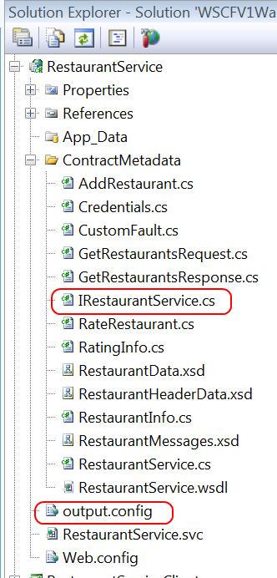
The highlighted files are the IRestaurantService interface and the output.config (discussed below)

Service Configuration Generation
There are currently no options to control the service configuration generation. The following screenshot shows the default configuration that is generated.
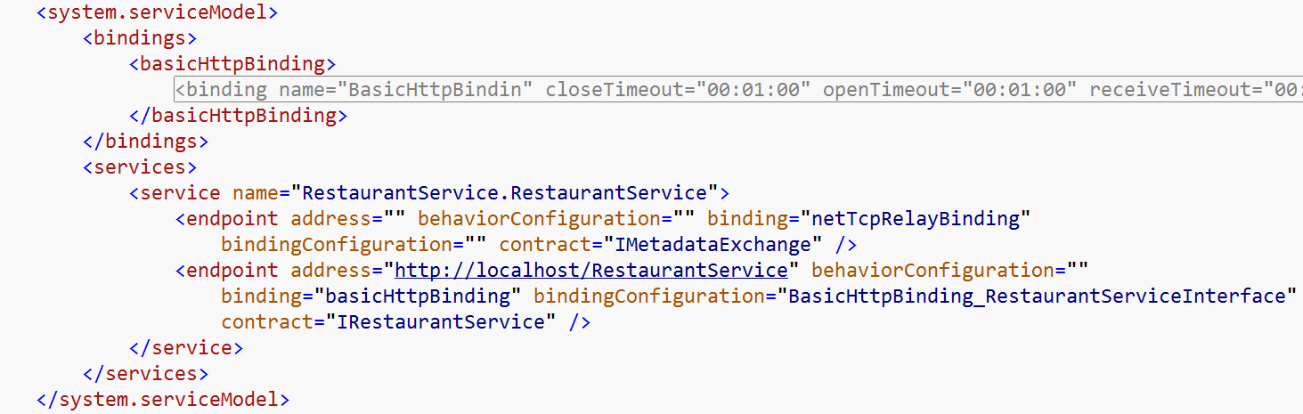
The defaults in the file have been chosen to align with common/recommended practices
- basicHttpBinding is the most interoperable binding (for both non Microsoft clients as well as clients communicating with a service that has just been upgraded from ASMX to WCF). A standard basicHttpBinding config is generated as shown above.
- The MEX endpoint is exposed only over netTcpBinding (please ignore the ‘Relay’ binding shown above – that’s a documentation machine specific setting)
- The main service operations are exposed over the basicHttpBinding.
You will need to merge this configuration info into the web.config.
For future releases, if you think it would be useful to provide more options for bindings, metadata control and configuration merging, please let us know via the forums and we will try to incorporate them.

Client-side Code Generation
For client side code-generation, the same dialog as the one above is launched. However only a subset of the options are needed , that is, mainly the Code Style option, so the rest are disabled.
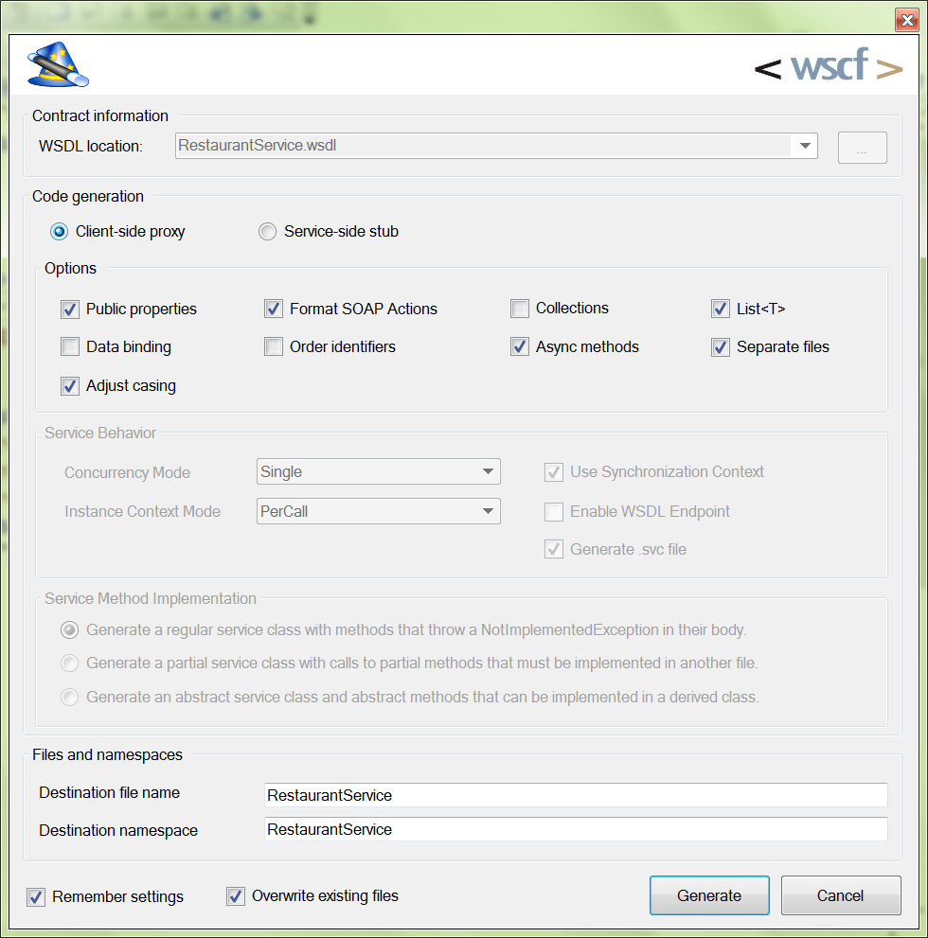
The output config is shown below. This has to be merged into the app.config file.
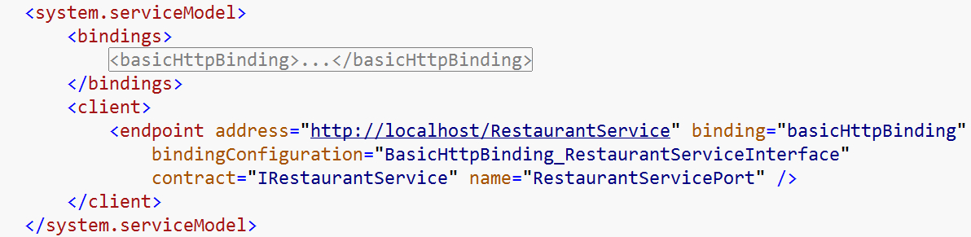

Data Contract Generation
WSCF also supports generating only data contracts (instead of entire service or client side stubs)
The generated data contract types are designed to work with the XmlSerializer. WSCF.blue uses the XmlSerializer because the DataContractSerializer is limited in regards to its support for many of the XSD constructs that often appear in contract-first WSDL. If you would like to us to add the ability to generate data contract types using the DataContractSerializer then please let us know via the forums.
To generate data contracts start by selecting the required XSD or WSDL file in your project. You can select one or more files as required.
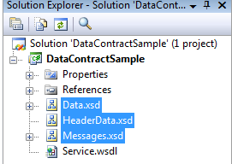
Right-click your selection and choose WSCF.blue → Generate Data Contract Code... from the context menu. You will be presented with the Data Contract Code Generation Options dialog.
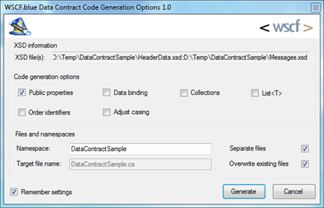
You can choose to create a separate file for each type or keep them all in a single file. The usual list of Code generation options are available.

Iterating the Contract and Code
WSCF comes with WSDL round-tripping feature which allows you to modify your existing contracts with the minimum effort. Please note that we are not talking about modifying a published and released contract but rather working in an iterative fashion on one instance of a WSDL-based interface description during development.
Let’s assume that we need to add a new operation into our service. Once we define the types and the messages, we can start round-tripping by right clicking on the initial WSDL and selecting the Edit WSDL Interface Description menu item from the context menu.
This brings up the same WSDL wizard we used to create our original service description with. However, this time it is pre-populated with the values from the RestaurantService.wsdl file. Now we can do things like inferring operations which adds a new operation to the list.
Once you have the new WSDL copy it to the client and service projects. You need to re-generate the code but if you have chosen options (for the service) such as partial classes or abstract classes then your code will not be overwritten. However this time we can select the Overwrite existing files option, while generating code for both client side and service side. This will replace the existing files by the newly generated files. Otherwise the code generation will automatically produce unique file names to preserve your existing code.

Summary
This wraps up our walkthrough of the WSCFblue toolset. We hope it will make you more productive in your web service development efforts. Please get in touch with us via the CodePlex workspace to give us feedback, make suggestions, report bugs etc

