**BOOK PUBLISHING AND COPYRIGHT AGREEMENT**

This Book Publishing and Copyright Agreement (hereinafter referred to as the "Agreement") is entered into between **Renato R. Maaliw III** (hereinafter referred to as the "Author") and **Xoffencer International Publication** (hereinafter referred to as the "Publisher") as of February 2022.

1. **Book Title and Description:**
   1. The Author represents that they are the sole owner of the rights to the work titled **“Theory and Applications in Deep Learning”** (hereinafter referred to as the "Work"), and that they have full power and authority to enter into this Agreement.
2. **Grant of Rights:**
   1. The Author hereby grants the Publisher exclusive worldwide rights to publish, distribute, and sell the work in print, electronic, audio, and any other formats, as determined by the Publisher, for the duration of the copyright term.
   2. The Publisher is granted the right to create derivative works based on the Work, including translations, adaptations, and abridged versions, as deemed necessary for the promotion and distribution of the Work.
   3. The Author agrees to collaborate with the Publisher on marketing and promotional activities related to the Work, including but not limited to book signings, interviews, and public appearances.
3. **Copyright Ownership and Registration:**
   1. The Author retains copyright ownership of the Work. The Publisher acknowledges that all rights not expressly granted in this Agreement are reserved to the Author.
   2. The Publisher agrees to include a copyright notice on each copy of the Work, indicating the Author's name as the copyright owner, as well as any additional copyright notices required by law.
   3. The Author agrees to promptly provide the Publisher with any necessary information or materials required for copyright registration, and the Publisher agrees to assist the Author in the registration process, if applicable.
4. **Royalties and Financial Terms:**
   1. The Publisher agrees to pay the Author 12% royalties based on the net revenue generated from the sale of the Work. To be equally divided to number of authors per book.
   2. Royalty payments will be made on a semi-annual basis, within 30 days following the end of each reporting period.
   3. The Publisher shall provide the Author with detailed sales reports, indicating the number of copies sold, the revenue generated, and any applicable deductions or expenses.
5. **Editing, Proofreading, and Design:**
   1. The Publisher is responsible for editing, proofreading, and designing the Work, subject to the Author's approval. The Author agrees to provide reasonable assistance and cooperation in reviewing and approving the edited manuscript and the book cover design.
   2. The Publisher shall make commercially reasonable efforts to ensure that the Work is free from errors, omissions, and any unauthorized alterations that may affect the integrity of the Author's original content.
6. **Termination:**
   1. Either party may terminate this Agreement upon written notice to the other party in the event of a material breach of any provision of this Agreement, provided that the breaching party has failed to cure such breach within 60 days of receiving written notice specifying the breach.
   2. In the event of termination, the rights granted to the Publisher shall revert back to the Author, subject to any rights granted to third parties for the distribution and sale of copies already published or sold.
7. **Governing Laws and Jurisdiction:**
   1. This Agreement shall be governed by and construed in accordance with the laws of Indiawithout regard to its conflict of laws principles.
   2. Any disputes arising out of or in connection with this Agreement shall be resolved through good faith negotiations between the parties. If the dispute cannot be resolved amicably, either party may initiate legal proceedings in the appropriate courts of India.

IN WITNESS WHEREOF, the parties hereto have executed this Book Publishing and Copyright Agreement as of the date first above written.

**Author:**

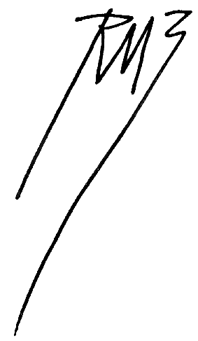

Renato R. Maaliw III, DIT

Southern Luzon State University

Lucban, Quezon, Philippines

**Publisher:**

Satyam Soni (Mr. Xoffencer)

Director, Xoffencer International Publication

Laxmi Colony, Dabra Gwalior, India