Renato Matos
renato.matos79@gmail.com
+55 11 95494 0703
Skype: renato.matos.79

iCreate Test
All answers for this test are available at Github
https://github.com/renatomatos79/movies.git

Question 1:
For this question I’ve done:
- Designed the Database Model using SQL Server;
- Imported some sample data to the database (movie list);
- Created a backend API using .NET Core with some endpoints to:
Authenticate and Authorize the user persisting an API Token which must be sent on header
- I also organized the backend into these simlple layers, such as: Domain, Service and Api. But I also added Log Control, IoC and Api Token Validation
- As a result I could test my endpoints using Postman

Database Model
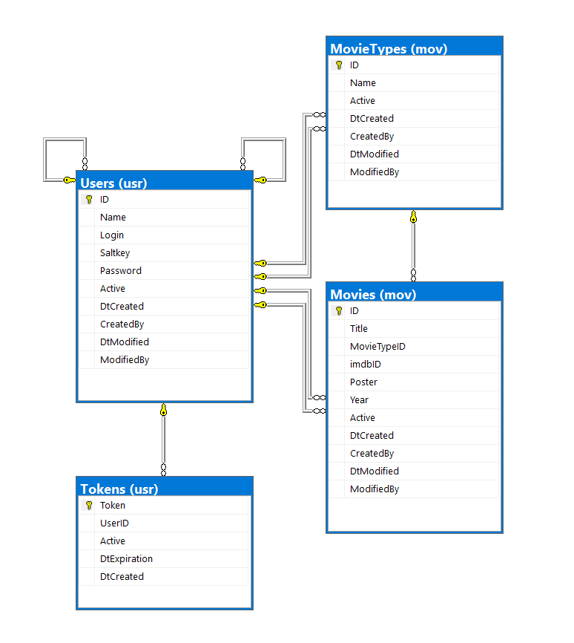

Samples for my test

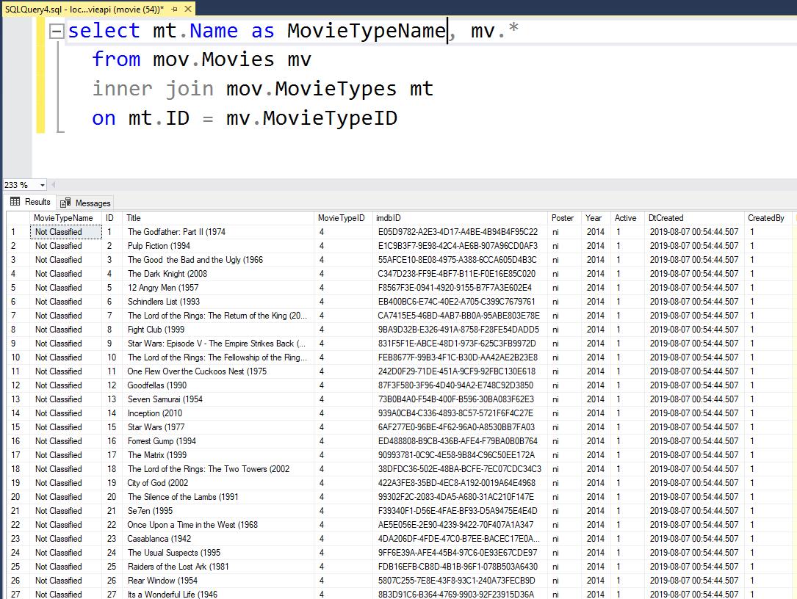

Authenticating the User
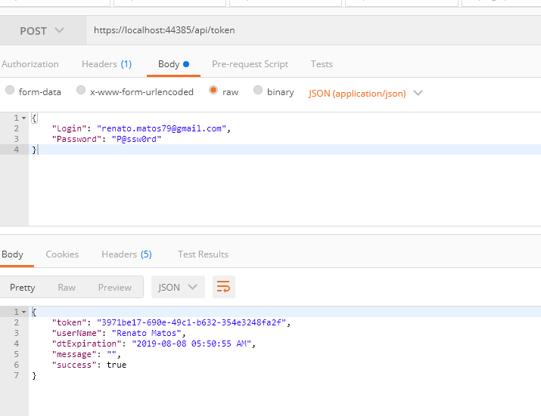

Simulating a wrong password
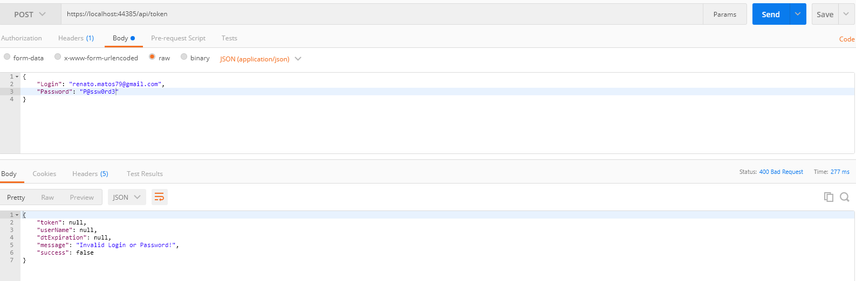

Getting the movie types
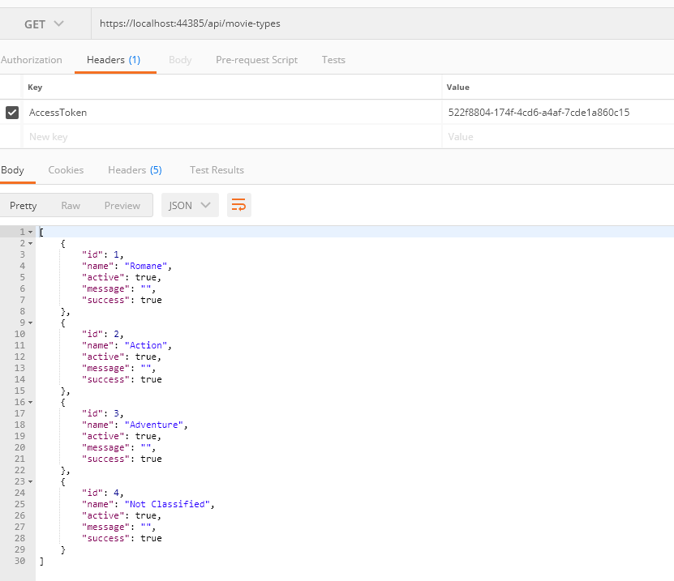
Trying to get the list using an invalid Token
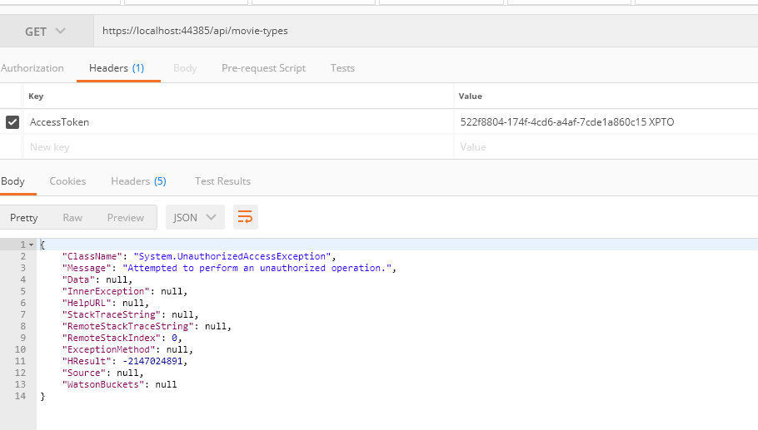
Searching movies on page 2
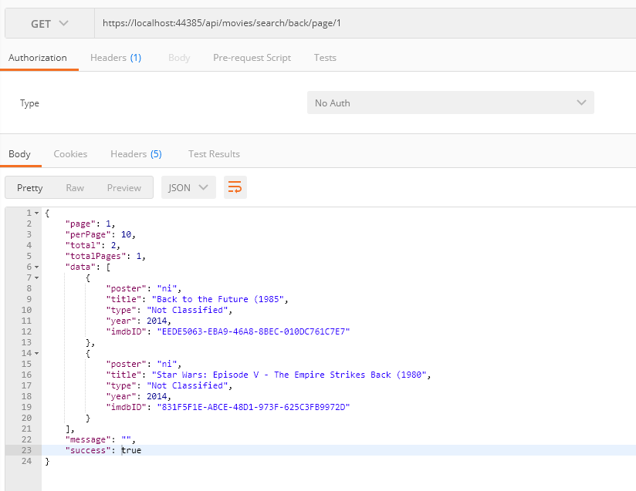

Checking the LOG file
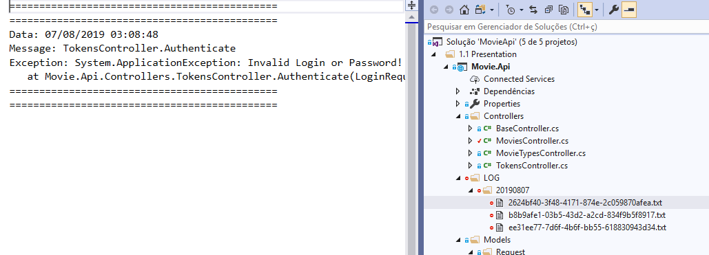

Question 2:
For this question I decided to add another class named BaseCar just to implement toString and getMileage as a way to make codeless the children classes:

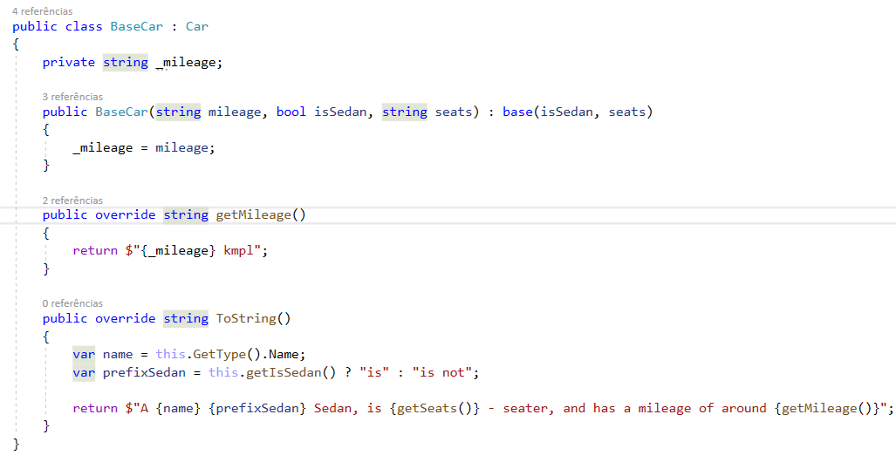
My Children classes:
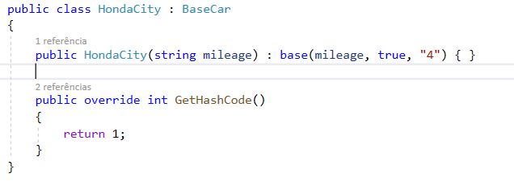 | 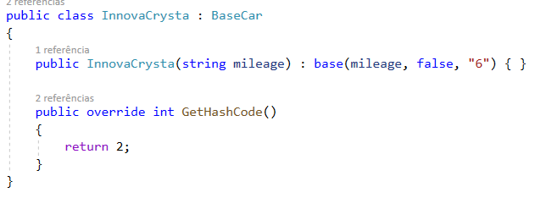 | 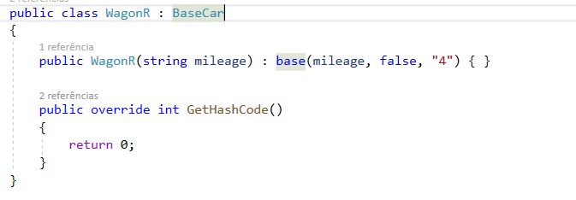

The result after two executions:

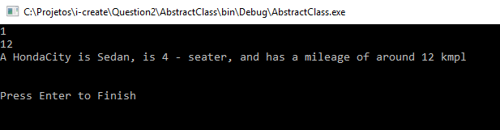
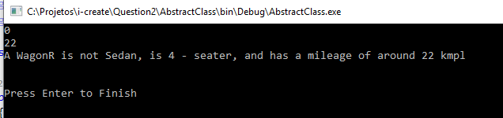

Question 3:
Thats the way I fixed the source codeless

namespace BugFix
{
public class Person
{
public Person(string name)
{
this.Name = name;
}
public Person(string name, DateTime birthdate) : this(name)
{
this.CalcAge(birthdate);
}

public string Name { get; set; }
public int? Age { get; set; }
public void CalcAge(DateTime birthdate)
{
var today = DateTime.Today;
var age = today.Year - birthdate.Year;
if (birthdate.Date > today.AddYears(-age))
{
age--;
}
this.Age = age;
}
}

public static class PersonManager
{
private static readonly List<Person> DB = new List<Person>();

public static void AddPerson(string name, DateTime birthDate)
{
DB.Add(new Person(name, birthDate));
}
public static void DeletePerson(int id)
{
if (DB.Count >= id)
{
DB.RemoveAt(id);
}
}
public static List<Person> People { get { return DB; } }
}

class Program
{
static void Main(string[] args)
{
Console.WriteLine("Adding people...");
PersonManager.AddPerson("Renato", new DateTime(1979, 6, 23));
PersonManager.AddPerson("Vanessa", new DateTime(1978, 5, 5));
PersonManager.People.ToList().ForEach(p =>
{
Console.WriteLine($"{p.Name}, Age {p.Age}");
});

Console.WriteLine("Removing person at index 0...");
PersonManager.DeletePerson(0);
PersonManager.People.ToList().ForEach(p =>
{
Console.WriteLine($"{p.Name}, Age {p.Age}");
});

Console.ReadLine();
}
}
}

The result window after programming execution:
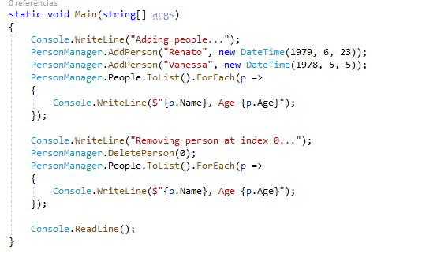 | 