Are wine reviews and prices normaly distributed?

We see normal distribution for rating but not for prices. Prices have a non symetrical distribution with fat tails.

The fact that the distribution of prices is not normal is good reason why we should look at the median instead of the mean when analyzing prices.

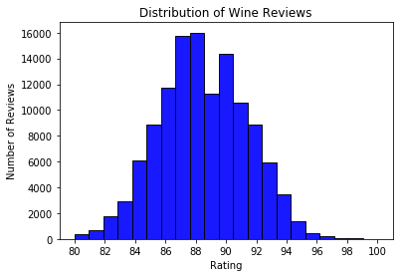

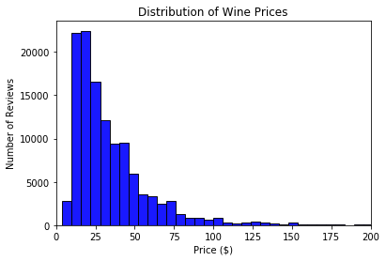

Is there a correlation between wine prices and ratings?

Yes, we do see that as rating increases the wine become more expensive. The relationship is not linear, instead we see an acceleration in the price as the rating increases.

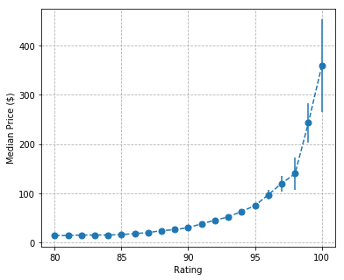

Is there a correlation between wine prices and countries?

Yes, we see that wine prices increase at different rates for different countries.

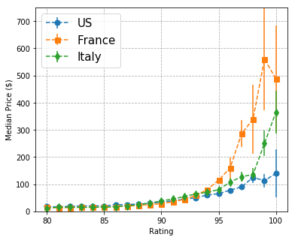

Do tasters specialize in reviewing wines of a specific type or from specific country?

No, although not evenly taster tend to cover multiple varieties of wines.

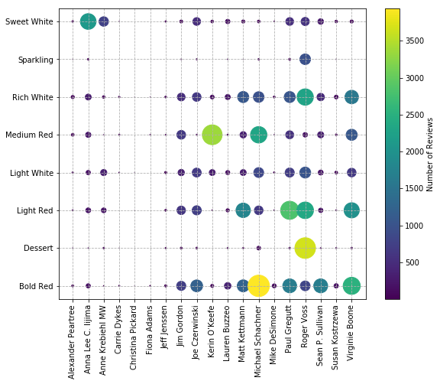

However, when we look at a similar chart using countries instead of variety we do see more of a specialization.

For example Karin O’keefe has over 4,000 reviews, all for Italian wines, Roger Voss has well over 10,000 reviews and almost all are for French and Portuguese wines.

