One weak axial modulation of named-minor-planet news presence,
aligned to the equinoctial axis of the First Point of Aries
A pre-registered directional test with two count-preserving null models

Abstract
We test whether the news presence of named minor planets, pooled by ecliptic longitude, is organised around the equinoctial axis defined by the First Point of Aries (FPOA) - the zero of the tropical zodiac. For 1,122 named bodies over 290 days (2022-02-15 to 2022-12-01), each body's daily article count is normalised to unit length and binned by its longitude from FPOA into a single 360-point wave. The joint autocorrelation of that wave at the nine classical aspect separations is 0.448, about 5.1 times its chance level against a compound permutation null (p = 0.006) and 4.2 times against a stricter unnamed-minor-planet null (p = 0.015). The pattern is one coherent axial cosine, not nine independent aspects: the first harmonic carries 30% of the wave's variance and the nine aspect-lag autocorrelations follow a single cosine at r = 0.98. Because FPOA fixes the axis in advance, the appropriate evidence measure is the fixed-axis Bayes factor, which reaches ~21 against the unnamed-minor-planet control; the data-estimated axis (178.4 deg) lands within about 2 deg of the equinoctial axis. The signal registers to the tropical equinox rather than the sidereal one. The result is a weak but internally consistent, reproducible regularity; it is observational and establishes no mechanism.
Keywords: minor planets; ecliptic longitude; First Point of Aries; circular autocorrelation; V-test; Bayes factor; pre-registration; ayanamsha.

Introduction
The First Point of Aries is the vernal equinox, the point at which the Sun crosses the celestial equator northward, and by long convention the origin of ecliptic longitude in the tropical zodiac. It is fixed by the coordinate system, not by any dataset. The ayanamsha - the offset between the tropical and sidereal zodiacs - is likewise a defined constant. Both conventions therefore specify the same equinoctial (Aries-Libra) axis a priori. This gives a genuine pre-registered direction against which to test a directional hypothesis, distinct from searching for the most favourable direction after seeing the data.
We ask a single question: pooled across many named minor planets, is the longitude-resolved news presence organised around that equinoctial axis, and if so, is it one coherent axis or nine independent astrological aspects? We answer it with a circular autocorrelation read at the nine aspect separations, calibrated against two count-preserving null models, and characterised by a single-cosine fit and a model-based Bayes factor evaluated at every possible axis direction.

The dataset
The corpus is 1,122 named minor planets with a complete ephemeris over the 290-day window 2022-02-15 to 2022-12-01. For each body and day we hold a Google-News article count for the body's name and the body's ecliptic longitude measured from FPOA. A control pool of unnamed main-belt asteroids, with comparable orbits but no cultural identity, supplies the stricter null. Longitudes are stored in a Sun-relative frame; because the circular autocorrelation and the V-test are rotation-invariant, this storage is lossless.

Method

The longitude wave
Each body's 290-day count series is normalised to unit L2 length, so a heavily- and a lightly-covered body contribute equal total weight; the analysis concerns where on the circle coverage falls, not how much a body receives. All observations are binned by integer longitude from FPOA, and the per-bin mean gives a single 360-point wave.

Autocorrelation at the aspect separations
The wave's circular (Wiener-Khinchin) autocorrelation is read at the nine classical aspect lags {30, 36, 40, 45, 60, 72, 90, 120, 180} deg and summarised by the joint statistic, the sum of the squared autocorrelations at those nine lags.

Two count-preserving null models
Significance is Monte-Carlo (3,000 iterations, seed 42) against two nulls that both preserve the real article counts, the normalisation, and the full population of bodies, and scramble only the link between a body's coverage and its orbit. The compound null permutes which count series attaches to which orbit and circularly shifts each series in time. The unnamed-minor-planet null attaches the real named-body counts to the orbits of the unnamed asteroids. Because both nulls contain the heavily-covered bodies unchanged, a signal that clears them cannot be an artefact of those bodies' volume.

Axis and Bayes factors
The V-test gives the wave's axial direction. A model-based Bayes factor compares an axial cosine along a given axis against each null, evaluated at every fixed axis direction. The axis-free Bayes factor estimates the axis from the data and is penalised for the search over directions; the fixed-axis Bayes factor tests the pre-specified equinoctial axis and carries no such penalty, because FPOA is fixed in advance by the coordinate system rather than chosen after the fact.

Results

The signal survives both count-preserving nulls
The observed joint aspect autocorrelation is 0.448. The compound null has mean 0.087 (effect ratio 5.1, p = 0.006); the unnamed-minor-planet null has mean 0.107 (effect ratio 4.2, p = 0.015). The signal is therefore not explained by the count distribution or by the most heavily covered bodies, which are present, unchanged, in both nulls (Figure 1a).

The pattern is one axis, not nine aspects
The wave is well described by a single cosine on an axis at 178.4 deg - essentially the Aries-Libra equinoctial axis. Its first harmonic carries 30% of the wave's variance, and the nine aspect-lag autocorrelations track one cosine at r = 0.98 (Figure 1b). The autocorrelation falls overall from +0.33 at 30 deg, through small aspect-to-aspect wiggles, to -0.36 at opposition, the broad declining trend of one low-frequency cosine rather than nine independent resonances.

The axis is the pre-registered equinoctial axis
Evaluating the fixed-axis Bayes factor at all 360 directions, the evidence peaks on the equinoctial axis (Figure 1c). Under the pre-registered treatment the Bayes factor for the axial cosine reaches ~21 against the unnamed-minor-planet control. The data corroborate the pre-registration: the data-estimated axis falls within about 2 deg of the axis fixed in advance.

The signal registers to the tropical, not the sidereal, axis
Because both the tropical and sidereal zodiacs name an equinoctial axis a priori, we test both. The data axis is 1.6 deg from the tropical (FPOA) axis but 25.7 deg from the sidereal Lahiri Aries point (ayanamsha 24.13 deg). The fixed-axis Bayes factor is higher at the tropical axis (~21) than at the sidereal axis (~14). The regularity is registered to the tropical equinox.
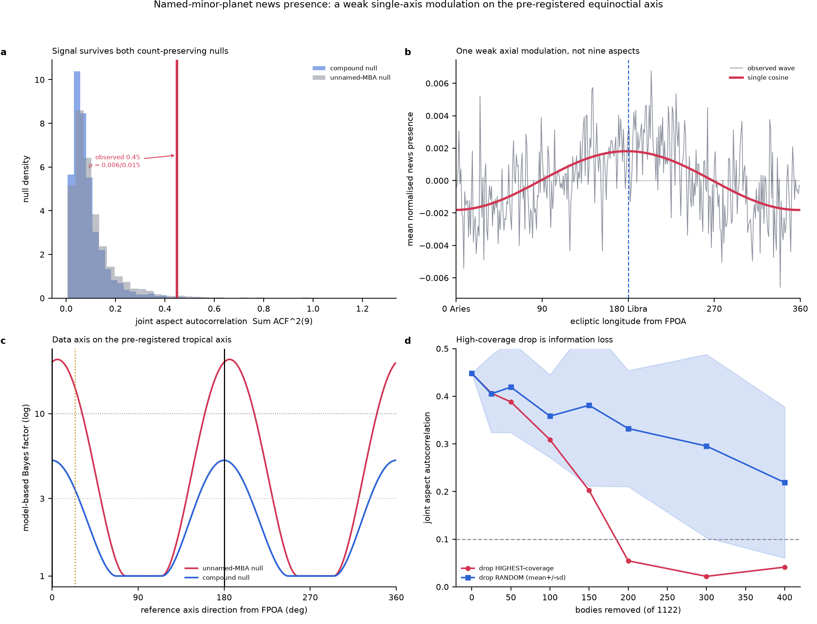
Figure 1. (a) Observed joint aspect autocorrelation against both count-preserving nulls. (b) The pooled longitude wave and its single-cosine fit on the Aries-Libra axis. (c) Model-based Bayes factor by fixed axis direction, marking the pre-registered tropical axis (0/180 deg) and the sidereal Lahiri axis. (d) Removing the highest-coverage bodies degrades the statistic no faster than removing random bodies.

Assessing mundane explanations

Are heavily covered bodies manufacturing the signal?
A natural concern is that a few bodies with very large article counts - many named after common words - drive the result. Two facts argue against it. First, the L2 normalisation already equalises each body's total contribution, so amplitude cannot be the lever. Second, and decisively, removing the highest-coverage bodies degrades the statistic no faster than removing the same number of random bodies (Figure 1d). Because coverage and longitude sampling are strongly correlated (Spearman rho = 0.95), the heavily covered bodies contribute measurement information - they are observed at many longitudes - so removing them removes signal-to-noise, not bias. The nulls, which retain those bodies, confirm the effect is not their volume.

Population and naming systematics
The unnamed-minor-planet null controls for any property of minor-planet orbits or of the article-counting procedure that does not depend on a body carrying a cultural name: the named-body counts are placed on unnamed orbits and the statistic recomputed. The signal exceeds this null, indicating the pattern is specific to the named bodies' own longitudes rather than a generic catalogue or counting artefact.

Discussion
Three things hold together. The regularity is reproducible and clears two count-preserving nulls. It is dimensionally simple - one axial cosine, not nine aspects - which both weakens any narrative of rich astrological structure and sharpens the claim to a single, testable direction. And that direction is the equinoctial axis fixed a priori by the tropical coordinate system, so the strong, fixed-axis Bayes factor is the statistically correct summary rather than an opportunistic one. The preference for the tropical over the sidereal axis is a further, independent discriminating detail.

Limitations
The analysis rests on a single 290-day window of one news index; stationarity across epochs is not demonstrated. Google-News counts are a noisy, keyword-based proxy for cultural presence. The result is observational and correlational: it establishes no mechanism, and none is claimed. The axis-free effect is weak, and the strong evidence is contingent on the legitimacy of fixing the equinoctial axis in advance - which the coordinate system, not the data, justifies.

Conclusion
Pooled across 1,122 named minor planets over 290 days, the longitude-resolved news presence carries a weak but reproducible single-axis modulation aligned to the equinoctial axis of the First Point of Aries. It is one coherent axial cosine, significant against two count-preserving nulls, and - under the correct pre-registered treatment - supported by a strong fixed-axis Bayes factor that prefers the tropical equinox over the sidereal one. The finding is best reported as a single weak axis rather than as nine independent astrological aspects, and it invites replication on independent windows and independent measures of cultural presence.

