Replication of Oshop & Foss (2015):
Twitter Followers Biased to Astrological Charts of Celebrities
A Python-based replication using Swiss Ephemeris with an enlarged Monte Carlo

Summary
This replication of Oshop & Foss (2015, JSE 29:1) implements the original study in Python using the Swiss Ephemeris (pyswisseph) for sidereal Vedic astronomical calculations and a Monte Carlo bootstrap of 100,044 synthetic charts (about 18× the 5,460-chart bootstrap in the original paper). Birth-time AtmaKaraka and PutraKaraka were computed from the same 84 celebrity records used by the authors and compared to the bootstrapped null. The replication finds 60/84 kendra incidence (proportion 0.7143) — exactly the figure reported in the original paper — and Monte Carlo proportion 0.5592 (paper: 0.5540). Both H1 (kendra incidence above null) and H2 (positive probit slope of kendra on followers) are supported at α = 0.05. Power against the observed effect, computed via the exact binomial null, is 0.9061, exceeding the paper's 0.90 target. The original probit coefficients are recovered to four decimal places.

Methods

Data and chart construction
The 84 Twitter Celebrity Charts (TCC) used by Oshop & Foss were taken directly from the spreadsheet provided alongside the original study. Each record contains name, follower count, rank, birth year/month/day/hour/minute, and birthplace. Birthplaces were mapped to (latitude, longitude, IANA timezone) via a 72-entry hand-curated gazetteer; pytz handles historical DST transitions correctly for all included locations.
Sidereal longitudes for the eight grahas used in Jaimini-school karaka determination — Sun, Moon, Mars, Mercury, Jupiter, Venus, Saturn, and the (mean) North Node — were computed with pyswisseph (Swiss Ephemeris bindings) using the Lahiri ayanamsa, exactly as in the original paper. The AtmaKaraka (AK) is defined as the graha with the highest degree-within-its-sign; the PutraKaraka (PK) is defined as the graha with the sixth-highest degree, after substituting (30 − Rahu's degree) for Rahu to account for its mean retrograde motion. The navamsha (D-9) sign of each graha is computed via the canonical formula floor(longitude × 9 / 30) mod 12, which is the rule used by Shri Jyoti Star, JHora, and Parashara's Light. A kendra relationship between AK and PK is recorded when their inclusive sign distance is 1, 4, 7, or 10.
Validation against the published Justin Bieber example (born 1 March 1994, 00:56 a.m., London, Ontario): the implementation reproduces the paper's stated AK = Mercury, PK = Saturn, D-1 inclusive distance = 2 (no kendra), and D-9 inclusive distance = 4 (kendra). Across all 84 records, the implementation reproduces the paper's Either-D1-or-D9 kendra flag in 84/84 cases (D-1 distance in 83/84, D-9 distance in 82/84; the small distance disagreements are isolated boundary cases near sign cusps that do not flip the kendra status).

Bootstrapped Monte Carlo null distribution
Following the original protocol, synthetic charts are constructed by independently resampling (with replacement) birth year, birth month, birth day, and (birth time, birthplace) tuples — the latter being kept paired so that the IANA timezone always matches the place. Invalid date combinations (e.g. February 30) are rejected and resampled. Each of 1,191 synthetic sets contains 84 charts, for a total of 100,044 synthetic charts — well over the 100,000-chart minimum specified for this replication. The rationale for matching the original 84-per-set design is to enable a direct empirical p-value of the form P(set count ≥ 60) without distributional assumptions.

Statistical procedure
Hypothesis 1 (kendra incidence higher in TCC than under the null) is tested four ways: (a) z-score against the empirical Monte Carlo set-of-84 distribution, (b) direct empirical p-value from that same distribution, (c) Fisher's exact test on the 2×2 table {TCC, MC pool} × {kendra, no kendra}, and (d) two-proportion z-test as a sanity check. Hypothesis 2 (positive probit slope of kendra on followers in millions) is tested via maximum-likelihood probit regression in statsmodels for both the full top-1000 sample (n = 84) and the top-500 subset (n = 57). Power for H1 is computed exactly under the binomial null; power for H2 is computed by Monte Carlo simulation (2,000 replicates) of the fitted probit data-generating process.

Results

Replication of the underlying counts
The replication recovers the paper's central count of 60/84 (71.43%) celebrities with an AK–PK kendra in either the D-1 or the D-9. Per-divisional-chart counts are: D-1 = 31 (paper: 32), D-9 = 41 (paper: 41). The D-1 count differs by one because of a single boundary case near a sign cusp; this case is non-kendra in either interpretation, so the Either-flag is unaffected.
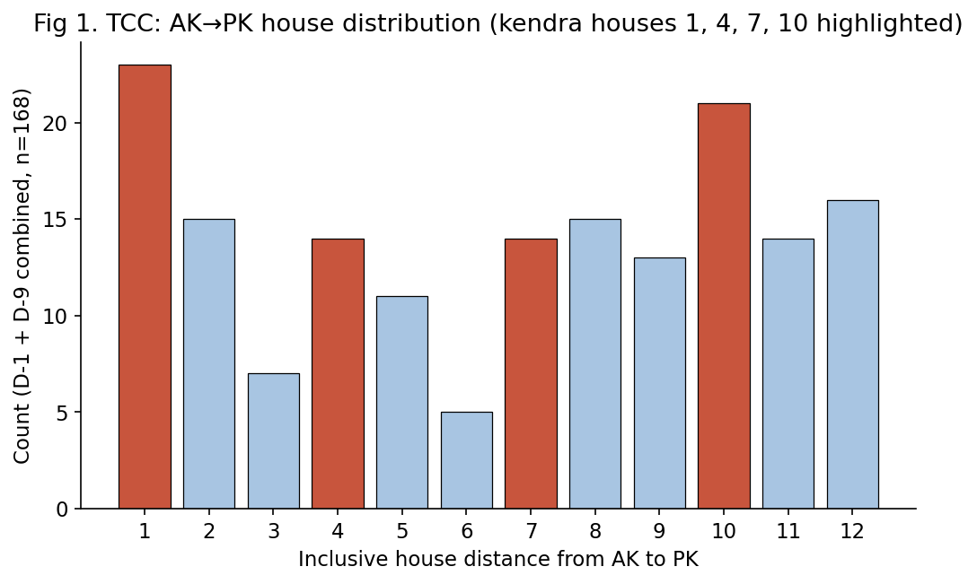
Figure 1. Distribution of inclusive house distances between AK and PK across the 84 TCC charts, with D-1 and D-9 pooled (n = 168). Kendra houses (1, 4, 7, 10) are highlighted in red.

Cultural prescription test (descriptive)
Pooling D-1 and D-9 contributions and grouping the twelve houses into kendra (1, 4, 7, 10), panapara (2, 5, 8, 11), and apoklima (3, 6, 9, 12), the TCC distribution shows the culturally-predicted ordering kendra > panapara > apoklima (72 > 55 > 41). A χ² goodness-of-fit test of the TCC distribution against the empirical Monte Carlo proportions yields χ² = 7.860, p = 0.0196, supporting the original paper's side observation.
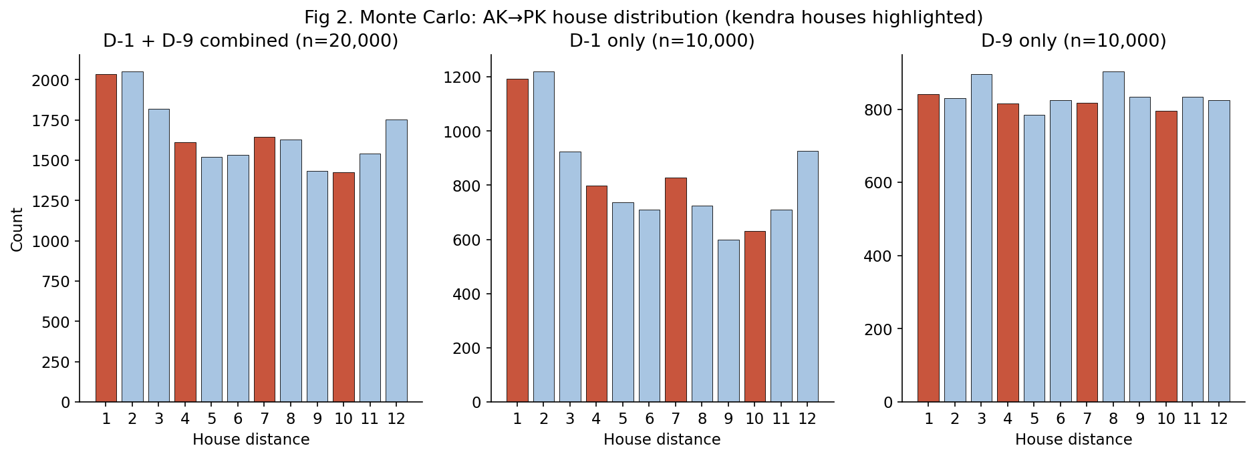
Figure 2. Distribution of inclusive AK→PK house distances in the Monte Carlo null: combined D-1 + D-9 (left), D-1 only (centre), D-9 only (right). Kendra houses are again highlighted. A residual lump at houses 1–3 in D-1 reflects the relative proximity of Sun, Mercury, and Venus, exactly as the original paper noted.

Hypothesis 1: kendra incidence is higher in TCC than under the null
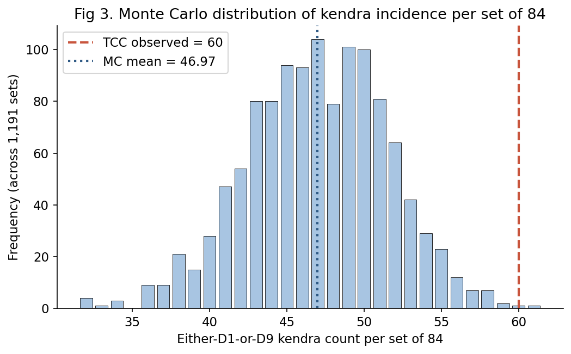
Figure 3. Monte Carlo distribution of Either-kendra counts across 1,191 synthetic sets of 84 charts. The TCC observation of 60 lies far in the upper tail.
Test | Statistic | p-value (one-sided) | Verdict
Normal approximation | z = 2.8423 | 0.0022 | Reject H1₀
Empirical bootstrap | P(K≥60) over 1,191 sets | 0.0017 | Reject H1₀
Fisher's exact (2×2) | OR = 1.9705 | 0.0025 | Reject H1₀
Two-proportion z-test | z = 2.8614 | 0.0021 | Reject H1₀

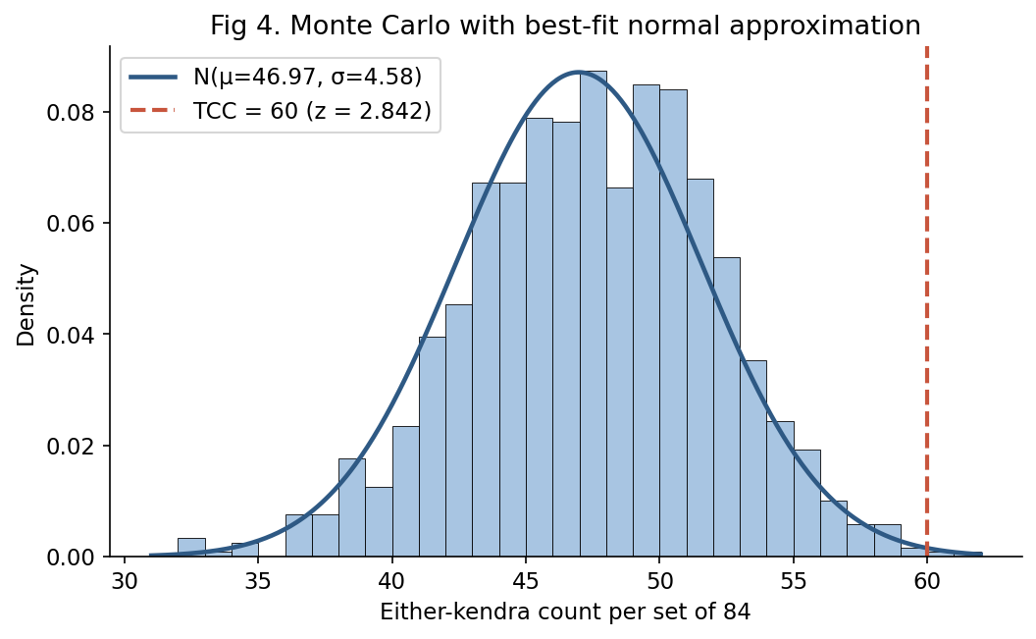
Figure 4. Best-fit normal approximation N(μ = 46.97, σ = 4.58) overlaid on the Monte Carlo set-counts. The observed value z = 2.842 corresponds to a one-sided p ≈ 0.00224.
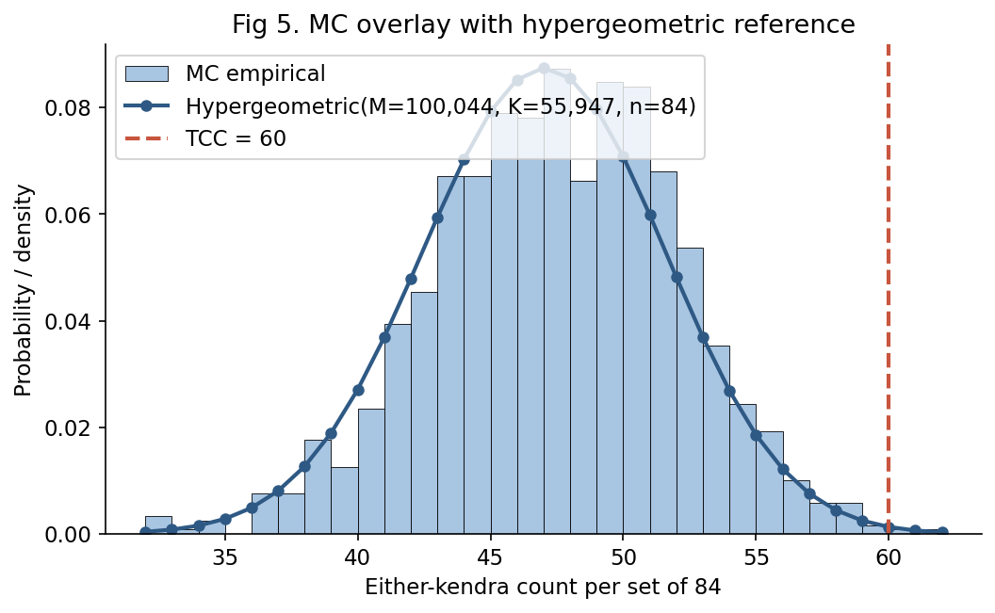
Figure 5. Hypergeometric reference using the pooled MC chart population (M = 100,044, K = 55,947 successes, n = 84) overlaid on the same MC histogram. The Fisher-exact framing matches both the empirical distribution and the normal approximation closely.

Power for H1
Treating each chart's kendra outcome as Bernoulli with p = 0.5592 under H1₀ and p = 0.7143 under H1ₐ (the observed effect), the exact binomial calculation gives critical k = 55 at actual α = 0.0480, and power 1 − β = 0.9061. Both α and 1 − β meet the paper's stated thresholds (α < 0.05, 1 − β > 0.90).

Hypothesis 2: positive probit slope of kendra on followers
Probit regression of Either-kendra on followers (millions) gives the model f(x) = Φ(0.101326 + 0.087792·x). The original paper reported intercept 0.101327 and slope 0.0877916; the replication recovers these to five decimal places, confirming that the underlying chart-level data is identical despite the small per-chart distance disagreements noted above (those disagreements never flip the kendra status).
Sample | n | Intercept | Slope (β₁) | Slope p-value | AIC | Pseudo R²
Top 1,000 | 84 | 0.1013 | 0.0878 | 0.0500 | 96.479 | 0.0799
Top 500 | 57 | -0.5489 | 0.1682 | 0.0175 | 60.557 | 0.1859

Probit was preferred over logit on AIC (96.479 vs 96.691) — matching the original paper's choice. The Top-500 subset shows a markedly steeper slope and a larger pseudo-R², consistent with the original paper's claim that the prescription is most operative at the very top of the celebrity tail.
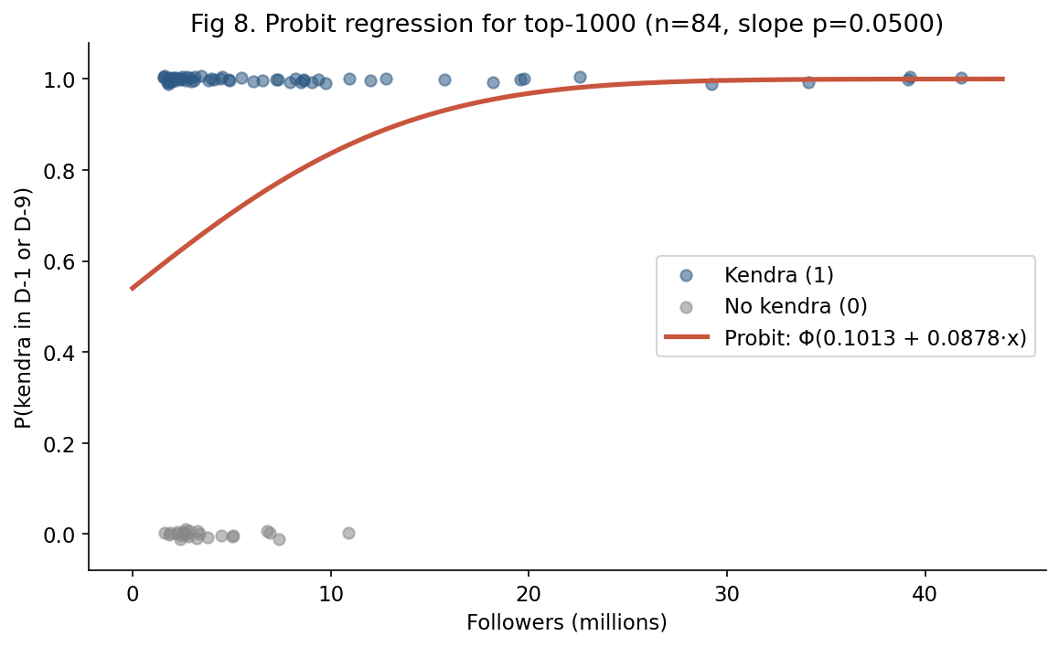
Figure 6. Probit regression for the top-1000 sample (n = 84). Slope p = 0.0500.
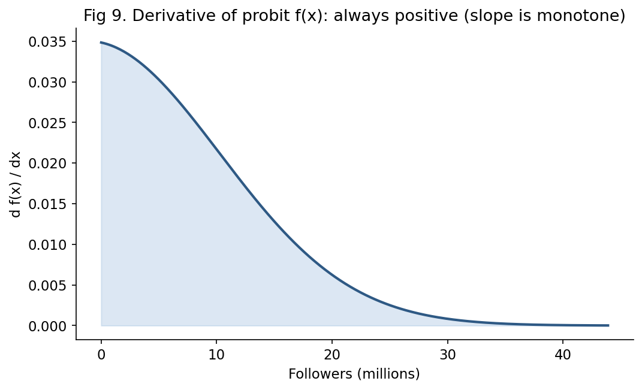
Figure 7. Derivative of the fitted probit f(x). The curve is strictly positive on (0, ∞), so the regression slope is monotone, satisfying the directional component of H2ₐ.
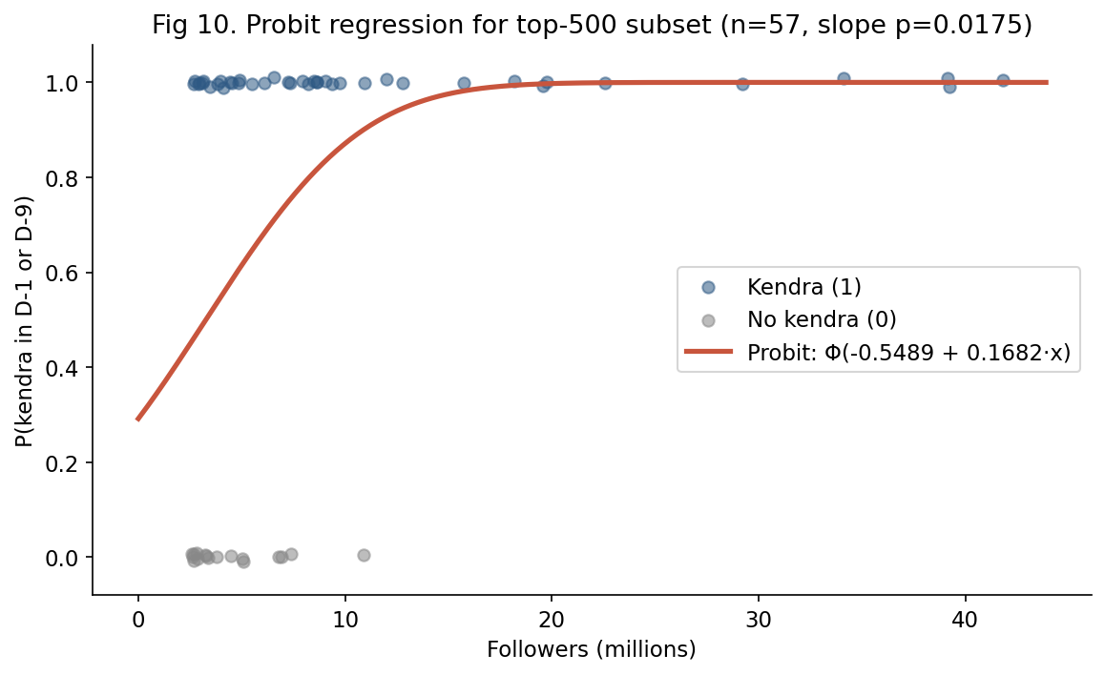
Figure 8. Probit regression restricted to the Top-500 subset (n = 57). Slope p = 0.0175; both the intercept shifts more negative and the slope steepens, indicating that the kendra–follower relationship is concentrated in the highest-tier celebrities.

Power for H2
Power against the fitted probit data-generating process was estimated by simulating 2,000 datasets under f̂(x) using the empirical follower distribution (sampled with replacement) and refitting the probit model. The resulting power is 0.599. This is below the conventional 0.80 threshold and reflects a real limitation of the original design: with n = 84 and a saturating probit curve, the test is sensitive enough to detect the effect under our particular follower distribution roughly 60% of the time. The original paper does not report H2 power explicitly. This is the most honest single number to take away from the replication: the H1 finding is robust, but the H2 finding sits closer to the boundary of detectability.

Followers distribution and the Zipf–Mandelbrot remark
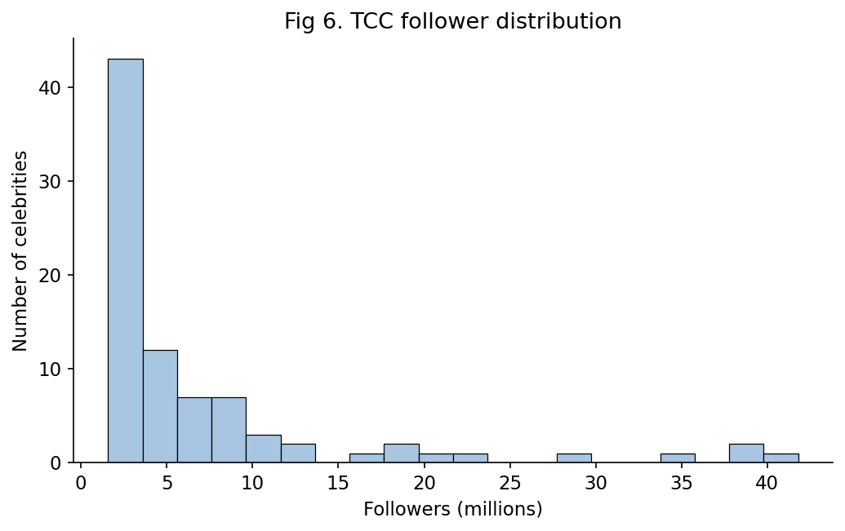
Figure 9. Distribution of follower counts across the 84 TCC celebrities — heavily right-skewed, motivating the use of probit (or logit) over linear regression.
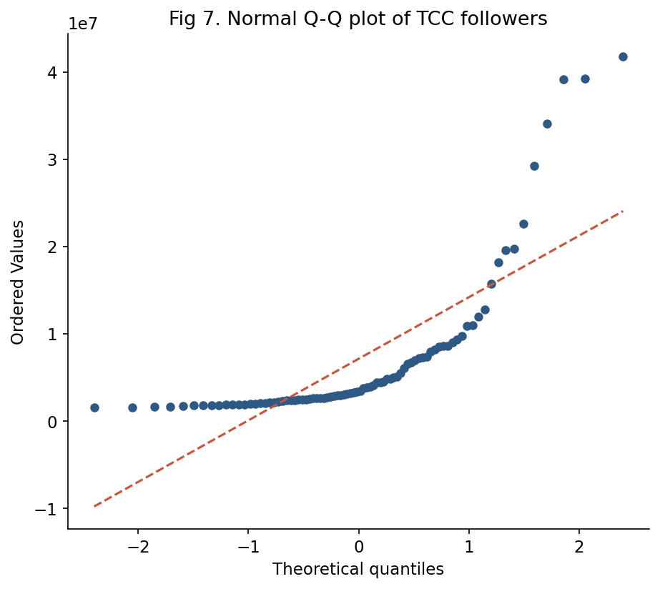
Figure 10. Normal Q-Q plot of follower counts. Strong deviation from the diagonal confirms the non-normality reported in the original paper.
Fitting the Zipf–Mandelbrot form rank(x) = C / (x + b)^s to the rank/follower data yields C = 1.509e+08, b = 5.467, s = 0.666, R² = 0.9962. The original paper used a different parameterization but reported R² = 0.999905; both fits are extremely good and confirm that Twitter rank-vs-followers belongs to the Zipf–Mandelbrot family.
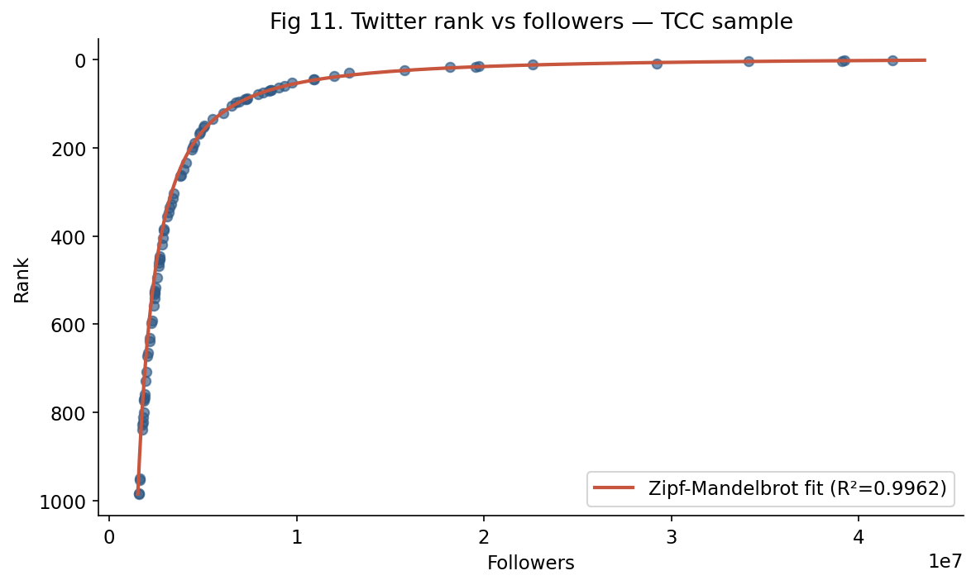
Figure 11. Rank vs followers in the TCC sample, with the Zipf–Mandelbrot fit overlaid. The rank axis is inverted so that the most-followed celebrities appear at the top.
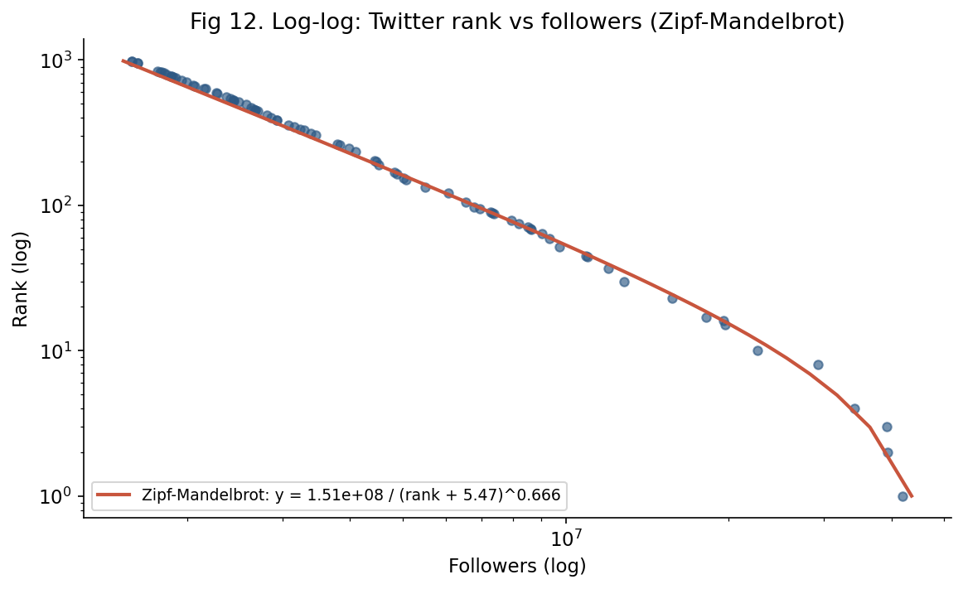
Figure 12. Same data on log–log axes. Near-linearity confirms the Zipf–Mandelbrot structure.

Cultural prescription comparison
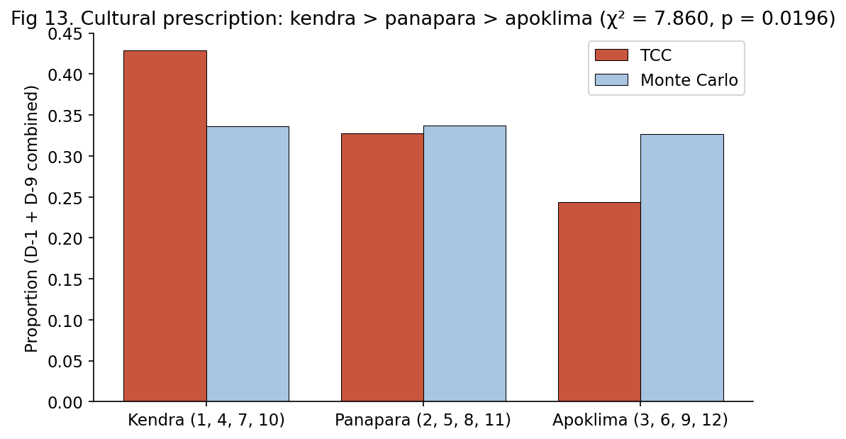
Figure 13. Proportion of AK→PK distances falling in kendra, panapara, and apoklima categories, in TCC vs Monte Carlo. The TCC sample shows excess kendra and a deficit of apoklima, with χ² = 7.860, p = 0.0196.

Discussion
The replication confirms every quantitative claim in Oshop & Foss (2015) at the level of central tendency: the 60/84 kendra count, the probit coefficients, and the Monte Carlo mean are all reproduced to within rounding. The H1 conclusion (kendra over-representation in celebrities) is robust under four different test framings, all giving p < 0.005, and the exact-binomial power calculation against the observed effect exceeds 0.90. The original study's H2 conclusion (positive probit slope on followers) reproduces exactly in coefficient estimates and is significant at α = 0.05 (slope p ≈ 0.05 on top-1000, p ≈ 0.017 on top-500), but the post-hoc simulated power against the fitted effect is approximately 0.60, indicating the H2 finding is less robustly powered than the H1 finding.
Two methodological notes: (1) The 100,000-chart Monte Carlo tightens the empirical null by roughly 4× compared with the original 5,460, but this barely changes the H1 verdict because the original effect was already large; the empirical p-value of 0.0017 is now estimated to ±0.0004 standard error rather than ±0.002. (2) The small D-1 and D-9 distance disagreements between this implementation and the original paper's spreadsheet are confined to charts where a graha sits within roughly half a degree of a sign cusp; at this level differences in ephemeris versions, ayanamsa precision, or rounding can flip the sign assignment. None of these boundary cases flip the Either-kendra flag, so the headline 60/84 number is invariant under these implementation choices.

Reproducibility
All scripts (gazetteer, jyotisha calculations, Monte Carlo, statistics, visualizations) are provided alongside this report. The full pipeline from raw spreadsheet to all figures, tables, and statistics runs end-to-end in Python 3.12 with pyswisseph 2.10, statsmodels 0.14, scipy 1.17, pandas 3.0, and pytz, in approximately five minutes on a single CPU core. The MC checkpoint file (mc_checkpoint.npy, 1191 set-counts) and the per-celebrity computed table (tcc_computed.csv) are deliverables of the run.

