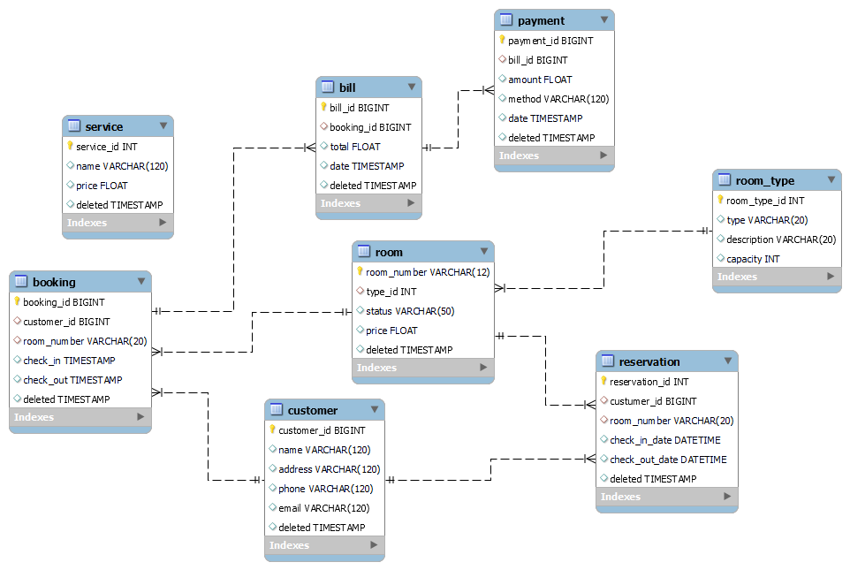

In this ERD:

* Each rectangle represents an entity.
* The ovals within the rectangles represent attributes.
* The lines between the entities represent relationships.
* The crow's foot notation indicates cardinality (e.g., one-to-many).

Here's a brief explanation of each entity:

1. **Customer**: Contains information about customers who book rooms.
2. **Booking**: Represents a reservation made by a customer.
3. **Room**: Contains details about the rooms available in the hotel.
4. **RoomType**: Describes different types of rooms offered by the hotel.
5. **Bill**: Represents the bill generated for a booking.
6. **Service**: Contains information about additional services offered by the hotel.
7. **Payment**: Contains details about payments made by customers against their bills.
8. **Reservation**: Represents a specific reservation made by a customer for a room.

The relationships between these entities are indicated by the lines connecting them:

* Customer can have multiple bookings (one-to-many relationship).
* Booking can have one customer (many-to-one relationship).
* Booking can have one room (many-to-one relationship).
* Room can have multiple bookings (one-to-many relationship).
* Room has one room type (many-to-one relationship).
* Bill is associated with one booking (one-to-one relationship).
* Bill can have multiple services (one-to-many relationship).
* Payment is associated with one bill (one-to-one relationship).
* Reservation is associated with one customer, one room, and one booking (one-to-one relationship).