 typefaces you'll use, your color scheme, textures, mood/feel

Name #123

Clutch

$1

Color: ———

11.4”long

5.9” high

1” deep

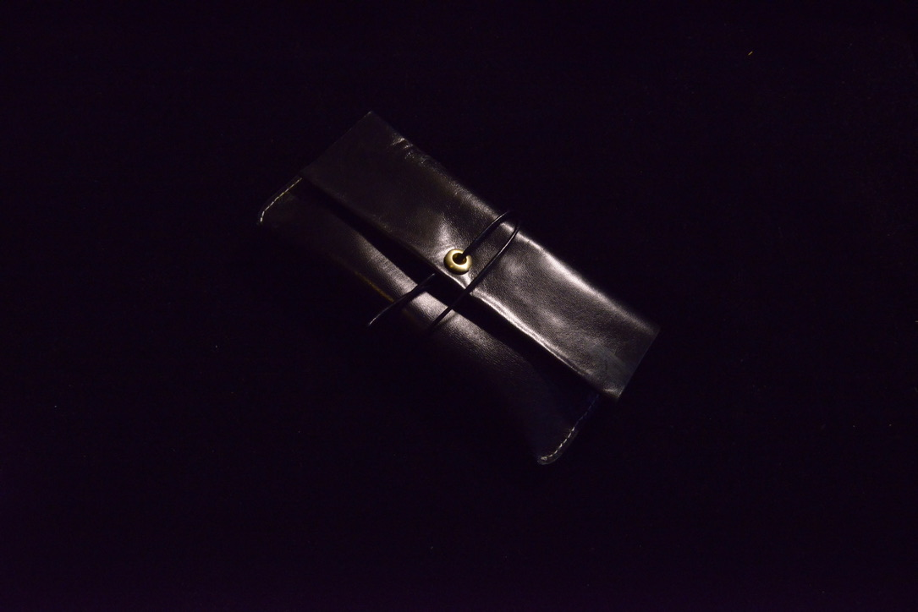

Name #123

Clutch

$1

Color: ———

11.4”long

5.9” high

1” deep

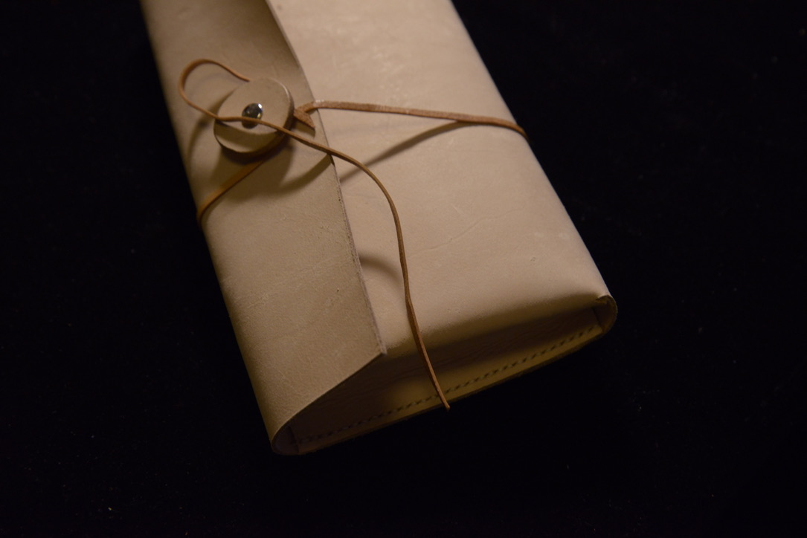

Name #123

Cigarette Box

$1

Color: ———

11.4”long

5.9” high

1” deep

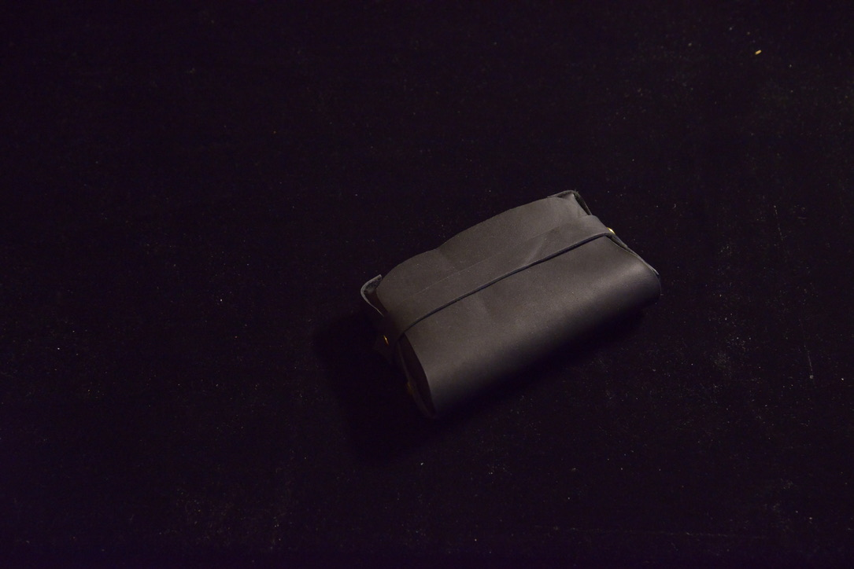

Christmas Tree #123

Accessary

$1

Color:

11.4”long

5.9” high

1” deep

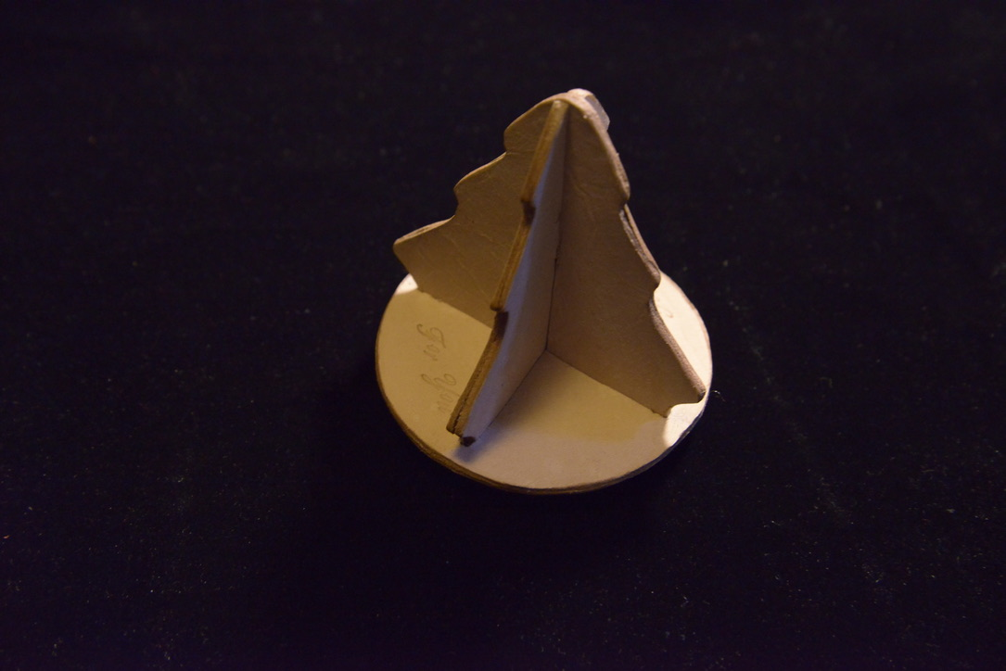

Name #123

Wallet

$1

Color: ———

11.4”long

5.9” high

1” deep

