How to Build the Dance Floor
How to Build the Dance Floor 1
Ideal Dance Floor Layout 1
Before You Arrive 1
When You First Arrive 2
During Pennsic 3
Making New Floorboards 3
Floor Setup 5
Band Shell 11
Audio Set-up 11
Bench Set-up 11
Lighting and Electrical 11
Tear Down 12
Packing the Trailer 13
Appendix A: Contacts 14
Appendix B: Floor Parquet Designs 15

Ideal Dance Floor Layout
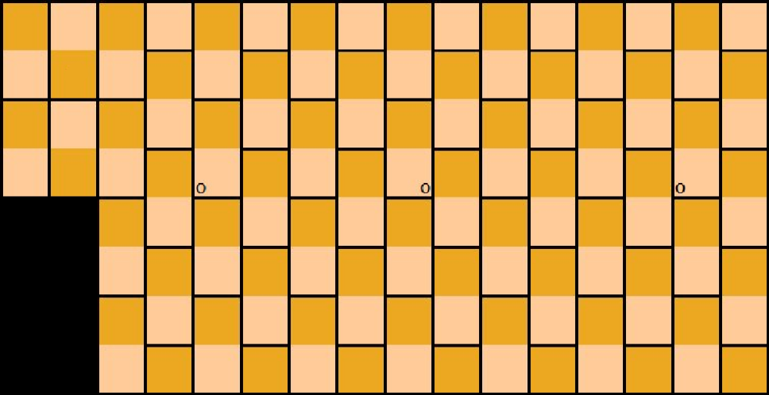
Man Hours
For Pennsic 42, we had a team of 14 for setup, who finished the floor in 7 hours. This was after a team of 3 laid out about two-thirds of the 2x4s the night before, for spacing. For breakdown, we had a team of 22 who finished taking down everything and packing the trailer in 6 hours.

Before You Arrive
Early Spring: Contact the Quartermaster to order all necessary supplies (new floorboards, screws, paint, etc.) All supplies should now be ordered through the Quartermaster. Also contact Tech Services to request 4-5 tables and 30-40 chairs, and to arrange for all electrical needs. Should we get sheet walls made for Pennsic 43, we will also need to make arrangements with Tech Services to place the poles for us.

Before Class Registration Deadline: Register the Floor Construction and Takedown as a class through Pennsic University, labeling them as European dance classes.

2 Weeks Before Pennsic: Post to the Pennsic Dance (pennsicdance@pbm.com) and SCA Dance (sca-dance@andrew.cmu.edu) mailing lists and to the Pennsic Dance Facebook Page to let people know when the floor will be installed so you can get volunteers. Try to let everyone know the intended schedule. Also request that people bring cordless drills. We have several driver bits for the screws, so they don't need to bring those.

When You First Arrive
- Find the Dance Tent: The dance tent should already be set up when you get there. In 2009, there were significant issues with wind, some of the side poles had fallen down and we had to ask Pennsic tech to put them back up. It wasn't difficult, but it had to be dealt with before floor construction could start.

- Get the Dance Trailer Unlocked: Talk to Pennsic Tech (usually located in the center of the block that the dance tent is on) when you get there and ask them to take off the Pennsic locks that are on the trailer. Then go in the side door of the trailer and get our own locks to put on each door. The locks should always to be kept in the Red Plastic container, and this box should always be sitting just to the right (or left) once you open the side door (where the brooms often live). From that point, the Dean, Floor Coordinator and Daily Pavilion Manager/Steward should each take a key.

- Unload Any Non-Dance Items: If (and only if) another group has stuff stored in the Dance trailer, coordinate an unloading time with them. Ideally this unloading time would be EARLY (like Saturday or Sunday), so it doesn't hold up floor construction.

- Ask For the Lighting: Ask Pennsic Tech about installing the lights if not already done (see Appendix D). You may want to give them a diagram of the suggested light set-up found in the section for “Lighting Setup”. Pennsic Tech will install the lights as soon as they can.

- Tables and Chairs: If tables and chairs are already in the dance tent, move them to the edges of the dance tent. If they are not already in the tent, talk to Tech Services.

- Fire Extinguishers: The dance tent requires at least 2 fire extinguishers for safety. If they are not already in the tent and/or mounted on the poles, talk to Tech Services.

- Scrap Wood: You may want to get rid of scrap wood if you find that you have any left over from the previous year’s floor teardown. If there is any scrap materials that you would like to get rid of, set it beside the trailer and let Pennsic Tech know about it. They’ll send someone to take or dispose of the materials.

During Pennsic
- Accessing the Dance Trailer: It is not critical to get in and out of the trailer too often once the floor is set up. You should only need to go in there for mops and squeegees for when it rains, or decorations for some of the parties.

- Purchasing Supplies: All supplies should be preordered through the Dean of European Dance and the Quartermaster. As of Pennsic 42, supplies for the Floor should not be personally purchased. If you need new floorboards, see the next section for directions and Appendix B for design ideas.

- Tent Walls: Among the dance supplies, there is a container of small bungee cords. These are used to hold up the tent walls. Roll the wall up and strap it with a bungee that hooks onto the rope with both of its hooks. You'll want the walls up for air flow and light. Drop them if the wind picks up or if it gets stormy. We use bungees instead of ropes or the built-in clip hooks because if a storm blows in we want to be able to drop the walls quickly.

The first teacher each day is responsible for raising the walls, and either the last person out of the tent is responsible for lowering them or they need to be lowered by 2am, whichever comes first. This information is conveyed to the teachers in the Teacher Packet.

- Ropes: The new tent has ropes wrapped around each tent pole. These are storm ropes and must not be untied, moved, or covered except by Tech Services. If decorations are used on or around the poles, they must not obstruct these ropes (for example, crepe paper streamers are acceptable because they can be ripped off if needed without slowing Tech Services down, but actual ribbon would not). Talk to Tech Services before adding any decorations that might obstruct these ropes or before touching said ropes.

- Take Inventory: This can be done after the floor is up, once you've had a chance to clean up the trailer a bit and put away the supplies used during floor construction. You can go through and confirm that you have everything and that you know where it all is.

- Stereo: The stereo gets locked up in the Music Box every night or any time when there is no one else in the dance tent. You don't need to disconnect the speaker wires. Try to run the speaker wires out the hole in the top of the Music Box so as not to damage the speaker wires by closing the box on them directly (i.e. pinching them near the hinges) when putting the stereo in the music box before locking it.

Making New Floorboards
We have quite a few spare 2x4s that haven't been used yet. These could potentially be used to expand the dance floor. The extra 16ft pieces in the trailer have all been waterproofed. The 2x4’s have never been replaced, and even though some do say scrap on them they have still been used.

- Ordering: All supplies should be preordered through the Dean of European Dance and the Quartermaster. As of Pennsic 42, supplies for the Floor should not be personally purchased.

- Required Supplies:
  - Plywood: 4’ x 8’ Sheets of A/C grade 3/4 inch TG (tongue and groove) plywood subflooring

  - Paint: National Trust Brand paints in semi-gloss:
94-6A Pale Copper for the general floor color
93-7C Hickory Wood for the lighter pattern color
93-7A Lyndhurst Mahogany for the darker pattern color
93-8A Walnut for the borders

  - Water proofer: Thompson’s water seal.

  - Primer

  - Screws: We are currently using 1 5/8” Philips/square screws and it takes about 5lbs of screws for the entire floor. Inventory screws during War to make sure that there are at least 5lbs of screws for the next floor coordinator.

- Schedule for Replacing Floorboards: As of Pennsic 42, only about 20 floorboards had been replaced, but 20 were marked needing replacement. Given this, we should be replacing between 2 and 4 boards per year.

- Procedure:
- Set-up: We have made new boards both on the ground and propped up on tables. For waterproofing and priming, it’s probably easier to paint them while they are on the ground. When painting borders and parquet designs, it’s sometimes easier to do when they are sitting on top of a table, but you have a limited number of tables.

- Waterproofing: Water seal the undersides of the plywood, and all sides of 2x4s. Note: the latter is reasonably accomplished by putting them on the plywood, and spraying them, then nudging the boards over and around. Don't waterproof the top side of the plywood (the primer won't stick properly to the boards if the top has been watersealed). The suggested time for allowing the water sealant to dry is 48 hours.

- Priming: Once the waterproofing is dry, prime the top side of all the plywood sheets. Suggested drying time may vary. Make sure to double check the drying time on the container. Primers generally take 6 to 12 hours to dry. If it is an oil-based primer, then it takes about 24 hours to dry. If you want to do a second coat, you only need to wait an hour for the primer to dry. All drying times may be longer if the humidity is high.

- Base Coat: Once the primer is dry, apply the base coat to the top side of all plywood sheets. This can be done with rollers, so it goes fairly quickly. Note: the primer is tinted, so to avoid confusion, it is best to apply a base coat to ALL of the plywood sheets now, even if some won’t be painted further until some future date.

- Doing the Borders: After the base coat of paint is dry, measure the size of the borders and apply painter's tape. (3" borders on short edge, 2.75" on long.) Paint along the edge of the painter's tape, along the side you're going to paint with the dark boarder, with the light base color. (The reason you do this is because the wood is not perfectly smooth, so if you do that first and let it dry, it fills in the gaps under the tape with the correct color.) Then once that is dry, you can apply the dark border paint with rollers. This makes for a cleaner edge.

- Painting Patterns: If you put the boards up on a table, it's a lot easier to paint the patterns than if they are on the ground. You may paint any pattern design that you would like as long as it looks somewhat medieval. See Appendix E for parquet patterns that have previously been painted on the floor.


You can do this when you first arrive at Pennsic, leave them to dry for a few days, and then use them. But we've found that sometimes the patterns were coming off from being danced on, especially if it rained. So, depending on the schedule, you may not want to integrate the new boards the year that you first paint them. You also want to be careful not to stack them too early, because you don't want the paint to stick the boards together.

- Drill Screw Holes: This is the last step of preparing the new boards. Use a thin drill bit to drill holes for the screws. The red dots indicate where the holes should be driven.

- Cutting New Single Pieces: If you ever need to scrap out any 4x4’ boards, they’ll need to be replaced by cutting a 4x8’ board in half. Choose a 4x8’ board where the pattern is painted on the left side of the board (indicated by looking at the board with the tongue on top as in the picture above) or a 4x8’ board where only one half of the board is scrap. Note that your cuts need to be as straight and perpendicular as possible otherwise you may have alignment problems when you’re putting the rows together.

Floor Setup
- Unloading the Trailer: This can all be done during Land Grab on Saturday morning, if you managed to get the locks switched early enough and if you have enough people to help.

  - Water Coolers: Bring LOTS of water for the initial unpacking. The filtered water from Chirurgeon’s Point usually isn’t usually set up until Sunday, but you can still unload and clean the water coolers to get them out of the way.

  - Benches: The benches have been packed along the right side of the trailer. These should be fine where they are, but if they are in the way, they should be unpacked to the east end of the pavilion, where they will be out of the way until the Floor is constructed.

  - Tarps: Find all of the black tarps. These will be the first things to be placed on the ground.

  - Band Shell: Unload the band shell onto a table at the west end of the dance tent until the floor for the band shell is done. Do not set them on the ground because people will walk on them and they will break.

  - 5. 2x4’s: Set out enough 2x4’s for the first row. You’ll need 3 A’s, 3 B’s, 5 Sleepers, and one special Short Sleeper. The remaining 2x4 framework can be laid out around the first row.

  - First Floorboard: This should be the top piece under the band shell. Unload it near the western center pole.

  - Touch Ups/Scrap: Set aside any pieces that need its design repainted on the east side of the dance tent so that it is out of the way of the construction of the first couple of rows. There may also be pieces which need to be determined whether or not it’s scrap.

  - Minimize Unloading: Don’t unload any more than you have to. Try to unload the remaining items only as you need them. Avoid stacking too much stuff where you're going to be laying your first few rows. Make sure any wood pieces are unloaded onto extra tarps, not resting directly on the ground. Moisture can warp or damage them.

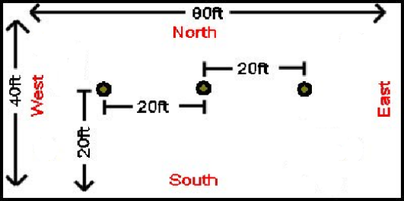
- Center the Poles: Align the west center pole in the center of the tent if it’s off-center. The tent is approximately40ft wide. Take measurements with a tape measure to get the poles roughly equidistant from the walls of the tent. Assuming we continue to receive the same size of tent, the three center poles should be about 20ft apart from each other. If we end up with a bigger tent, this distance will need to be some increment of 4 feet.
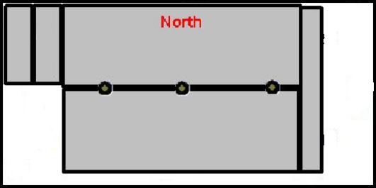
To Move the Poles: Use one of the stakes (that are used to support the band shell) and slide it through the holes in the pole. Two strong people should be able to lift and move it. If the pole is too far into the ground, use a shovel to dig a small trench in the direction you want the pole to be moved.

- Tarp Placement: Place the two large tarps on each side of center poles starting about 8 ft west of the western center pole. The black tarps that are 4’x16’ go along the east side of the dance floor, while the shorter 8’ tarps are used in the northwest corner under the band shell. Use 2x4’s to keep the wind from blowing them.

- Lay Out Floor Joists: The long floor joists are labeled A and B. The A’s are longer than B’s (16' versus 15'5”, respectively). A’s are on the south side and extend the width of center poles. B’s go on the north side and their ends are flush with the north edge of the poles. Each row has an A&B down the center of each floor board. The A’s & B’s are also laid to cover half of the top and half of the bottom of each row of flooring.

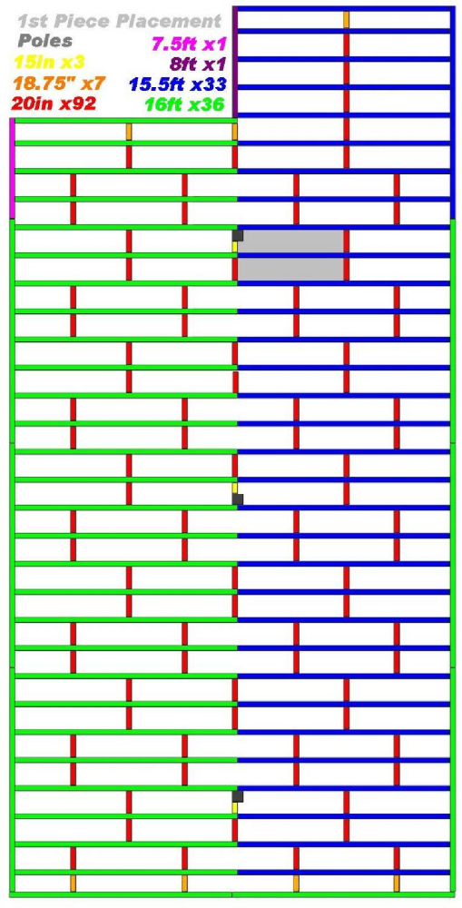
- Laying Down Sleepers: Sleepers are usually the 20inch 2x4’s, but there are a couple shorter ones to fit between a joist and the center poles. A’s must extend beyond center enough to get to edge of center sleepers or be at least 3 inches from the south edge of the floor. The sleepers should not be touching the B’s in the center. The sleepers are placed where perpendicular to the A’s & B’s at every place two floor boards meet in the same row.

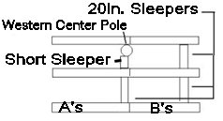
The pictures below show a view from the east, looking west. If you can’t eyeball its straightness, use a string tied between the western and eastern center poles to help you with the alignment.
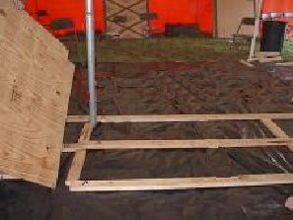
Some sleepers are labeled 18.75. These are used at the ends of the floor so that the last joists fit under the last row of floor. Occasionally, they may need to be used elsewhere to readjust a row if the layout of the joists no longer lines up correctly with the floorboards.

Sleepers labeled as 20.25” and 20.5” weren’t cut correctly. They can still be used, but try to use all of them in a row together so that things remain aligned. As a project, someone may want to trim them down to 20” sleepers to ensure we have enough to go around.
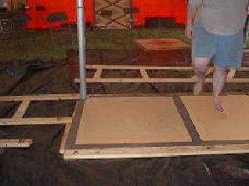
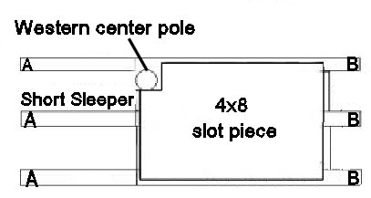
- Starting Floorboard Layout: Start at west center pole with the notched, 4'x8' sheet. This board should be labeled as “First Down” or “Last In”. The notch is along the tongue side of the TG plywood. On all pieces of the main floor, the tongues go to the west (Tongues To Troll). Again, the photograph is from the east and the diagram is from the west.


Once you have the board in place, screw in the corners. Look down the edge of board to check to see if it is aligned with the center of the other end of the dance tent. Rotate the board accordingly if not.

- Completing the First Row: As each row gets laid out, double check on ends of joists to make sure that 3.5 inches are available for the edge 2x4’s that are put in last (this will result in a small amount of the 2x4 hanging outside the edge floor, preventing garb from catching). This needs to be done before floor sections are screwed into the joists. If you do find that these 2x4s are out of line, you can tap them with the rubber mallet to move them into place, before they're screwed in. Once the row is properly aligned, drive in all of the screws. Use 17 screws on the 4x8’ boards and 12 screws for the 4x4’ boards. The red squares show where your screws should be placed. (Note: the tongues are across the top)

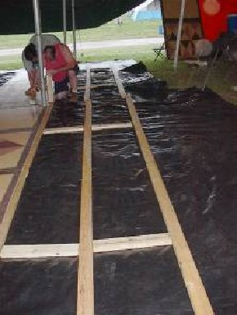
- Starting the Next Row: Sleepers and joists get laid out beside this row for the next row. [Reminder: Sleepers only need to be under the seams between floor sections. Generally, the seam placements are offset by four feet (half of a floor piece) from the previous row’s seams.]

- Techniques for Alignment: Fit tongue into groove. Use mallets and scrap lumber to fit sections into place. If a piece doesn’t align correctly on all sides, choose a side to align it and screw in a corner to use it as a pivoting point to align the side.

Notice that there are two different widths of floorboards. Some of the newer pieces have a slightly longer tongue and slightly shorter floor space. Perhaps marking these pieces while you’re unloading would help. Then you’ll be able to keep all of the boards of the same size in the same row to minimize gaps.

If you're a couple of pieces along the floor, where you're straddling across a seam from the previous row, you can sometimes end up with a pivot point in the middle because of slight misalignments or because some boards have a different length due to the tongues being smaller or bigger than others. Because of this, sometimes you'll find you're hammering on one side, and the other side is coming loose. If you're working from the south side, adding sheets to the row, then the southwest corner is being tapped into two sheets. If you get that corner flush enough you can drive a single screw into the corner of the sheet, and then do a bit more tapping on the north-east corner of the sheet to try to tap the north-west corner in.

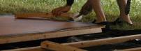
You can use a couple of your people to “stand” for you. Two people are best, to get either end of the board. They can put their heels on one sheet and their toes on the other and adjust their weight on either to help with alignment when you're using the mallets to tap the tongue into the groove.

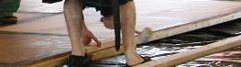
As new rows get laid down, use shims under joists where there are depressions in the ground. Not doing this caused problems in Pennsic 32! Put the shims perpendicular to the 2x4s or sleepers you are putting them under to make them more stable. Shim as you go and keep centered on the line established by the string (if you’re using string).

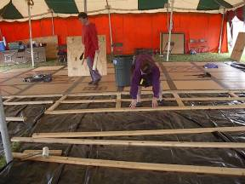
Sleepers (20") do end up being fairly snug against the A's and B's, so they are good spacers. But you can always make minor adjustments. When you're getting new A's and B's aligned when you're trying to put new boards in, you're trying to make sure everything is running nice and straight to the edge of the board, and you want there to be some overlap. You want the 2x4 to be roughly halfway under a new board, for the one that is along the edge, so that there is enough room for the next board to also screw into it.

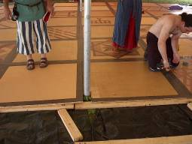
Remember, sleepers only go under the seams between floor sections, not every four feet, regardless of what is above them. They can be placed temporarily while laying out the joists and sleepers for better alignment, but then the inappropriate sleepers should be taken out before the floor sections are put down.

You can start by roughly laying the sleepers in the positions you'll need them for the upcoming rows, but as you bring the sheets over you'll want to move the sleepers out of the way. The floor is heavy and hard to maneuver. It's easy to pinch fingers. Put the sleepers in roughly the right place but slightly offset – if you're laying a sheet on the south side, then offset them to the north by 6" - 1'. As you start to get everything tapped and screwed into place you can just slide the sleepers down to be partially under the floor where it will be screwed into place.

- Notched Sections: As the floor sections are being placed, keep watch for the notched 4x8’ sections that are for the center poles. This is a fussy step, but the center poles can be moved. (Note: a 4'x4' section is shown in the photo, but the new notched floorboards are now 4x8').

As an experiment in 2009, for the center pole section, we decided to cut the notch out of the bottom corner of the left side of the sheet. As a result, you need to shift the center pole approximately 6 inches to the west, so that it is slightly out of alignment from the other poles. This shouldn't have any impact on the structure integrity of the tent.
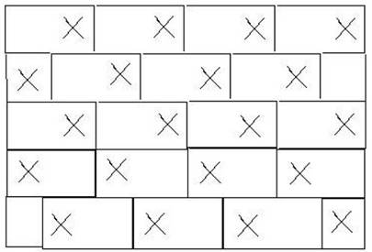
- Checkerboard Pattern: The goal, as floor sections are set out, is to eventually make a checkerboard pattern. This isn’t entirely possible as sections have been painted. Most sections, when viewed with the tongue at the top, have been painted with the parquet design on the right side. New sections should be painted in this manner. Sections that were painted on the left side were put aside until needed for the last few rows at the eastern end of the floor. If needed, the checkerboard design can be maintained by not offsetting one row from the one next to it.

- Long Edges of Floor: The 2x4s labeled “C” get placed under the long edges of the floor. Hopefully, people have been making sure that all joists are 3.5 inches in from the ends of the floor so these 2x4s fit evenly! Along the edge of the floor you want a bit of 2x4 hanging out, but not too much. This is to prevent garb catching on the edge of the floor. The other benefit is that along the west side, you have exposed tongues of the floor, so if you have an extra 1" to 1.5" overhanging, that's a bit of extra wood protecting the tongue.

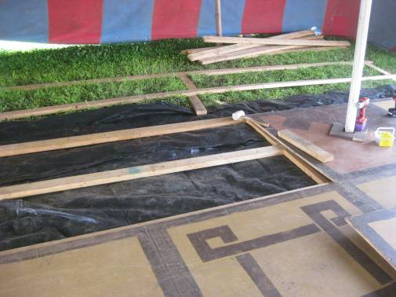
There is a special border piece that for the southwest corner which is clearly labeled. Also, along the north edge of the floor, you can fit 3 C pieces and 1 B piece evenly.

- Musician's Area: Layout of the musician’s area is shown to the right. It is an 8x16’ area using 4 floorboards. In 2010, we used 3 B’s and 1 A piece on the end. This eliminated the need for all of the D pieces except one which was used on the left side (not pictured).


In general, pieces that are splintered from rain damage or painted incorrectly go here because of less fast-paced foot traffic. Someone sitting is much less likely to trip over a splinter than someone who is dancing, and this area is more likely to get wet being at the very edge of the tent.
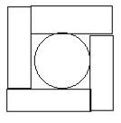
- Trim around Poles: Use small brown painted blocks and screw them around each pole with the 3” gold decking screws.

Band Shell
There are 5 wall sections for a band shell (labeled 1 through 5). This really should be put up, as it keeps drafts from the musicians and directs their lovely music toward the dancers, even though it makes the area really hot during the day. Lay all the wall pieces face down and connect the hinges with pins. Once all of the pieces have been pinned together, it takes about 4 or 5 people to lift it and move it to curve around the northwest corner. With enough tall people, this process can be done with the boards standing up. Once the band shell is in place, there are 4 support beams which are also hinged to the walls using pins. The bottom of each support beam is then staked to the ground.

Audio Set-up
Once the northwest corner of the floor is done, the music box can be hauled out of the trailer and then you may begin setting up the stereo system.

The stereo is kept in the music box. If the music box is locked, the code for the lock is currently 1581. There are instructions taped to the inside of the small red box of how to change the combination code number if the need arises.

Attaching the speaker wires to the stereo should be self explanatory. Each wire is labeled with a color (black, red, grey or blue) and whether it’s left or right. Leave enough slack in the speaker wires such that the stereo can be put inside the music box, with the wires routed through the hole in the back top left corner of the box.

Bench Set-up
The benches are easy to assemble. Take two leg pieces and slide them into a support beam, then place the seat on top. Set these up last. Once they are set up, they are difficult to move since you’ll need two people to carry them by the legs. If you set them up before the floor is completed, they’ll just get in the way. If the benches are getting difficult to assemble, contact Master Stephen of Cambion (lanhamlaw AT att.net), who provided many of the benches, to fix this.

Lighting and Electrical
Lighting and electricity is set up by Tech Services’ Electrician. Contact Pennsic Tech Services in the Spring about this.

People have had concerns in the past about rain water hitting the lights/electrical. As long as the light is well sealed (no problems with the gasket), then the water will just steam off of the thick glass. So far we have had no problems. Avoid water on the stereo. For the grey electrical boxes on the side poles, the worst that would happen is that the GFI might trip in the grey box. Tech Services has asked that we do not reset these ourselves, as there are sometimes other groups on our system and doing so affects them as well. Please contact Tech Services to fix any problems with the electricity or lights.
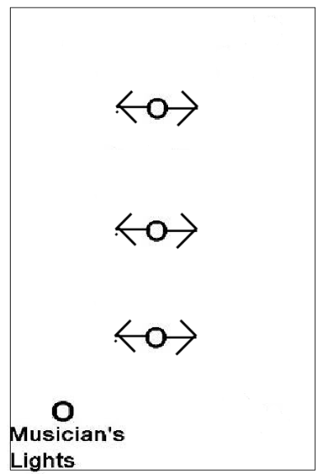
Installing Lights:

- Have the Electrician point all lights upwards towards the tent ceiling, to give a nice, ambient, indirect light.

- For Pennsic 42, the Electrician put the lights on the two end poles on one switch, and the lights on the center pole on a separate switch. This allowed us to dim the lights on certain evenings for better ambience. With the Electrician’s consent, we should continue to have the lights on each pole put on their own switch.

Tear Down

- Sweeping and Mopping the Floor: This can potentially be started during the last class, as long as they don't mind.

- Unscrewing the Floor: Once the floor is dry (from mopping), people can start pulling up screws. Don't worry about removing the floorboards yet. Removing screws is the part that takes the longest, so you want to get a head start on this. Bring as many cordless power drills as possible for removing screws. Try to organize the people removing screws, to be efficient. Have someone follow behind the people with the screw guns to pick up the screws.

- Removing the Floorboards: Once a bunch of floorboards are screw-free, and more helpers have arrived, you can start removing floorboards. It's easy to miss screws. Verify that there are not any screws stuck in the floorboards. If so, they need to be removed.

- Removing Problem Screws: Try not to strip the heads of the screws. If you're having difficulties, try using another screw to remove any dirt from the head of the screw you are trying to remove. If this doesn't work, have the team move on to removing other boards. Tilt it on its side to get a better view and try pushing the screw from the underside using a block of wood while trying to unscrew it. If it's a short sleeper that's stuck, rotate the sleeper to unscrew it from the screw, and then try pushing the screw out with a block of wood. As a last resort, we bought a tool in 2009 to cut off the dead screw and then hammer it down so it's flush with the other side.

- Packing the Stereo: Everything should fit in the cardboard box, but may hang over the top of the box making it slightly difficult to close the lids of the stereo’s box.

- Tearing Down the Band Shell: The band shell is easier to teardown than to put together. Start with piece #1 and remove all the pins. Once each piece is free, set them out of the way until all of the floorboards are loaded into the trailer.

- Disassembling the Benches: Each bench is made up of four pieces of wood which be disassembled. The seats come off very easily. If you have troubles removing the legs, hold the legs upside-down and use one of the mallets to knock the support beam off.

- Packing the Trailer: See the next section of this document.

- Locking the Trailer: Remove our locks and get Pennsic Tech to put their locks on the trailer. Our locks are to be kept in the red plastic container, and this box should always be put away at the end of the year just inside the side door where it can easily be found.

- Stacking the Tables and Chairs: Stack tables and chairs at the east end of the tent for collection.

- Fill the Trenches: If there were any small trenches dug to move the poles, make sure that they get refilled.

Packing the Trailer
- Balancing the Trailer: The most important rule to loading the trailer is that it needs to remain balanced. While loading, someone needs to periodically keep lifting the front of the trailer to confirm that the weight is evenly distributed. It should take about 80 to 100 lbs to lift tongue; if it is a little off it is okay because it is moved with a tractor, but more than that is dangerous. The weight needs to be well balanced over the axels. If there’s too much weight on the back of the trailer and not enough near the front, Pennsic staff has a hell of a time keeping the trailer hitched while hauling it.

- Stacking the Floorboards: Stack all of the 4x8 sheets as neatly as possible in the center of the trailer. The order in which the pieces are stacked may vary from year to year depending on what needs to be done during the next year. For the most part, floorboards can be stacked as they are removed from the floor east to west, with a pair of 4x4’ sheets between about every six to seven 4x8’ sheets. The 4x4’ sheets must be loaded in pairs to keep the floorboards stack balanced. Also, make sure that the western notched floor board is the last floorboard to be stacked. Only the band shell pieces are allowed to be stacked on top of all the floorboards.

Floorboards which may be scrap should probably be placed towards the top so the next year’s Floor Coordinator can determine if they should be used again or not. Also, if pieces need to their painted designs to be touched up, then those pieces should also be stacked near the top so that it can get repainted.

- Stacking the 2x4’s: Stack the 2x4’s on the left side of the floorboards. It is not necessary to keep the A, B and C pieces separated. They can easily be separated when removed next year. It is advisable to stack the sleepers in order against the wall and use the longer 2x4’s to keep them in place. The floorboards in the center of the trailer will keep the 2x4’s from falling over.

- Stacking the Benches: The benches need to be stacked in the very back of the trailer to offset having too much weight in the front of the trailer. The seats can be stacked against the floorboards, then the support beams in front of the seats. The legs of the benches can be stacked in a couple of piles on the right side of the trailer.

- Packing the Tarps: The ground tarps can be placed on top of the floorboard pile because they aren't too heavy. You always want to make sure it's easily accessible for unloading because they get laid down first underneath everything else.

- Packing the Rest: All the rest of the supplies can be stacked along the front wall of the trailer near the side door.

Appendix A: Contacts

Pennsic Staff Permanent Emails:  Mayor:  pennsicmayor@gmail.com  Exchequer:  exchequer@pennsicwar.org  Deputy Mayor of Cultural Affairs: pennsic.cultural@gmail.com  Pennsic University Chancellor: pennsicuniversity@gmail.com  Pennsic University Registrar: pennsicuregistrar@gmail.com  Pennsic University Point Coordinator: pennsicupoint@gmail.com  Dean of School of European Dance: pennsic.eurodance@gmail.com  Deputy Mayor of Technical Services: pennsic.techserv@gmail.com  Site Coordinator: sitecoord@pennsicwar.org  Pennsic Power & Lights:  No Email, contact through Deputy Mayor of Technical Services or Site Coordinator | Previous Floor Coordinators:  Pennsic 30 – Flip  Pennsic 31 – Adele  Pennsic 32 – Adele  Pennsic 33 – Margaret  Pennsic 34 – Adele  Pennsic 35-38 Darius david.a.learmonth@gmail.com  and Lynnette  andrea.lynn.learmonth@gmail.com  Pennsic 39 – Gwommy gwommy@gmail.com  Pennsic 40 – Darius and Lynnette  Pennsic 41 – Darius and Lynnette  Pennsic 42 – Connor Roe jcmroe@yahoo.com  and Darius  Pennsic 43 –

Appendix B: Floor Parquet Designs
Shown here are pictures of every parquet design ever painted for the Pennsic dance floor. There are a few that have been painted with the same design, and some copied multiple times. It’s preferred to have as few duplicates as possible. These should give you ideas as to what to paint, but avoid doing something off the wall like the very last tile in the list.

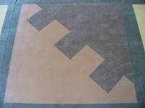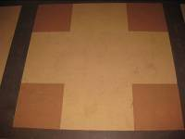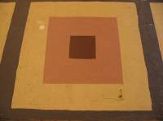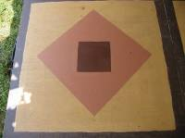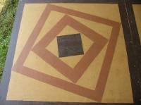

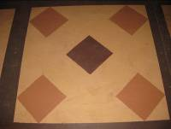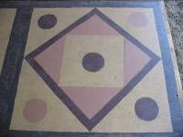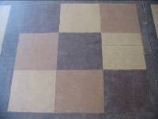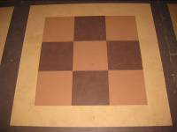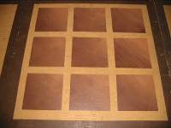

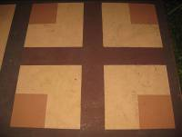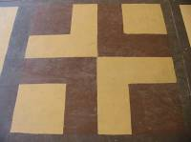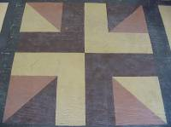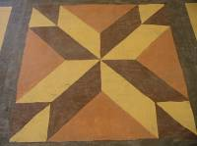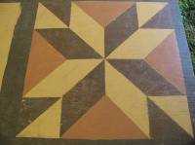

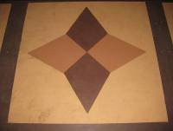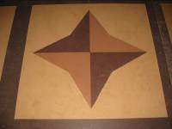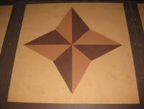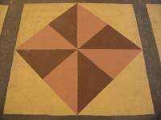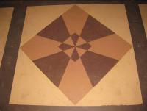

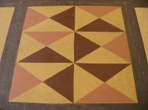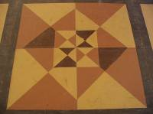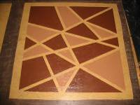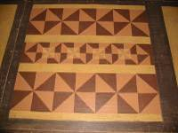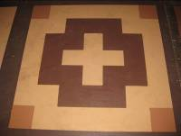

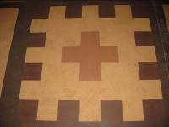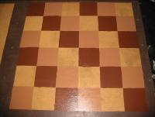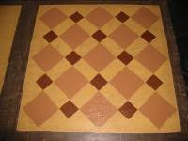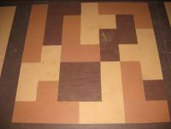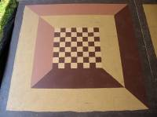

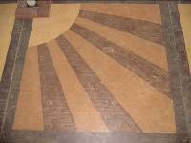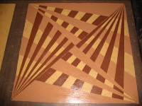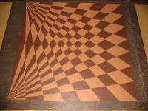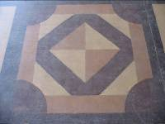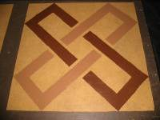

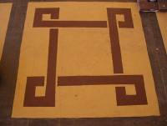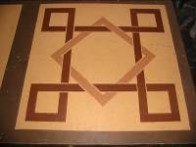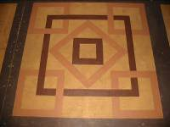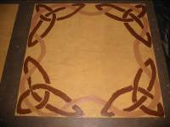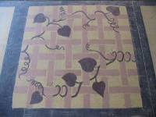

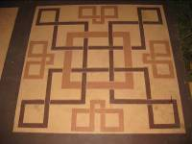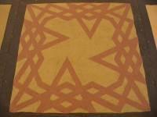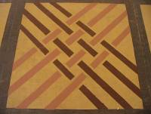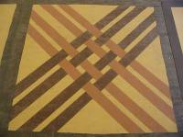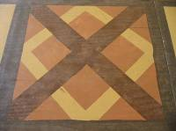

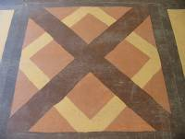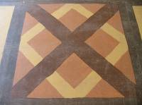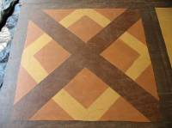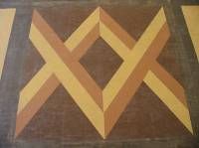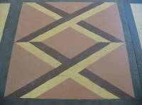

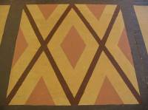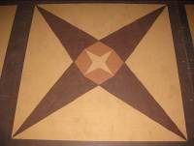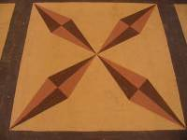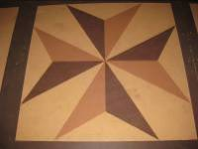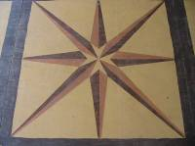

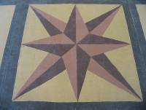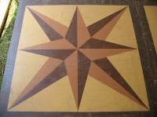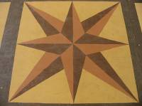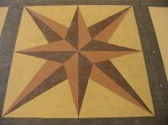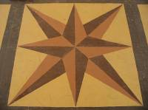

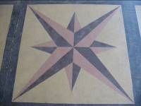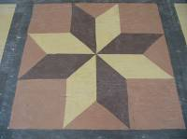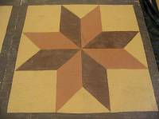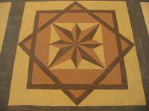

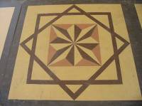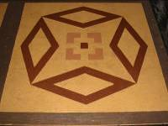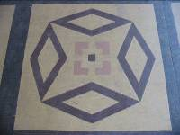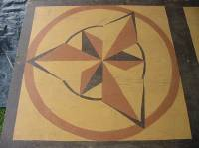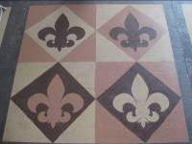

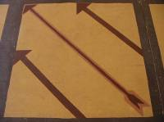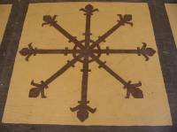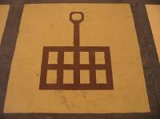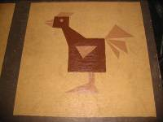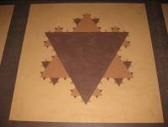

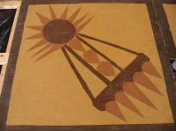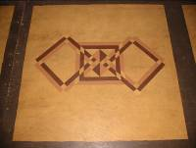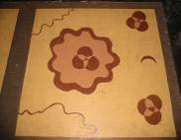

Updated 08/2013 by THL Margherita Battistina and Lord Gwommy Arpad

