Project Case | 
COSC6050003 | COSC6067052
Programming for Business
Computer Science | E263-COSC6050-EV01-00
Valid on Even Semester Year 2025/2026 | Revision 00

- Mahasiswa tidak diperkenankan untuk:
Students are prohibited from:
    - Berdiskusi dan/atau bekerja sama dengan mahasiswa lainnya,
Discussing and/or cooperating with other students,
    - Melihat sebagian atau seluruh jawaban mahasiswa lainnya,
Seeing a part or the whole answer from other students,
    - Membuka dan/atau menyalin jawaban dari buku, catatan, video, dan jenis referensi lainnya,
Open and/or copy answer from books, notes, videos, and other references,
    - Membuka dan/atau menyalin jawaban dari internet,
Open and/or copy answer from the internet,
    - Mengumpulkan jawaban yang tidak sesuai dengan tema soal,
Submitting an answer with a different theme from the given case,
    - Melakukan tindakan yang menyebabkan jawaban dicontek oleh orang lain atau kelompok lain, baik disengaja maupun tidak disengaja,
Doing action that could result the answer being copied by someone or other groups, intentionally or unintentionally,
    - Melakukan tindakan kecurangan lainnya.
Committing other dishonest actions.

- Jika mahasiswa dan/atau terbukti melakukan tindakan seperti yang dicantumkan pada butir ke-1, maka nilai mahasiswa dan/atau kelompok yang melakukan kecurangan, baik menyontek atau dicontek, akan dinolkan sesuai dengan peraturan yang berlaku.
If it has been proven that a student and/or group has committed dishonest actions outlined in point 1 above, the students and/or groups related to the incident, regardless of which one copies or has their answer copied, will be issued a score of zero according to the regulation.

- Jawaban yang dapat diterima dan dinilai adalah jawaban yang dikumpulkan sebelum batas waktu yang telah ditentukan.
The answer must be submitted before the designated deadline to be accepted and graded,
- Jawaban akan dinilai berdasarkan teknik yang diajarkan dalam praktikum dengan menggunakan software yang telah ditentukan.
The scoring will be based on the materials taught during the practicum classes using the designated software. Using different software than requested may result in your answer not being graded.

- Jika Anda tidak membaca peraturan ini, maka Anda dianggap sudah membaca dan menyetujuinya.
By taking this exam, you agree to these regulations, regardless of whether you have read it or not.

- Persentase penilaian untuk matakuliah ini adalah sebagai berikut:
The score will be distributed as follows:
Tugas Mandiri  Assignment | Proyek  Project | UAP  Final Exam
40% | 60% | -

- Perangkat lunak yang digunakan pada matakuliah ini adalah sebagai berikut:
This course uses the following software:
Software
Software
Visual Studio Code
XAMPP 8.2.12

- Ekstensi file yang harus dikumpulkan untuk matakuliah ini adalah sebagai berikut:
Your answers must be in the following file extensions:
Tugas Mandiri  Assignment | Proyek  Project | UAP  Final Exam
HTML, CSS, JS | PHP | -

Soal
Case
SEVeros Blackmarket
SEVeros Blackmarket is an online marketplace where users can view and purchase weapons that are currently available on the market. Since this is a black-market environment, the items listed are typically illegal. All weapon listings, including their setting, price, and stock, are managed and updated by the admin, who controls the available inventory.
The system is built as a PHP-based website that handles all Create, Read, Update, and Delete (CRUD) operations through HTTP requests. It supports three user roles: Admin, Member, and Guest (non-logged-in user), each with different pages and access permissions based on their role.
- Guest
  - Home
  - Login
  - Register
- Member
  - Home
  - Marketplace
  - Arsenal
  - Transaction
- Admin
  - Dashboard
  - Manage Weapon
  - Manage Weapon Type
  - Manage Payment Method

Here is the entity relationship diagram of the database that you will be working with:
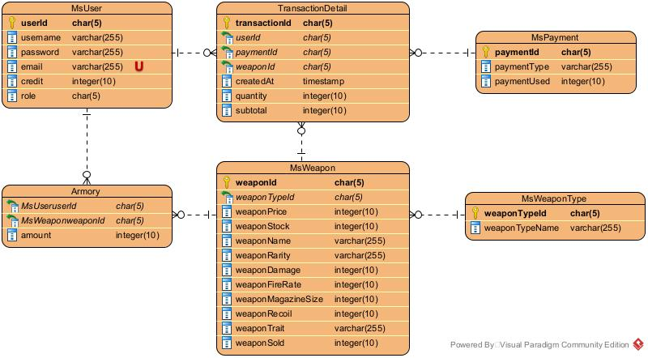
Figure 1. Entity Relationship Diagram
Each page shows the name of Member or Admin. If the member hasn’t logged in (guest), then the user can access the login page instead. You need to build this website based on the following criteria:

      - Home Page
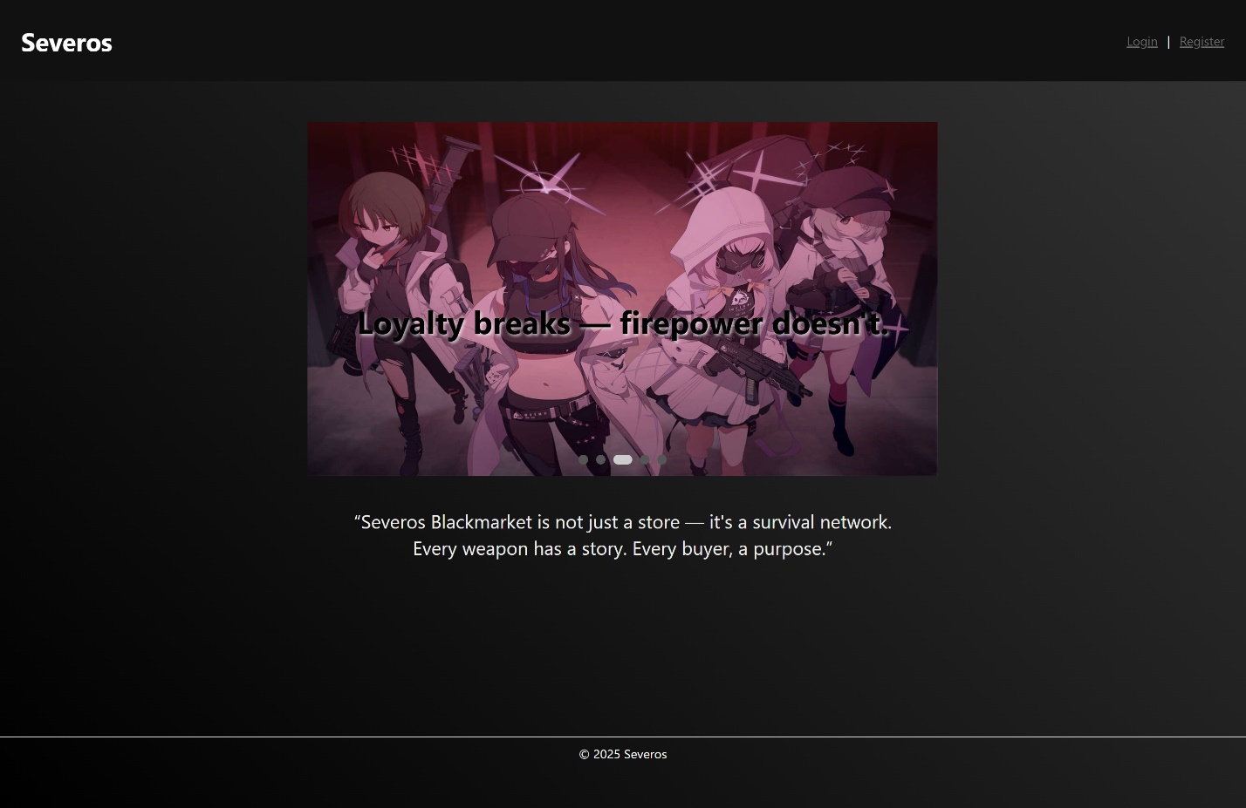
Figure 2. Home Page
- Show navigation bar with content according to user role status.
  - Show the company name.
  - Show link for accessible pages based on user roles.
  - Show username if authenticated.
  - Add login, register or logout button according to user authentication status.
  - Clear cookies after successful logout.
Figure 3. Guest Navigation Bar
Figure 3. User Navigation Bar
Figure 5. Admin Navigation Bar

- Display an image slider and a slogan for the company. You are free to use any image that is suitable for the website.
- Display footer. You are free to design the footer as long as it’s suitable for the website.

- Login Page
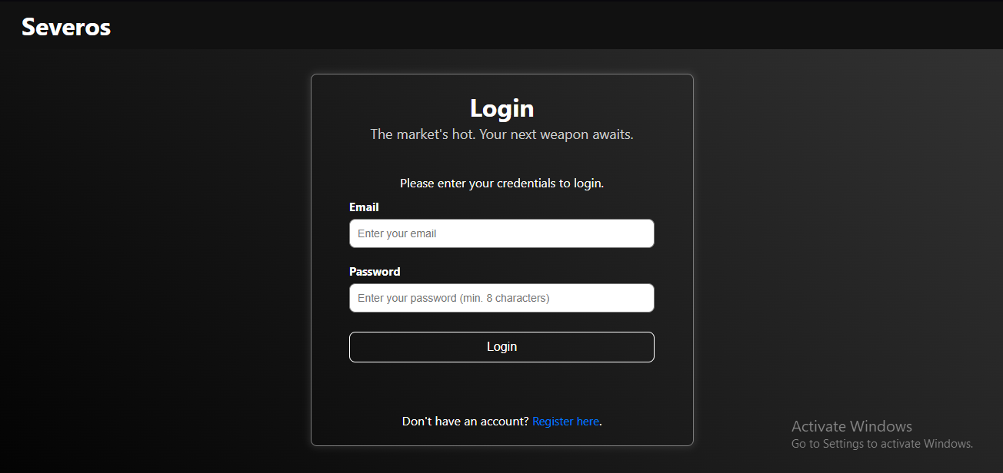
Figure 4. Login Page
- Validate that the input must not be empty. If not, display error message.
- Validate that the password length must be greater than equal to 8 characters.
- Add register button to redirect user to register page.
- Create cookies after successful login. Make sure each role can’t access other roles page and authenticated user can’t access login and register page.

- Register Page
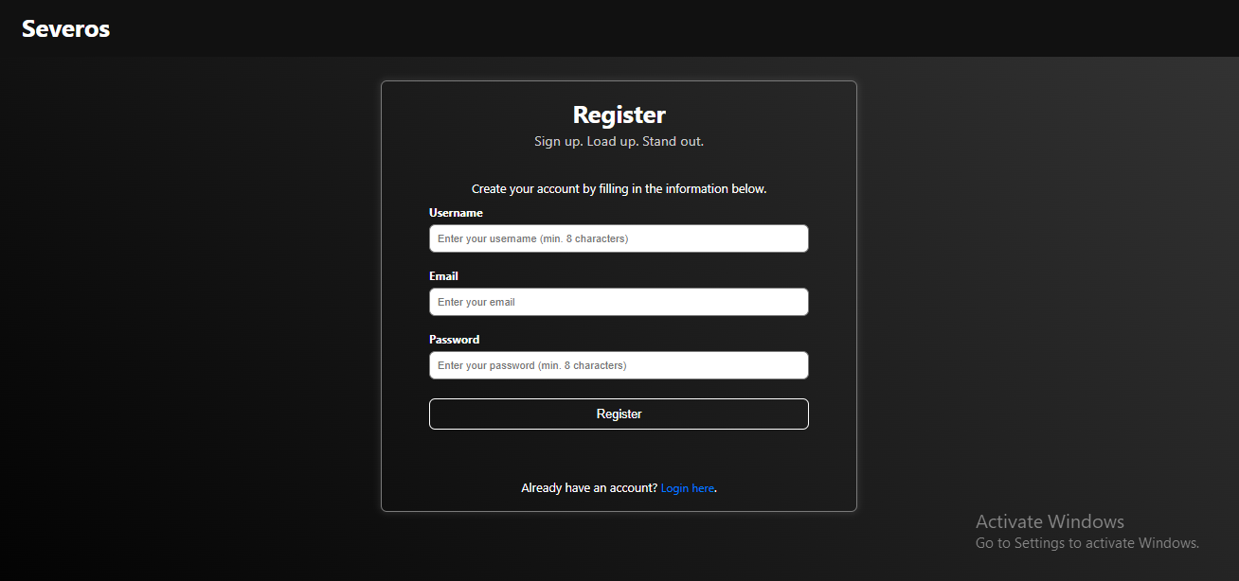
Figure 5. Register Page
  - Validate that the input must not be empty. If not, display error message.
  - Validate that the username and password length must be greater than equal to 8 characters.
  - Validate the email format manually.
  - Store the user data in the database after successful validation and hash the password using bcrypt hashing.

- Marketplace Page
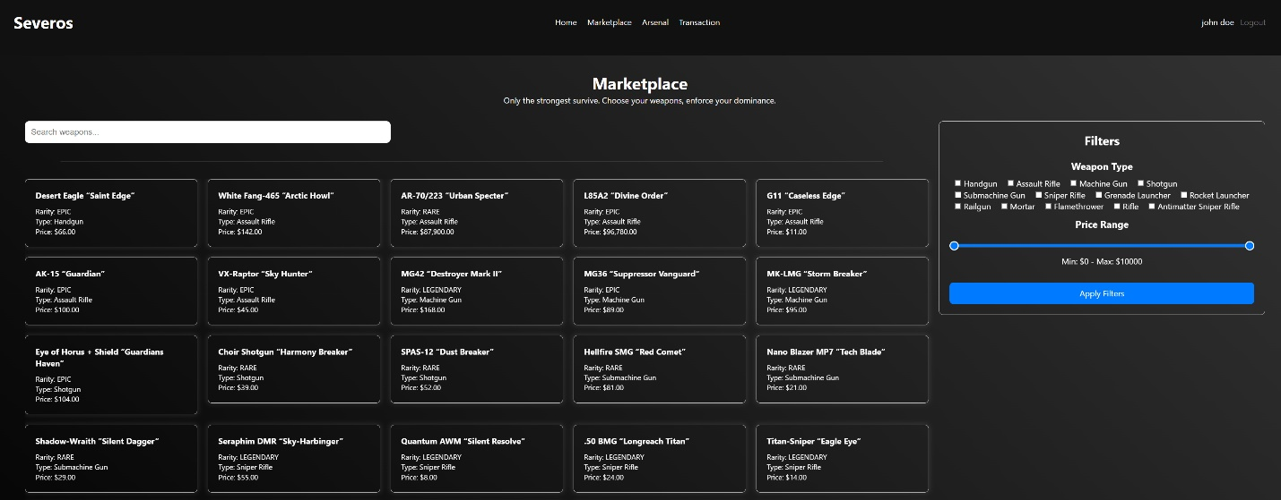
Figure 6. Marketplace Page
- Add search bars for users to search for weapon names.
- Add filter based on weapon type and price range. Apply the filter if user click the apply filter button.
- Display all weapon that available in the marketplace along with the information such as weapon name, weapon rarity, weapon type, weapon price. Implement scrollable to prevent content overflow.
- Redirect user to the respective weapon detail page if user click the weapon card.

- Marketplace Weapon Detail Page
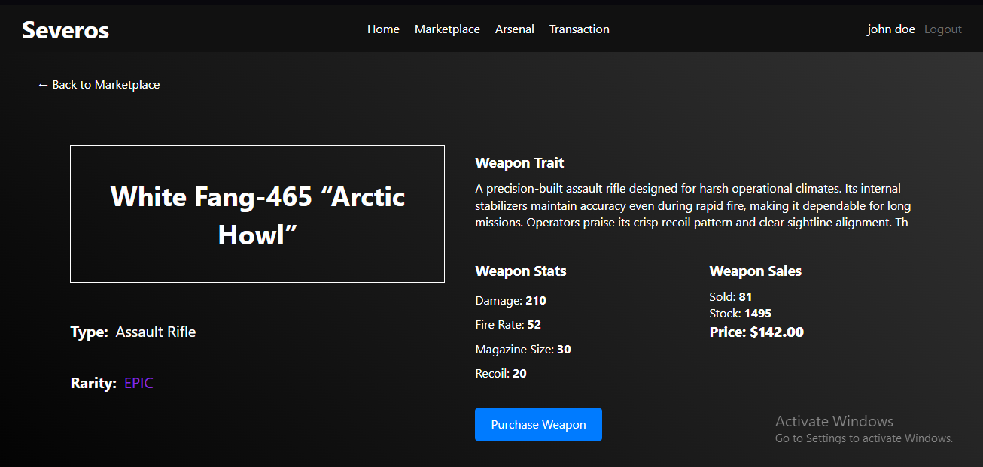
Figure 7. Weapon Detail Page
- Display all weapon data such as weapon name, weapon type, weapon rarity, weapon trait, weapon damage, weapon fire rate, weapon magazine size, weapon recoil, weapon sold, weapon stock, and weapon price.
- Add back button for user to go back to marketplace page.
- Add purchase button to redirect user to checkout page.

- Checkout Page
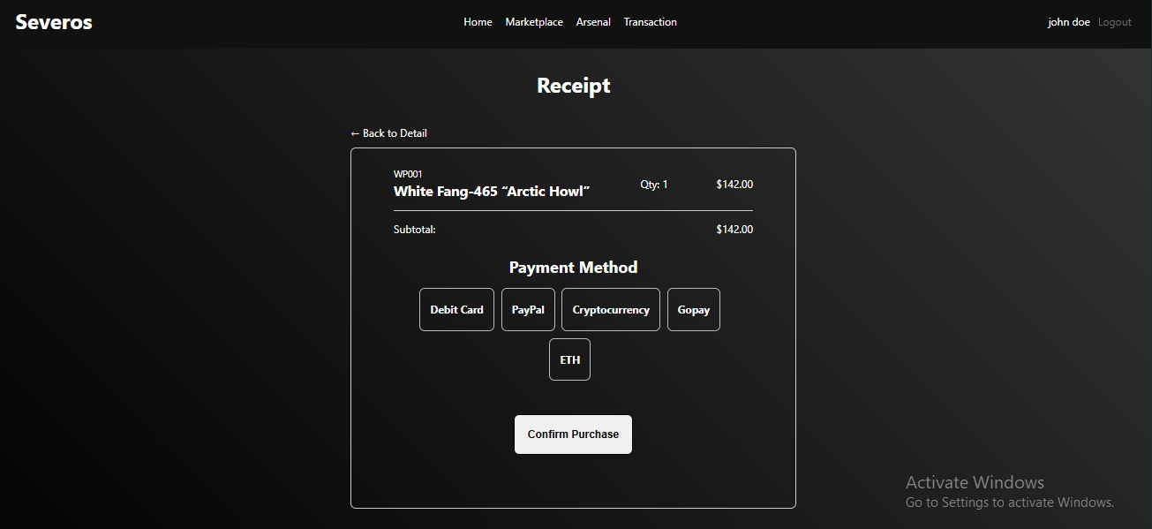
Figure 8. Checkout Page
- Display weapon name, weapon id, weapon quantity, and weapon price. Every transaction can only purchase 1 weapon.
- Display transaction subtotal
- Display all available payment methods. Validate that user must choose one of the available methods.
- Add submit button to confirm purchase. Redirect user back to marketplace page after successful purchase.
- Add back button to cancel the transaction. Redirect user back to weapon detail page.

- Arsenal Page
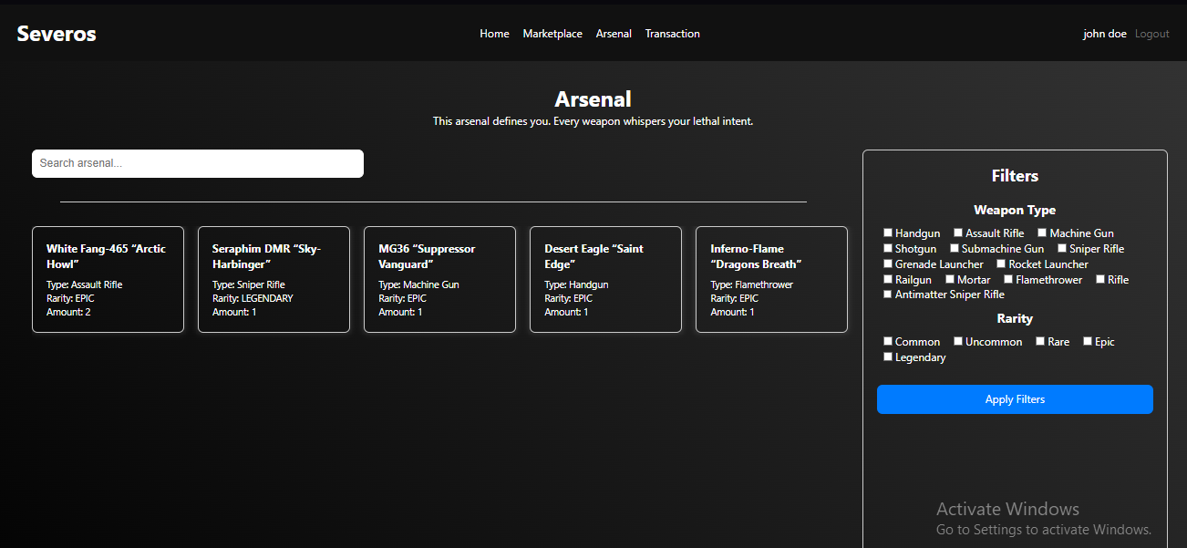
Figure 9. Arsenal Page
- Add search bars for users to search for weapon names.
- Add filter based on weapon type and weapon rarity. Apply the filter if user click the apply filter button.
- Display all weapon that available in the respective user arsenal along with the information such as weapon name, weapon rarity, weapon type, weapon price. Implement scrollable to prevent content overflow.
- Redirect user to the respective arsenal weapon detail page if user click the weapon card.

- Arsenal Weapon Detail Page
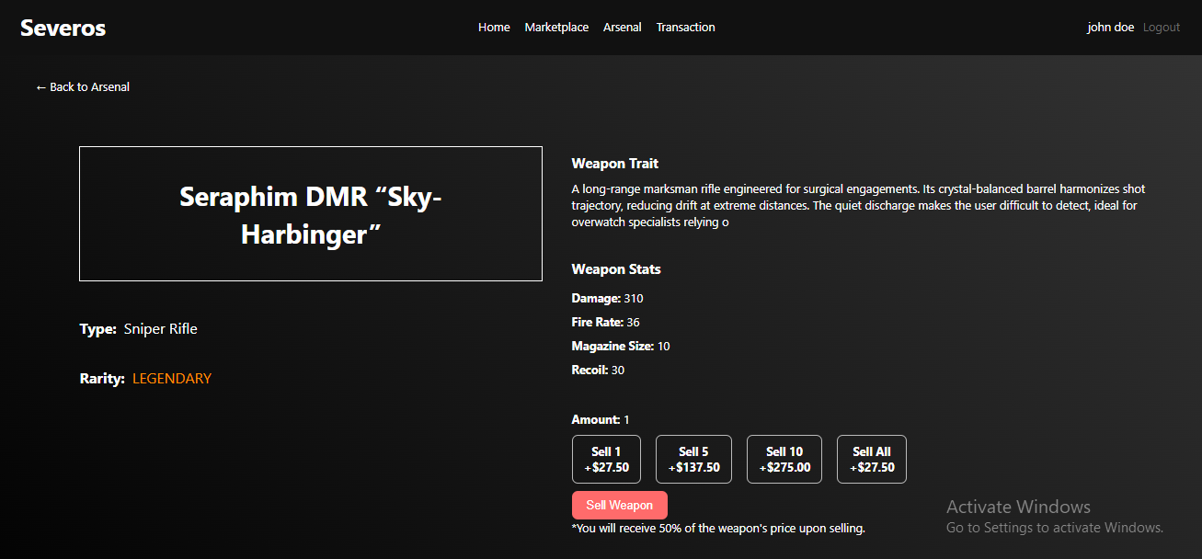
Figure 10. Arsenal Weapon Detail Page
- Display all weapon data such as weapon name, weapon type, weapon rarity, weapon trait, weapon damage, weapon fire rate, weapon magazine size, weapon recoil, weapon amount.
- Add sell quantity options for users to sell their weapon. Sell compensation is half of the weapon price.
Figure 11. Weapon Compensation Formula
Weapon Compensation = 0.5 × Weapon Price

Example:
Weapon Price = 98000
Weapon Compensation = 0.5 × 98000 = 49000
- Add back button for user to go back to arsenal page.
- Add sell button to sell the weapon.

- Transaction Page
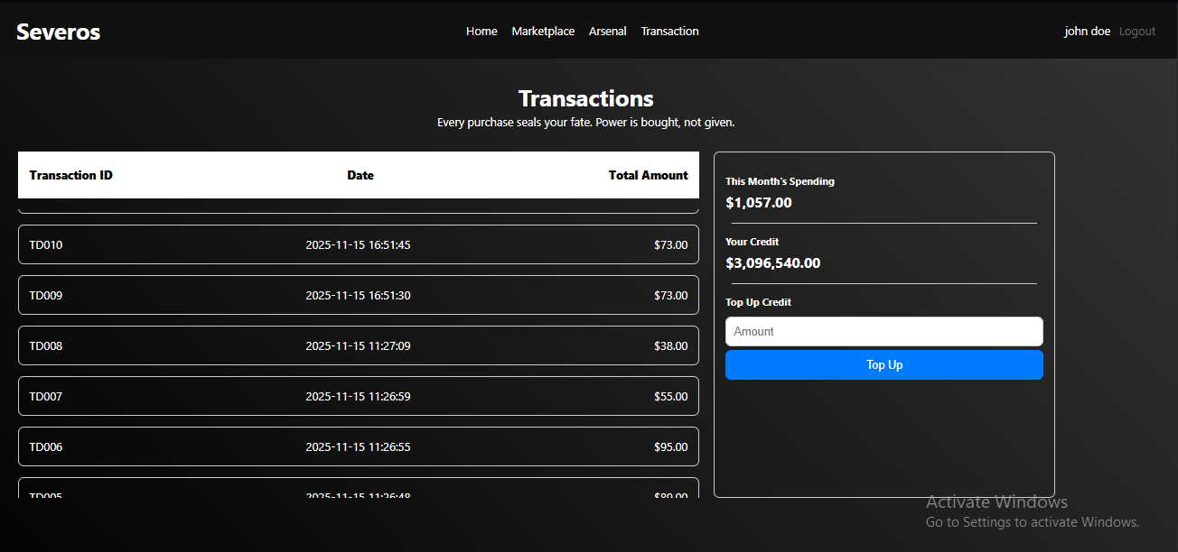
Figure 12. Transaction Page
- Display current user transaction history consists of transaction id, transaction date, transaction subtotal. Implement scrollable to prevent content overflow.
- Display current user balance overview such as this month spending and user credit.
- Add top up form for users to recharge their credit balance for transactions. Validate that the input must be positive integer greater than 0.
- Add top button to confirm the top up transaction.

- Admin Dashboard Page
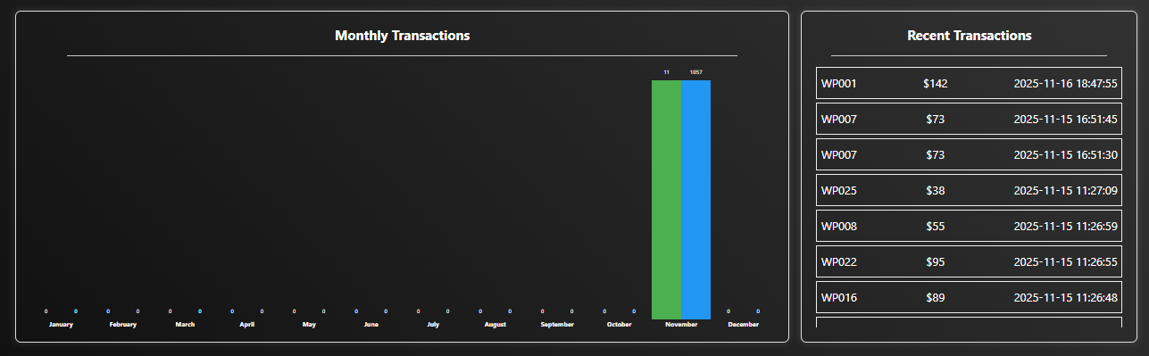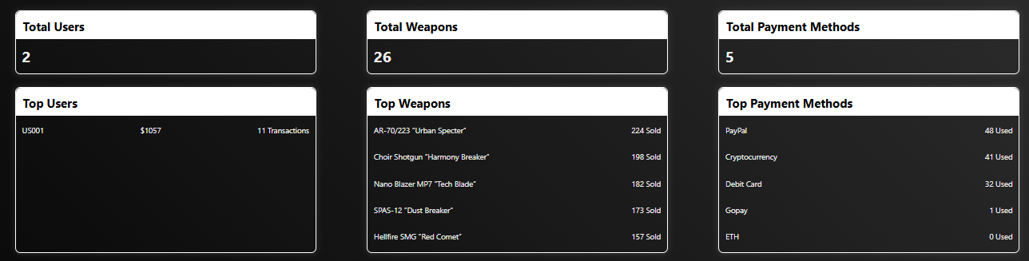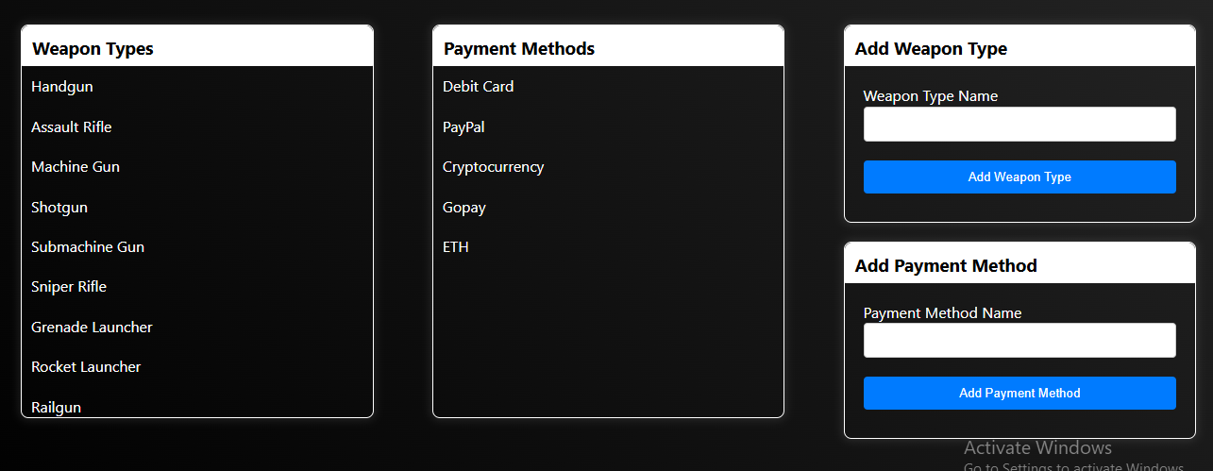
Figure 13. Admin Dashboard Transaction Overview
Figure 14. Admin Dashboard User, Weapon, and Payment Overview
Figure 15. Admin Dashboard Weapon Type and Payment Method
- Display transaction overview such as recent transaction and transaction yearly performance. You are free to design the layout as long as it’s informative. Implement scrollable to prevent content from overflowing.
- Display user overview such as total user and top active user.
- Display weapon overview such as total weapon and top selling weapon.
- Display payment overview such as total payment method and top used payment method.
- Display weapon type list that available. Implement scrollable to prevent content from overflowing.
- Display payment method list that available. Implement scrollable to prevent content from overflowing.
- Add form for adding new wepaon type and new payment method.

- Admin Weapon List Page
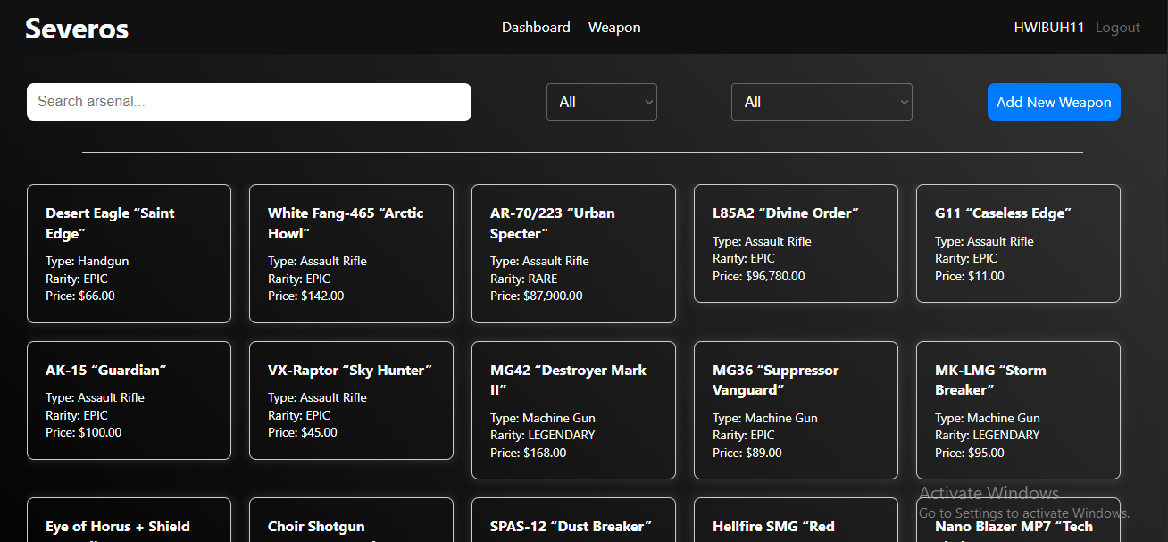
Figure 16. Admin Weapon List Page
- Add search bars for users to search for weapon names.
- Add dropdown for filter based on weapon type and weapon rarity.
- Add add new wepaon button. Redirect user to add weapon page.
- Display all available weapon list. Implement scrollable to prevent content from overflowing. Redirect user to respective weapon detail page if user click weapon card.

- Admin Weapon Detail Page
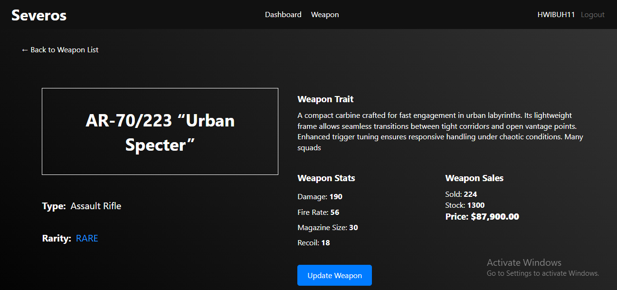
Figure 17. Admin Weapon Detail Page
  - Display all weapon data such as weapon name, weapon type, weapon rarity, weapon trait, weapon damage, weapon fire rate, weapon magazine size, weapon recoil, weapon sold, weapon stock, and weapon price.
  - Add back button for user to go back to weapon list page.
  - Add update button to redirect user to weapon update page.

- Admin Update Weapon Page
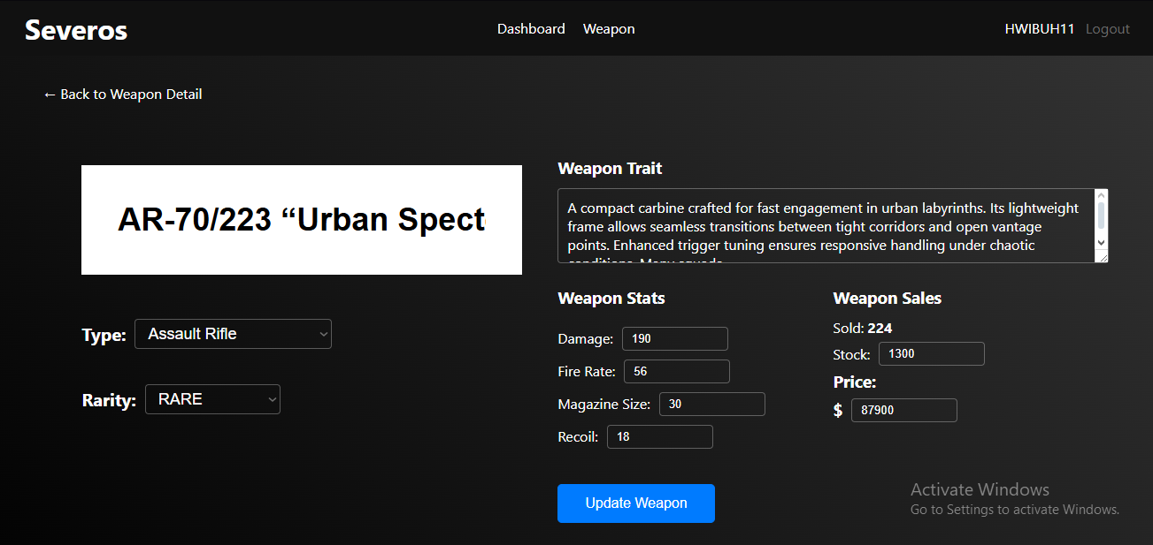
Figure 18. Admin Update Weapon Page
- Display input field for all weapon data such as weapon name, weapon type, weapon rarity, weapon trait, weapon damage, weapon fire rate, weapon magazine size, weapon recoil, weapon stock, and weapon price.
- Add button to update the weapon. Redirect user back to weapon detail after successful update.
- Add back button to redirect user back to weapon detail page.

- Admin Add Weapon Page
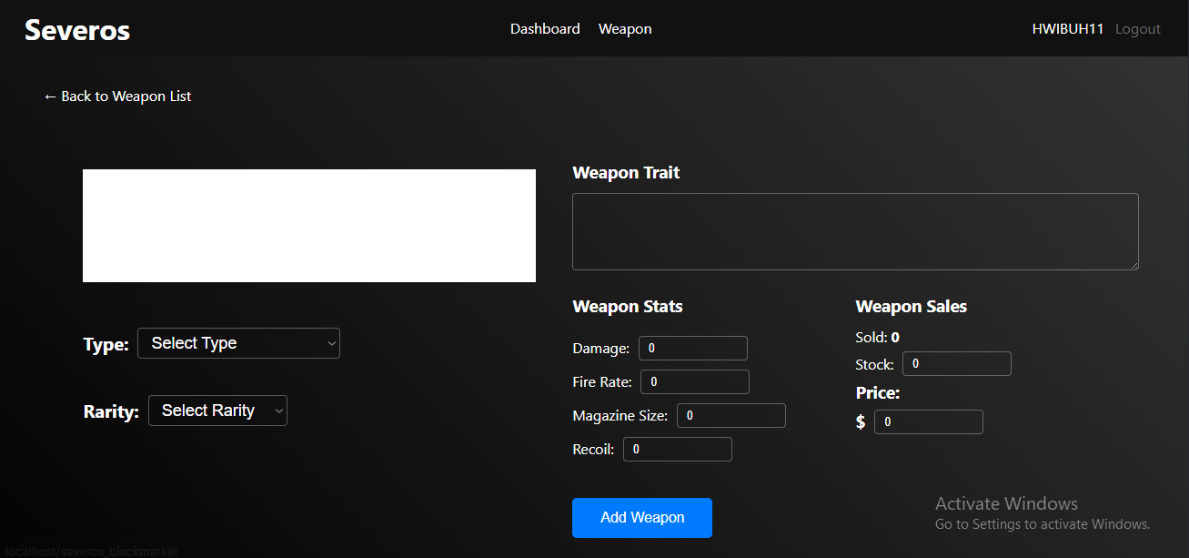
Figure 19. Add Weapon Page
- Display input field for all weapon data such as weapon name, weapon type, weapon rarity, weapon trait, weapon damage, weapon fire rate, weapon magazine size, weapon recoil, weapon stock, and weapon price.
- Add button to add the weapon. Redirect user back to weapon list after successful creation.
- Add back button to redirect user back to weapon detail page.

