**RESUME**

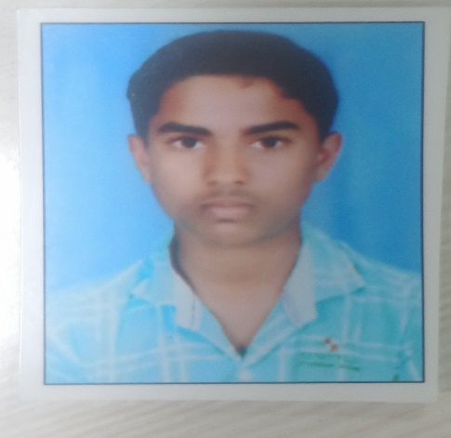

**Name**: RENDLA VAMSHI

**Email ID**: vamshiv897@gmail.com

**Mobile**: +91 9652735589

**Career Objective**:

I found myself unique. Me as a student want to learn a new skill and adding the uniqueness to my skill may find me a good place to showcase and process my knowledge to have an appreciable eve and I want to make this with the help of your organisation.

**Educational Qualification**:

|  |  |  |  |  |  |
| --- | --- | --- | --- | --- | --- |
| S.no | Qualification | Institute | Board\university | Batch | Percentage% |
| 1 | Btech  (Civil engineering) | Sri indu institute of engineering and technology,Hydreabad | JNTUH | 2021 | 63 |
| 2 | Intermediate | Nri junior college,  Hanamkonda | Board of Intermediate  Education | 2017 | 90 |
| 3 | SSC | Zphs,Goverdhanagiri | Board of Secondary  Education | 2015 | 8.5(cgpa) |

**Technical skills:**

# • JAVA

* Excellent Knowledge on Features of java.
* Very good knowledge on Typecasting.
* Well aware of Variables, Members of a class.
* Well aware of Static Variables, non-static variables.
* Very good knowledge in Methods.
* Excellent knowledge in writing programs using Constructors.
* Very good knowledge in OBJECT ORIENTED PROGRAMMING CONCEPTS.

# • SQL (BASICS).

* Automatiom testing(on going).
* Python (intermediate knowledge).

**Personal details**:

Date of Birth :20-10-2000.

Nationality: Indian

Address for communication: H.NO: 1-21,regonda.

Akkanapet,Siddipet-505467, TELANGANA.