Stream Corridors as Cooling Infrastructure in Baltimore
How the width, continuity and height of riparian forest shape summer surface temperature
Report 1 — draft for review · 12 October 2026 · Baltimore Urban Heat Research · [Authors]
Status: exploratory analysis. All numbers are preliminary and may change as methods are finalised. Buffer widths are measured per side of the channel; the total forested corridor is about twice as wide. Text in [square brackets] marks places still to be written.

Summary
Baltimore's stream valleys are among the coolest places in the city on summer afternoons. This report asks why, and what that means for how streams and their banks should be managed. Using 13 summers of Landsat 8 surface temperature (2013–2025), 1 m land cover and stream maps from the Chesapeake Conservancy, ECOSTRESS observations at different times of day, and a 1 m canopy height map, we examined 854 locations spaced every 150 m along the city's open stream channels.

Key findings
- The water itself does little; the forest around it does the cooling. Blocks next to open channels are 5.6 °C cooler than blocks 450–1000 m away, but almost all of this difference is explained by the vegetation and built form around streams. After accounting for land cover, terrain and surroundings, proximity to a stream adds only −0.18 °C (not significant).
- Narrow forested buffers leave corridors much warmer. Compared with corridors that have at least 200 m of forest on each side, corridors with 10–30 m per side are 2.3 °C warmer, 30–50 m are 1.3 °C warmer, and 50–100 m are 0.4–0.9 °C warmer. Beyond about 100 m per side there is no further measurable difference. The pattern holds across ten alternative model specifications.
- The benefit keeps growing up to roughly 100 m per side (≈ 200 m total corridor). A simple breakpoint model puts the change of slope at about 60 m per side, but a sensor simulation shows this is largely an artefact of the 100 m thermal pixels. Narrow buffers probably cool more than satellites can show.
- Both banks matter, and so does continuity. A narrow buffer on either bank warms the corridor. Each additional 10 percentage points of canopy along the stream network (within ±500 m) is associated with 0.6 °C cooler corridors.
- Taller trees cool more at the same width. Each additional 5 m of mean canopy height in the buffer is associated with 1.0 °C cooler corridors (0.8 °C comparing only nearby points). The true per-metre rate is probably smaller, because the height map underestimates tall forest.
- It is a daytime, leaf-on effect. ECOSTRESS shows the narrow-buffer penalty peaks at midday and in the afternoon (+1.4 °C for 10–30 m buffers) and nearly vanishes at night (+0.1 °C). In winter it is about a quarter of its summer size.
- Gaining canopy brings cooling over time. Where buffer canopy increased between 2013/14 and 2021/22, corridors cooled relative to the city by 0.02–0.03 °C per year for every 10 percentage points gained (comparing points within the same 1 km square).
- Many people live within reach of the cooling. Corridor cooling extends 120 m from the channel for the narrowest buffers and about 390 m for the widest. An estimated 91,000 residents live inside these cooled zones.

What this means for planning
- Treat forested stream buffers as heat infrastructure, not only as water-quality or habitat measures.
- Where possible, aim for at least 100 m of forest on each side of the channel; every widening below that width is associated with cooler corridors.
- Protect existing tall, mature riparian forest: it delivers more cooling per hectare than young planting, and replacements will take decades to match it.
- Prioritise gaps that break canopy continuity and reaches where both banks are narrow.
- Candidate neighbourhoods for buffer widening (narrow buffers, hot surroundings, many residents) include Glen Oaks, Allendale, Panway/Braddish Avenue, Winchester, Frankford, Morrell Park and Lakeland (Section 5).
These are associations from observational data, not controlled experiments. Section 6 sets out the main limitations.

1. Background and questions
Summer surface temperatures vary by more than 10 °C across Baltimore. Trees, water and pervious ground cool the surface through shade and evaporation, while roofs and pavement store and re-emit heat. Stream valleys combine all of the cooling elements: water, moist soils and, often, the city's most continuous forest. Riparian buffers are already a target of stormwater, stream restoration and Chesapeake Bay programmes; if they also provide substantial cooling, that strengthens the case for protecting and widening them.
[Literature context to add: urban riparian cooling studies, recommended buffer widths in water-quality and habitat guidance, and Baltimore/Chesapeake programmes.]
We address four questions:
- Do stream corridors cool their surroundings, and is it the water or the vegetation?
- How wide must a forested buffer be to deliver most of its cooling, and is there a threshold?
- Do bank asymmetry, forest continuity and tree height matter beyond width?
- When and how far does the cooling reach, and where would widening buffers help the most people?

2. Study area and data
The study area is Baltimore City, Maryland (Neighborhood Statistical Areas, NSAs). All analysis is done in WGS 84 / UTM zone 18N (EPSG:32618).
Table 1. Data sources.
Dataset | Used for | Resolution / period | Source
Landsat 8 Collection 2 Level-2 surface temperature (WRS-2 path 15 / row 33) | Summer and seasonal relative LST; LST trends | 100 m thermal resampled to 30 m; 2013–2025 | USGS (via Microsoft Planetary Computer)
ECOSTRESS ECO_L2T_LSTE v002 (tile 18SUJ) | LST by time of day | 70 m; June–August 2018–2025 | NASA JPL / LP DAAC
Chesapeake Conservancy 1 m land use / land cover, 2013/14 and 2021/22 (2024 edition) | Tree canopy, impervious cover, buffer width | 1 m | Chesapeake Conservancy / UMBC
Chesapeake Conservancy hyper-resolution hydrography | Stream centrelines; open vs hidden channels; order; channel width | ~1 m derived | Chesapeake Conservancy / UMBC
Meta / WRI global canopy height v1 | Tree height | 1 m; imagery mostly 2018–2020 | Tolan et al. (2024), CC BY 4.0
USGS 3DEP DEM and geomorphons | Terrain controls (elevation, slope, valley position, solar illumination) | 10 m | USGS; Chesapeake Conservancy
USGS National Hydrography Dataset (HR) | Harbour shoreline (distance to harbour) | 1:24,000+ | USGS
Baltimore NSA boundaries and population | Residents and neighbourhood summaries | NSA | Baltimore City

3. Methods

3.1 Relative land surface temperature
Landsat surface temperature was scaled to °C (ST × 0.00341802 + 149.0 − 273.15). Fill, cloud, dilated cloud, cloud shadow and snow pixels were removed using the QA_PIXEL band. Only scenes with at least 50% of the city clear were used. For each scene we subtracted the city-wide median. This relative LST removes day-to-day weather, so scenes from different days can be averaged. The main outcome is the July–August mean relative LST for 2013–2025. Seasonal versions (DJF, MAM, JJA, SON) use all months. LST is the temperature of the surface, not of the air.

3.2 Sample points and buffer width
Points were placed every 150 m along stream reaches with a visible (open) channel, giving 854 points. Around each point we defined a local frame ±150 m along the stream and up to 300 m from the channel. Within this frame, 1 m canopy share was measured in distance bands from the channel (0–10, 10–20, 20–30, 30–50, 50–75, 75–100, 100–150, 150–200 and 200–300 m), with water excluded and both banks pooled.
Forested buffer width is the outer edge of the last band such that every band from the channel outward has at least 50% canopy. Because the bands are measured outward from the channel, this is a per-side width. Widths were also measured separately for each bank. Points were grouped into six classes: <10, 10–30, 30–50, 50–100, 100–200 and ≥200 m per side. The widest class is the reference.

3.3 Outcomes and models
The corridor outcome is the mean relative LST of 30 m pixels within 0–60 m of the channel. A neighbourhood outcome (90–210 m) and full cross-stream profiles to 630 m were also extracted. Corridor LST was regressed on width class with ordinary least squares. Standard errors are clustered by 1 km square, because neighbouring points share thermal pixels and are not independent.
The main model (M2) controls for:
- impervious cover and canopy in rings 300–600 m and 600–1000 m from the point;
- elevation, slope, topographic position (300 m and 1000 m) and solar illumination at overpass;
- stream order, channel width and distance to the harbour.
Robustness checks:
- fixed effects for 1 km and 500 m squares, so points are compared only with nearby points;
- a within-reach model that compares points on the same stream reach;
- control for along-stream forest continuity;
- canopy thresholds of 40%, 60% and 70% instead of 50%;
- 300 m point spacing instead of 150 m.

3.4 Additional tests
- Shape of the relationship: a natural spline in continuous width, and a breakpoint (hinge) model whose breakpoint was estimated by 500 bootstrap resamples of 1 km squares.
- Seasonal falsification: if leaves drive the effect, it should be largest in summer and smallest in winter.
- Time of day: ECOSTRESS scenes (cloud-free, QC best or nominal, ≥50% clear) converted to relative LST and grouped by local time (night 22–05 h, morning 06–09, midday 10–13, afternoon 14–17, evening 18–21); the same models were refit to each group.
- Tree height: mean height of canopy pixels inside the forested buffer, from the Meta 1 m height map aligned to the 1 m land cover; tested at fixed width class.
- Change over time: change in buffer canopy share (2013/14 to 2021/22) against the per-pixel LST trend.
- Cooling extent: median cross-stream profile per width class; the extent is the first distance within 0.5 °C of the 480–630 m background. Residents were estimated from NSA population density over the cooled zone on both banks.
- Detection limit: a one-dimensional simulation of how much of a corridor's true cooling each sensor records, given its footprint and grid (Landsat 100 m thermal on a 30 m grid; ECOSTRESS 70 m).

4. Results

4.1 Streams, vegetation and terrain
Across 25,215 blocks of 90 m, blocks within 90 m of an open channel were 5.6 °C cooler (relative LST) than blocks 450–1000 m away, and had 39 percentage points more canopy. Adjusting for land-cover fractions reduced the difference to 1.2 °C, and adjusting for terrain changed it little (1.3 °C). Adding the cover of the surrounding area reduced it to −0.18 °C [−0.39, +0.03], which is not significant. In other words, stream valleys are cool because of the green landscape they sit in. Reaches with no visible channel (buried or piped) showed a smaller raw difference of −2.8 °C. Larger streams were not consistently cooler once surroundings were taken into account.
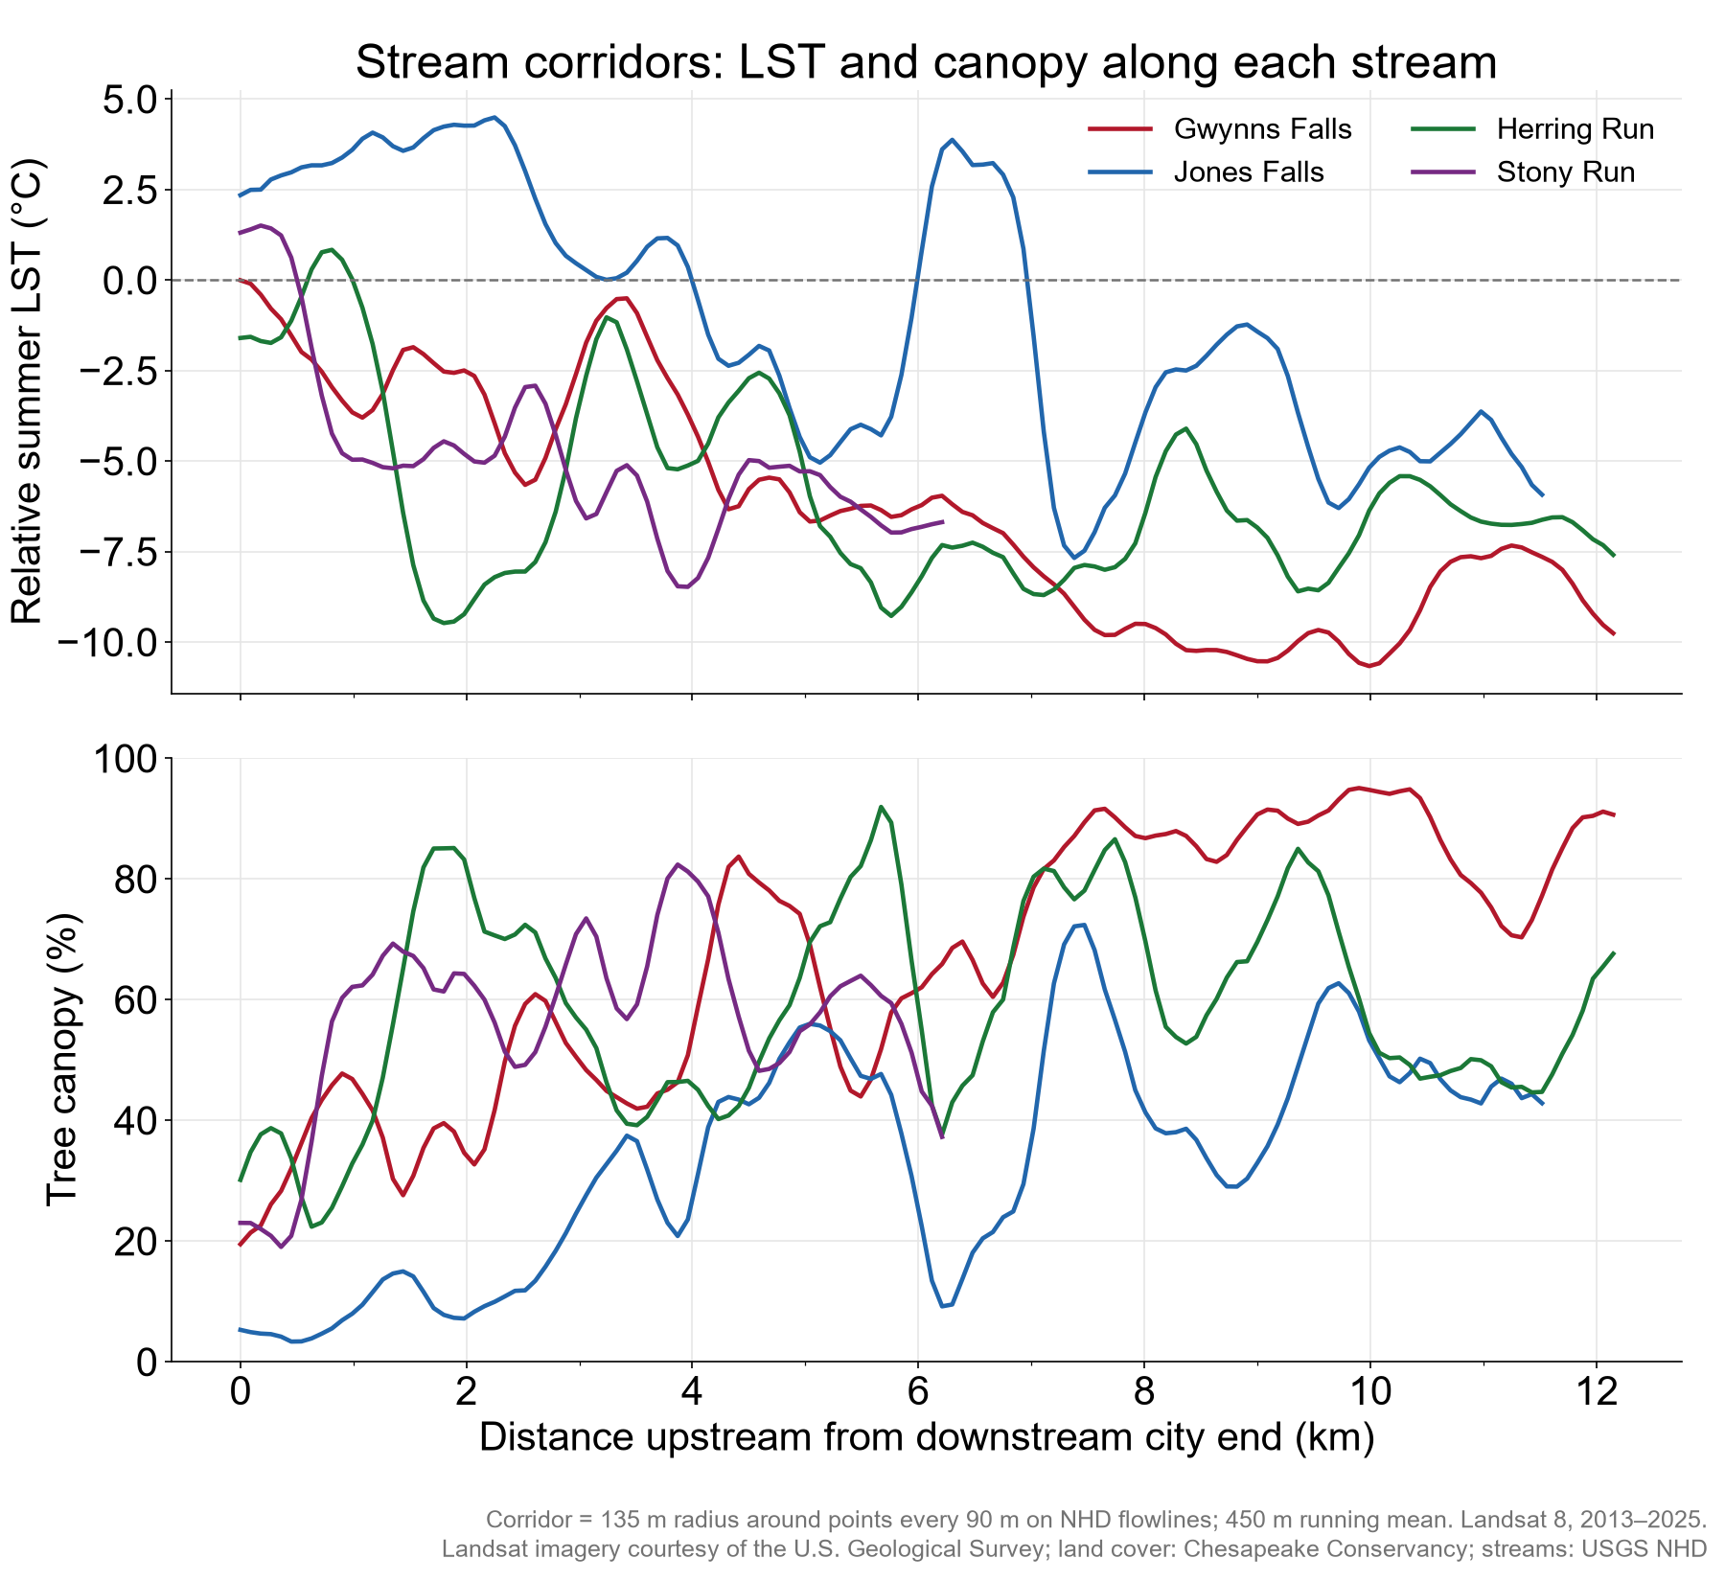
Figure 1. Relative summer LST (top) and tree canopy (bottom) along Baltimore's four main streams, from the downstream city boundary upstream. Temperature tracks canopy: the forested upper Gwynns Falls is up to 10 °C below the city median, while the heavily built lower Jones Falls is 2–4 °C above it.

4.2 Buffer width and corridor temperature
Corridor temperature rises steadily as the forested buffer narrows (Table 2, Figure 2). With the main controls (M2), corridors with less than 10 m of forest per side are 3.0 °C warmer than those with at least 200 m. The penalty is 2.3 °C for 10–30 m and 1.3 °C for 30–50 m. For 50–100 m it is 0.4 °C in M2 and 0.6–0.9 °C when points are compared only with nearby points. For 100–200 m it is indistinguishable from zero.
Table 2. Corridor relative LST (°C) by forested buffer width per side, relative to ≥200 m per side. Values are coefficients with 95% confidence intervals clustered by 1 km square; n.s. = not significant at p < 0.05. n = 854 points (within-reach model: points on reaches with ≥2 points).
Model | 10–30 m | 30–50 m | 50–100 m | 100–200 m
M1 Surrounding impervious only | +2.53 [+1.85, +3.21] | +1.37 [+0.76, +1.98] | +0.39 [-0.11, +0.89] (n.s.) | -0.12 [-0.69, +0.44] (n.s.)
M2 Full controls (main) | +2.27 [+1.64, +2.90] | +1.28 [+0.66, +1.91] | +0.41 [-0.06, +0.88] (n.s.) | -0.17 [-0.62, +0.27] (n.s.)
M3 + 1 km square fixed effects | +2.08 [+1.56, +2.60] | +1.35 [+0.88, +1.82] | +0.70 [+0.31, +1.10] | +0.05 [-0.28, +0.39] (n.s.)
M3b + 500 m square fixed effects | +1.78 [+1.19, +2.36] | +1.34 [+0.87, +1.80] | +0.89 [+0.52, +1.26] | +0.15 [-0.20, +0.49] (n.s.)
M4 + forest continuity | +1.46 [+0.92, +1.99] | +1.01 [+0.48, +1.54] | +0.55 [+0.16, +0.93] | +0.14 [-0.20, +0.48] (n.s.)
M5 Within the same reach | +1.95 [+1.25, +2.65] | +1.26 [+0.64, +1.89] | +0.60 [+0.05, +1.14] | -0.09 [-0.64, +0.47] (n.s.)
M2, canopy threshold 40% | +2.45 [+1.84, +3.06] | +1.31 [+0.58, +2.05] | +0.50 [+0.06, +0.94] | -0.40 [-0.77, -0.03]
M2, canopy threshold 60% | +2.22 [+1.52, +2.92] | +1.47 [+0.91, +2.03] | +0.49 [-0.03, +1.01] (n.s.) | -0.08 [-0.50, +0.34] (n.s.)
M2, canopy threshold 70% | +1.96 [+1.24, +2.67] | +0.91 [+0.29, +1.53] | +0.27 [-0.31, +0.85] (n.s.) | -0.05 [-0.38, +0.29] (n.s.)
M2, 300 m point spacing | +2.27 [+1.55, +2.99] | +1.17 [+0.44, +1.91] | +0.46 [-0.09, +1.01] (n.s.) | -0.05 [-0.58, +0.48] (n.s.)

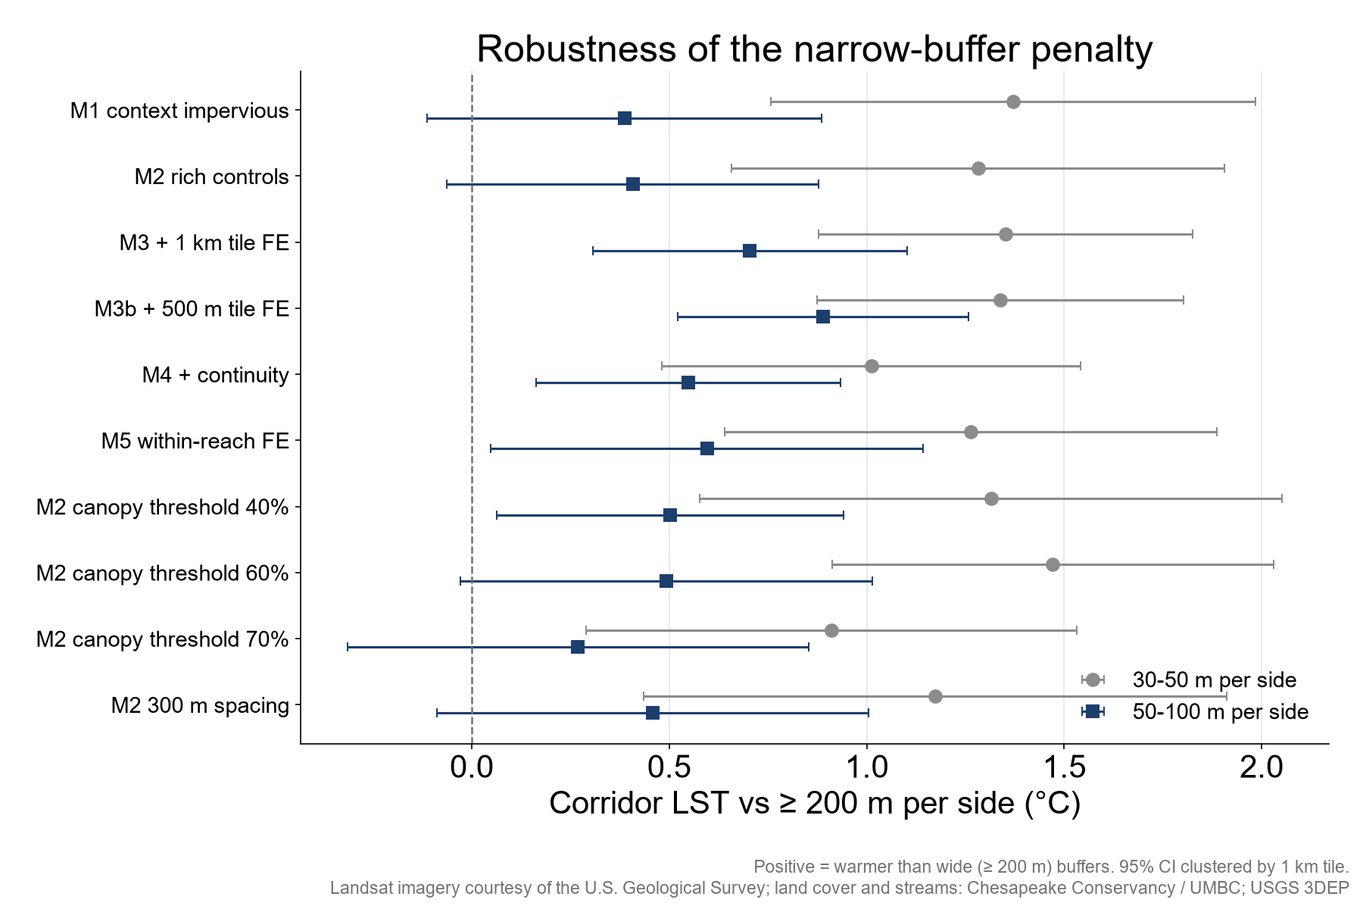
Figure 2. The narrow-buffer penalty for 30–50 m and 50–100 m per side across model specifications.

4.3 Is there a threshold width?
A smooth fit shows corridor temperature falling steeply from 0 to about 75 m per side and levelling off beyond roughly 100 m. A breakpoint model places the change of slope at 60 m per side (bootstrap 95% interval 40–110 m). Below it, each additional 10 m of forest per side is associated with 0.52 °C cooler corridors [0.29, 0.95]; above it the slope is essentially zero.
This breakpoint should not be read as a physical minimum width. Landsat measures heat over about 100 m footprints, so a narrow cool strip is averaged with the warm land around it. Section 4.9 shows that this blurring alone produces a fall-off very similar to the one observed. The defensible conclusion is that cooling increases with forested width up to about 100 m per side, with no measurable gain beyond.
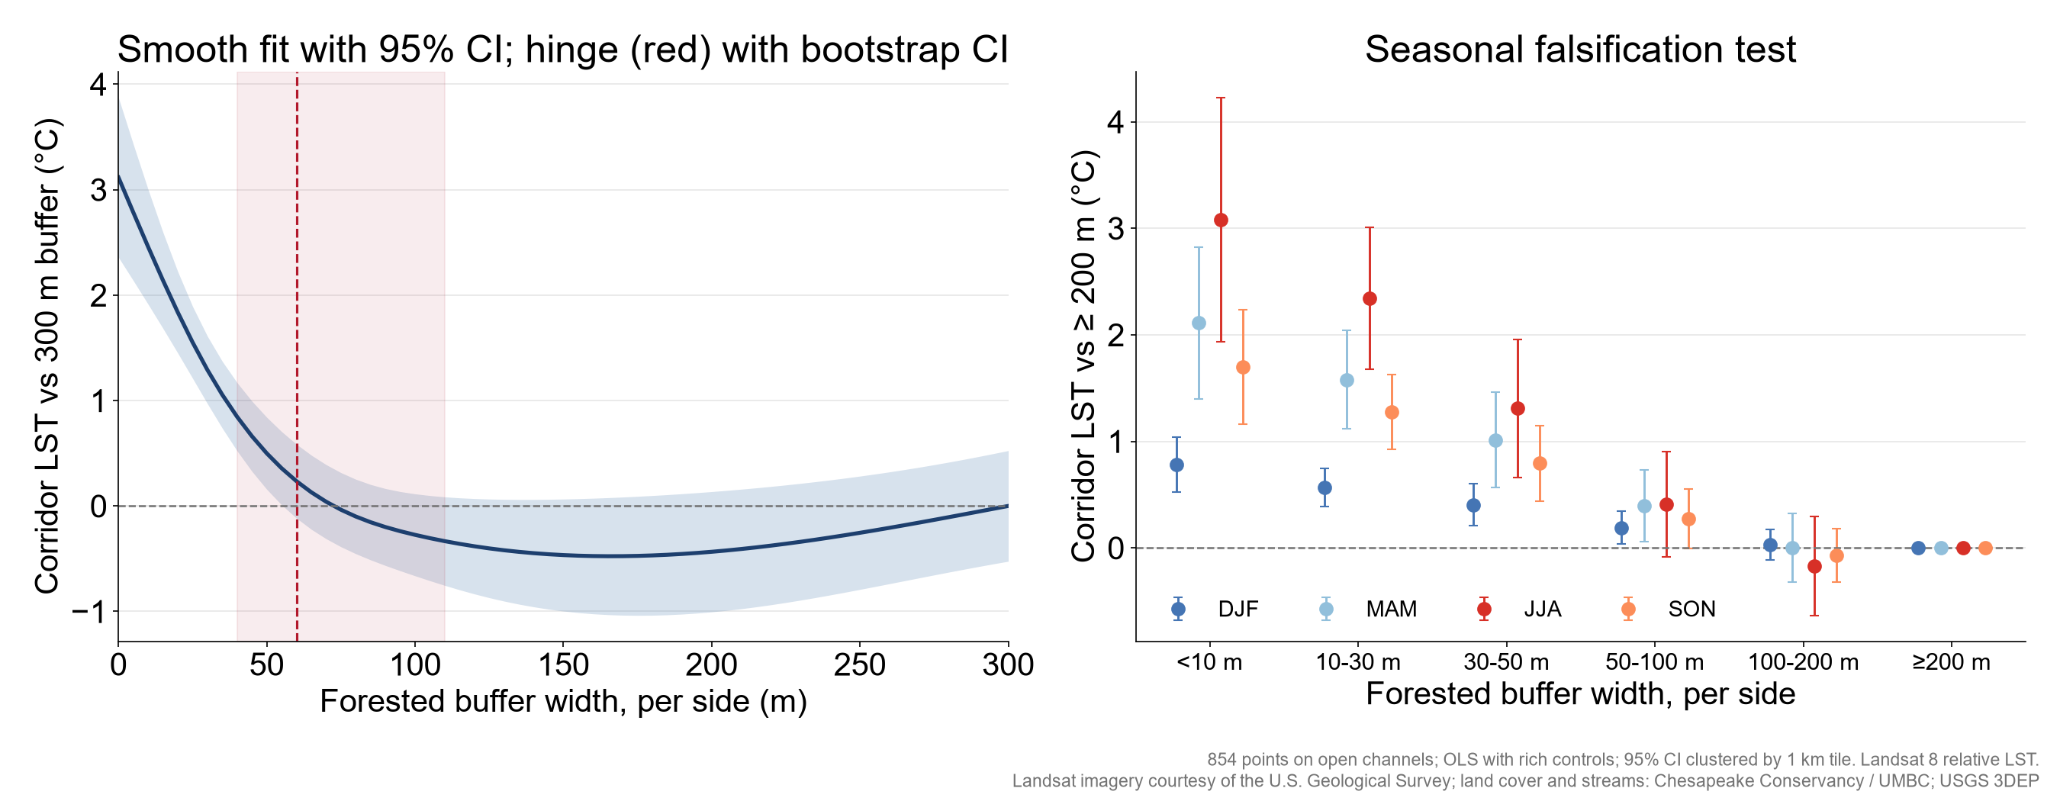
Figure 3. Left: corridor LST against continuous buffer width per side (spline with 95% CI; red line and band = breakpoint and its bootstrap interval). Right: width-class effects in each season.

4.4 Both banks and continuity
Fitting the narrower and wider bank together shows that both matter. A narrow bank of 10–30 m adds 1.2 °C even when the other bank is accounted for, and a wide bank of only 10–30 m adds 2.0 °C. The narrow bank's effect fades by 50–100 m (+0.37 °C, not significant). Forest continuity is the canopy share within 50 m of the stream network over ±500 m along it. Each additional 10 percentage points of continuity is associated with 0.61 °C cooler corridors, and including continuity reduces, but does not remove, the width effect (Table 2, M4).

4.5 Seasons and time of day
Table 3. Corridor relative LST (°C) by width per side and season, relative to ≥200 m per side (model M2, Landsat 8, all months 2013–2025).
Width per side | Summer (JJA) | Spring (MAM) | Autumn (SON) | Winter (DJF)
<10 m | +3.08 | +2.11 | +1.70 | +0.78
10-30 m | +2.34 | +1.58 | +1.28 | +0.57
30-50 m | +1.31 | +1.01 | +0.79 | +0.41
50-100 m | +0.41 (n.s.) | +0.39 | +0.27 (n.s.) | +0.19
100-200 m | -0.17 (n.s.) | +0.00 (n.s.) | -0.07 (n.s.) | +0.03 (n.s.)

The effect follows the leaf cycle: largest in summer, intermediate in spring and autumn, and about a quarter of the summer value in winter. A difference caused only by location (for example soils or building form) would not change this much with the seasons.
Table 4. Corridor relative LST (°C) by time of day from ECOSTRESS (70 m, June–August 2018–2025), relative to ≥200 m per side; model M2 with 95% CI.
Local time (EDT) | Scenes | 10–30 m | 30–50 m | 50–100 m
Night (22–05 h) | 43 | +0.10 [+0.00, +0.20] | +0.08 [-0.03, +0.19] (n.s.) | +0.03 [-0.07, +0.14] (n.s.)
Morning (06–09 h) | 20 | +0.54 [+0.36, +0.71] | +0.37 [+0.20, +0.53] | +0.22 [+0.03, +0.41]
Midday (10–13 h) | 42 | +1.39 [+0.93, +1.85] | +0.97 [+0.52, +1.42] | +0.70 [+0.31, +1.09]
Afternoon (14–17 h) | 39 | +1.26 [+0.82, +1.70] | +0.86 [+0.47, +1.26] | +0.54 [+0.21, +0.86]
Evening (18–21 h) | 26 | +0.36 [+0.20, +0.51] | +0.20 [+0.04, +0.36] | +0.18 [+0.06, +0.31]

ECOSTRESS, an independent sensor with finer pixels and a different period, reproduces the Landsat pattern at midday, when Landsat passes over (about 10:40 local time). The penalty is largest at midday and in the afternoon, smaller in the morning and evening, and close to zero at night. The cooling benefit of wide buffers is therefore mainly a daytime effect of shade and evaporation. At night, surface temperatures under narrow and wide buffers converge. The neighbourhood band 90–210 m from the channel shows a similar daytime pattern, consistent with cooling that extends well beyond the corridor itself.
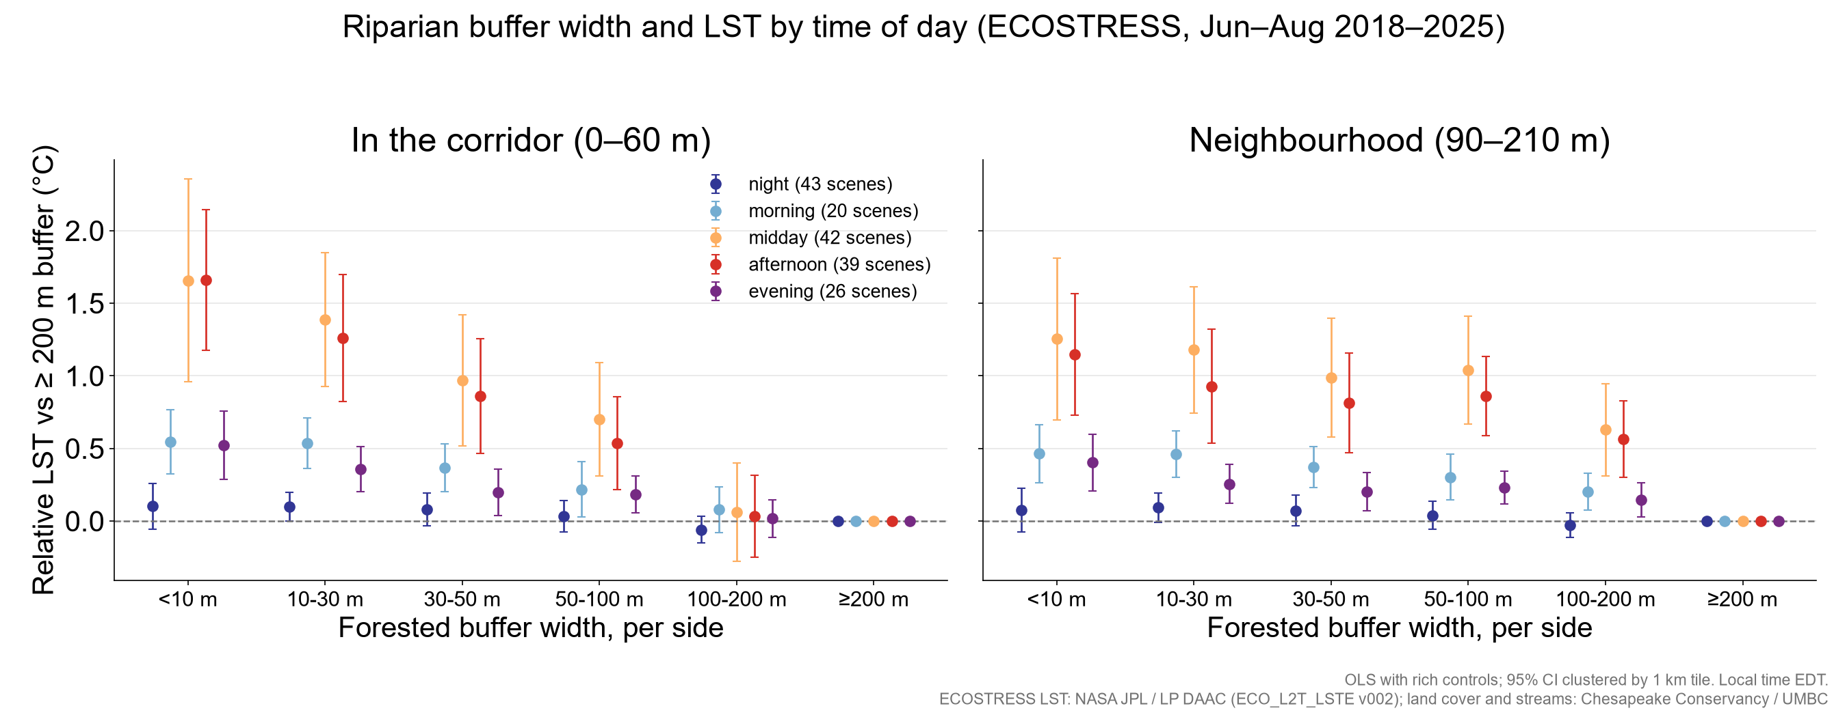
Figure 4. Buffer width effects by time of day from ECOSTRESS, in the corridor (left) and the 90–210 m neighbourhood (right).

4.6 Tree height
Mean canopy height inside the forested buffer averages 12.1 m and rises with width, from 8.4 m in 10–30 m buffers to 15.0 m in buffers of at least 200 m per side. Among buffers at least 30 m wide per side (n = 650), and holding width class fixed, each additional 5 m of height is associated with 1.04 °C cooler corridors (95% CI 0.75–1.33), or 0.80 °C comparing only points in the same 1 km square. The height effect also follows the seasons: -1.13 °C in summer, -0.72 in spring, -0.61 in autumn and -0.26 in winter per 5 m. A model with both canopy share and canopy height fits clearly better than either canopy share alone or a combined volume measure, so extent and height carry separate information.
The height map is a model estimate from imagery, not a lidar measurement. It shows a median of 15 m in the widest buffers, where mature riparian forest is typically 25–35 m tall. Because heights are compressed, the per-metre coefficients are likely overstated. The direction and the seasonal pattern are more reliable than the exact rate.
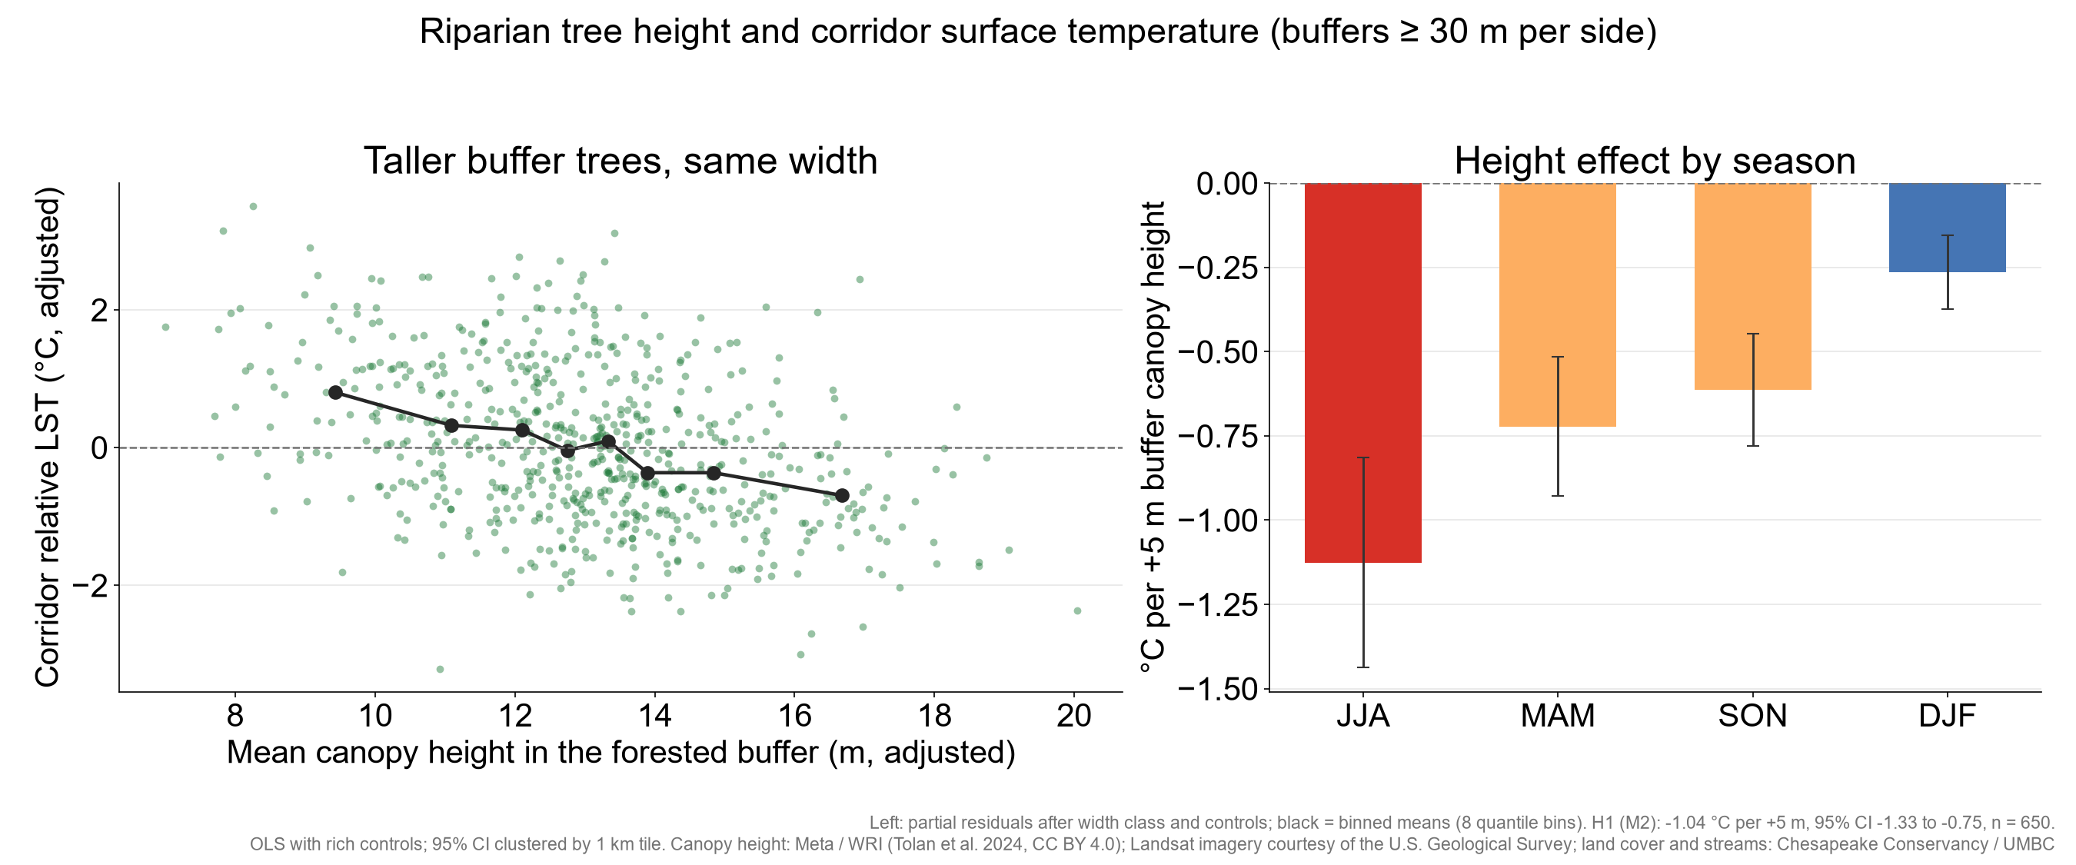
Figure 5. Left: corridor LST against mean buffer canopy height after adjusting for width class and controls. Right: the height effect by season.

4.7 Canopy change and LST trends
Between 2013/14 and 2021/22, buffer canopy changed by a few percentage points at most points (standard deviation 3.7 percentage points within 50 m of the channel). Where canopy increased, the summer relative LST trend was more negative: -0.023 °C per year per 10 percentage points within 0–50 m and -0.031 within 0–100 m (comparing points in the same 1 km square, p < 0.01). Without the local comparison the estimates have the same sign but are not significant. Because typical changes were small, this is supporting rather than primary evidence. It is, however, the test closest to a before-and-after comparison.

4.8 How far the cooling reaches, and who benefits
Table 5. Cooling extent from the channel (median profile within 0.5 °C of the 480–630 m background) and residents within the cooled zone on both banks, by buffer width per side.
Width per side | Points | Channel sampled (km) | Cooling extent (m) | Residents in cooled zone | Residents per km
<10 m | 32 | 4.8 | 120 | 2,815 | 586
10-30 m | 172 | 25.8 | 150 | 11,541 | 447
30-50 m | 107 | 16.1 | 180 | 11,512 | 717
50-100 m | 202 | 30.3 | 210 | 23,047 | 761
100-200 m | 122 | 18.3 | 270 | 11,493 | 628
≥200 m | 219 | 32.9 | 390 | 31,027 | 944

Wider buffers cool farther. The cooled zone extends about 120–150 m from the channel for buffers under 30 m per side and about 390 m for buffers of at least 200 m. Summed over all sampled reaches, an estimated 91,434 residents live within these zones. This figure is approximate: it uses neighbourhood-average density and may double-count near confluences.
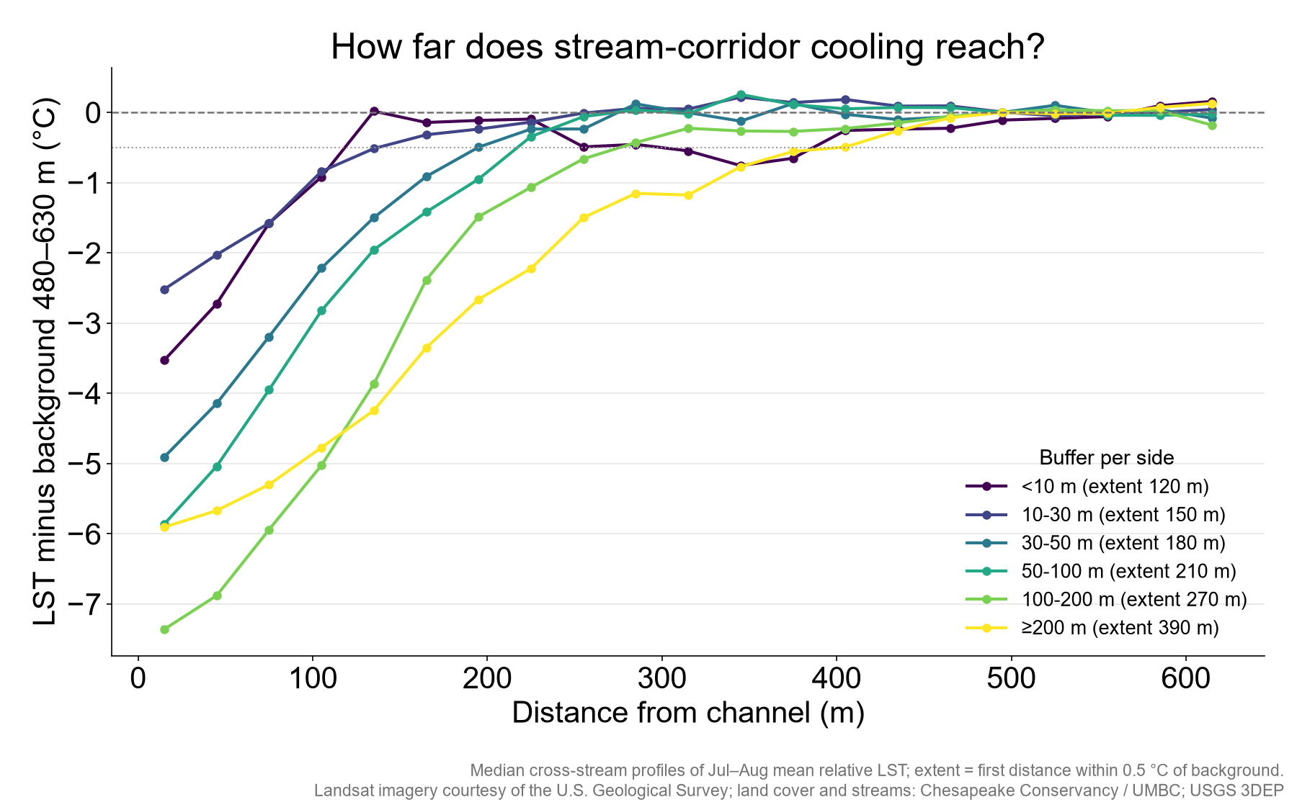
Figure 6. Median cross-stream profiles of summer relative LST minus the 480–630 m background, by buffer width per side.

4.9 What the satellites can and cannot see
Table 6. Share of a corridor's true cooling recorded by each sensor, from a one-dimensional blur simulation (corridor = 0–60 m from the channel).
Buffer width per side | Landsat 8 (100 m) | ECOSTRESS (70 m)
10 m | 15% | 18%
30 m | 42% | 49%
50 m | 64% | 74%
75 m | 84% | 92%
100 m | 95% | 99%
150 m | 100% | 100%

Narrow cool strips are partly averaged away by the thermal footprint. Landsat would record only about 15% of the true cooling of a 10 m buffer, 42% at 30 m and 64% at 50 m, reaching about 95% at 100 m per side. Relative to the widest buffers, the observed cooling is about 24% (10–30 m), 57% (30–50 m) and 87% (50–100 m). This fall-off is close to what blurring plus the smaller forested area of narrow buffers would produce. Two conclusions follow. First, the apparent breakpoint is not evidence that buffers narrower than 60 m are ineffective. Second, the real benefit of narrow buffers at the scale of a path or a backyard is probably larger than satellites can show. Even so, both sensors could detect the cooling of a buffer as narrow as about 15 m per side.
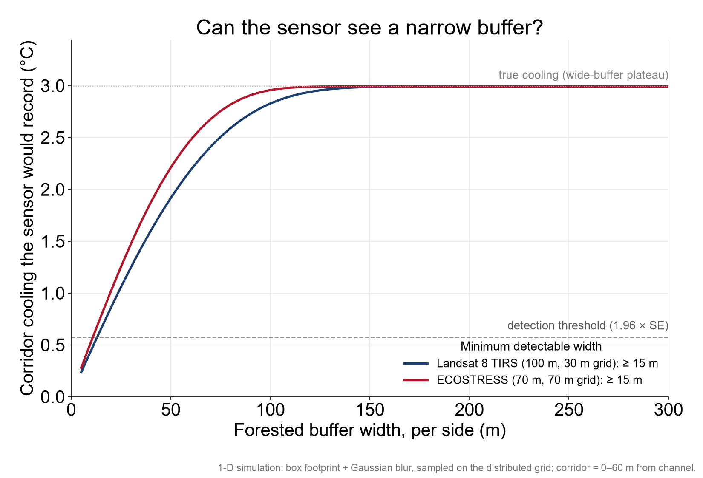
Figure 7. Expected corridor cooling recorded by Landsat 8 and ECOSTRESS as a function of true buffer width per side, with the statistical detection threshold.

5. Where widening buffers could help most
Priority points have buffers under 50 m per side and surroundings hotter than the city median. Their score is the expected cooling from widening the buffer to 50–100 m per side (from model M2) multiplied by local population density. Scores were summed by neighbourhood. The ranking is a screening tool: it identifies where field review is most worthwhile, not where planting is feasible.
Table 7. Top neighbourhoods for riparian buffer widening (narrow buffers, hot surroundings, many residents).
Neighbourhood (NSA) | Priority points | Channel (km) | Median width (m) | Expected cooling (°C) | Residents / km² | Score
Glen Oaks | 4 | 0.60 | 0 | 2.6 | 3,840 | 39.7
Allendale | 6 | 0.90 | 10 | 1.9 | 3,021 | 35.9
Panway/Braddish Avenue | 3 | 0.45 | 0 | 2.6 | 5,678 | 34.3
Winchester | 3 | 0.45 | 0 | 2.6 | 5,455 | 33.0
Frankford | 9 | 1.35 | 30 | 0.9 | 3,115 | 24.5
Morrell Park | 9 | 1.35 | 20 | 1.9 | 1,838 | 23.5
Lakeland | 3 | 0.45 | 10 | 1.9 | 3,517 | 19.6
Greenmount West | 1 | 0.15 | 0 | 2.6 | 6,495 | 16.8
New Northwood | 3 | 0.45 | 30 | 0.9 | 5,439 | 14.3
Gwynns Falls | 4 | 0.60 | 20 | 1.9 | 2,058 | 13.3
Cheswolde | 2 | 0.30 | 20 | 1.9 | 3,435 | 12.8
Brooklyn | 2 | 0.30 | 25 | 1.4 | 4,323 | 11.8

[Add map of priority points from the QGIS project, layer 'Buffer priority points'.]

6. Limitations
- Observational design. Buffer width is not randomly assigned. Wider buffers occur in parks and steep valleys, so the estimates are associations, even with controls, local comparisons and the seasonal test. The canopy-change analysis is the closest to a causal test, but it rests on small changes.
- Surface, not air, temperature. Satellite LST measures the surface seen from above, mostly the canopy top over forest. Air temperature at pedestrian height varies less, and the two should not be equated.
- Sensor resolution. Landsat thermal data are acquired at 100 m and resampled to 30 m, so neighbouring pixels are not independent and narrow features are blurred (Section 4.9). ECOSTRESS has positioning errors of tens of metres and a variable viewing angle.
- Satellite overpass times. Landsat passes over in the morning (about 10:40 local time), before the afternoon peak. ECOSTRESS covers other hours but with fewer scenes per time bin (20–43).
- Canopy and height data. The buffer definition depends on a 50% canopy threshold (tested at 40–70%). Tree heights are modelled and compress tall forest.
- Time mismatch. Land cover (2021/22), heights (around 2018–2020) and LST (2013–2025) cover different periods.
- Resident counts use neighbourhood-average density and are approximate.

7. Next steps
- Validate corridor cooling with air-temperature measurements (for example, transects or existing sensor networks).
- Replace the modelled height map with a lidar canopy height model from the 3DEP point cloud.
- Field-check the top priority reaches for land ownership and planting feasibility.
- [Add literature context and policy references.]

Data, code and acknowledgements
All scripts are in the project repository (scripts 17–35), and every decision and run is recorded in METHODS.md. Raw data are listed with their sources and checksums in data/raw/MANIFEST.csv.
Landsat imagery courtesy of the U.S. Geological Survey. ECOSTRESS data: NASA JPL / LP DAAC. Land cover and hydrography: Chesapeake Conservancy / University of Maryland, Baltimore County. Canopy height: Meta and World Resources Institute (Tolan et al., 2024, CC BY 4.0). Elevation: USGS 3D Elevation Program. Neighbourhood boundaries: Baltimore City.
Tolan, J., et al. (2024). Very high resolution canopy height maps from RGB imagery using self-supervised vision transformer and convolutional decoder trained on aerial lidar. Remote Sensing of Environment, 300, 113888.

