**Summary**

We are students of a Master’s Degree in Informatics and Computing Engineering at FEUP. In Computer Networks class, we have been challenged to develop a program that uses the serial port to send data between two connected Linux machines.

Write main conclusions here.

**Introduction**

Objectives: Create software to send information between two Linux machines using the serial port. Use Stop-and-Wait ARQ mechanism. Each frame is delimited on both ends by a flag byte. Byte stuffing is performed on each information frame.

Logic of the report: what can we find in each section.

**Architecture**

The program consists of two decupled primary modules: application layer and link layer. On the other hand, the link layer module depends on a set of secondary modules: alarm, serial port and utilities.

The link layer is a set of functions that create an API. It’s responsible for developing a protocol that allows it to open/close the serial port connection, read/write data from/to the serial port buffer and recover from errors and interruptions.

The application layer is a generic program that uses the link layer API to send data through a serial port. Its purpose is to read a file’s data and call the link layer functions to open/close the serial port and read/write the data. It’s responsible for adopting an application-specific protocol, so that both sender and receiver work in sync.

**Code Structure**

**Code Flow**

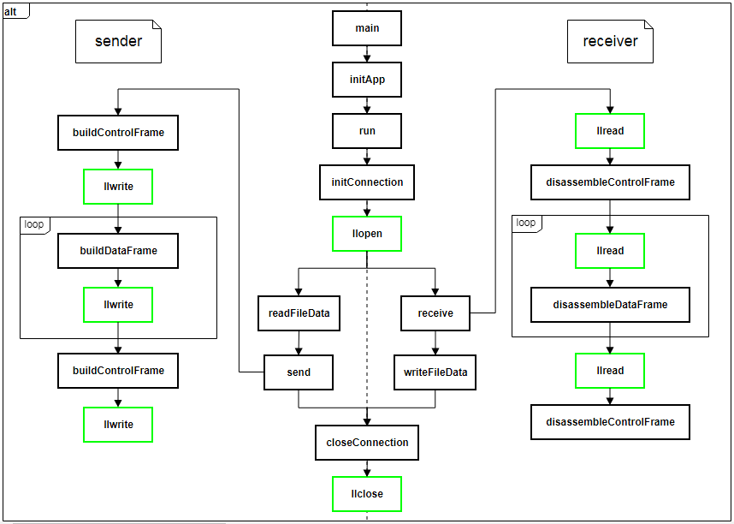

Figure 1 - Application layer code flow

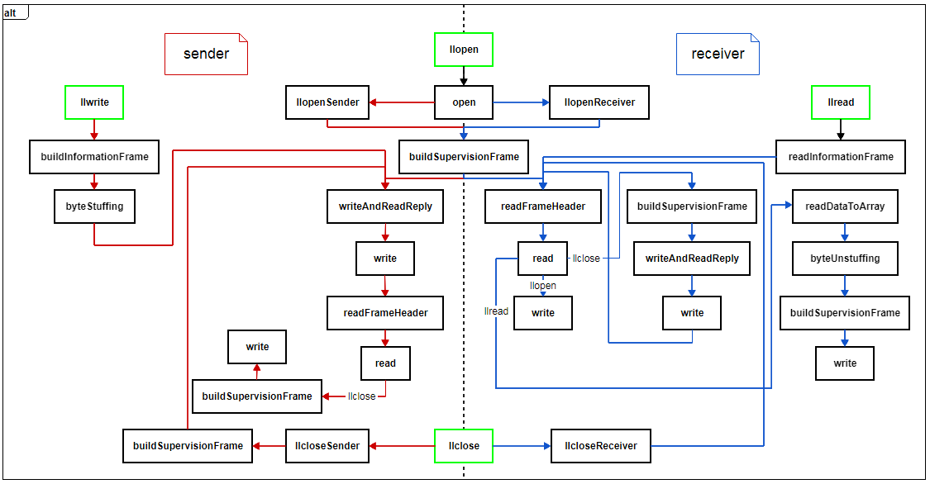

Figure 2 - Link layer code flow

**Primary data structures**

**Primary functions**

**Protocols**

**Link Layer Protocol**

The program can send and read Information, Supervision and Unnumbered acknowledge frames. We’ll define Supervision and Unnumbered Acknowledge as Headers, as they are very similar to Information frame headers.

A Header consists of ADDRESS FIELD, CONTROL FIELD and BCC1.

**ADDRESS FIELD** is used to identify who is sending the frame and the type of the frame.

**CONTROL FIELD** is used to identify the sequence number of the frame on Information frames. On Control frames it is used to identify the type of control byte being sent which can be SET, DISC, UA, RR or REJ.

SET - establish the connection.

DISC - close the connection.

UA - unnumbered acknowledge.

RR - receiver ready: positive acknowledge.

REJ - reject: negative acknowledge.

**BCC1** is the parity byte, calculated as the XOR between ADDRESS and CONTROL BYTE.

An Information frame consists of a Header, DATA and BCC2.

**DATA** is the data to be transmitted.

**BCC2** is the parity byte, calculated as the XOR between all DATA bytes.

All the frames are delimited on both ends by a **FLAG** byte.

To ensure transparency when sending Information frames, byte stuffing is done on all DATA and BCC2 bytes thus avoiding a byte being interpreted as a FLAG or as the ESCAPE character used on the process. For the same reason, when reading Information frames, DATA and BCC2 bytes are unstuffed before checking BCC2 correctness.

To read **Headers** a state machine is used to make sure that the **Sender** sent a valid frame.

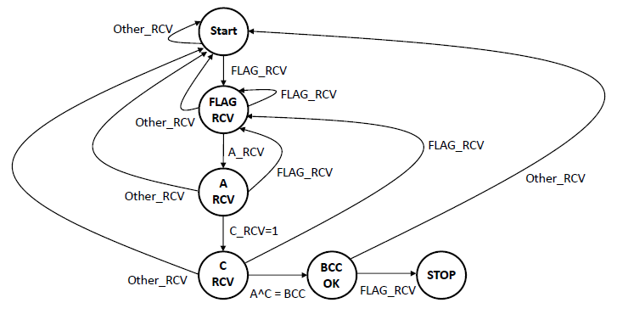

Figure 3 - State machine used to read a frame header

**FALTA FALAR DE ERROS, REJECTS, ALARM TIME-OUT …**

**Application Layer Protocol**

**Validation**

**Link Layer Protocol’s Efficiency**

**Conclusions**

**Attachments**

**Attachment I - Source Code**

https://github.com/jflcarvalho/RCOM-FEUP/tree/master/source

**Attachment II - Usage**

Firstly, execute ‘make’ inside the sources directory to compile the program. Both sender and receiver are the same application, though they receive different command line arguments. To launch the application, type the name of the executable (i.e. ‘./app’). Then, you should type the port (e.g. /dev/ttyS0) and the mode on which the program should operate (i.e. ‘receiver’ or ‘sender’).

        The sender program will also need to receive as a command line argument the path of the file to send (e.g. ‘banana.gif’). Optionally, you can specify the amount of file data in bytes to send per packet (e.g. ‘1024’).

        Example of usage:

-       ‘./app /dev/ttyS0 receiver’

-       ‘./app /dev/ttyS0 sender banana.gif 1024’