RESULTS

Section 1
FastQC examples.

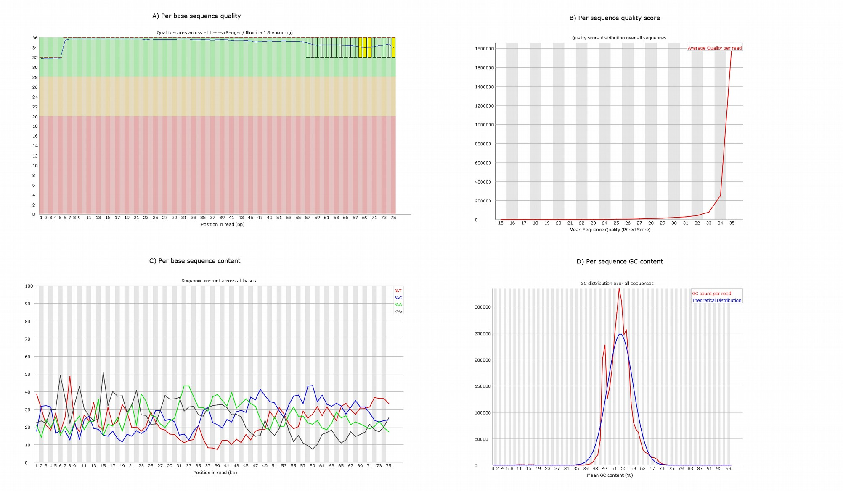

Section 2
Mapping statistics

Table
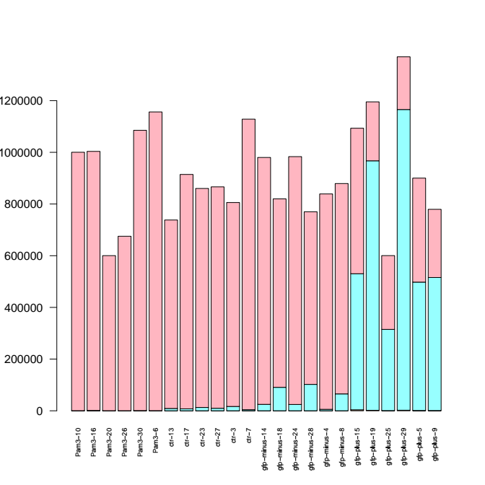
2 Figures: Figure 1 unmapped/mapped? Figure2: mapped_leg vs mapped_human vs mapped_both. Cambiar colores.

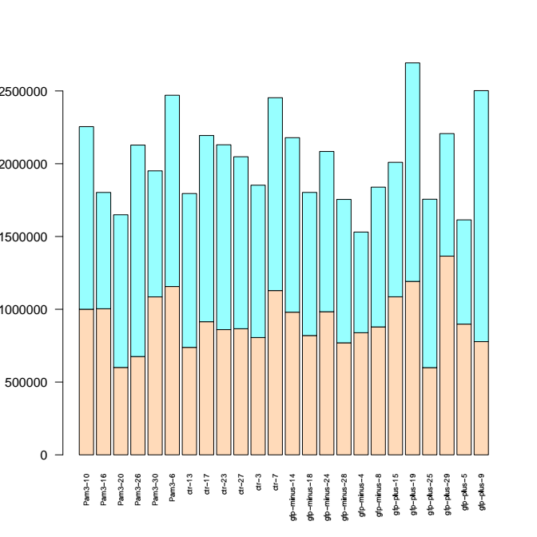

Section 2-3-4-5

General statistics from the mapper, quantifier, miRDeep2. Number of consensus miRNAs predicted.

Section 6.1

Heatmaps after Deseq analysis:

known mirnas/known relevant mirnas/novel miRNAs. Remove trees?

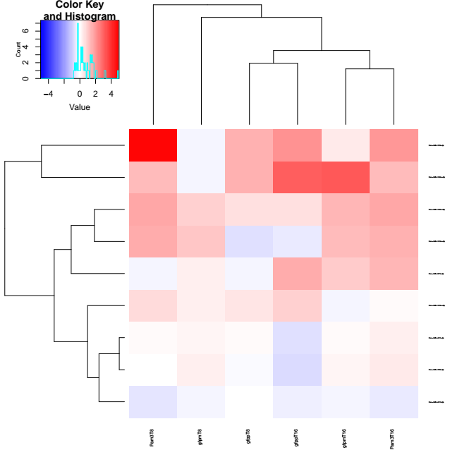
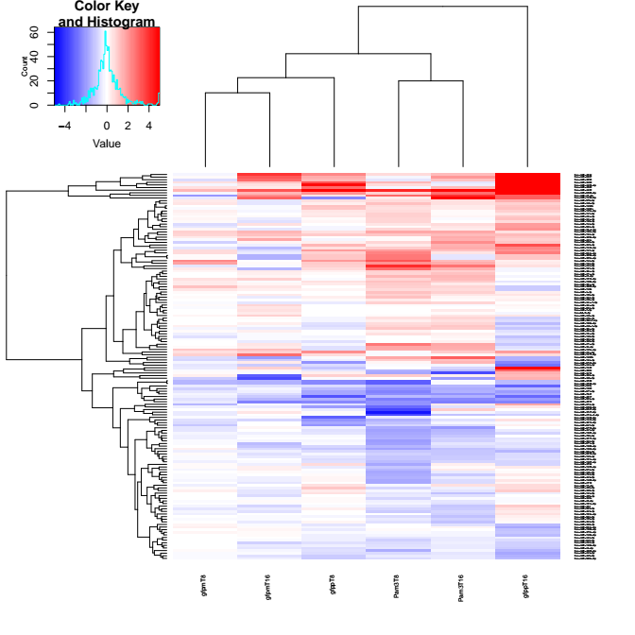
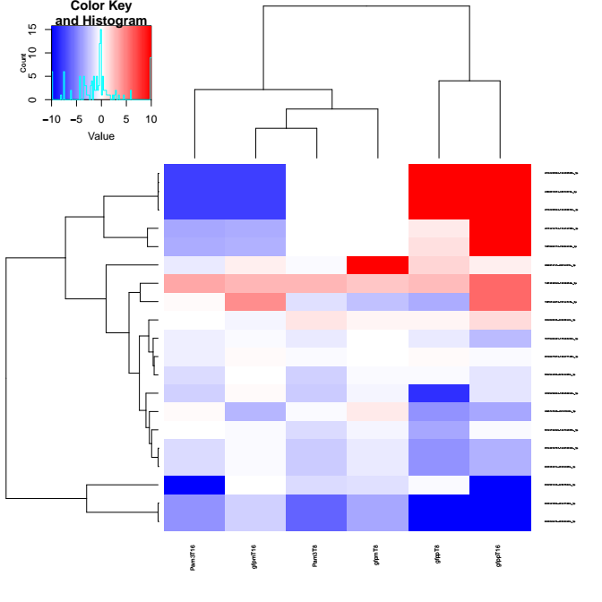

Section 6.2. miRNAs-like legionella small RNAs.

Confirmation that those top miRNAs-like small rnas are uniquely mapped to legionella. Take individual predicted targets. Overrepresentation analysis:
Pathway plot and euler plots?

Something like this for each legionella miRNA. Top5. Then the Venn/Euler Diagram
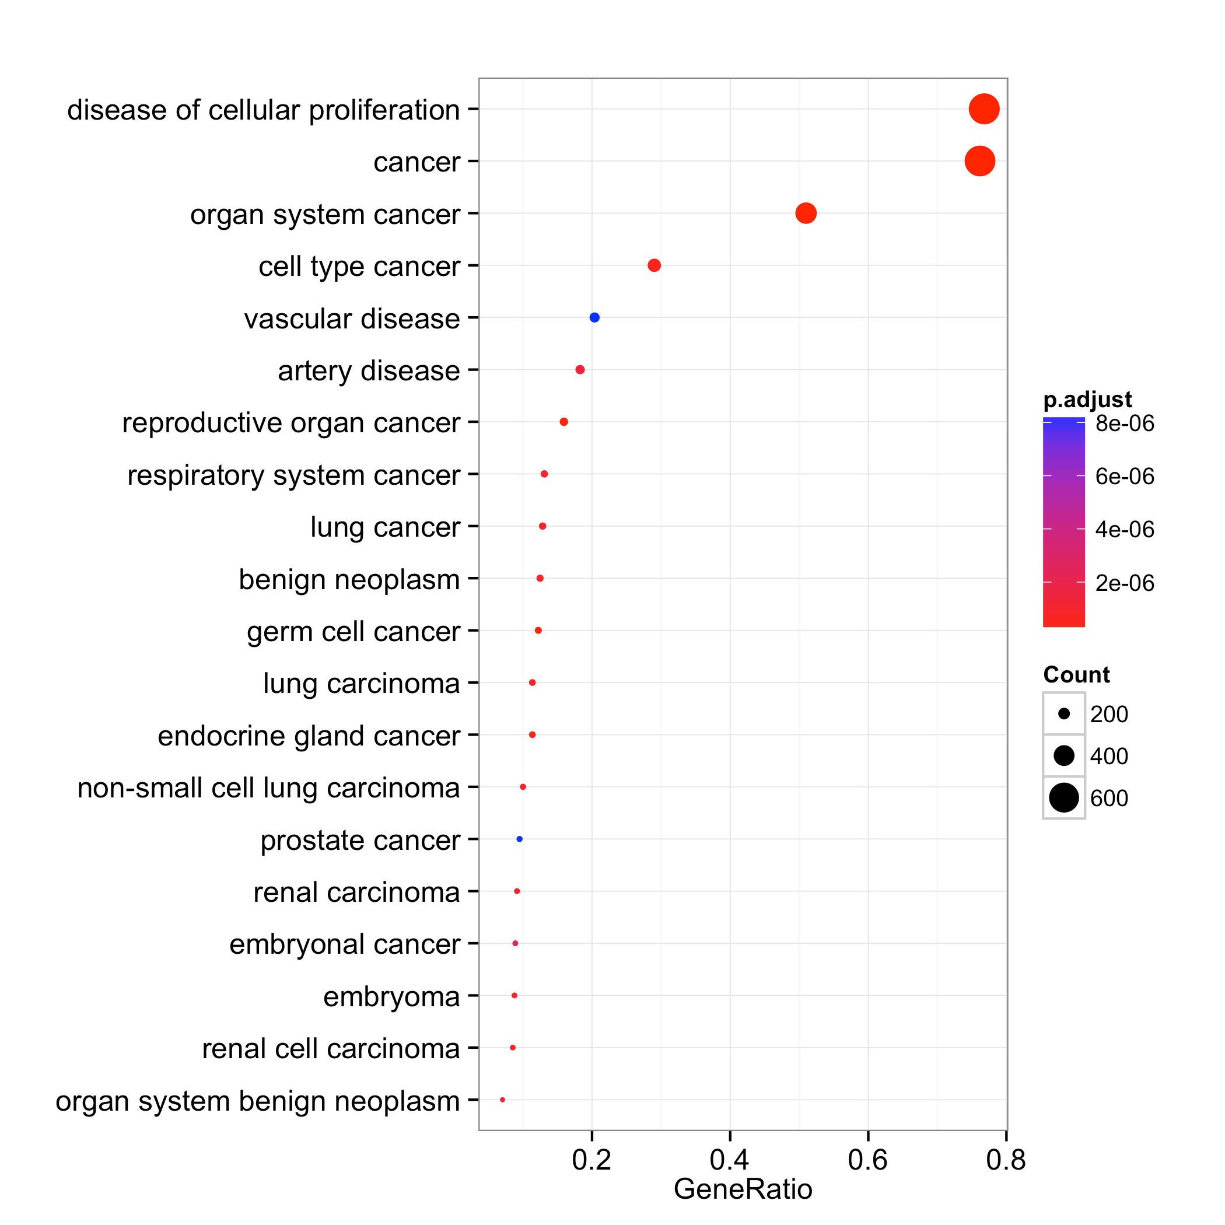

Venn diagram top4. Try with another package see if 5-diagram

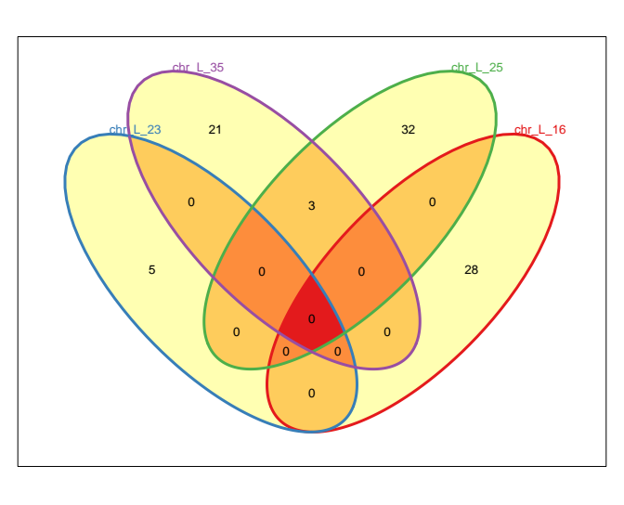

L_35 and L_25 have three sets in common:
-Direct p53 effectors
-Transcriptional regulation by RUNX3
-Validated transcriptional targets of TAp63 isoform

Section 6.3. Interaction network

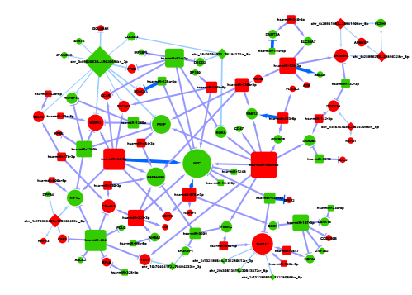

Section 7. Reciprocal best blast hits. Orthologs.

Histogram of top predicted miRNAs by Rcs

Histogram of predicted orthologs per miRNA

Pick some miRNAs: alignment with Jalview, phylogenetic tree, predicted structure. Which ones to pick? INKSCAPE, JALVIEW, FIGTREE, RANDFOLD?

