11.10A=$\frac{P}{∈σT^{4}}$=$\frac{100}{0.3×5.67×{10}^{-8}×{2800}^{4}}$≈0.0956m²
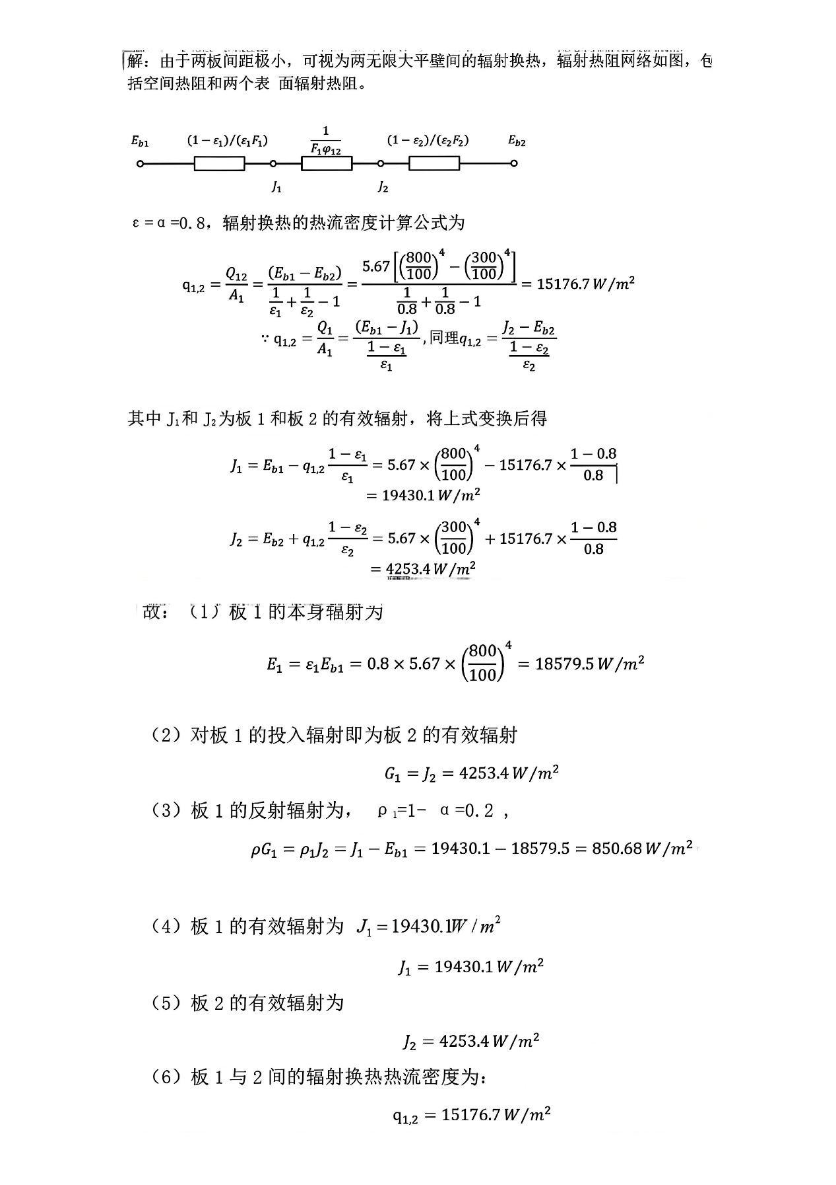
11.13

