2021111750任铎
1.根据帕斯卡三角，写出平面8节点矩形单元的位移插值函数（只需给出函数的形式，无需给出各个待定系数的值）。
$u\left(x,y\right)=α_{1}+α_{2}x+α_{3}y+α_{4}xy+α_{5}x^{2}+α_{6}y^{2}+α_{7}x^{2}y+α_{8}xy^{2}$;
$v\left(x,y\right)=β_{1}+β_{2}x+β_{3}y+β_{4}xy+β_{5}x^{2}+β_{6}y^{2}+β_{7}x^{2}y+β_{8}xy^{2}$;
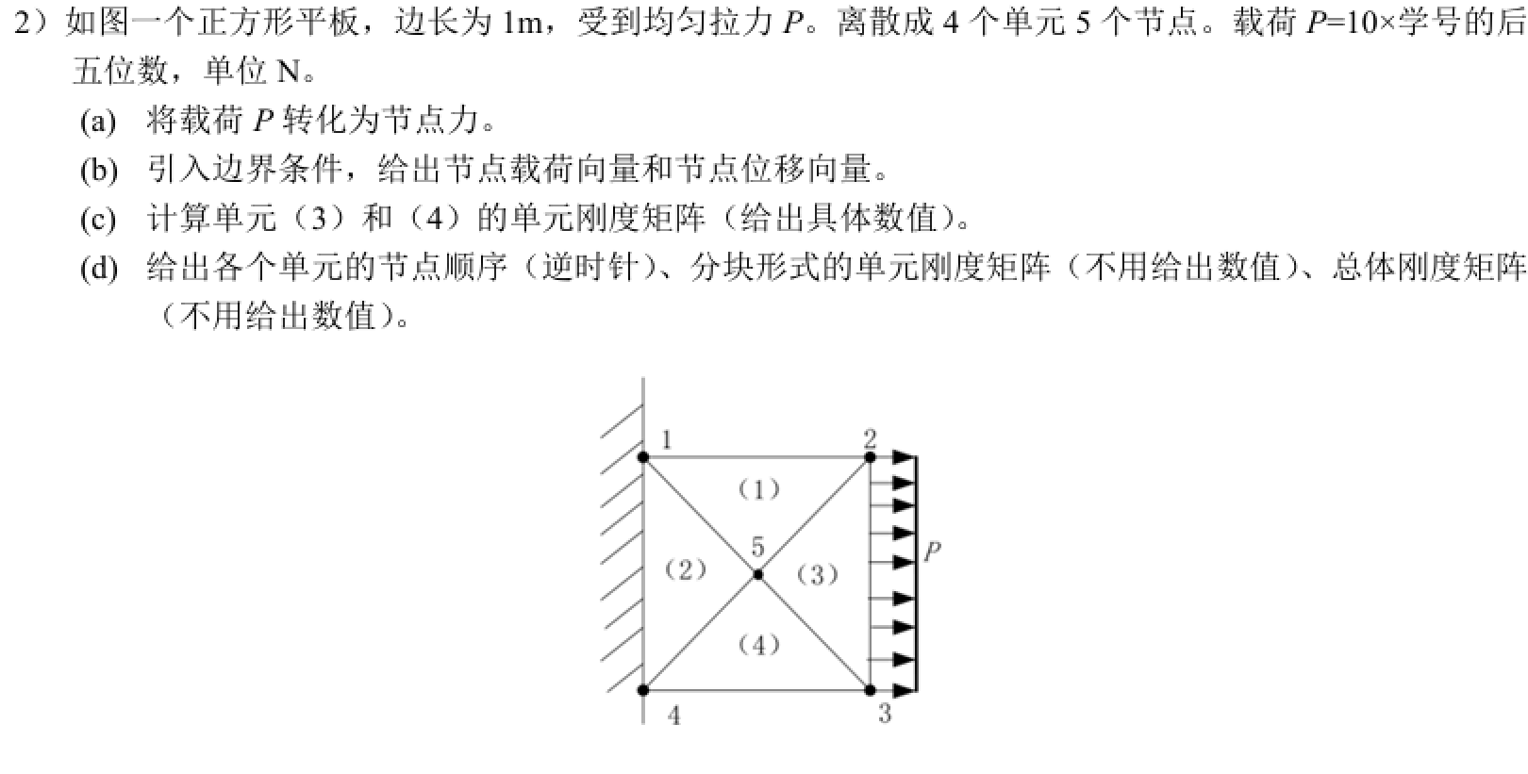
（A）P=10×11750=117500N
$F_{x2}=\frac{P}{2}=58750N ,F_{x3}=\frac{P}{2}=58750N, F_{y2}=0,{ F}_{y3}=0,F_{x1}=F_{x4}=58750N,F_{y1}=F_{y4}=0,{ F}_{5}=0$;
(B)边界条件U₁=V₁=U₄=V₄=0
$P=\left[\begin{matrix}\begin{matrix}F_{x1} & 0\end{matrix} & \begin{matrix}\frac{P}{2} & 0\end{matrix} & \begin{matrix}\frac{P}{2} & 0\end{matrix} & \begin{matrix}F_{x4} & 0\end{matrix} & \begin{matrix}0 & 0\end{matrix}\end{matrix}\right]$^{T};
$δ=\left[\begin{matrix}\begin{matrix}0 & 0\end{matrix} & u_{2} & v_{2} & \begin{matrix}u_{3} & v_{3}\end{matrix} & \begin{matrix}0 & 0\end{matrix} & \begin{matrix}u_{5} & v_{5}\end{matrix}\end{matrix}\right]$^{T};
（C）建系：以节点4为原点，水平向右为x轴，竖直向上为y轴
单元3的坐标为5（1/2,1/2）2（1,1）3（1,0）面积为1/4
弹性模量矩阵为[D]=$\left[\begin{matrix}1 & \frac{μ}{1-μ} & \\ \frac{μ}{1-μ} & 1 & \\ & & \frac{1-2μ}{2(1-μ)}\end{matrix}\right]$=$\left[\begin{matrix}d_{11} & d_{12} & \\ d_{21} & d_{22} & \\ & & d_{33}\end{matrix}\right]$
单元3的单元刚度矩阵[k^{③}]=$\left[\begin{matrix}K_{22}^{③} & K_{23}^{③} & K_{25}^{③} \\ K_{32}^{③} & K_{33}^{③} & K_{35}^{③} \\ K_{52}^{③} & K_{53}^{③} & K_{55}^{③}\end{matrix}\right]$ 单元4同理[k^{④}]=$\left[\begin{matrix}K_{33}^{④} & K_{34}^{④} & K_{35}^{④} \\ K_{43}^{④} & K_{44}^{④} & K_{45}^{④} \\ K_{53}^{④} & K_{54}^{④} & K_{55}^{④}\end{matrix}\right]$
（4）节点顺序: (1)单元: 1, 5, 2; (2)单元:1, 4, 5; (3)单元: 2, 5, 3; (4)单元:5, 4, 3;
$K^{1}=\left[\begin{matrix}K_{11}^{ = 1 \backslash * GB3 ①} & K_{15}^{ = 1 \backslash * GB3 ①} & K_{12}^{ = 1 \backslash * GB3 ①} \\ K_{51}^{ = 1 \backslash * GB3 ①} & K_{55}^{ = 1 \backslash * GB3 ①} & K_{52}^{ = 1 \backslash * GB3 ①} \\ K_{21}^{ = 1 \backslash * GB3 ①} & K_{25}^{ = 1 \backslash * GB3 ①} & K_{22}^{ = 1 \backslash * GB3 ①}\end{matrix}\right]$; $K^{2}=\left[\begin{matrix}K_{11}^{ = 2 \backslash * GB3 ②} & K_{14}^{ = 2 \backslash * GB3 ②} & K_{15}^{ = 2 \backslash * GB3 ②} \\ K_{41}^{ = 2 \backslash * GB3 ②} & K_{44}^{ = 2 \backslash * GB3 ②} & K_{45}^{ = 2 \backslash * GB3 ②} \\ K_{51}^{ = 2 \backslash * GB3 ②} & K_{54}^{ = 2 \backslash * GB3 ②} & K_{55}^{ = 2 \backslash * GB3 ②}\end{matrix}\right]$ ; $K^{3}=\left[\begin{matrix}K_{22}^{ = 3 \backslash * GB3 ③} & K_{25}^{ = 3 \backslash * GB3 ③} & K_{23}^{ = 3 \backslash * GB3 ③} \\ K_{52}^{ = 3 \backslash * GB3 ③} & K_{55}^{ = 3 \backslash * GB3 ③} & K_{53}^{ = 3 \backslash * GB3 ③} \\ K_{32}^{ = 3 \backslash * GB3 ③} & K_{35}^{ = 3 \backslash * GB3 ③} & K_{33}^{ = 3 \backslash * GB3 ③}\end{matrix}\right]$;
$K^{4}=\left[\begin{matrix}K_{55}^{ = 4 \backslash * GB3 ④} & K_{54}^{ = 2 \backslash * GB3 ②} & K_{53}^{ = 4 \backslash * GB3 ④} \\ K_{45}^{ = 4 \backslash * GB3 ④} & K_{44}^{ = 4 \backslash * GB3 ④} & K_{43}^{ = 4 \backslash * GB3 ④} \\ K_{35}^{ = 4 \backslash * GB3 ④} & K_{34}^{ = 4 \backslash * GB3 ④} & K_{33}^{ = 4 \backslash * GB3 ④}\end{matrix}\right]$;
$$总刚矩阵[K]=\left[\begin{matrix}\begin{matrix}K_{11}^{①②} & K_{12}^{①} & 0 \\ & K_{22}^{①③} & K_{23}^{③} \\ & & K_{33}^{③④}\end{matrix} & \begin{matrix}K_{14}^{②} & K_{15}^{①②} \\ 0 & K_{25}^{①③} \\ K_{34}^{④} & K_{35}^{③④}\end{matrix} \\ \begin{matrix} & 对 & \\ & 称 & \end{matrix} & \begin{matrix}K_{44}^{②④} & K_{45}^{②④} \\ & K_{55}^{①②③④}\end{matrix}\end{matrix}\right]$$
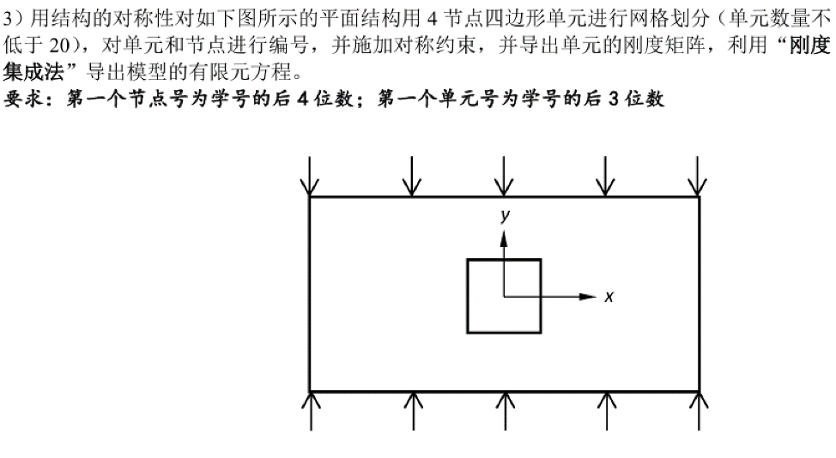
划分区域为一个矩形，由于单元数不低于20则用4*5划分
则网格节点数为30单元数为20
划分单元号从750开始节点数从1750开始
该单元关于中心对称有竖直方向的载荷则轴线上单元节点自由度为0
这样划分
单元号$\left[\begin{matrix}\begin{matrix}750 & 751 & 752 \\ 755 & & \\ 760 & & \end{matrix} & \begin{matrix}753 & 754 \\ & \\ & \end{matrix} \\ \begin{matrix}765 & 766 & 767\end{matrix} & \begin{matrix}768 & 769\end{matrix}\end{matrix}\right]$
矩阵[N]=$\left[\begin{matrix}\begin{matrix}N_{1} & & N_{2}\end{matrix} & \begin{matrix} & N_{3} & \begin{matrix} & \begin{matrix}N_{4} & \end{matrix}\end{matrix}\end{matrix} \\ \begin{matrix} & N_{1} & \end{matrix} & \begin{matrix}N_{2} & & \begin{matrix}N_{3} & \begin{matrix} & N_{4}\end{matrix}\end{matrix}\end{matrix}\end{matrix}\right]$
B矩阵
弹性模量矩阵为[D]=$\left[\begin{matrix}1 & \frac{μ}{1-μ} & \\ \frac{μ}{1-μ} & 1 & \\ & & \frac{1-2μ}{2(1-μ)}\end{matrix}\right]$
总刚矩阵
$$\left[\begin{matrix}\begin{matrix}K_{17501750}^{750} & K_{17501751}^{750} & 0 \\ & K_{17521752}^{751752} & K_{17521753}^{753} \\ & & K_{17531753}^{752753}\end{matrix} & \begin{matrix}… & 0 & 0 \\ … & 0 & 0 \\ … & … & …\end{matrix} \\ \begin{matrix} & 对 & 称 \\ & & \end{matrix} & \begin{matrix}… & K_{17781778}^{768769} & K_{17781779}^{769} \\ … & & K_{17791779}^{779}\end{matrix}\end{matrix}\right]$$

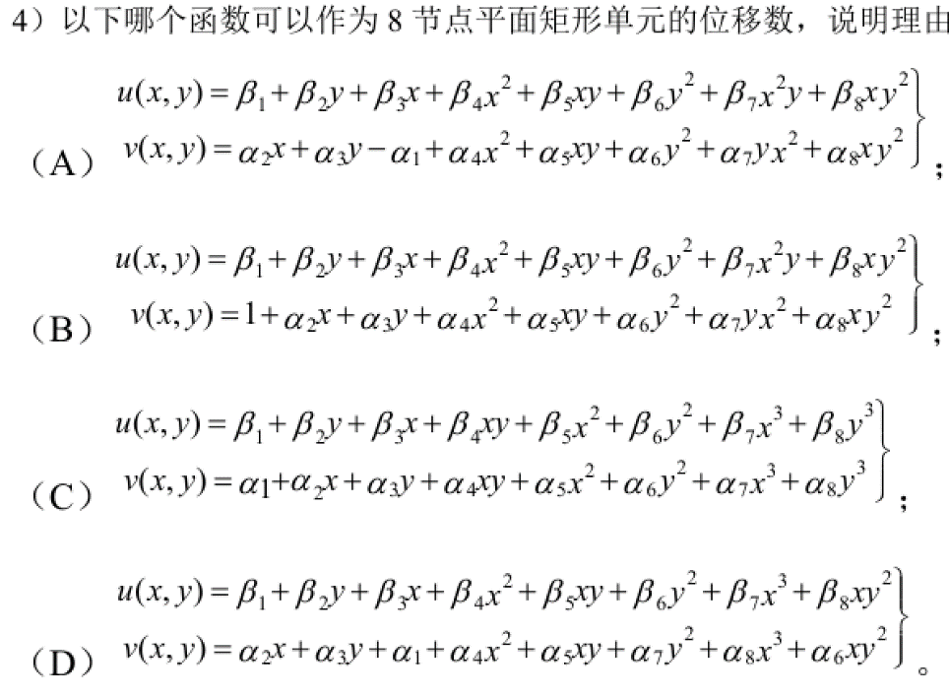
（A）根据帕斯卡三角1,x,y,x²,xy,y²,x²y,y²x 符合要求的是A
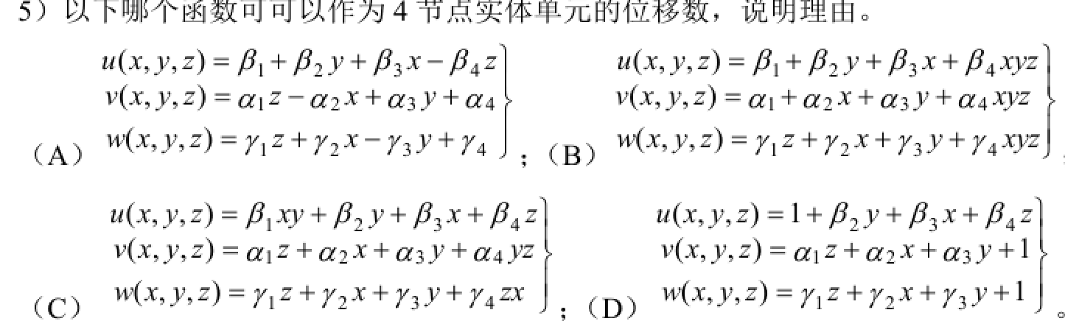

（A）包含项，符合要求

