ERA Security Control “Rosetta Stone” Paper

This Security Plan was found online and used for the GRC lab.
The State of Alaska Health and Social Services Security Plan
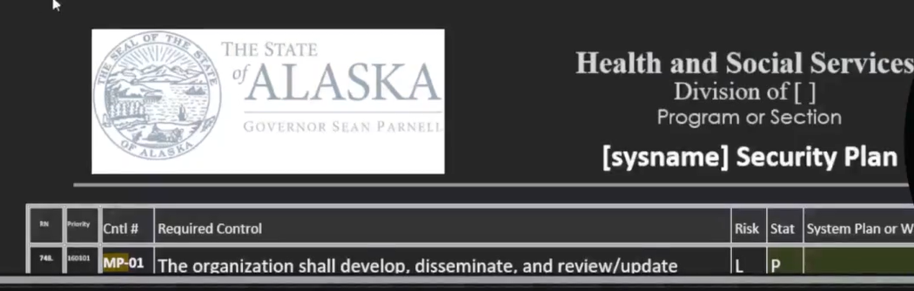

VERY IMPORTANT TO TAKE GOOD NOTES B/C AUDITOR RETURNS IN 2 WEEKS, A MONTH ETC. TO FIGURE OUT IF CONTROLS ARE IN PLACE OR NOT.

MP (Target IT)
MP-1
What policies and procedures around Media Protection?
No media protection policy or procedures were available

MP-2
Is there any restricted data or media? How is this technically enforced? (for legal?)
Tony Jones, Bob Smith.
Privacy Act Data
HR data
Medical records
USB drives are not automounted to computers they need to be mounted by admins
AD controlled data sources.
DLP service

MP-3
What media marking protocols are there and are there any attributes for when to apply or not apply? (internal docs not needing it, externally distributed marked, financials always, etc.)
COVID data we collected, that is not for dissemination. COVID only markings.
Financial information is not to be distributed but there should be a template for it or system has marked it.

MP-4
How are old thumb drives, etc (digital media with company data) handled, sanitized, destroyed?
Question auditor asks is ……Organization has tons of data but how are storing/ keeping them and how are they keeping this data protected? How is organization protecting the data that gets put on thumb drives?
Nothing official. We do it but there’s not a standard process.
Computer end of lifecycle, HDD is pulled and drilled through
*Whenever we’re going to replace a computer or computer goes to end of lifecycle, we pull the hard drive out and we degauss it, or we take a drill and drill though the hard drive.
USB drives must be mounted but there’s no rules on the use of thumb drives, no standards on thumb drives,
Shred bins are in the open office area for the disposal of printed documents.
There’s no documentation or record keeping of media storage or sanitization.

MP-5
When media with company information travels how is it controlled and ensure secure? (physical backups, ex: HDD, print outs)
Sensitive data on a hard drive is physically shipped. How’s it being protected? Is there tracking information on it? Is it encrypted? If someone intercepted the package, could they access the data?
We don’t allow people to travel with data like that, we use cloud storage and have people access it from the cloud when they get to where they are going.
Any system sent out for maintenance or repair has sensitive data wiped before sending.

MP-6
What are the data sanitization processes and are they followed?
Previously discussed in MP-4
Drill hard drives; wipe drives before they go out.
Do you keep logs of this? How do you know you successfully drilled the hard drive?
We keep records.
The auditor asks to see records of the last 3 hard drives that were destroyed.

MP-7
What restrictions around portable media (usb drives) are there and are they being enforced?
No standards, no controls in place.
Go to Alaska SSP to see if it said anything about restrictions; Alaska’s SSP has nothing in place for MP-7. Alaska’s not looking at MP-7 controls.

MP-8
Are there multiple levels of information classification?
There is no process or requirement for media downgrading.
If yes, whats the process for downgrading information from one classification to the next and is the process being executed consistently?

