**Reneal 2021B Box and Project Notes**

**Version 3**

Miscellaneous Notes

1. Because the boxes will be sent stacked on wooden pallets, we have packed them with less bubble-wrap inside since the boxes will not be moving around during shipping. That way we also could fit in more equipment. But it also means that it will be good to handle these boxes more carefully. There is a label on each box that says “THIS SIDE UP”. Whenever you are moving the boxes in a vehicle or storing the boxes, please try to place the boxes so that the “THIS SIDE UP” label is on top facing up.
2. Our donor organization, Apto Solutions, is very focused on saving the environment. So we ask that Reneal Team Tanzania collect any laptops, laptop adapters, or other equipment donated by Apto that fails, so we can return it to the US for recycling. Our idea is that Neal and I can carry it back to the US in boxes. So when a school returns dead equipment to you from Apto Solutions, please store it in a box at RO for us.
3. A single letter (for example, “A) means it is a small box. A double letter (for example “AA”) means it is a big box.
4. Five network switches and power cables at the RO (from Einoti, Mwandet, Kimnyaki, Kiranyi, and Mringa) will be used for Nkoanrua, Sing’isi, Maji ya Chai, Muungano, and Arusha Day CC.

Summary of Box Contents

1. There are Team supplies in four of the boxes.
   1. Box DD: This box has a bag for each Team member with blue tape, pens, and some tools.
   2. Box EE: This includes RJ45s for the five Meru DC and Arusha CC schools. There is also a “power meter” to measure voltage. The power meter should be stored with the other Team tools at the RO. Please return it to the RO after using it.
   3. Box FF: The new wire tracker tool for the Team is in this box. It should also be stored at the RO for any Team member to use.

This box also includes a Getac laptop that is very rugged. Neal has put the server software on it, so it is something that a Team member can carry to a school to use as a server or use for testing at the RO. The adapter for this laptop (a Toshiba adapter) is with the other Team supplies in Boxes DD/EE. Both the laptop and adapter are marked as “AS-Team”. The laptop is for any member of the Team to use, but please store it in a secure place and return it to storage when you are finished using it.

* 1. Box W: The RJ45s and zip ties for Handeni DC are in this box. When you’re finished at Handeni DC, take the remaining zip ties back to Arusha RO for use at the Meru DC and Arusha CC schools.

1. Here is the basic organization of the boxes:
   1. Boxes A-V have laptops, adapters, mice, a keyboard, and the sys admin manual for each of the 11 schools. There are ten laptops in each box, and there are two boxes per schools (total of 22 boxes).
   2. Box W has spare items for Handeni as well as part of the monitor stands (Mon Stand A) for all six of the the Handeni DC school server monitors.
   3. Boxes AA, BB, and CC have the servers, network switches, Mon Stand B, and power and VGA cables for the Handeni DC schools.
   4. Boxes DD, EE, and FF have the servers, Mon Stand A, Mon Stand B, and power and VGA cables for the Meru DC/Arusha CC schools.
   5. Box FF also has some spare items for Arusha RO.
   6. Boxes GG (Handeni DC) and HH (Meru DC and Arusha CC) have the monitor screens.
   7. Team supplies are in Boxes DD, EE, FF, and W.
   8. There are some magazines for the Mlangarini SS library in Box FF.
2. The following 17 boxes have all of the Handeni DC school’s equipment: A, B, C, D, E, F, G, H, I, J, K, L, W, AA, BB, CC, GG. Everything in those boxes goes to Handeni DC. All Handeni DC boxes are marked on the top “Handeni DC”.
   1. Handeni SS: A, B, part of W, part of AA, part of GG
   2. Misima SS: C, D, part of W, part of AA, part of GG
   3. Komnyang’anyo SS: E, F, part of W, part of BB, part of GG
   4. Kisaza SS: G, H, part of W, part of BB, part of GG
   5. Ndolwa SS: I, J, part of W, part of CC, part of GG
   6. Mkata SS: K, L, part of W, part of CC, part of GG

1. The following 14 boxes have the equipment for the Meru DC schools and Arusha CC school: M, N, O, P, Q, R, S, T, U, V, DD, EE, FF, HH
   1. Nkoanrua SS: M, N, part of DD, part of HH [plus used switch from RO]
   2. Sing’isi SS: O, P, part of DD, part of HH [plus used switch from RO]
   3. Maji ya Chai SS: Q, R, part of EE, part of HH [plus used switch from RO]
   4. Muungano SS: S, T, part of EE, part of HH [plus used switch from RO]
   5. Arusha Day SS: U, V, part of FF, part of HH [plus used switch from RO]
2. PLEASE NOTE: The monitors for the servers have parts in different boxes – I hope it is not too confusing. All monitor screens are in Boxes GG (6 for Handeni DC) and HH (5 for Meru DC, Arusha CC). All Mon Stand B pieces are in the boxes with their servers. All Handeni DC Mon Stand A parts are in Box W. All Meru DC/Arusha CC Mon Stand A pieces are in the boxes with their servers. The cables for a school (2 power cables and 1 VGA cable) are in the boxes with their server.
3. Here is a list of what you will need at each new school being installed: server, power cord for server, keyboard, monitor screen/stand (2 pieces A & B)/VGA cable/power cord, network switch and power cord, 20 laptops, 20 laptop adapters, 21 mice, UPS, voltage stabilizer, 5 extensions, 1 multiplug, Cat6 cable, RJ45 connectors, zip ties, tape, pens, cable clips, screws for mounting the switch, SysAdmin manual with donation letters, hammer and drill. Please also take the power meter. Before you plug anything in, check the voltage to make sure it is around 220 volts and stable.
4. Box W has spare equipment for Handeni DC. They will need to store it in a secure place, and please remind them that it is only for Reneal labs. They must get permission from Reneal to take anything from that box.
   1. 1 monitor/stand/VGA cable/power cable
   2. 3 keyboards
   3. 4 mice
   4. 6 HP laptop adapters
   5. 1 VGA cable, 1 power cable
5. Box FF has spare equipment for Arusha RO. Please add to the inventory stored at the RO.
   1. 4 laptops and adapters (G001, G002, G003, G004)
   2. 10 mice

Arusha Purchases

|  |  |  |
| --- | --- | --- |
| **Item** | **To Buy** | **Destination** |
| Uninterruptible power supply (UPS) | 11 | All schools |
| Voltage stabilizer, 500VA | 11 | All schools |
| Power universal extensions (5 outlets) | 55 | 5 each for all schools |
| Multiplug (so 3 things can be plugged into UPS) | 11 | All schools |

PLEASE NOTE: I’m not sure how much Cat6 we have. We will plan to buy 5 boxes from Fatma’s shop. I think that will be enough, but please let me know if we need another box.

PLEASE NOTE: UPS should be charged for 12 hours before it is used the first time.

Installation Notes

1. Please use Erick’s checklist during installation to make sure all steps are completed and you gather all the needed information about the new school.
2. Before you plug anything in, check the computer room voltage with the power meter to make sure it is around 220 volts and stable.
3. When starting installation at a new lab, please inspect the server before you turn it on for the first time. Take off the cover and check the power connectors to the motherboard, the hard disk and DVD connections, make sure the RAM is inserted fully, and check the network cards to make sure they are inserted completely.
4. The multi-plug should plug into the UPS. The server, network switch, and monitor will plug into the multi-plug.
5. I did not put white labels on the computers this time, but I have the specifications for all of the units in a spreadsheet. Please leave the blue tape with the number on the laptop, for identification. “AS” with a number means the laptop/adapter was donated by Apto Solutions.
6. There are donation letters for all 11 new schools – these are included with the SysAdmin manual. There are 2 copies of the donation letter for each school. Have each school head and main super user sign them. Please give them a copy, keep a copy for David, and post one at the Reneal github site.
7. This note is only for Sing’isi and Maji ya Chai. Apto Solutions gave us 2 different types of adapters. Most of them are the regular HP adapters (65-Watts or greater) that work with any of the laptop models we received. However, they also gave us 15 adapters that are 45-Watt adapters – these 45-Watt adapters will only work with the HP 9470M units. I gave 10 of these 45-Watt adapters to Sing’isi SS and 5 to Maji ya Chai SS. It is marked on the boxes, so hopefully it is clear. But I did not put blue tape labels on the adapters, so you will have to make sure you put the 45-Watt adapters with the 9470M units. It might be good if you can put blue tape on the adapters, just so it is clear what adapters go with the 9470M models.
8. This note is only for Arusha Day. There was one laptop in the original shipment that did not work, so Apto Solutions sent a replacement (AS-362). However it uses one of the different HP small diameter blue-tip connector adapters, instead of the regular adapter. The adapter for AS-362 has a label on it saying “AS-362 only”.

Laptop Notes

There are six main laptop models from Apto Solutions in this shipment. Each school received the following:

* 10 units (some combination of HP 9470M/HP 820/HP 840) – these are thinner models
* 10 units (some combination of HP 8470P/HP8460P/HP8440P) – these are the thicker models

There are some notes below about the different models.

***HP 9470M Issues***

* Sometimes when I first plugged in a unit, it would not start up (black screen). But if I unplugged it and waited a little while and tried it again, then it would start. This happened for about 5 units (out of 92).
* I changed some of the dead CMOS batteries in the HP 94570M units but not all of them. They are easy to change. But I’m not sure you need to. If the CMOS battery is dead, it will show a message.

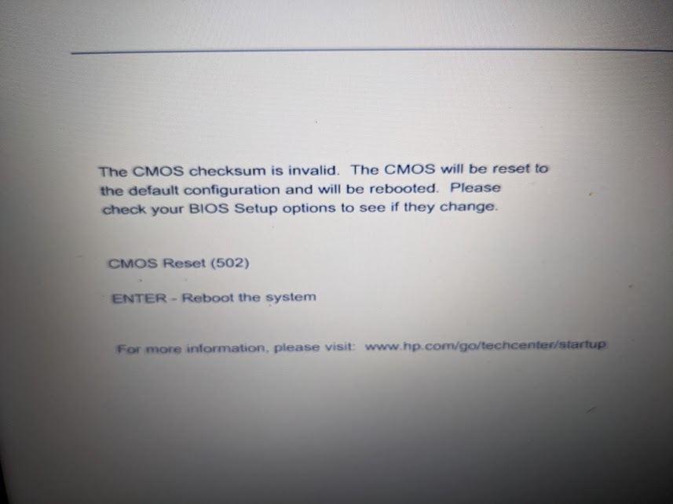

But after it shows that message for a while, it will go on by itself to boot to the network properly (you don’t need to hit “enter” or anything else).

* If you start the 9470M and it doesn’t find something to boot to (for example, if you forgot to turn on the network switch), it will give a message about no bootable device.

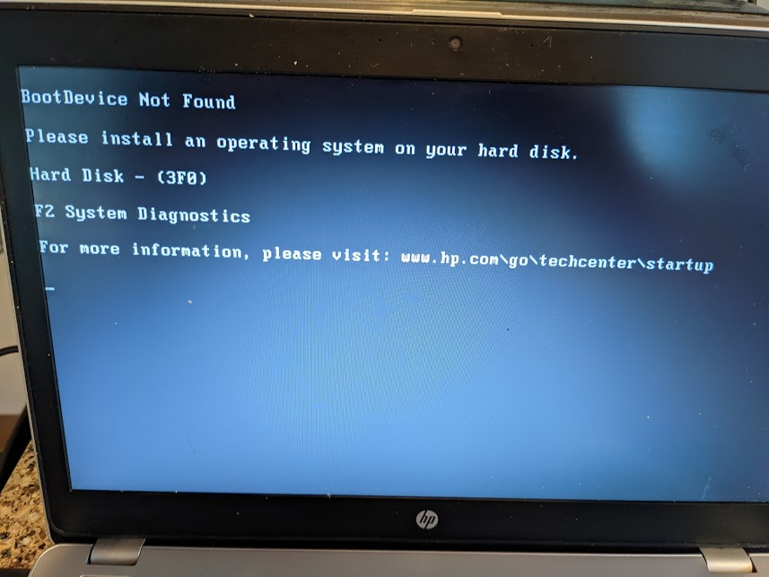

Then the next time you try to boot, it will take you to the HP Diagnostic Test. You then have to choose “Exit” and then “Yes” before it will try to boot again to the network.

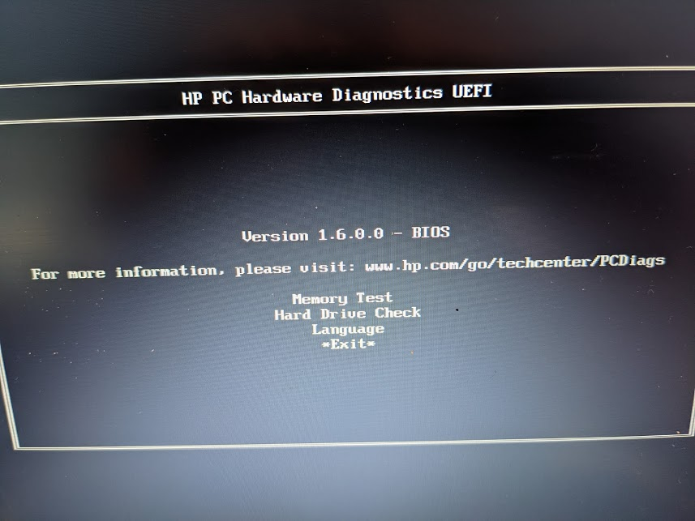 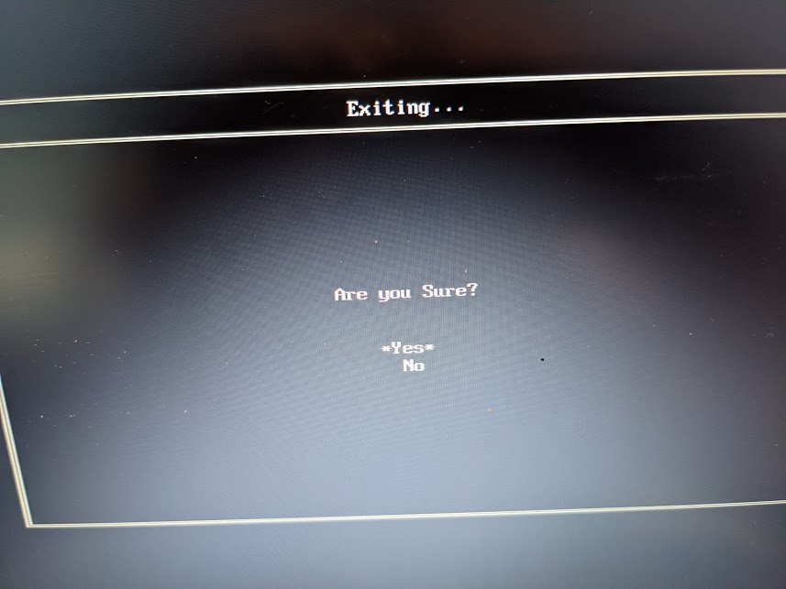

So for example if they forgot to turn the switch on, they will have to go through this “Exit” and “Yes” for any of the clients that were on and didn’t find something to boot to. Once you do “Exit” and “Yes”, the next time it will boot just fine. This is a hassle, but I couldn’t find a way to disable this. Please share this issue with the Super Users, so they are not worried when they see it.

***HP 8470P, HP8460P, HP 820, HP 840 Issues***

* I did not change any dead CMOS batteries for these models. It appeared to be a difficult operation. However, just like the 9470M, these units will show an error message but then go on to boot to the network without any input. So I recommend that you do not try to change the CMOS batteries for these models.
* There is one 8470P unit (AS-282) that gives a message (something like “manufacturing information missing”) – but if you just hit “Enter”, it will boot fine. There is a piece of blue tape on this unit saying “Enter”.

***HP 8440P Issues***

* There are not many of these models, but they were assigned to Arusha Day School since that is easy to visit if they have problems.
* It appears to be a difficult CMOS change, so I did not try. However, I think they will need to hit “F1” to boot if the CMOS is dead. There is a piece of blue tape saying “F1” on the one 8440P that has a dead CMOS.
* The screen is a bit dim when the blue welcome screen comes up. To increase the brightness, you have to sign in and then click on the key for screen brightness. You may have to click the brightness down and then back up. But it will become brighter. (This issue may also affect the 8460P, I can’t remember…)

**Complete List of Box Contents (sorted by school)**

|  |  |  |  |
| --- | --- | --- | --- |
| **Box** | **Item** | **Quantity** | **Destination** |
| W | Team supplies-Handeni | 1 box | All schools |
| DD | Team supplies | 1 box | All schools |
| EE | Team supplies | 1 box | All schools |
| FF | Team supplies | 1 box | All schools |
| FF | Team server | 1 | All schools |
|  |  |  |  |
| **Box** | **Item** | **Quantity** | **Destination** |
| A | Laptop | 10 | Handeni SS |
| A | Laptop adapter | 10 | Handeni SS |
| A | Mouse | 10 | Handeni SS |
| A | Reneal manual | 1 | Handeni SS |
| B | Laptop | 10 | Handeni SS |
| B | Laptop adapter | 10 | Handeni SS |
| B | Mouse | 11 | Handeni SS |
| B | Keyboard | 1 | Handeni SS |
| W | Mon stand A | 1 | Handeni SS |
| AA | Desktop computer | 1 | Handeni SS |
| AA | Network switch, 24-port | 1 | Handeni SS |
| AA | Mon stand B | 1 | Handeni SS |
| AA | VGA-1, Power-2 | 1 | Handeni SS |
| GG | Monitor screen | 1 | Handeni SS |
|  |  |  |  |
| **Box** | **Item** | **Quantity** | **Destination** |
| C | Laptop | 10 | Misima SS |
| C | Laptop adapter | 10 | Misima SS |
| C | Mouse | 10 | Misima SS |
| C | Reneal manual | 1 | Misima SS |
| D | Laptop | 10 | Misima SS |
| D | Laptop adapter | 10 | Misima SS |
| D | Mouse | 11 | Misima SS |
| D | Keyboard | 1 | Misima SS |
| W | Mon stand A | 1 | Misima SS |
| AA | Desktop computer | 1 | Misima SS |
| AA | Network switch, 24-port | 1 | Misima SS |
| AA | Mon stand B | 1 | Misima SS |
| AA | VGA-1, Power-2 | 1 | Misima SS |
| GG | Monitor screen | 1 | Misima SS |
|  |  |  |  |
| **Box** | **Item** | **Quantity** | **Destination** |
| E | Laptop | 10 | Komnyang'anyo SS |
| E | Laptop adapter | 10 | Komnyang'anyo SS |
| E | Mouse | 10 | Komnyang'anyo SS |
| E | Reneal manual | 1 | Komnyang'anyo SS |
| F | Laptop | 10 | Komnyang'anyo SS |
| F | Laptop adapter | 10 | Komnyang'anyo SS |
| F | Mouse | 11 | Komnyang'anyo SS |
| F | Keyboard | 1 | Komnyang'anyo SS |
| W | Mon stand A | 1 | Komnyang'anyo SS |
| BB | Desktop computer | 1 | Komnyang'anyo SS |
| BB | Network switch, 24-port | 1 | Komnyang'anyo SS |
| BB | Mon stand B | 1 | Komnyang'anyo SS |
| BB | VGA-1, Power-2 | 1 | Komnyang'anyo SS |
| GG | Monitor screen | 1 | Komnyang'anyo SS |
|  |  |  |  |

|  |  |  |  |
| --- | --- | --- | --- |
|  |  |  |  |
| **Box** | **Item** | **Quantity** | **Destination** |
| G | Laptop | 10 | Kisaza SS |
| G | Laptop adapter | 10 | Kisaza SS |
| G | Mouse | 10 | Kisaza SS |
| G | Reneal manual | 1 | Kisaza SS |
| H | Laptop | 10 | Kisaza SS |
| H | Laptop adapter | 10 | Kisaza SS |
| H | Mouse | 11 | Kisaza SS |
| H | Keyboard | 1 | Kisaza SS |
| W | Mon stand A | 1 | Kisaza SS |
| BB | Desktop computer | 1 | Kisaza SS |
| BB | Network switch, 24-port | 1 | Kisaza SS |
| BB | Mon stand B | 1 | Kisaza SS |
| BB | VGA-1, Power-2 | 1 | Kisaza SS |
| GG | Monitor screen | 1 | Kisaza SS |
|  |  |  |  |
| **Box** | **Item** | **Quantity** | **Destination** |
| I | Laptop | 10 | Ndolwa SS |
| I | Laptop adapter | 10 | Ndolwa SS |
| I | Mouse | 10 | Ndolwa SS |
| I | Reneal manual | 1 | Ndolwa SS |
| J | Laptop | 10 | Ndolwa SS |
| J | Laptop adapter | 10 | Ndolwa SS |
| J | Mouse | 11 | Ndolwa SS |
| J | Keyboard | 1 | Ndolwa SS |
| W | Mon stand A | 1 | Ndolwa SS |
| CC | Desktop computer | 1 | Ndolwa SS |
| CC | Network switch, 24-port | 1 | Ndolwa SS |
| CC | Mon stand B | 1 | Ndolwa SS |
| CC | VGA-1, Power-2 | 1 | Ndolwa SS |
| GG | Monitor screen | 1 | Ndolwa SS |
|  |  |  |  |
| **Box** | **Item** | **Quantity** | **Destination** |
| K | Laptop | 10 | Mkata SS |
| K | Laptop adapter | 10 | Mkata SS |
| K | Mouse | 10 | Mkata SS |
| K | Reneal manual | 1 | Mkata SS |
| L | Laptop | 10 | Mkata SS |
| L | Laptop adapter | 10 | Mkata SS |
| L | Mouse | 11 | Mkata SS |
| L | Keyboard | 1 | Mkata SS |
| W | Mon stand A | 1 | Mkata SS |
| CC | Desktop computer | 1 | Mkata SS |
| CC | Network switch, 24-port | 1 | Mkata SS |
| CC | Mon stand B | 1 | Mkata SS |
| CC | VGA-1, Power-2 | 1 | Mkata SS |
| GG | Monitor screen | 1 | Mkata SS |
|  |  |  |  |
| **Box** | **Item** | **Quantity** | **Destination** |
| W | Keyboard | 3 | Spares Handeni |
| W | Monitor screen | 1 | Spares Handeni |
| W | Mon stand A/B | 1 | Spares Handeni |
| W | VGA-1, Power-1 | 1 | Spares Handeni |
| W | Mouse | 4 | Spares Handeni |
| W | HP adapters | 6 | Spares Handeni |
|  |  |  |  |

|  |  |  |  |
| --- | --- | --- | --- |
|  |  |  |  |
| **Box** | **Item** | **Quantity** | **Destination** |
| M | Laptop | 10 | Nkoanrua SS |
| M | Laptop adapter | 10 | Nkoanrua SS |
| M | Mouse | 10 | Nkoanrua SS |
| M | Reneal manual | 1 | Nkoanrua SS |
| N | Laptop | 10 | Nkoanrua SS |
| N | Laptop adapter | 10 | Nkoanrua SS |
| N | Mouse | 11 | Nkoanrua SS |
| N | Keyboard | 1 | Nkoanrua SS |
| DD | Desktop computer | 1 | Nkoanrua SS |
| DD | Mon stand A | 1 | Nkoanrua SS |
| DD | Mon stand B | 1 | Nkoanrua SS |
| DD | VGA-1, Power-2 | 1 | Nkoanrua SS |
| HH | Monitor screen | 1 | Nkoanrua SS |
|  |  |  |  |
| **Box** | **Item** | **Quantity** | **Destination** |
| O | Laptop | 10 | Sing'isi SS |
| O | Laptop adapter | 10 | Sing'isi SS |
| O | Mouse | 10 | Sing'isi SS |
| O | Reneal manual | 1 | Sing'isi SS |
| P | Laptop | 10 | Sing'isi SS |
| P | Laptop adapter | 10 | Sing'isi SS |
| P | Mouse | 11 | Sing'isi SS |
| P | Keyboard | 1 | Sing'isi SS |
| DD | Desktop computer | 1 | Sing'isi SS |
| DD | Mon stand A | 1 | Sing'isi SS |
| DD | Mon stand B | 1 | Sing'isi SS |
| DD | VGA-1, Power-2 | 1 | Sing'isi SS |
| HH | Monitor screen | 1 | Sing'isi SS |
|  |  |  |  |
| **Box** | **Item** | **Quantity** | **Destination** |
| Q | Laptop | 10 | Maji ya Chai SS |
| Q | Laptop adapter | 10 | Maji ya Chai SS |
| Q | Mouse | 10 | Maji ya Chai SS |
| Q | Reneal manual | 1 | Maji ya Chai SS |
| R | Laptop | 10 | Maji ya Chai SS |
| R | Laptop adapter | 10 | Maji ya Chai SS |
| R | Mouse | 11 | Maji ya Chai SS |
| R | Keyboard | 1 | Maji ya Chai SS |
| EE | Desktop computer | 1 | Maji ya Chai SS |
| EE | Mon stand A | 1 | Maji ya Chai SS |
| EE | Mon stand B | 1 | Maji ya Chai SS |
| EE | VGA-1, Power-2 | 1 | Maji ya Chai SS |
| HH | Monitor screen | 1 | Maji ya Chai SS |
|  |  |  |  |
| **Box** | **Item** | **Quantity** | **Destination** |
| S | Laptop | 10 | Muungano SS |
| S | Laptop adapter | 10 | Muungano SS |
| S | Mouse | 10 | Muungano SS |
| S | Reneal manual | 1 | Muungano SS |
| T | Laptop | 10 | Muungano SS |
| T | Laptop adapter | 10 | Muungano SS |
| T | Mouse | 11 | Muungano SS |
| T | Keyboard | 1 | Muungano SS |
| EE | Desktop computer | 1 | Muungano SS |
| EE | Mon stand A | 1 | Muungano SS |
| EE | Mon stand B | 1 | Muungano SS |
| EE | VGA-1, Power-2 | 1 | Muungano SS |
| HH | Monitor screen | 1 | Muungano SS |
|  |  |  |  |
|  |  |  |  |
| **Box** | **Item** | **Quantity** | **Destination** |
| U | Laptop | 10 | Arusha Day SS |
| U | Laptop adapter | 10 | Arusha Day SS |
| U | Mouse | 10 | Arusha Day SS |
| U | Reneal manual | 1 | Arusha Day SS |
| V | Laptop | 10 | Arusha Day SS |
| V | Laptop adapter | 10 | Arusha Day SS |
| V | Mouse | 11 | Arusha Day SS |
| V | Keyboard | 1 | Arusha Day SS |
| FF | Desktop computer | 1 | Arusha Day SS |
| FF | Mon stand A | 1 | Arusha Day SS |
| FF | Mon stand B | 1 | Arusha Day SS |
| FF | VGA-1, Power-2 | 1 | Arusha Day SS |
| HH | Monitor screen | 1 | Arusha Day SS |
|  |  |  |  |
| **Box** | **Item** | **Quantity** | **Destination** |
| FF | Magazines | 12 | Mlangarini SS Library |
|  |  |  |  |
| **Box** | **Item** | **Quantity** | **Destination** |
| FF | Laptops-spares | 4 | Spares Arusha |
| FF | Adapters for spare laptops | 4 | Spares Arusha |
| FF | Mice | 10 | Spares Arusha |