**JAMHURI YA MUUNGANO WA TANZANIA**

**OFISI YA RAIS**

**TAWALA ZA MIKOA NA SERIKALI ZA MITAA**



**MKOA WA ARUSHA**

**TAARIFA YA MRADI WA KOMPYUTA KWENYE SHULE 120 ZA SEKONDARI ZA KATA MIKOA YA ARUSHA, TANGA, LINDI, MTWARA, MANYARA, PWANI, IRINGA, MARA, KILIMANJARO, MBEYA NA DODOMA HADI TAREHE 01 OCTOBER, 2025.**

**Imetolewa na:**

**RENEAL IEO,**

**S. L. P. 3050,**

**ARUSHA.**

**OCTOBER, 2025**

**TAARIFA FUPI YA MAABARA ZA KOMPYUTA KWENYE SHULE 119 ZA SEKONDARI ZA KATA MIKOA YA ARUSHA, TANGA, KILIMANJARO, PWANI,**

**DODOMA, LINDI, IRINGA, MARA, MTWARA, MBEYA NA MANYARA.**

**UTANGULIZI.**

Mikoa ya Arusha, Dodoma, Tanga, Lindi, Mtwara, Pwani, Iringa, Kilimanjaro, Mara, Mbeya na Manyara wamepata msaada wa Kompyuta mpakato kwenye shule 119 za Sekondari za kata za Serikali.

Aidha ufadhili huu wa Kompyuta mpakato unatoka kwenye Shirika lisilo la kiserikali (***NGO***) lijulikanalo kama ***Reneal International Education Outreach***, msaada huu ni matokeo ya andiko na usimamizi wa Afisa Tehama wa Mkoa Ndugu, David William Nyangaka kuiomba ***NGO*** hiyo kusaidia kuzipatia shule vifaa vya Tehama. Shirika hili liliridhia na kuweza kugawa Kompyuta mpakato 20 kwa kila shule, Server moja kwa kila shule kwa maabara zote 119 ambapo kwenye server hizo tumefanikiwa kuweka vitu vifuatavyo:-

1. Vitabu vya kiada na ziada
2. Mitihani ya kitaifa kidato cha Pili, Nne na sita kwa masomo yote kuanzia miaka ya 1988 mpaka 2024
3. Video za masomo mbalimbali
4. Simulation kwa Masomo ya Science
5. Syllabus na Curriculum

Sambamba na hilo walimu wanaweza kuweka/Kuongeza Material mbalimbali kwenye Server zao kadiri ya wanavyoona inafaa.

**MANUFAA YA MRADI WA MAABARA ZA KOMPYUTA**

Kuwepo kwa Maabara hizi 119 za Kompyuta Mashuleni kumekuwa na faida nyingi sana kwa walimu na wanafunzi, baadhi tu ya faida hizo ni pamoja na:-

1. Kusajili somo la Kompyuta (Information and Computer Studies) kama somo rasmi shuleni na shule nyingi kuweza kufanya mitihani ya kitaifa ya ICT kidato cha pili na kidato cha nne.
2. Wanafunzi kuweza kufanya Programming, kutengeneza Tovuti pamoja na kutengeneza Compyuta Aplication mbalimbali, kujifunza ufundi wa Kompyuta (PC maintenance) wakisaidiwa na walimu wao.
3. Walimu kuweza kuandaa masomo na matokeo ya wanafunzi kwa kutumia kompyuta hizo.
4. Kuwezesha kuwepo kwa e-Library katika shule zilizonufaika.
5. Mradi umerahisisha shughuli za ofisi kama vile usajili wa wanafunzi, utoaji na upokeaji wa taarifa mbalimbali za kiserikali katika idara ya Elimu mfano matumizi ya mifumo kama Prems, Madeni MIS, Salary Slip Portal’ pamoja na FFARS.

**CHANGAMOTO**

1. Kukosekana kwa walimu wa kutosha wa Tehama ambao ni maalum kwa ajili ya kufundisha somo husika, Matokeo ambayo yanaonekana hapo chini ni baada ya kuwashawishi walimu wa masomo mengine waweze pia kulifundisha somo hilo
2. Shule nyingi zinahitaji Internet kwa ajili ya kuandaa masomo na rejea mbalimbali.
3. Idadi ya Kompyuta zinazogawiwa ni chache ukilinganisha na idadi ya wanafunzi waliopo kwenye hizi shule zetu za kata.
4. Uhitaji wa Printers pamoja na Photocopier Machine kwa ajili ya kudurufu mitihani pindi wanafunzi wakifanya mitihani ya Taifa ya ICT wanapaswa kudurufu tayari kwa ajili ya kwenda kusahihishwa na Baraza la mitihani.

**ORODHA YA SHULE ZILIZOPATA MSAADA WA KOMPYUTA KUTOKA RENEAL IEO**

| **SN** | **JINA LA SHULE** | **WILAYA** | **MWAKA WA MAPOKEZI** | **IDADI** |
| --- | --- | --- | --- | --- |
| 1. | Mlangarini Sekondari | Arusha DC | 2013 | 33 |
| 2. | Mukulat Sekondari | Arusha DC | 2013 | 18 |
| 3. | Ilkiding’a Sekondari | Arusha DC | 2014 | 16 |
| 4. | Mwandet Sekondari | Arusha DC | 2014 | 42 |
| 5. | Enyoito Sekondari | Arusha DC | 2015 | 24 |
| 6. | Ilboru Sekondari | Arusha DC | 2015 | 16 |
| 7. | Mringa Sekondari | Arusha DC | 2015 | 30 |
| 8. | Oldadai Sekondari | Arusha DC | 2015 | 17 |
| 9. | Mateves Secondari | Arusha DC | 2017 | 19 |
| 10. | Kimnyaki Sekondari | Arusha DC | 2018 | 32 |
| 11. | Kiranyi Sekondari | Arusha DC | 2018 | 31 |
| 12 | Oldonyowas Sekondari | Arusha DC | 2021 | 20 |
| 13. | Sokon II Sekondari | Arusha DC | 2018 | 16 |
| 14. | Olmotonyi Sekondari | Arusha DC | 2019 | 20 |
| 15. | Osiligi Sekondari | Arusha DC | 2019 | 22 |
| 16. | Bangata Sekondari | Arusha DC | 2019 | 17 |
| 17. | Einot Sekondari | Arusha DC | 2019 | 39 |
| 18. | Olokii Sekondari | Arusha DC | 2019 | 19 |
| 19. | Oltrumet Sekondari | Arusha DC | 2019 | 19 |
| 20. | Ngiresi Sekondari | Arusha DC | 2020 | 18 |
| 21. | Sambasha Sekondari | Arusha DC | 2020 | 19 |
| 22. | Oljoro Sekondari | Arusha DC | 2022 | 20 |
| 23. | Namanga Sekondari | Longido DC | 2020 | 35 |
| 24. | Engarnaibor Sekondari | Longido DC | 2020 | 18 |
| 25. | Enduiment Sekondari | Longido DC | 2020 | 18 |
| 26. | Tinga Tinga Sec | Longido DC | 2020 | 18 |
| 27. | Longido Sekondari | Longido DC | 2021 | 20 |
| 28. | Suye Sekondari | Arusha CC | 2021 | 20 |
| 29. | Kinana Sekondari | Arusha CC | 2021 | 20 |
| 30. | Kimaseki Sekondari | Arusha CC | 2021 | 20 |
| 31. | Elerai Sekondari | Arusha CC | 2021 | 20 |
| 32. | Arusha Day | Arusha CC | 2021 | 20 |
| 33. | Nkoarua Sekondari | Meru DC | 2021 | 20 |
| 34. | Sing’isi Sekondari | Meru DC | 2021 | 18 |
| 35. | Muungano Sekondari | Meru DC | 2021 | 20 |
| 36. | Handeni Sekondari | Handeni TC | 2021 | 20 |
| 37. | Ndolwa Sekondari | Handeni DC | 2021 | 20 |
| 38. | Mkata Sekondari | Handeni DC | 2021 | 20 |
| 39. | Komnyang’anyo Sekondari | Handeni DC | 2021 | 20 |
| 40. | Kisaza Sekondari | Handeni DC | 2021 | 20 |
| 41. | Misima Sekondari | Handeni TC | 2021 | 18 |
| 42. | Abeid Amani Sekondari | Kondoa DC | 2021 | 34 |
| 43. | Ula Sekondari | Kondoa DC | 2021 | 20 |
| 44. | Kikwe Sekondari | Meru DC | 2021 | 20 |
| 45. | Poli Sekondari | Meru DC | 2022 | 20 |
| 46. | Nkoarisambu Sekondari | Meru DC | 2022 | 20 |
| 47. | Nakwa Sekondari | Babati TC | 2022 | 20 |
| 48 | Nangara Sekondari | Babati TC | 2022 | 20 |
| 49. | Bagara Sekondari | Babati TC | 2022 | 20 |
| 50. | Komoto Sekondari | Babati TC | 2022 | 20 |
| 51. | Kwaraa Sekondari | Bababti TC | 2022 | 20 |
| 52. | Babati Day Sekondari | Babati TC | 2022 | 20 |
| 53. | Lengijave Sekondari | Arusha DC | 2022 | 20 |
| 54. | Themi Sekondari | Arusha CC | 2022 | 20 |
| 55. | Irkisongo sekondari | Monduli DC | 2022 | 20 |
| 56. | Engutoto Sekondari | Monduli DC | 2022 | 18 |
| 57. | Chief Dodo Sekondari | Bababa TC | 2023 | 20 |
| 58. | Mtama Sekondari | Lindi DC | 2023 | 20 |
| 59. | Kiwalala Sekondari | Lindi DC | 2023 | 20 |
| 60. | Nyegendi Sekondari | Lindi DC | 2023 | 20 |
| 61. | Mahiwa Sekondari | Lindi DC | 2023 | 20 |
| 62. | Namalenga Sekondari | Mtwara DC | 2023 | 20 |
| 63. | Bicha Sekondari | Kondoa DC | 2023 | 20 |
| 64. | Bukulu Sekondari | Kondoa DC | 2023 | 20 |
| 65. | Irkisale Sekondari | Monduli DC | 2023 | 20 |
| 66. | Bihawana Sekondari | Dodoma CC | 2023 | 20 |
| 67. | Moshono Sekondari | Arusha CC | 2023 | 20 |
| 68. | Naura Sekondari | Arusha CC | 2023 | 20 |
| 69. | Nkoasenga Sekondari | Meru DC | 2023 | 20 |
| 70. | Dareda Sekondari | Babati DC | 2023 | 20 |
| 71. | Ayagalaya Sekondari | Babati DC | 2023 | 20 |
| 72. | Gorowa Sekondari | Babati DC | 2023 | 20 |
| 73. | Oloasiti Sekondari | Arusha CC | 2023 | 20 |
| 74. | Moita Sekondari | Monduli DC | 2023 | 20 |
| 75. | Florian Sekondari | Karatu DC | 2023 | 20 |
| 76. | Selebu Sekondari | Kilolo DC | 2024 | 20 |
| 77. | Kilolo Sekondari | Kilolo DC | 2024 | 20 |
| 78. | Udzungwa Sekondari | Kilolo DC | 2024 | 20 |
| 79. | Nyalumbu Sekondari | Kilolo DC | 2024 | 20 |
| 80. | Mboga Sekondari | Chalinze DC | 2024 | 20 |
| 81. | Mdaula Sekondari | Chalinze DC | 2024 | 20 |
| 82. | Msata Sekondari | Chalinze DC | 2024 | 20 |
| 83. | Mandela Sekondari | Chalinze DC | 2024 | 20 |
| 84. | Mkonoo Sekondari | Arusha DC | 2024 | 20 |
| 85. | Banjika Sekondari | Karatu DC | 2024 | 20 |
| 86. | Kiboroloni Sekondari | Moshi CC | 2024 | 20 |
| 87. | Ifati Sekondari | Moshi DC | 2024 | 20 |
| 88. | Lucas Malia Sekondari | Ruangwa DC | 2024 | 20 |
| 89. | Hawa Mchopa Sekondari | Ruangwa DC | 2024 | 20 |
| 90. | Ruangwa Sekondari | Ruangwa DC | 2024 | 20 |
| 91. | Nkowe Sekondari | Ruangwa DC | 2024 | 20 |
| 92  . | Mbekenyera Sekondari | Ruangwa DC | 2024 | 20 |
| 93. | Butiama Sekondari | Butiama DC | 2024 | 20 |
| 94. | Bumangi Sekondari | Butaima DC | 2024 | 20 |
| 95. | Butuguri Sekondari | Butiama DC | 2024 | 20 |
| 96. | Kiagata Sekondari | Butiama DC | 2024 | 20 |
| 97. | Kiabakari Sekondari | Butiama DC | 2024 | 20 |
| 98. | Mitesa Sekondari | Masasi DC | 2024 | 20 |
| 99. | Oshara Sekondari | Siha DC | 2025 | 20 |
| 100. | Nuru Sekondari | Siha DC | 2025 | 20 |
| 101. | Namwai Sekondari | Siha DC | 2025 | 20 |
| 102. | Sanya juu Sekondari | Siha DC | 2025 | 20 |
| 103. | Manyara Girls Sekondari | Babati TC | 2025 | 20 |
| 104. | Viwandani Sekondari | Dodoma MC | 2025 | 20 |
| 105. | Ikuti Sekondari | Rungwe DC | 2025 | 20 |
| 106. | Kinyala Sekodari | Rungwe DC | 2025 | 20 |
| 107. | Lupoto Sekondari | Rungwe DC | 2025 | 20 |
| 108. | Mpuguso Sekondari | Runwe DC | 2025 | 20 |
| 109. | Uhambingeto Sekondari | Rungwe DC | 2025 | 20 |
| 110. | Chifu Mang’enya Sekondari | Tanga CC | 2025 | 20 |
| 111. | Mwapachu Sekondari | Tanga DC | 2025 | 20 |
| 112. | Mbwego Sekondari | Kilindi DC | 2025 | 20 |
| 113. | Semkiwa Sekondari | Korogwe DC | 2025 | 20 |
| 114. | Losinoni Sekondari | Arusha DC | 2025 | 20 |
| 115. | Iyunga Technical Sekondari | Mbeya MC | 2025 | 20 |
| 116. | Songwe Sekondari | Mbeya DC | 2025 | 20 |
| 117. | Malama Sekondari | Mbeya DC | 2025 | 20 |
| 118. | Usongwe Sekondari | Mbeya DC | 2025 | 20 |
| 119. | Ilunga Sekondari | Mbeya DC | 2025 | 20 |

**MATOKEO YA MITIHANI YA TAIFA ICT**

Kuwepo kwa maabara hizi za Kompyuta kuliweza kufanikisha baadhi ya shule kuweza kusajili somo la Tehama na baadhi ya shule hii zilianza kufanya mitihani ya kitaifa na matokeo hayakua mabaya sana. Jedwali hapa chini imeonyesha idadi ya shule zilizofanya mitihani hiyo na matokeo ya somo husika.

***MATOKEO YA ICT NECTA LONGIDO SS 2024 KIDATO CHA NNE***

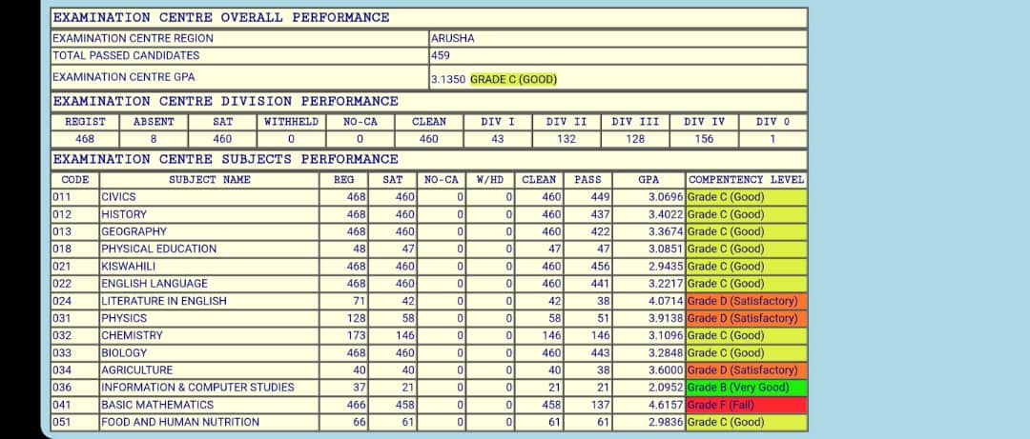

***MATOKEO YA ICT NECTA MWANDET SS 2024 KIDATO CHA NNE***

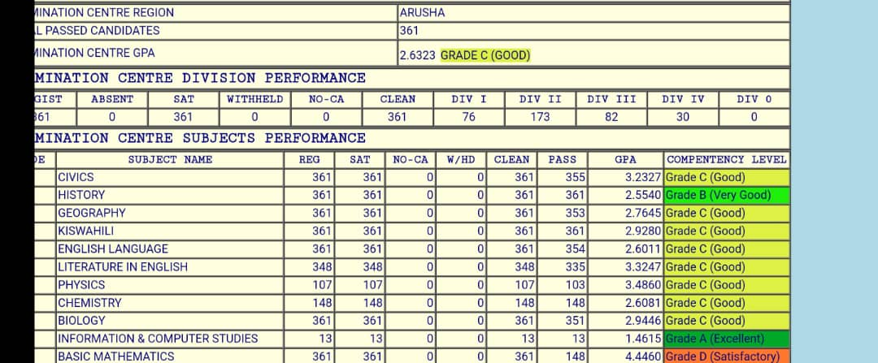

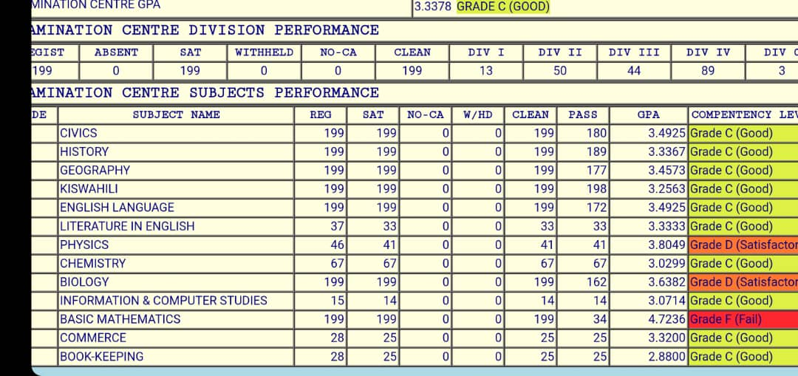

***MATOKEO YA ICT NECTA 2019 KIDATO CHA PILI***

|  |  |  |  |  |  |  |  |
| --- | --- | --- | --- | --- | --- | --- | --- |
| **SN** | **SHULE** | **A** | **B** | **C** | **D** | **F** | **WALIOFANYA** |
| 1. | Enyoito | 0 | 0 | 0 | 4 | 17 | 21 |
| 2. | Ikidinga | 0 | 0 | 0 | 5 | 27 | 32 |
| 3. | Mateves | 0 | 0 | 10 | 14 | 3 | 27 |
| 4. | Mlangarini | 0 | 0 | 8 | 19 | 22 | 49 |
| 5. | Mringa | 0 | 3 | 5 | 11 | 5 | 24 |
| 6. | Mukulat | 0 | 0 | 0 | 6 | 19 | 25 |
| 7. | Mwandet | 0 | 0 | 8 | 21 | 14 | 43 |
| 8. | Nduruma | 0 | 0 | 0 | 6 | 10 | 16 |
| 9. | Olmotonyi | 0 | 0 | 2 | 15 | 9 | 26 |
| 10. | Osiligi | 0 | 0 | 3 | 15 | 13 | 31 |
| ***MATOKEO*** | | 0 | 3 | 36 | 116 | 139 | 294 |

***MATOKEO YA ICT NECTA 2020 KIDATO CHA PILI***

|  |  |  |  |  |  |  |  |
| --- | --- | --- | --- | --- | --- | --- | --- |
| SN | SHULE | A | B | C | D | F | WALIOFANYA |
| 1. | Engarnaibor | 0 | 0 | 0 | 11 | 3 | 14 |
| 2. | Enyoito | 0 | 0 | 0 | 5 | 6 | 11 |
| 3. | Ilkiding’a | 0 | 0 | 0 | 2 | 23 | 25 |
| 4. | Mateves | 0 | 0 | 3 | 16 | 15 | 34 |
| 5. | Mlangarini | 0 | 0 | 5 | 17 | 15 | 37 |
| 6. | Mringa | 0 | 0 | 8 | 8 | 7 | 23 |
| 7. | Mwandet | 0 | 0 | 3 | 6 | 14 | 23 |
| 8. | Nduruma | 0 | 0 | 0 | 0 | 5 | 5 |
| 9. | Olmotonyi | 0 | 0 | 1 | 5 | 15 | 21 |
| 10. | Osiligi | 0 | 0 | 1 | 5 | 5 | 11 |
| ***MATOKEO*** | | 0 | 0 | 21 | 75 | 108 | 204 |

**M*ATOKEO YA ICT NECTA 2020 KIDATO CHA NNE***

|  |  |  |  |  |  |  |  |
| --- | --- | --- | --- | --- | --- | --- | --- |
| **SN** | **SHULE** | **A** | **B** | **C** | **D** | **F** | **WALIOFANYA** |
| 1. | Mlangarini | 0 | 1 | 3 | 4 | 8 | 16 |
| 2. | Mwandet Sec | 0 | 1 | 2 | 2 | 0 | 5 |
| 3. | Longido Sec | 0 | 1 | 9 | 8 | 1 | 19 |

Aidha mradi huu umeweza kufanikiwa sana kwa kuwa na timu imara ya Wataalam (Technicians) ambao ni vijana wazawa wa Kitanzania ambao mara baada ya kuhitimu masomo yao waliomba kujitolea na kuweza kufanya ‘installations, Training’ pamoja na kutoa ‘support’ kwenye shule zote 119 bure,

Vijana hao ni Pamoja na

1. Daniel Nnko
2. Erick Mneney
3. Ashura Hamis
4. Juma Ramadhani
5. James Ngahemelwa
6. Justin Msechu
7. Abubakari S. Frenk
8. Janeth Mmbaga

Sambamba na Timu hii pia tumekua tukipata msaada mkubwa kutoka Arusha Node Marie (ANM) pamoja na Habari Node ambao nao wamekua wakitupatia Wataalam (Technicians) ambao wamekua wakishirikiana na Technians niliowataja hapo juu.

Mradi umefanyikiwa kufunga kompyuta mpakato pamoja na server zake kama ifwatavyo, Arusha 1147, Tanga 214, Manyara 242, Dodoma 168, Mtwara 42, Pwani 84, Kilimanjaro 210, Iringa 105, Mbeya 189, Mara 105 na Lindi 110 kufanya jumla kuu kwa shule zote kua 2612 kama inavyoonekana kwenye jedwali chini.

**JEDWALI LA MAKADIRIO - IDADI YA KOMPYUTA + SERVER KWA KILA MKOA - (SHULE 119)**

|  |  |  |
| --- | --- | --- |
| SN | JINA LA MKOA | IDADI |
| 1. | ARUSHA | 1,147 |
| 2. | TANGA | 214 |
| 3. | MANYARA | 242 |
| 4. | DODOMA | 168 |
| 5. | LINDI | 110 |
| 6. | MTWARA | 42 |
| 7. | PWANI | 84 |
| 8. | IRINGA | 105 |
| 9. | KILIMANJARO | 210 |
| 10. | MBEYA | 189 |
| 11. | MARA | 105 |
|  | **JUMLA KUU** | **2,612** |

Kufunga mfumo wa kompyuta mpakato kulihitaji vifaa saidizi, vifaa hivi vya mradi ni Power Extensions 595, Voltage Regulator 119, UPS 119, Network Switch 119 na Ethernet Box 61 kufanya jumla ya vifaa kua 993.

**JEDWALI LA MAKADIRIO - IDADI YA VIFAA VINGINEVYO - (SHULE 119)**

|  |  |  |
| --- | --- | --- |
| SN | VIFAA | IDADI |
| 1. | POWER EXTENSIONS | 595 |
| 2. | VOLTAGE REGULATOR | 119 |
| 3. | UPS (Uninterruptable Power Supply) | 119 |
| 4. | NETWORK SWITCH | 119 |
| 5. | ETHERNET CABLE BOXES | 61 |
|  | **JUMLA VIFAA VINGINEVYO** | **993** |

**JEDWALI LA MAKADIRIO – THAMANI YA MRADI - (SHULE 119)**

|  |  |  |  |  |
| --- | --- | --- | --- | --- |
| SN | VIFAA | IDADI | THAMANI | JUMLA |
| 1. | POWER EXTENSIONS | 595 | 22,000 | 13,090,000 |
| 2. | VOLTAGE REGULATOR | 119 | 90,000 | 10,710,000 |
| 3. | UPS (Uninterruptable Power Supply) | 119 | 120,000 | 14,280,000 |
| 4. | NETWORK SWITCH | 119 | 250,000 | 29,750,000 |
| 5. | ETHERNET CABLE BOXES | 61 | 450,000 | 27,450,000 |
| 6. | NORMAL LAPTOPS  MACBOOKS | 2428  100 | 700,000  3,000,000 | 1,699,600,000  300,000,000 |
| 7. | SERVER | 119 | 3,000,000 | 357,000,000 |
| 8. | RJ45 | 119 | 5,000 | 595,000 |
| 9. | CABLE TIE | 206 | 5,000 | 1,030,000 |
|  | **JUMLA KUU** |  |  | **2,453,505,000** |

**PICHA MBALIMBALI**

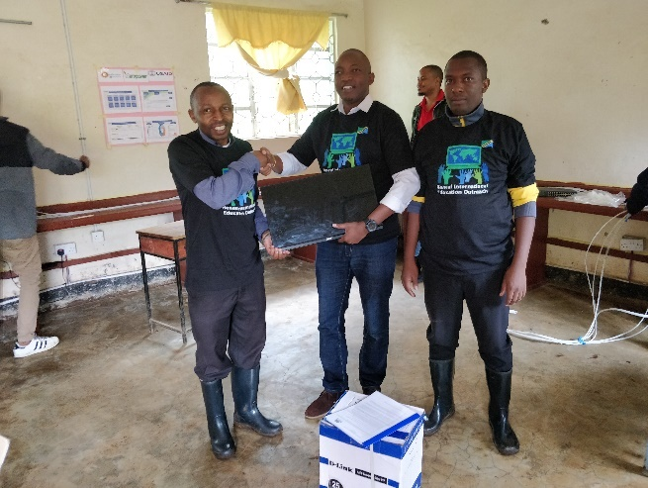 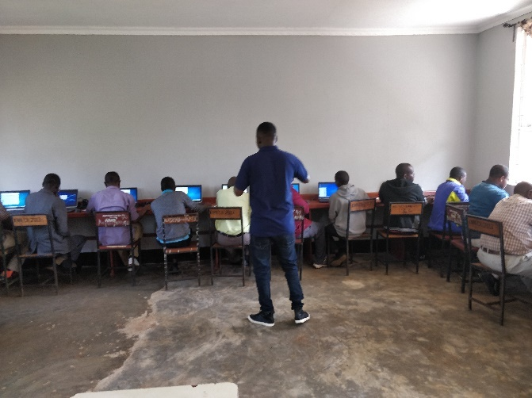

*Afisa Tehama wa Mkoa Ndugu David William Walimu mbalimbali wakipatiwa mafunzo ya awali*

*Nyangaka akifanya makabidhiano na mkuu wa shule baada Ya maabara kuwa tayati kwa makwanza ya suye secondari CCni arusha ya monitor ya kisasa*

*itakayotumika katika server*

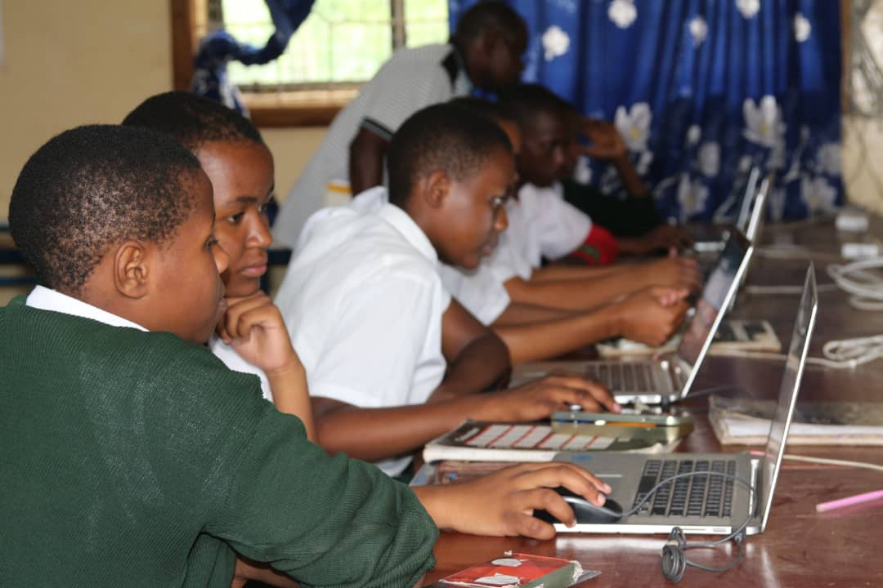 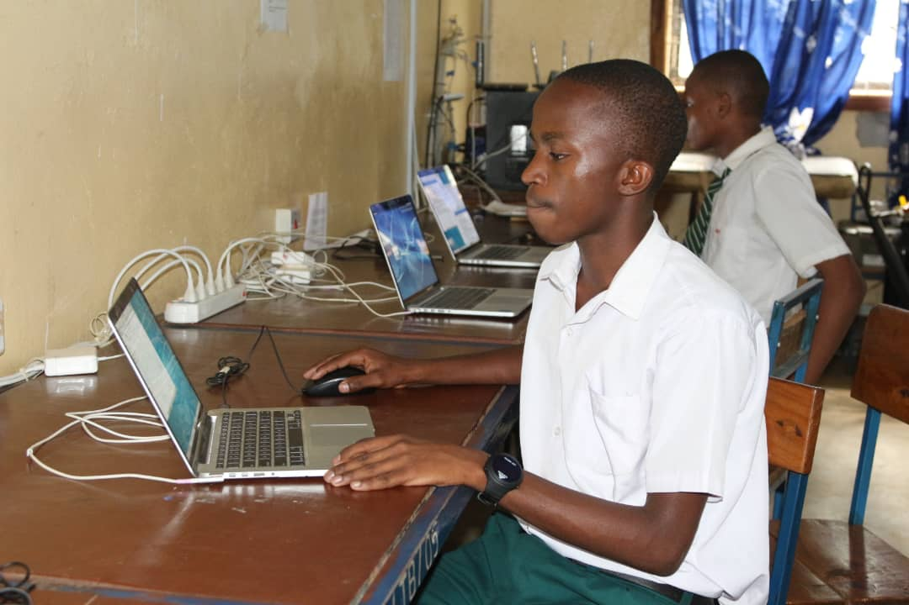

*Wanafunzi wakiendelea na masomo yao darasani Mwanafunzi akiwa ndani ya maabara mojawapo*

*Ya Kompyuta.*

**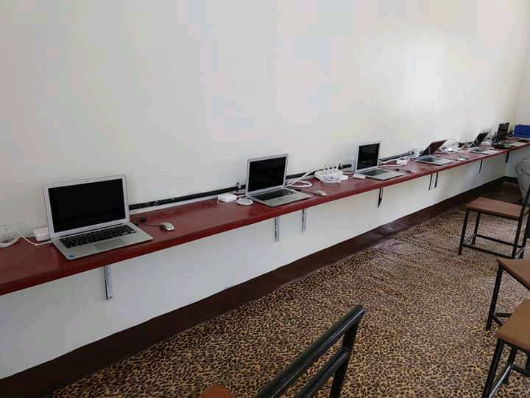***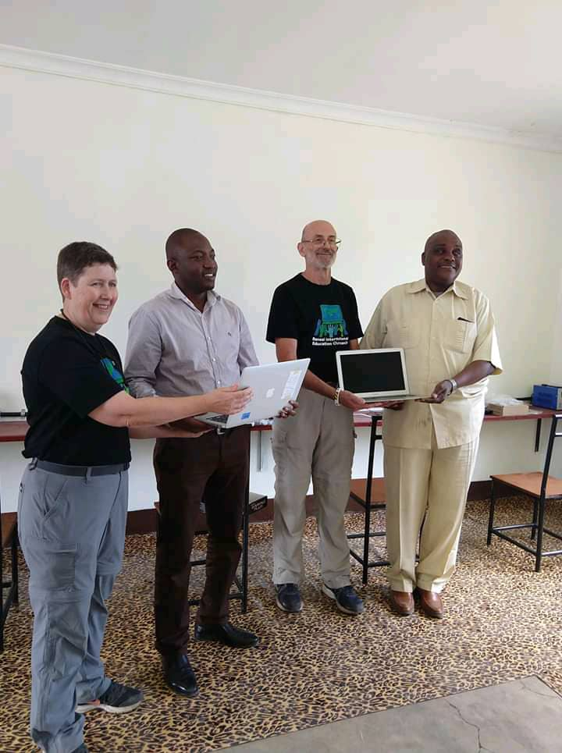*

Mfadhili akigawa Kompyuta mpakato Mwandet sekondari Chumba cha Kompyuta A ‘level Mwandet sekondari

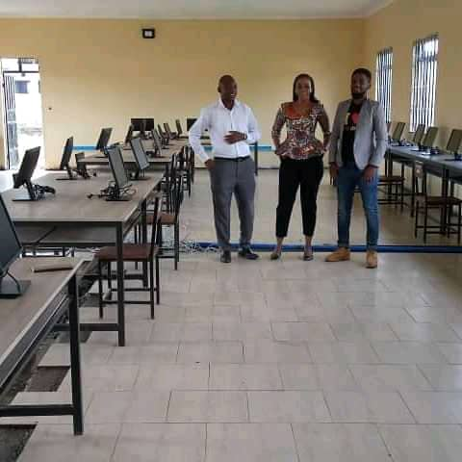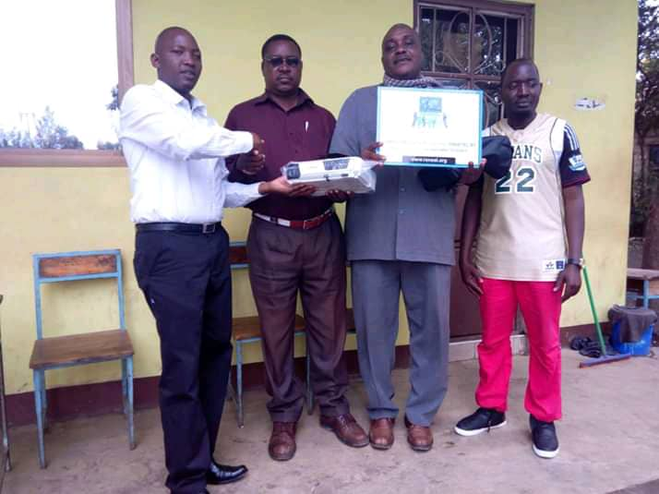

Muonekano wa Baadhi ya Vyumba vya Kompyuta Makabidhiano ya Projector Mwandet Sekondari

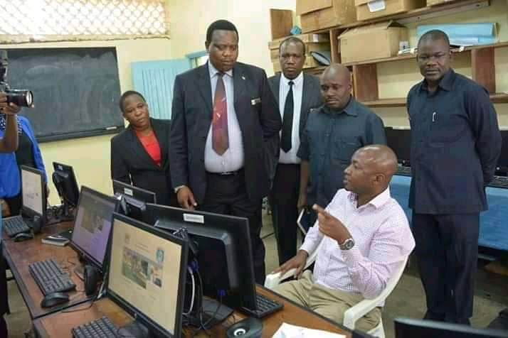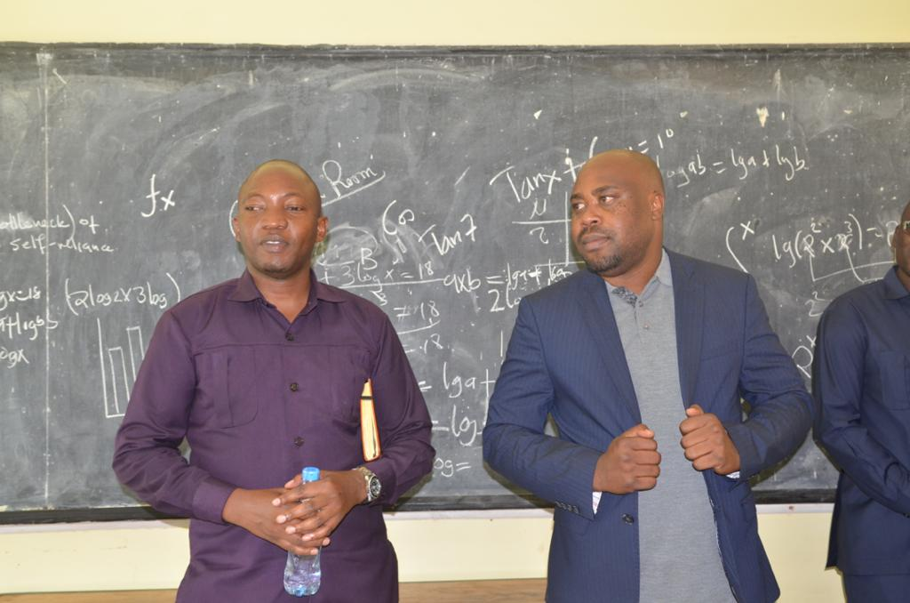

Chumba cha Kompyuta Ilboru sekondari Naibu Katibu Mkuu TAMISEMI akiwa kwenye Maabara

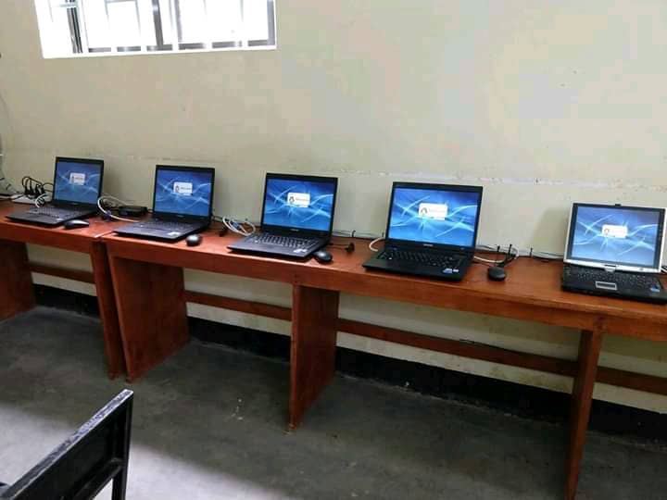

Imeandaliwa na:

***David William Nyangaka***

**Afisa Tehama Mkoa (Mratibu wa Mradi)**

***Reneal IEO Schools Liaison***