

KiNET Protocol

Tier 2 Specification

Revision Date: December 22, 2009

Revision Control

Date | Revision | Description | Author
14Jul08 | E00 | Created | J. Warwick
24Apr09 | E01 | Added KTYPE_SET/GET/GET_REPLY | G. Gong
7Jul09 | E02 | Added packet captures  Moved KTYPE to Tier 3 | F. Matho
22Dec09 | E03 | Deprecating DISCOVER reply IP | J. Warwick

Table of Contents
1 Introduction 4
1.1 Data Model 4
1.2 Endianness and byte ordering 4
2 Supply Discovery 5
2.1 Discover Packet 5
2.1.1 Packet Diagram 5
2.1.2 Packet Capture 5
2.1.3 Field Definitions 5
2.2 Discover Reply Packet 7
2.2.1 Packet Diagram 7
2.2.2 Packet Capture 7
2.2.3 Field Definitions 8
3 Port Discovery 9
3.1 Discover Ports Packet 9
3.1.1 Packet Diagram 9
3.1.2 Packet Capture 9
3.1.3 Field Definitions 9
3.2 Discover Ports Reply Packet 10
3.2.1 Packet Diagram 10
3.2.2 Packet Capture 10
3.2.3 Field Definitions 10
4 Fixture Discovery (KiNET v1) 12
4.1 BlinkScan Packet 12
4.1.1 Packet Diagram 12
4.1.2 Packet Capture 12
4.1.3 Field Definitions 12
4.2 BlinkScan Reply Packet 13
4.2.1 Packet Diagram 13
4.2.2 Packet Capture 13
4.2.3 Field Definitions 13
4.3 BlinkScan CA Reply Packet 14
4.3.1 Packet Diagram 14
4.3.2 Packet Capture 14
4.3.3 Field Definitions 14
5 Fixture Discovery (KiNET v2) 16
5.1 BlinkScan2 Packet 16
5.1.1 Packet Diagram 16
5.1.2 Packet Capture 16
5.1.3 Field Definitions 16
5.2 BlinkScan2 Reply Packet 17
5.2.1 Packet Diagram 17
5.2.2 Packet Capture 17
5.2.3 Field Definitions 17

Introduction
KiNET is a lightweight UDP/IP based protocol used to communicate via Ethernet with Color Kinetics light fixtures and power supplies. This specification will serve to document the so-called “Tier 2” KiNET functionality; namely, the packet types which encapsulate power supply and light fixture discovery.

Data Model
KiNET refers to three distinct concepts: power supplies, ports, and fixtures. Power supplies are devices with a single IP address containing one more ports (KiNET v1 devices implicitly have one port). Ports are distinct data universes; ports can independently receive data. Ports contain zero or more fixtures. Fixtures are independently addressable color changing units. They may take the form of a professional fixture containing many LEDs or a single Chromasic node. Multiple fixtures may be packaged together physically, presenting a light fixture with multiple independent sections of control.

Endianness and byte ordering
In contrast to the big-endian network byte ordering used by the MAC, UDP, and IP headers, KiNET packets use little-endian byte ordering, with the LSB coming first for all multi-byte fields. See the capture examples below for an illustration (the KiNET header magic number of 0x4ADC0104 is easy to spot).

Supply Discovery

Discover Packet
The Discover Packet is broadcast by a client application to discover KiNET power supplies on the local network. Depending on the network configuration, various broadcast addresses may be used. Power supplies are required to send a Discover Reply packet to the transmitter.

Packet Diagram
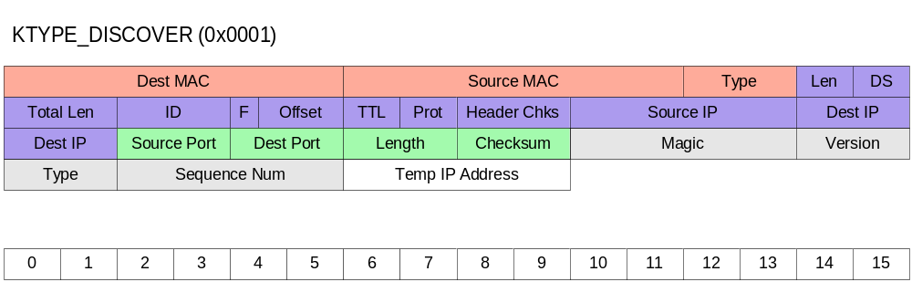

Packet Capture
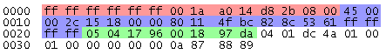

Field Definitions
Note: MAC, IP, and UDP header fields apply for all subsequent KiNET packet types in this document.

MAC Header
Field Name | Bytes | Offset | Value | Notes
Dest MAC | 6 | 0 |  | Set to the MAC address of the target power/data supply. Each power/data supply has a unique MAC address that is assigned during manufacture and also marked on the supply via a sticker. The MAC address of a power/data supply can also be determined using the discovery process. For broadcast Discover packet destination MAC should be set to 0xFFFFFFFFFFFF.
Source MAC | 6 | 6 |  | Set to MAC address of the sender.
Type | 2 | 12 | 0x0800 | Set to 0x0800 for IP.
Total Size | 14

IP Header
Field Name | Bytes | Offset | Value | Notes
Version | 4bits | 14 | 0x4 | Set to IP version. For KiNET this will always be V4.
Length | 4bits | 14.5 |  | Set to IP header length, in number of 32-bit words.
DS | 1 | 15 | 0x00 | Set for differentiated services. Not used for KiNET, typically set to 0.
Total Length | 2 | 16 |  | Set to packet total length in bytes, including header and data.
ID | 2 | 18 |  | Set to id for fragmentation. Not used for KiNET.
Flags | 4bits | 20 |  | Set for fragmentation. KiNET packets will not be fragmented.
Offset | 12bits | 20.5 |  | Set for fragment offset. Not used for KiNET.
TTL | 1 | 22 |  | Set for time to live. Not used for KiNET.
Protocol | 1 | 23 | 0x11 | Set to UDP (0x11) for KiNET.
Header Checksum | 2 | 24 |  | Set to IP header checksum.
Source IP | 4 | 26 |  | Set to the IP Address of the sender.
Dest IP | 4 | 30 |  | Set to the IP Address of the target power/data supply. Each power/data supply has a unique IP address that is assigned during manufacture and also marked on the supply via a sticker. The IP address of a power/data supply can also be determined using the discovery process. For broadcast Discover packets destination IP should be set to 255.255.255.255.
Total Size | 20

UDP Header
Field Name | Bytes | Offset | Value | Notes
Source Port | 2 | 34 |  | Set to source port. User can select an available port (other than 6038) for this use.
Destination Port | 2 | 36 | 0x1796 | Set to 6038 (0x1796). All KiNET packets will use this as dest port.
Length | 2 | 38 |  | Length of UDP header and payload.
Checksum | 2 | 40 |  | Set to checksum of header and data.
Total Size | 8

KiNET Header
Field Name | Bytes | Offset | Value | Notes
Magic Number | 4 | 42 | 0x4ADC0104
Version | 2 | 46 | 0x0002 | Latest version of KiNET protocol is V2.0. Older supplies may support KiNET V1.0 only.
Type | 2 | 48 | 0x0001 | Set to KiNET packet type. For Discover, packet type is 0x0001.
Sequence Number | 4 | 50 |  | Can be used for ordering/numbering of packets. Not implemented on most supplies. Should be set to 0.
Total Size | 12

KiNET Discover Header
Field Name | Bytes | Offset | Value | Notes
TempIP | 4 | 54 |  | DEPRECATED – All supplies should respond with their current 32-bit IP address and ignore this field. 32-bit IP address that should be used by supplies to reply to a Discover request. Some supplies ignore this field and reply using their own IP address.
Total Size | 4

Discover Reply Packet
The Discover Reply packet is transmitted by a power supply when a Discover packet is received.

Packet Diagram
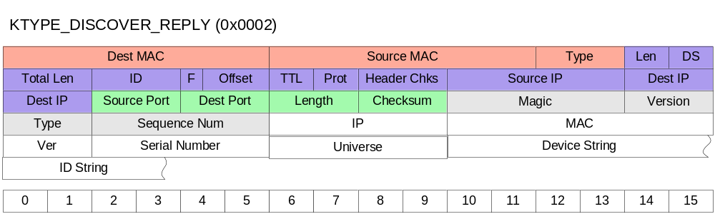

Packet Capture
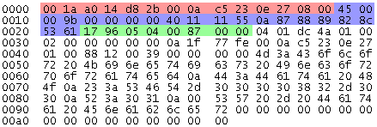

Field Definitions

KiNET Header
Field Name | Bytes | Offset | Value | Notes
Magic Number | 4 | 42 | 0x4ADC0104
Version | 2 | 46 | 0x0002 | Latest version of KiNET protocol is V2.0. Older supplies may support KiNET V1.0 only.
Type | 2 | 48 | 0x0002 | Set to KiNET packet type. For Discover Reply, packet type is 0x0002.
Sequence Number | 4 | 50 |  | Can be used for ordering/numbering of packets. Not implemented on most supplies. Should match the sequence number of the Discover packet.
Total Size | 12

KiNET Discover Reply Header
Field Name | Bytes | Offset | Value | Notes
IP | 4 | 54 |  | IP address of the supply issuing the discover reply packet.
MAC | 6 | 58 |  | MAC address of the supply issuing the discover reply packet.
Version | 2 | 64 |  | Supported KiNET version for the supply.
Serial | 4 | 66 |  | Serial number of the supply issuing the discover reply packet.
Universe | 4 | 70 |  | Universe number of the supply issuing the discover reply packet. Universe numbers can be used when sending data to achieve multicast-like semantics.
Device String | Variable | 74 |  | Hard-coded device description string.
ID String | Variable | Variable |  | User-modifiable device identity string.
Total Size | Variable

Port Discovery

Discover Ports Packet
Power Supplies that support KiNET v2 have one or more ports which can be addressed individually. A client application can send the Discover Ports packet to a power supply. The power supply will reply with a Discover Ports Reply packet.

Packet Diagram
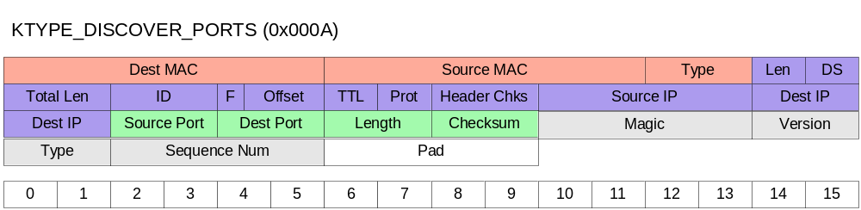

Packet Capture
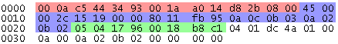

Field Definitions

KiNET Header
Field Name | Bytes | Offset | Value | Notes
Magic Number | 4 | 42 | 0x4ADC0104
Version | 2 | 46 | 0x0002 | Latest version of KiNET protocol is V2.0. Older supplies may support KiNET V1.0 only.
Type | 2 | 48 | 0x000A | Set to KiNET packet type. For Discover Ports, packet type is 0x000A.
Sequence Number | 4 | 50 |  | Can be used for ordering/numbering of packets. Not implemented on most supplies. Should be set to 0.
Total Size | 12

KiNET Discover Ports Header
Field Name | Bytes | Offset | Value | Notes
Pad | 4 | 54 | 0x00000000 | Not used, set to 0x00000000.
Total Size | 4

Discover Ports Reply Packet
When a power supply that supports KiNET v2 receives a Discover Ports packet it will respond with a Discover Ports Reply packet. The packet consists of the reply block, followed by one or more Port Entry blocks.

Packet Diagram
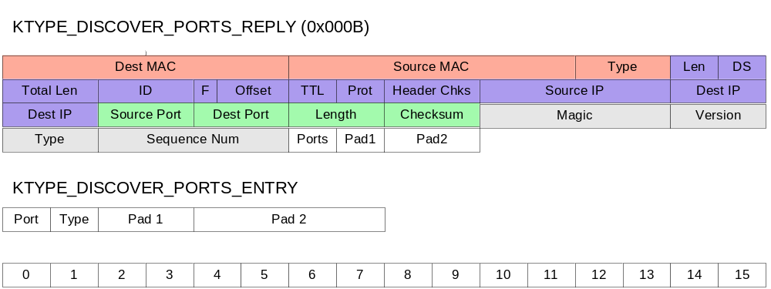

Packet Capture
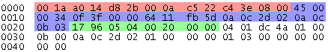

Field Definitions

KiNET Header
Field Name | Bytes | Offset | Value | Notes
Magic Number | 4 | 42 | 0x4ADC0104
Version | 2 | 46 | 0x0002 | Latest version of KiNET protocol is V2.0. Older supplies may support KiNET V1.0 only.
Type | 2 | 48 | 0x000A | Set to KiNET packet type. For Discover Ports Reply, packet type is 0x000B.
Sequence Number | 4 | 50 |  | Can be used for ordering/numbering of packets. Not implemented on most supplies. Should match the sequence number of the Discover Ports packet.
Total Size | 12

KiNET Discover Ports Reply Header
Field Name | Bytes | Offset | Value | Notes
Ports | 1 | 54 |  | Number of Port Entry blocks in the packet
Pad1 | 1 | 55 | 0x00 | Not used, set to 0x00.
Pad2 | 2 | 56 | 0x0000 | Not used, set to 0x0000.
Total Size | 4

KiNET Discover Ports Reply Entry
Field Name | Bytes | Offset | Value | Notes
Port | 1 | 58 |  | Port number.
Type | 1 | 59 |  | Type of port.  - Type 0x00 – Port Type NULL  - Type 0x01 – DMX Output, Blinkscannable  - Type 0x02 – DMX Output  - Type 0x03 – Chromasic
Pad1 | 2 | 60 | 0x0000 | Not used, set to 0x0000.
Pad2 | 4 | 62 | 0x00000000 | Not used, set to 0x00000000.
Total Size | 8

Fixture Discovery (KiNET v1)

BlinkScan Packet
Power supplies support the ability to query for attached fixtures via a technology called BlinkScan. A client application can send a BlinkScan packet to a KiNET v1 device and receive multiple BlinkScan Reply or BlinkScan CA Reply packets with information about attached fixtures.

Packet Diagram
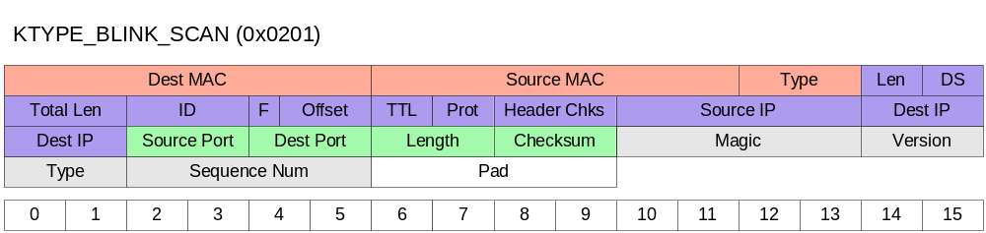

Packet Capture
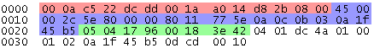

Field Definitions

KiNET Header
Field Name | Bytes | Offset | Value | Notes
Magic Number | 4 | 42 | 0x4ADC0104
Version | 2 | 46 | 0x0002 | Latest version of KiNET protocol is V2.0. Older supplies may support KiNET V1.0 only.
Type | 2 | 48 | 0x0201 | Set to KiNET packet type. For BlinkScan, packet type is 0x0201.
Sequence Number | 4 | 50 |  | Can be used for ordering/numbering of packets. Not implemented on most supplies. Should be set to 0.
Total Size | 12

KiNET BlinkScan Header
Field Name | Bytes | Offset | Value | Notes
Pad | 4 | 54 | 0x00000000 | Not used, set to 0x00000000.
Total Size | 4

BlinkScan Reply Packet
Power supplies that support KiNET v1 transmit a BlinkScan Reply packet for each attached professional (i.e. non-Chromasic) fixture attached upon receipt of a BlinkScan packet.

Packet Diagram
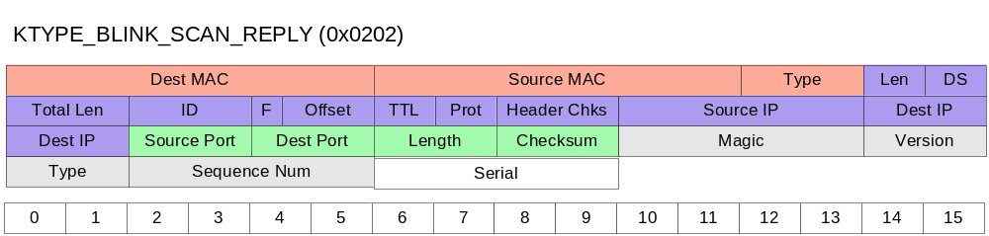

Packet Capture
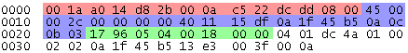

Field Definitions

KiNET Header
Field Name | Bytes | Offset | Value | Notes
Magic Number | 4 | 42 | 0x4ADC0104
Version | 2 | 46 | 0x0002 | Latest version of KiNET protocol is V2.0. Older supplies may support KiNET V1.0 only.
Type | 2 | 48 | 0x0202 | Set to KiNET packet type. For BlinkScan Reply, packet type is 0x0202.
Sequence Number | 4 | 50 |  | Can be used for ordering/numbering of packets. Not implemented on most supplies. Should match the sequence number of the BlinkScan packet.
Total Size | 12

KiNET BlinkScan Header
Field Name | Bytes | Offset | Value | Notes
Serial | 4 | 54 |  | Serial number of the attached fixture.
Total Size | 4

BlinkScan CA Reply Packet
Power supplies that support KiNET v1 transmit a BlinkScan CA Reply packet that indicates the number of attached Chromasic nodes upon receipt of a BlinkScan packet.

Packet Diagram
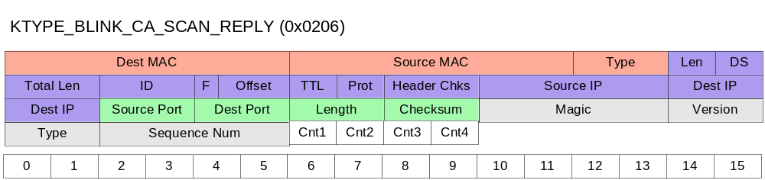

Packet Capture
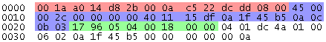

Field Definitions

KiNET Header
Field Name | Bytes | Offset | Value | Notes
Magic Number | 4 | 42 | 0x4ADC0104
Version | 2 | 46 | 0x0002 | Latest version of KiNET protocol is V2.0. Older supplies may support KiNET V1.0 only.
Type | 2 | 48 | 0x0206 | Set to KiNET packet type. For BlinkScan CA Reply, packet type is 0x0206.
Sequence Number | 4 | 50 |  | Can be used for ordering/numbering of packets. Not implemented on most supplies. Should match the sequence number of the BlinkScan packet.
Total Size | 12

KiNET BlinkScan CA Header
Field Name | Bytes | Offset | Value | Notes
Cnt1 | 1 | 54 |  | Number of Chromasic nodes on output 1.
Cnt2 | 1 | 55 |  | Number of Chromasic nodes on output 2.
Cnt3 | 1 | 56 |  | Number of Chromasic nodes on output 3.
Cnt4 | 1 | 57 |  | Number of Chromasic nodes on output 4.
Total Size | 4

Fixture Discovery (KiNET v2)

BlinkScan2 Packet
Power supplies support the ability to query for attached fixtures via a technology called BlinkScan. A client application can send a BlinkScan2 packet to a KiNET v2 device and receive multiple BlinkScan2 Reply packets with information about attached fixtures.

Packet Diagram
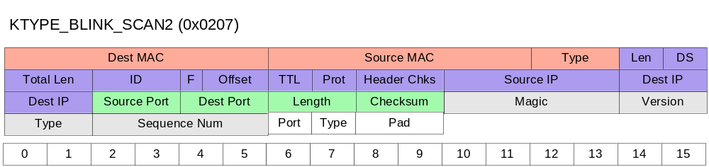

Packet Capture
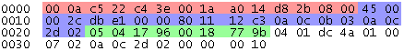

Field Definitions

KiNET Header
Field Name | Bytes | Offset | Value | Notes
Magic Number | 4 | 42 | 0x4ADC0104
Version | 2 | 46 | 0x0002 | Latest version of KiNET protocol is V2.0. Older supplies may support KiNET V1.0 only.
Type | 2 | 48 | 0x0207 | Set to KiNET packet type. For BlinkScan2, packet type is 0x0207.
Sequence Number | 4 | 50 |  | Can be used for ordering/numbering of packets. Not implemented on most supplies. Should be set to 0.
Total Size | 12

KiNET BlinkScan2 Header
Field Name | Bytes | Offset | Value | Notes
Port | 1 | 54 | 0x00 | Which port on the supply to blinkscan. Currently the only valid value is 0, which indicates that all ports should be scanned.
Type | 1 | 55 | 0x00 | Not used, set to 0x00.
Pad | 2 | 56 | 0x0000 | Not used, set to 0x0000.
Total Size | 4

BlinkScan2 Reply Packet
Power supplies that support KiNET v2 transmit one or more BlinkScan2 Reply packets that indicate the number of attached fixtures upon receipt of a BlinkScan2 packet. The packet consists of the reply block, followed by one or more Entry blocks. Each Entry block consists of a header followed by payload data that indicates either the serial number of the number of attached Chromasic nodes. The last BlinkScan2 Reply packet should indicate (via the More field) that it is the final packet transmitted from the supply.

Packet Diagram
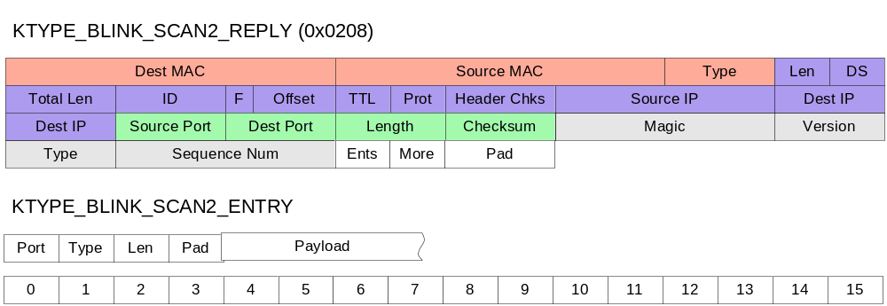

Packet Capture
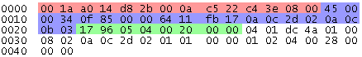

Field Definitions

KiNET Header
Field Name | Bytes | Offset | Value | Notes
Magic Number | 4 | 42 | 0x4ADC0104
Version | 2 | 46 | 0x0002 | Latest version of KiNET protocol is V2.0. Older supplies may support KiNET V1.0 only.
Type | 2 | 48 | 0x0208 | Set to KiNET packet type. For BlinkScan2 Reply, packet type is 0x0208.
Sequence Number | 4 | 50 |  | Can be used for ordering/numbering of packets. Not implemented on most supplies. Should match the sequence number of the BlinkScan2 packet.
Total Size | 12

KiNET BlinkScan2 Reply Header
Field Name | Bytes | Offset | Value | Notes
Ents | 1 | 54 |  | Number of subsequent Entry blocks.
More | 1 | 55 |  | Non-zero if this isn’t the last BlinkScan2 Reply packet.
Pad | 2 | 56 | 0x0000 | Not used, set to 0x0000.
Total Size | 4

KiNET BlinkScan2 Reply Entry Header
Field Name | Bytes | Offset | Value | Notes
Port | 1 | 58 |  | Port number that fixtures are attached to.
Type | 1 | 59 |  | The type of attached Entry blocks. See next table for values.
Len | 1 | 60 |  | Number of payload bytes following this header. Must be a multiple of 4.
Pad | 1 | 61 | 0x00 | Not used, set to 0x00.
Total Size | 4

KiNET BlinkScan2 Reply Entry Types
Entry Type | Value | Notes
NULL | 0x00 | No data in the payload.
SERIAL | 0x01 | Payload data is one or more DWords, each the serial number of a professional fixture.
CHROMASIC | 0x02 | Payload data is one or more DWords, each a count of Chromasic nodes. More than one value indicates that multi-module detection on a single port has found more than one terminated unit.

