

KiNET Protocol

Tier 3 Specification

Revision Date: July 7, 2009

Revision Control

Date | Revision | Description | Author
13Nov08 | E00 | Created | G. Gong
7Jul09 | E01 | Moved KTYPE here | F. Matho

Table of Contents
1 Introduction 4
1.1 Data Model 4
1.2 Endianness and byte ordering 4
2 KTYPE_SET/GET/GET_REPLY (KiNET v2) 5
2.1 KTYPE_SET Packet 5
2.1.1 Packet Diagram 5
2.1.2 Packet Capture (XXX – Fix) 5
2.1.3 Field Definitions 5
2.2 KTYPE_GET Packet 5
2.2.1 Packet Diagram 6
2.2.2 Packet Capture (XXX – Fix) 6
2.2.3 Field Definitions 6
2.3 KTYPE_GET_REPLY Packet 6
2.3.1 Packet Diagram 7
2.3.2 Packet Capture (XXX – Fix) 7
2.3.3 Field Definitions 7
3 Advanced Mode 8
3.1 Enter Advanced Mode 8
3.1.1 Packet Diagram 8
3.1.2 Packet Capture (XXX - FIX) 8
3.1.3 Field Definitions 8
3.2 Reset Fixture 10
3.2.1 Packet Diagram 10
3.2.2 Packet Capture (XXX – Fix) 10
3.2.3 Field Definitions 10
3.3 Write Byte 11
3.3.1 Packet Diagram 11
3.3.2 Packet Capture (XXX – Fix) 11
3.3.3 Field Definitions 11
3.4 Read Byte 12
3.4.1 Packet Diagram 13
3.4.2 Packet Capture (XXX – Fix) 13
3.4.3 Field Definitions 13
3.5 Read Byte Reply 13
3.5.1 Packet Diagram 14
3.5.2 Packet Capture (XXX – Fix) 14
3.5.3 Field Definitions 14
4 1337 Mode 15
4.1 Reset Packet 15
4.1.1 Packet Diagram 15
4.1.2 Packet Capture (XXX – Fix) 15
4.1.3 Field Definitions 15
4.2 Color Matrix Packet 16
4.2.1 Packet Diagram 16
4.2.2 Packet Capture (XXX – Fix) 16
4.2.3 Field Definitions 17

Introduction
KiNET is a lightweight UDP/IP based protocol used to communicate via Ethernet with Color Kinetics light fixtures and power supplies. This specification will serve to document the so-called “Tier 3” KiNET functionality; namely, the packet types which encapsulate fixture advanced mode and 1337 mode functions.

Data Model
Kinet refers to three distinct concepts: power supplies, ports, and fixtures. Power supplies are devices with a single IP address containing one more ports (Kinet v1 devices implicitly have one port). Ports are distinct data universes; ports can independently receive data. Ports contain zero or more fixtures. Fixtures are independently addressable color changing units. They may take the form of a professional fixture containing many LEDs or a single Chromasic node. Multiple fixtures may be packaged together physically, presenting a light fixture with multiple independent sections of control.

Endianness and byte ordering
In contrast to the big-endian network byte ordering used by the MAC, UDP, and IP headers, KiNET packets use little-endian byte ordering, with the LSB coming first for all multi-byte fields. See the capture examples below for an illustration (the KiNET header magic number of 0x4ADC0104 is easy to spot).

KTYPE_SET/GET/GET_REPLY (KiNET v2)

KTYPE_SET Packet
Power supplies support the ability to set parameters using the KTYPE_SET packet.

Packet Diagram
INSERT DIAGRAM HERE

Packet Capture (XXX – Fix)

Field Definitions

KiNET Header
Field Name | Bytes | Offset | Value | Notes
Magic Number | 4 | 42 | 0x4ADC0104
Version | 2 | 46 | 0x0002 | Latest version of KiNET protocol is V2.0. Older supplies may support KiNET V1.0 only.
Type | 2 | 48 | 0x0207 | Set to KiNET packet type. For BlinkScan2, packet type is 0x0207.
Sequence Number | 4 | 50 |  | Can be used for ordering/numbering of packets. Not implemented on most supplies. Should be set to 0.
Total Size | 12

KTYPE_SET Header
Field Name | Bytes | Offset | Value | Notes
Var | 2 | 54 | Varies | Describes the variable type to set.
Pad | 2 | 56 | Varies | Not used. Currently random values in memory.
Value | 4 | 58 | Varies | The value of the parameter to set.
Total Size | 8

KTYPE_GET Packet
Controllers can retrieve parameter data from power supplies using the KTYPE_GET packet.

Packet Diagram
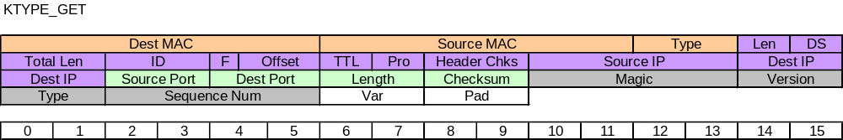

Packet Capture (XXX – Fix)

Field Definitions

KiNET Header
Field Name | Bytes | Offset | Value | Notes
Magic Number | 4 | 42 | 0x4ADC0104
Version | 2 | 46 | 0x0002 | Latest version of KiNET protocol is V2.0. Older supplies may support KiNET V1.0 only.
Type | 2 | 48 | 0x0208 | Set to KiNET packet type. For BlinkScan2 Reply, packet type is 0x0208.
Sequence Number | 4 | 50 |  | Can be used for ordering/numbering of packets. Not implemented on most supplies. Should match the sequence number of the BlinkScan2 packet.
Total Size | 12

KiNET KTYPE_GET Header
Field Name | Bytes | Offset | Value | Notes
Var | 2 | 54 | Varies | Describes the variable type to get.
Pad | 2 | 56 | Varies | Not used. Currently random values in memory.
Total Size | 4

KTYPE_GET_REPLY Packet
This is the packet response from a power supply to a controller.

Packet Diagram
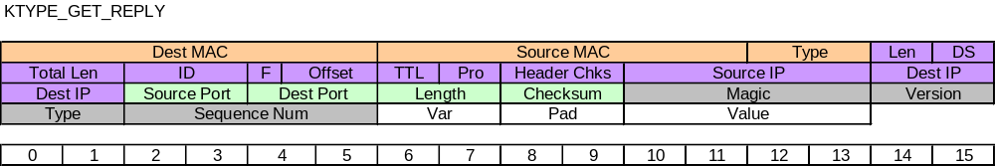

Packet Capture (XXX – Fix)

Field Definitions

KiNET Header
Field Name | Bytes | Offset | Value | Notes
Magic Number | 4 | 42 | 0x4ADC0104
Version | 2 | 46 | 0x0002 | Latest version of KiNET protocol is V2.0. Older supplies may support KiNET V1.0 only.
Type | 2 | 48 | 0x0208 | Set to KiNET packet type. For BlinkScan2 Reply, packet type is 0x0208.
Sequence Number | 4 | 50 |  | Can be used for ordering/numbering of packets. Not implemented on most supplies. Should match the sequence number of the BlinkScan2 packet.
Total Size | 12

KiNET KTYPE_GET Header
Field Name | Bytes | Offset | Value | Notes
Var | 2 | 54 | Varies | Describes the variable type to get.
Pad | 2 | 56 | Varies | Not used. Currently random values in memory.
Value | 4 | 58 | Varies | The value of the parameter.
Total Size | 8

Advanced Mode

Enter Advanced Mode
The Enter Advanced Mode Packet is broadcast by a client application five times to the KiNET fixtures on the local network that sends those fixtures into advanced mode.

Packet Diagram

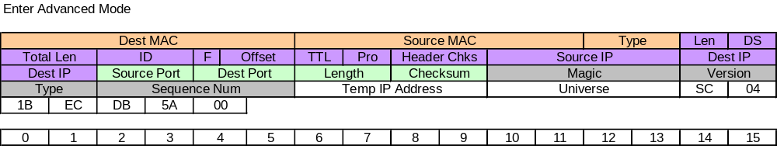

Packet Capture (XXX - FIX)
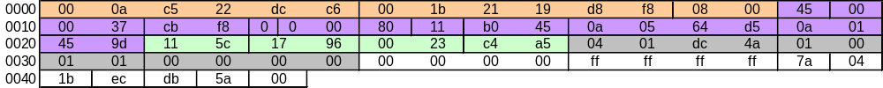

Field Definitions
Note: MAC, IP, and UDP header fields apply for all subsequent KiNET packet types in this document.

MAC Header
Field Name | Bytes | Offset | Value | Notes
Dest MAC | 6 | 0 |  | Set to the MAC address of the target power/data supply. Each power/data supply has a unique MAC address that is assigned during manufacture and also marked on the supply via a sticker. For broadcast packet destination MAC should be set to 0xFFFFFFFFFFFF.
Source MAC | 6 | 6 |  | Set to MAC address of the sender.
Type | 2 | 12 | 0x0800 | Set to 0x0800 for IP.
Total Size | 14

IP Header
Field Name | Bytes | Offset | Value | Notes
Version | 4bits | 14 | 0x4 | Set to IP version. For KiNET this will always be V4.
Length | 4bits | 14.5 |  | Set to IP header length, in number of 32-bit words.
DS | 1 | 15 | 0x00 | Set for differentiated services. Not used for KiNET, typically set to 0.
Total Length | 2 | 16 |  | Set to packet total length in bytes, including header and data.
ID | 2 | 18 |  | Set to id for fragmentation. Not used for KiNET.
Flags | 4bits | 20 |  | Set for fragmentation. KiNET packets will not be fragmented.
Offset | 12bits | 20.5 |  | Set for fragment offset. Not used for KiNET.
TTL | 1 | 22 |  | Set for time to live. Not used for KiNET.
Protocol | 1 | 23 | 0x11 | Set to UDP (0x11) for KiNET.
Header Checksum | 2 | 24 |  | Set to IP header checksum.
Source IP | 4 | 26 |  | Set to the IP Address of the sender.
Dest IP | 4 | 30 |  | Set to the IP Address of the target power/data supply. Each power/data supply has a unique IP address that is assigned during manufacture and also marked on the supply via a sticker. For broadcast packets destination IP should be set to 255.255.255.255.
Total Size | 20

UDP Header
Field Name | Bytes | Offset | Value | Notes
Source Port | 2 | 34 |  | Set to source port. User can select an available port (other than 6038) for this use.
Destination Port | 2 | 36 | 0x1796 | Set to 6038 (0x1796). All Kinet packets will use this as dest port.
Length | 2 | 38 |  | Length of UDP header and payload.
Checksum | 2 | 40 |  | Set to checksum of header and data.
Total Size | 8

Kinet Header
Field Name | Bytes | Offset | Value | Notes
Magic Number | 4 | 42 | 0x4ADC0104
Version | 2 | 46 | 0x0002 | Latest version of Kinet protocol is V2.0. Older supplies may support Kinet V1.0 only.
Type | 2 | 48 | 0x0001 | Set to KiNET packet type. For advanced mode, packet type is 0x0101.
Sequence Number | 4 | 50 |  | Can be used for ordering/numbering of packets. Not implemented on most supplies. Should be set to 0.
Total Size | 12

Advanced Mode Header
Field Name | Bytes | Offset | Value | Notes
TempIP | 4 | 54 | 00000000 | This field is not used in this command.
Universe | 4 | 58 | FFFFFFFF | This field is not used in this command.
Start Code  (SC) | 1 | 62 | 0x7A | Start code used to interpret payload as advanced mode data.
Payload | 6 | 63 | 041BECDB5A00 | This is the key code value send five times to the fixture to send it into advanced mode.
Total Size | 15

Reset Fixture
The Reset Fixture packet is transmitted by the client application to bring the fixtures out of advanced mode.

Packet Diagram
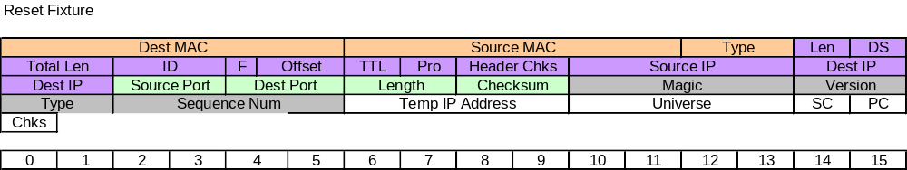

Packet Capture (XXX – Fix)
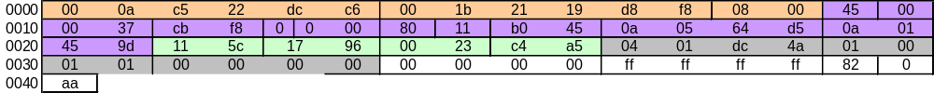

Field Definitions

Kinet Header
Field Name | Bytes | Offset | Value | Notes
Magic Number | 4 | 42 | 0x4ADC0104
Version | 2 | 46 |  | Latest version of Kinet protocol is V2.0. Older supplies may support Kinet V1.0 only.
Type | 2 | 48 | 0x0101 | Set to KiNET packet type. For advanced mode, packet type is 0x0101.
Sequence Number | 4 | 50 |  | Can be used for ordering/numbering of packets. Not implemented on most supplies. Should be set to 0.
Total Size | 12

Reset Fixture Header
Field Name | Bytes | Offset | Value | Notes
TempIP | 4 | 54 | 00000000 | This field is not used in this command.
Universe | 4 | 58 | FFFFFFFF | This field is not used in this command.
Start Code  (SC) | 1 | 62 | 0x82 | Start code is the additive sum of SC_PROGRAM (0x80) plus the length of the program data.
Param Code  (PC) | 1 | 63 | 0x00 | This is the command id that causes a fixture in advanced mode to reset and return to normal operation.
Checksum | 1 | 64 |  | Checksum of the payload data, essentially just the parameter code in this case.
Total Size | 11

Write Byte
The Write Byte packet is transmitted by the client application to the fixture with data to be written to the fixture EEPROM. This command is only valid when the fixture is put into advanced mode.

Packet Diagram
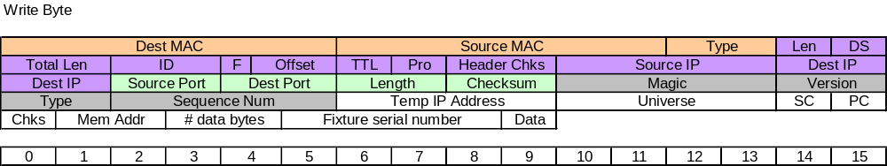

Packet Capture (XXX – Fix)
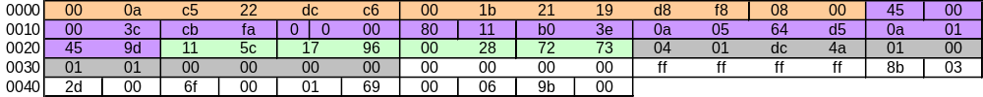

Field Definitions

Kinet Header
Field Name | Bytes | Offset | Value | Notes
Magic Number | 4 | 42 | 0x4ADC0104
Version | 2 | 46 |  | Latest version of Kinet protocol is V2.0. Older supplies may support Kinet V1.0 only.
Type | 2 | 48 | 0x0101 | Set to KiNET packet type. For advanced mode, packet type is 0x0101.
Sequence Number | 4 | 50 |  | Can be used for ordering/numbering of packets. Not implemented on most supplies. Should be set to 0.
Total Size | 12

Write Byte Header
Field Name | Bytes | Offset | Value | Notes
TempIP | 4 | 54 | 00000000 | This field is not used in this command.
Universe | 4 | 58 | FFFFFFFF | This field is not used in this command.
Start Code  (SC) | 1 | 62 | 0x8B | Start code is the additive sum of SC_PROGRAM (0x80) plus the length of the program data.
Param Code  (PC) | 1 | 63 | 0x03 | This is the command id that causes a fixture in advanced mode to reset and return to normal operation.
Checksum | 1 | 64 |  | Checksum of the payload data, essentially just the parameter code in this case.
Mem Addr | 2 | 65 |  | The address location of the fixture EEPROM where the data byte is to be written.
# Data Bytes | 2 | 67 |  | The number of bytes to write to the EEPROM.
Serial Number | 4 | 71 |  | The serial number of the fixture to write the EEPROM data to. This fixture should already be in advanced mode.
Data | 1 | 75 |  | The value of the data to be written.
Total Size | 20

Read Byte
The Read Byte packet is transmitted by the client application to the fixture to instruct it to read the EEPROM data at a particular memory location. The fixture does not have to be in advanced mode for this packet to be sent.

Packet Diagram
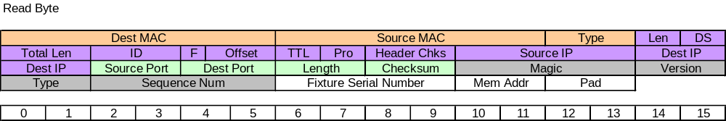

Packet Capture (XXX – Fix)

Field Definitions

Kinet Header
Field Name | Bytes | Offset | Value | Notes
Magic Number | 4 | 42 | 0x4ADC0104
Version | 2 | 46 |  | Latest version of Kinet protocol is V2.0. Older supplies may support Kinet V1.0 only.
Type | 2 | 48 | 0x0203 | Set to KiNET packet type. This read has a packet type of 0x0203
Sequence Number | 4 | 50 |  | Can be used for ordering/numbering of packets. Not implemented on most supplies. Should be set to 0.
Total Size | 12

Read Byte Header
Field Name | Bytes | Offset | Value | Notes
Serial Number | 4 | 54 |  | The serial number of the fixture to read the EEPROM from.
Mem Addr | 2 | 56 |  | The address location of the fixture EEPROM where the datat byte is to be read.
Pad | 2 | 58 |  | Unknown. Presumably to pad the end of the packet for some reason.
Total Size | 8

Read Byte Reply
The Read Byte Reply packet is transmitted by the fixture to the client application with data that is read from the fixture EEPROM. The fixture does not have to be advanced mode for this packet to be sent.

Packet Diagram
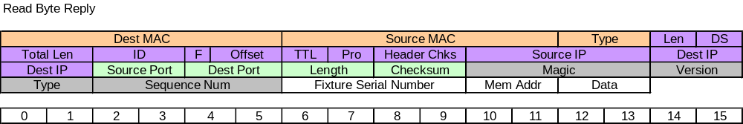

Packet Capture (XXX – Fix)

Field Definitions

Kinet Header
Field Name | Bytes | Offset | Value | Notes
Magic Number | 4 | 42 | 0x4ADC0104
Version | 2 | 46 |  | Latest version of Kinet protocol is V2.0. Older supplies may support Kinet V1.0 only.
Type | 2 | 48 | 0x0204 | Set to KiNET packet type. The read reply has a packet type of 0x0204.
Sequence Number | 4 | 50 |  | Can be used for ordering/numbering of packets. Not implemented on most supplies. Should be set to 0.
Total Size | 12

Read Byte Reply Header
Field Name | Bytes | Offset | Value | Notes
Serial Number | 4 | 54 |  | The serial number of the fixture to read the EEPROM from.
Mem Addr | 2 | 56 |  | The address location of the fixture EEPROM where the datat byte is to be read.
Data | 2 | 58 |  | The value stored in the EEPROM location.
Total Size | 8

1337 Mode

Reset Packet
1337 mode packets can be used to reset fixtures.

Packet Diagram
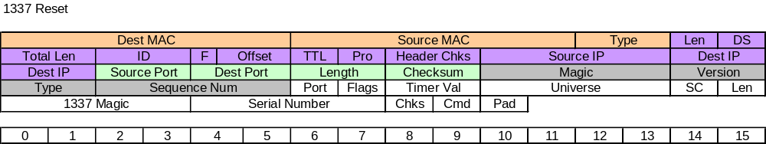

Packet Capture (XXX – Fix)
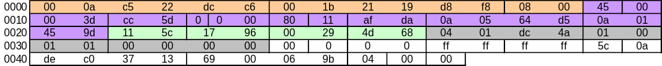

Field Definitions

Kinet Header
Field Name | Bytes | Offset | Value | Notes
Magic Number | 4 | 42 | 0x4ADC0104
Version | 2 | 46 | 0x0002 | Latest version of Kinet protocol is V2.0. Older supplies may support Kinet V1.0 only.
Type | 2 | 48 | 0x0101 | Set to KiNET packet type.
Sequence Number | 4 | 50 |  | Can be used for ordering/numbering of packets. Not implemented on most supplies. Should be set to 0.
Total Size | 12

1337 Reset Header
Field Name | Bytes | Offset | Value | Notes
Port | 1 | 54 |  | Not used, set to 0x00000000.
Flags | 1 | 55 |  | Not used, set to 0x00000000.
Timer Val | 2 | 57 |  | Not used, set to 0x00000000.
Universe | 4 | 61 |  | Not used, set to 0xFFFFFFFF.
Start Code | 1 | 62 | 0x5C | 1337 start code value is 0x5C.
Length | 1 | 63 |  | Length of the payload including this length byte. The payload is comprised of the 1337 magic number, the serial number, the checksum, the 1337 command byte, and any data bytes required for the command. The payload does not include the last pad byte.
1337 Magic Number | 4 | 67 | 0x1337CODE | The magic number used to signify a 1337 mode packet.
Serial Number | 4 | 71 |  | The serial number of the fixture to reset.
Checksum | 1 | 72 |  | Checksum of the 1337 packet data.
Command | 1 | 73 | 0x00 | The command ID for reset is 0x00.
Pad | 1 | 74 | 0x00 | This is a byte of blank data used to pad the end of the 1337 data.
Total Size | 21

Color Matrix Packet
The color matrix is a series of coefficients stored on the fixture to modify its output gamut. This is the packet description for updating the color matrix of a fixture.

Packet Diagram
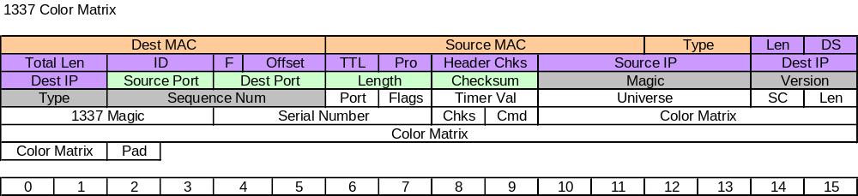

Packet Capture (XXX – Fix)
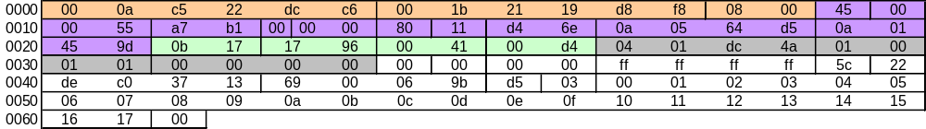

Field Definitions

Kinet Header
Field Name | Bytes | Offset | Value | Notes
Magic Number | 4 | 42 | 0x4ADC0104
Version | 2 | 46 | 0x0002 | Latest version of Kinet protocol is V2.0. Older supplies may support Kinet V1.0 only.
Type | 2 | 48 | 0x0101 | Set to KiNET packet type.
Sequence Number | 4 | 50 |  | Can be used for ordering/numbering of packets. Not implemented on most supplies. Should match the sequence number of the Discover Ports packet.
Total Size | 12

1337 Color Matrix Header
Field Name | Bytes | Offset | Value | Notes
Ports | 1 | 54 |  | Number of Port Entry blocks in the packet
Flags | 1 | 55 |  | Not used, set to 0x00000000.
Timer Val | 2 | 57 |  | Not used, set to 0x00000000.
Universe | 4 | 61 |  | Not used, set to 0xFFFFFFFF.
Start Code | 1 | 62 | 0x5C | 1337 start code value is 0x5C.
Length | 1 | 63 |  | Length of the payload including this length byte. The payload is comprised of the 1337 magic number, the serial number, the checksum, the 1337 command byte, and any data bytes required for the command. The payload does not include the last pad byte.
1337 Magic Number | 4 | 67 | 0x1337CODE | The magic number used to signify a 1337 mode packet.
Serial Number | 4 | 71 |  | The serial number of the fixture to reset.
Checksum | 1 | 72 |  | Checksum of the 1337 packet data.
Command | 1 | 73 | 0x00 | The command ID for reset is 0x00.
Color Matrix | 24 | 97 |  | This is the color matrix data used for fixture calibration.
Pad | 1 | 98 | 0x00 | This is a byte of blank data used to pad the end of the 1337 data.
Total Size | 45

