1

**BOM4XMI**

*Model date/time: 3/12/2021 11:04:16 AM*

|  |  |
| --- | --- |
| UML model BOM4XMI | |
| Allow matching | • |
| Profiles | Lifecycle |

|  |  |
| --- | --- |
| Lifecycle | |
| Registration Status | Provisional |

**Table of contents**

Click here and press F9 to create the table of contents

# Diagrams

## Agreement BOM Diagram

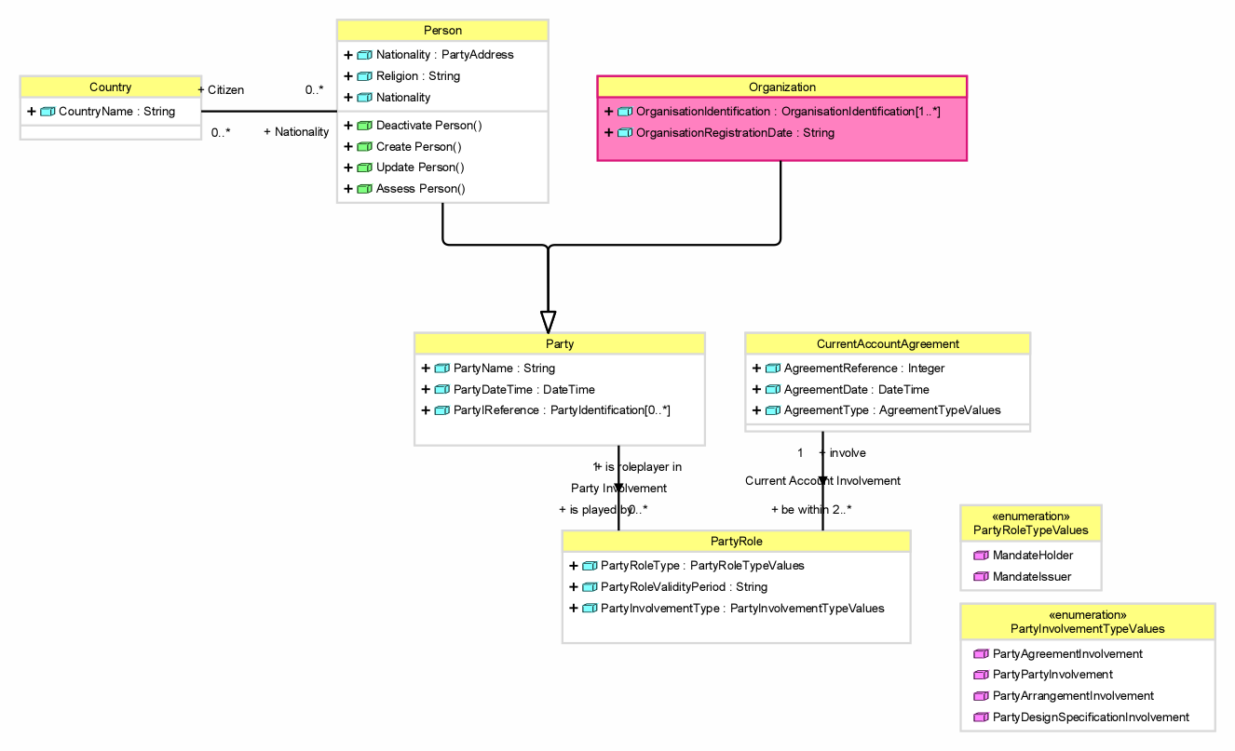

|  |  |
| --- | --- |
| Class diagram Agreement BOM Diagram | |
| Profiles | Lifecycle |

|  |  |
| --- | --- |
| Lifecycle | |
| Registration Status | Provisional |

| Agreement BOM Diagram - Documentation | |
| --- | --- |
| Name | Documentation |
| Person | Human entity, as distinguished from a corporate entity (which is sometimes referred to as an 'artificial person'). ISO20022 |
| Party | A party represents an autonomous entity in which a bank has a business interest. It has a legal definition and identity. A party is a Person, Organization, (a proposed definition for BIAN BOM adapted from BIAN Party Working Group)  - Entity involved in an activity. (ISO20022) |
| PartyRole | A specific responsibility of a specific Party in the specific relationship. |
| Organization | structure/make-up of an organizational entity |
| CurrentAccountAgreement | An agreement between bank and customer/client which regulates arrangements, terms and conditions for daily banking transactions as offered as services in the current account product. |
| PartyRoleTypeValues | The enumerated allowed values for a Party Role Type |
| PartyInvolvementTypeValues | The enumerated allowed values for a Party Involvement Type |

### Person

| Person - Documentation | |
| --- | --- |
| Name | Documentation |
| Nationality | Specifies the country where a person was born or is legally accepted as belonging to the country. (ISO20022) |
| Religion | The religion that a party believes in |

### Party

| Party - Documentation | |
| --- | --- |
| Name | Documentation |
| PartyName | Name by which a party is known and which is usually used to identify that party. (ISO20022) |
| PartyDateTime | A date relevant for a party  eg. date of birth, date of death |
| PartyIReference | A set of characteristics that allows to refer to a unique distinct instance of a Party |

### PartyRole

| PartyRole - Documentation | |
| --- | --- |
| Name | Documentation |
| PartyRoleType | Specification of the responsibility |
| PartyRoleValidityPeriod | Specification of the beginning and ending of the role. |
| PartyInvolvementType | Classification of the Party Involvement from the perspective of the associated object. |

### Organization

| Organization - Documentation | |
| --- | --- |
| Name | Documentation |
| OrganisationIdentification | Reference to identify uniquely and instance of an organization |
| OrganisationRegistrationDate | Date and time at which a given organisation was officially registered. (ISO20022) |

### CurrentAccountAgreement

| CurrentAccountAgreement - Documentation | |
| --- | --- |
| Name | Documentation |
| AgreementReference | A set of characteristics that allows to refer to a unique distinct instance of a CurrentAccountAgreement |
| AgreementDate | A date relevant i the context of this agreement |
| AgreementType | A classification of agreement |

### PartyRoleTypeValues

| PartyRoleTypeValues - Documentation | |
| --- | --- |
| Name | Documentation |
| MandateHolder | Party that was given the authority by another party to act on its behalf. |
| MandateIssuer | Party that gives the authority to another party to act on its behalf. |

### Basic profile

| Agreement BOM Diagram - Basic profile | | | | | | | | | | | | | | | | | | | |
| --- | --- | --- | --- | --- | --- | --- | --- | --- | --- | --- | --- | --- | --- | --- | --- | --- | --- | --- | --- |
| Element | 2. BIAN Class Type | Direction | From end | | | | | | | References | To end | | | | | | | Type | Visibility |
|  |  |  | Upper | Lower | Is unique | Is navigable | Name | Aggregation | Visibility |  | Upper | Lower | Is unique | Is navigable | Name | Aggregation | Visibility |  |  |
| AgreementDate |  |  |  |  |  |  |  |  |  |  |  |  |  |  |  |  |  | DateTime | public |
| AgreementReference |  |  |  |  |  |  |  |  |  |  |  |  |  |  |  |  |  | Integer | public |
| AgreementType |  |  |  |  |  |  |  |  |  |  |  |  |  |  |  |  |  | AgreementTypeValues | public |
| Association (Person - Country) |  | from to | * | 0 | • | • | Nationality | none | public |  | * | 0 | • | • | Citizen | none | public |  | public |
| CountryName |  |  |  |  |  |  |  |  |  |  |  |  |  |  |  |  |  | String | public |
| Current Account Involvement (CurrentAccountAgreement - PartyRole) |  | from to | 1 | 1 | • | • | involve | none | public |  | * | 2 | • | • | be within | none | public |  | public |
| Nationality |  |  |  |  |  |  |  |  |  |  |  |  |  |  |  |  |  | PartyAddress | public |
| OrganisationIdentification |  |  |  |  |  |  |  |  |  |  |  |  |  |  |  |  |  | OrganisationIdentification | public |
| OrganisationRegistrationDate |  |  |  |  |  |  |  |  |  |  |  |  |  |  |  |  |  | String | public |
| Organization | TBD |  |  |  |  |  |  |  |  | [ISO20022 Repository](https://www.iso20022.org/standardsrepository/public/wqt/Description/mx/dico/bc/_FNg_x8TGEeChad0JzLk7QA_908383601) |  |  |  |  |  |  |  |  | public |
| Party | TBD |  |  |  |  |  |  |  |  | [ISO20022 Repository](https://www.iso20022.org/standardsrepository/public/wqt/Description/mx/dico/bc/_FNqJt8TGEeChad0JzLk7QA_-1317971633) |  |  |  |  |  |  |  |  | public |
| Party Involvement (Party - PartyRole) |  | from to | 1 | 1 | • | • | is roleplayer in | none | public |  | * | 0 | • | • | is played by | none | public |  | public |
| PartyDateTime |  |  |  |  |  |  |  |  |  |  |  |  |  |  |  |  |  | DateTime | public |
| PartyInvolvementType |  |  |  |  |  |  |  |  |  |  |  |  |  |  |  |  |  | PartyInvolvementTypeValues | public |
| PartyIReference |  |  |  |  |  |  |  |  |  |  |  |  |  |  |  |  |  | PartyIdentification | public |
| PartyName |  |  |  |  |  |  |  |  |  |  |  |  |  |  |  |  |  | String | public |
| PartyRole | TBD |  |  |  |  |  |  |  |  | [ISO20022 Repository](https://www.iso20022.org/standardsrepository/public/wqt/Description/mx/dico/bc/_EwTfUMTGEeChad0JzLk7QA_-1978180945) |  |  |  |  |  |  |  |  | public |
| PartyRoleType |  |  |  |  |  |  |  |  |  |  |  |  |  |  |  |  |  | PartyRoleTypeValues | public |
| PartyRoleValidityPeriod |  |  |  |  |  |  |  |  |  |  |  |  |  |  |  |  |  | String | public |
| Person | TBD |  |  |  |  |  |  |  |  | [ISO20022 Repository](https://www.iso20022.org/standardsrepository/public/wqt/Description/mx/dico/bc/_FNXOwMTGEeChad0JzLk7QA_-1677946147) |  |  |  |  |  |  |  |  | public |
| Religion |  |  |  |  |  |  |  |  |  |  |  |  |  |  |  |  |  | String | public |

## Party Location BOM Diagram

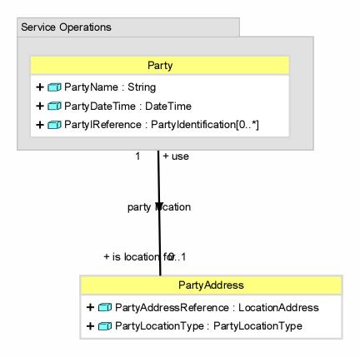

|  |  |
| --- | --- |
| Class diagram Party Location BOM Diagram | |
| Profiles | Lifecycle |

|  |  |
| --- | --- |
| Lifecycle | |
| Registration Status | Provisional |

| Party Location BOM Diagram - Documentation | |
| --- | --- |
| Name | Documentation |
| Party | A party represents an autonomous entity in which a bank has a business interest. It has a legal definition and identity. A party is a Person, Organization, (a proposed definition for BIAN BOM adapted from BIAN Party Working Group)  - Entity involved in an activity. (ISO20022) |
| PartyAddress | A specification of an address to locate a party. |

### Party

| Party - Documentation | |
| --- | --- |
| Name | Documentation |
| PartyName | Name by which a party is known and which is usually used to identify that party. (ISO20022) |
| PartyDateTime | A date relevant for a party  eg. date of birth, date of death |
| PartyIReference | A set of characteristics that allows to refer to a unique distinct instance of a Party |

### PartyAddress

| PartyAddress - Documentation | |
| --- | --- |
| Name | Documentation |
| PartyAddressReference | A unique reference to the place of the PartyAddress |
| PartyLocationType | The use a party makes of a location  e.g. domicile, correspondence address |

### Basic profile

| Party Location BOM Diagram - Basic profile | | | | | | | | | | | | | | | | | | | |
| --- | --- | --- | --- | --- | --- | --- | --- | --- | --- | --- | --- | --- | --- | --- | --- | --- | --- | --- | --- |
| Element | 2. BIAN Class Type | Direction | From end | | | | | | | References | To end | | | | | | | Type | Visibility |
|  |  |  | Upper | Lower | Is unique | Is navigable | Name | Aggregation | Visibility |  | Upper | Lower | Is unique | Is navigable | Name | Aggregation | Visibility |  |  |
| Party | TBD |  |  |  |  |  |  |  |  | [ISO20022 Repository](https://www.iso20022.org/standardsrepository/public/wqt/Description/mx/dico/bc/_FNqJt8TGEeChad0JzLk7QA_-1317971633) |  |  |  |  |  |  |  |  | public |
| party location (Party - PartyAddress) |  | from to | 1 | 1 | • | • | use | none | public |  | 1 | 0 | • | • | is location for | none | public |  | public |
| PartyAddressReference |  |  |  |  |  |  |  |  |  |  |  |  |  |  |  |  |  | LocationAddress | public |
| PartyDateTime |  |  |  |  |  |  |  |  |  |  |  |  |  |  |  |  |  | DateTime | public |
| PartyIReference |  |  |  |  |  |  |  |  |  |  |  |  |  |  |  |  |  | PartyIdentification | public |
| PartyLocationType |  |  |  |  |  |  |  |  |  |  |  |  |  |  |  |  |  | PartyLocationType | public |
| PartyName |  |  |  |  |  |  |  |  |  |  |  |  |  |  |  |  |  | String | public |

# BIAN Data Types

|  |  |
| --- | --- |
| Model BIAN Data Types | |
| Profiles | Lifecycle |

|  |  |
| --- | --- |
| Lifecycle | |
| Registration Status | Provisional |

| BIAN Data Types - Documentation | |
| --- | --- |
| Name | Documentation |
| AgreementTypeValues | The enumerated allowed values for subtyping agreements |
| PartyInvolvementTypeValues | The enumerated allowed values for a Party Involvement Type |
| PartyRoleTypeValues | The enumerated allowed values for a Party Role Type |

## OrganisationIdentificationTypeValues

| OrganisationIdentificationTypeValues - Documentation | |
| --- | --- |
| Name | Documentation |
| BICFI | Code allocated to a financial institution by the ISO 9362 Registration Authority as described in ISO 9362 "Banking - Banking telecommunication messages - Business identifier code (BIC)". |
| DUNS | Data Universal Numbering System. A unique identification number provided by Dun & Bradstreet to identify an organization. |
| ELF | Entity Legal Forms is a code allocated to a party as described in ISO 20275 "Financial services — Entity legal forms (ELF)". |
| LEI | Legal Entity Identifier is a code allocated to a party as described in ISO 17442 "Financial Services - Legal Entity Identifier (LEI)". |
| MIC | Market Identifier Code. Identification of a financial market, as stipulated in the norm ISO 10383 "Codes for exchanges and market identifications". |

## PartyIdentificationTypeValues

| PartyIdentificationTypeValues - Documentation | |
| --- | --- |
| Name | Documentation |
| NationalRegistrationNumber | Number assigned by a national registration authority to an entity. In Singapore this is known as the NRIC. (ISO20022) |
| RegistrationAuthorityIdentification | An identifier for the Legal Entity in a business registry in the jurisdiction of legal registration, or in the appropriate registration authority. (ISO20022) |
| TaxIdentificationNumber | Number assigned by a tax authority to an entity. (ISO20022) |

## PartyLocationTypeValues

| PartyLocationTypeValues - Documentation | |
| --- | --- |
| Name | Documentation |
| Domicile | Location in which a person is permanently domiciled (the place of a person's permanent home). ISO20022 |
| Residence | Location from which the affairs of a company are directed or location in which a person resides (the place of a person's home). ISO20022 |

## PartyRoleTypeValues

| PartyRoleTypeValues - Documentation | |
| --- | --- |
| Name | Documentation |
| MandateHolder | Party that was given the authority by another party to act on its behalf. |
| MandateIssuer | Party that gives the authority to another party to act on its behalf. |

## Basic profile

| BIAN Data Types - Basic profile | | |
| --- | --- | --- |
| Element | Type | Visibility |
| OrganisationIdentification | Identifier | public |
| OrganisationIdentificationTypeValues | OrganisationIdentificationTypeValues | public |
| PartyIdentification | Identifier | public |
| PartyIdentificationType | PartyIdentificationTypeValues | public |

# BOM4XMI1

|  |  |
| --- | --- |
| Model BOM4XMI1 | |
| Profiles | Lifecycle |

|  |  |
| --- | --- |
| Lifecycle | |
| Registration Status | Provisional |

| BOM4XMI1 - Documentation | |
| --- | --- |
| Name | Documentation |
| CurrentAccountAgreement | An agreement between bank and customer/client which regulates arrangements, terms and conditions for daily banking transactions as offered as services in the current account product. |
| Organization | structure/make-up of an organizational entity |
| Party | A party represents an autonomous entity in which a bank has a business interest. It has a legal definition and identity. A party is a Person, Organization, (a proposed definition for BIAN BOM adapted from BIAN Party Working Group)  - Entity involved in an activity. (ISO20022) |
| PartyAddress | A specification of an address to locate a party. |
| PartyRole | A specific responsibility of a specific Party in the specific relationship. |
| PartyRoleType | A Classification Hierarchy that distinguishes between Party Roles according to the associated object type.  Associated object types are for example location (PartyLocation), agreement (Agreement Involvement) , Product (Product Involvement); etc. |
| Person | Human entity, as distinguished from a corporate entity (which is sometimes referred to as an 'artificial person'). ISO20022 |

## CurrentAccountAgreement

| CurrentAccountAgreement - Documentation | |
| --- | --- |
| Name | Documentation |
| AgreementDate | A date relevant i the context of this agreement |
| AgreementReference | A set of characteristics that allows to refer to a unique distinct instance of a CurrentAccountAgreement |
| AgreementType | A classification of agreement |

## Organization

| Organization - Documentation | |
| --- | --- |
| Name | Documentation |
| OrganisationIdentification | Reference to identify uniquely and instance of an organization |
| OrganisationRegistrationDate | Date and time at which a given organisation was officially registered. (ISO20022) |

## Party

| Party - Documentation | |
| --- | --- |
| Name | Documentation |
| PartyDateTime | A date relevant for a party  eg. date of birth, date of death |
| PartyIReference | A set of characteristics that allows to refer to a unique distinct instance of a Party |
| PartyName | Name by which a party is known and which is usually used to identify that party. (ISO20022) |

## PartyAddress

| PartyAddress - Documentation | |
| --- | --- |
| Name | Documentation |
| PartyAddressReference | A unique reference to the place of the PartyAddress |
| PartyLocationType | The use a party makes of a location  e.g. domicile, correspondence address |

## PartyRole

| PartyRole - Documentation | |
| --- | --- |
| Name | Documentation |
| PartyInvolvementType | Classification of the Party Involvement from the perspective of the associated object. |
| PartyRoleType | Specification of the responsibility |
| PartyRoleValidityPeriod | Specification of the beginning and ending of the role. |

## Person

| Person - Documentation | |
| --- | --- |
| Name | Documentation |
| Nationality | Specifies the country where a person was born or is legally accepted as belonging to the country. (ISO20022) |
| Religion | The religion that a party believes in |

## Basic profile

| BOM4XMI1 - Basic profile | | | | | | | | | | | | | | | | | | | |
| --- | --- | --- | --- | --- | --- | --- | --- | --- | --- | --- | --- | --- | --- | --- | --- | --- | --- | --- | --- |
| Element | 2. BIAN Class Type | Direction | From end | | | | | | | References | To end | | | | | | | Type | Visibility |
|  |  |  | Upper | Lower | Is unique | Is navigable | Name | Aggregation | Visibility |  | Upper | Lower | Is unique | Is navigable | Name | Aggregation | Visibility |  |  |
| AgreementDate |  |  |  |  |  |  |  |  |  |  |  |  |  |  |  |  |  | DateTime | public |
| AgreementReference |  |  |  |  |  |  |  |  |  |  |  |  |  |  |  |  |  | Integer | public |
| AgreementType |  |  |  |  |  |  |  |  |  |  |  |  |  |  |  |  |  | AgreementTypeValues | public |
| Association (Person - Country) |  | from to | * | 0 | • | • | Nationality | none | public |  | * | 0 | • | • | Citizen | none | public |  | public |
| Current Account Involvement (CurrentAccountAgreement - PartyRole) |  | from to | 1 | 1 | • | • | involve | none | public |  | * | 2 | • | • | be within | none | public |  | public |
| Nationality |  |  |  |  |  |  |  |  |  |  |  |  |  |  |  |  |  | PartyAddress | public |
| OrganisationIdentification |  |  |  |  |  |  |  |  |  |  |  |  |  |  |  |  |  | OrganisationIdentification | public |
| OrganisationRegistrationDate |  |  |  |  |  |  |  |  |  |  |  |  |  |  |  |  |  | String | public |
| Organization | TBD |  |  |  |  |  |  |  |  | [ISO20022 Repository](https://www.iso20022.org/standardsrepository/public/wqt/Description/mx/dico/bc/_FNg_x8TGEeChad0JzLk7QA_908383601) |  |  |  |  |  |  |  |  | public |
| Party | TBD |  |  |  |  |  |  |  |  | [ISO20022 Repository](https://www.iso20022.org/standardsrepository/public/wqt/Description/mx/dico/bc/_FNqJt8TGEeChad0JzLk7QA_-1317971633) |  |  |  |  |  |  |  |  | public |
| Party Involvement (Party - PartyRole) |  | from to | 1 | 1 | • | • | is roleplayer in | none | public |  | * | 0 | • | • | is played by | none | public |  | public |
| party location (Party - PartyAddress) |  | from to | 1 | 1 | • | • | use | none | public |  | 1 | 0 | • | • | is location for | none | public |  | public |
| PartyAddressReference |  |  |  |  |  |  |  |  |  |  |  |  |  |  |  |  |  | LocationAddress | public |
| PartyDateTime |  |  |  |  |  |  |  |  |  |  |  |  |  |  |  |  |  | DateTime | public |
| PartyInvolvementType |  |  |  |  |  |  |  |  |  |  |  |  |  |  |  |  |  | PartyInvolvementTypeValues | public |
| PartyIReference |  |  |  |  |  |  |  |  |  |  |  |  |  |  |  |  |  | PartyIdentification | public |
| PartyLocationType |  |  |  |  |  |  |  |  |  |  |  |  |  |  |  |  |  | PartyLocationType | public |
| PartyName |  |  |  |  |  |  |  |  |  |  |  |  |  |  |  |  |  | String | public |
| PartyRole | TBD |  |  |  |  |  |  |  |  | [ISO20022 Repository](https://www.iso20022.org/standardsrepository/public/wqt/Description/mx/dico/bc/_EwTfUMTGEeChad0JzLk7QA_-1978180945) |  |  |  |  |  |  |  |  | public |
| PartyRoleName |  |  |  |  |  |  |  |  |  |  |  |  |  |  |  |  |  | String | public |
| PartyRoleType |  |  |  |  |  |  |  |  |  |  |  |  |  |  |  |  |  | PartyRoleTypeValues | public |
| PartyRoleValidityPeriod |  |  |  |  |  |  |  |  |  |  |  |  |  |  |  |  |  | String | public |
| Person | TBD |  |  |  |  |  |  |  |  | [ISO20022 Repository](https://www.iso20022.org/standardsrepository/public/wqt/Description/mx/dico/bc/_FNXOwMTGEeChad0JzLk7QA_-1677946147) |  |  |  |  |  |  |  |  | public |
| Religion |  |  |  |  |  |  |  |  |  |  |  |  |  |  |  |  |  | String | public |

## Multiplicity element

| BOM4XMI1 - Multiplicity element | | | |
| --- | --- | --- | --- |
| Element | Is unique | Lower | Upper |
| OrganisationIdentification | • | 1 | * |
| PartyIReference | • | 0 | * |

## XMI import

| BOM4XMI1 - XMI import | | |
| --- | --- | --- |
| Element | XMI objects | |
|  | XMI type | Xmi.id |
| Party | uml:Class | _45FA4A81017738D7997F0314 |
| Person | uml:Class | _45FA4A8101773B308861010C |

# BOM4XMI2

|  |  |
| --- | --- |
| Model BOM4XMI2 | |
| Profiles | Lifecycle |

|  |  |
| --- | --- |
| Lifecycle | |
| Registration Status | Provisional |

| BOM4XMI2 - Documentation | |
| --- | --- |
| Name | Documentation |
| Party | A party represents an autonomous entity in which a bank has a business interest. It has a legal definition and identity. A party is a Person, Organization, (a proposed definition for BIAN BOM adapted from BIAN Party Working Group)  - Entity involved in an activity. (ISO20022) |

## Party

| Party - Documentation | |
| --- | --- |
| Name | Documentation |
| PartyDateTime | A date relevant for a party  eg. date of birth, date of death |
| PartyIReference | A set of characteristics that allows to refer to a unique distinct instance of a Party |
| PartyName | Name by which a party is known and which is usually used to identify that party. (ISO20022) |

## Basic profile

| BOM4XMI2 - Basic profile | | | | |
| --- | --- | --- | --- | --- |
| Element | 2. BIAN Class Type | References | Type | Visibility |
| CountryName |  |  | String | public |
| Party | TBD | [ISO20022 Repository](https://www.iso20022.org/standardsrepository/public/wqt/Description/mx/dico/bc/_FNqJt8TGEeChad0JzLk7QA_-1317971633) |  | public |
| PartyDateTime |  |  | DateTime | public |
| PartyIReference |  |  | PartyIdentification | public |
| PartyName |  |  | String | public |

## Multiplicity element

| BOM4XMI2 - Multiplicity element | | | |
| --- | --- | --- | --- |
| Element | Is unique | Lower | Upper |
| PartyIReference | • | 0 | * |

## XMI import

| BOM4XMI2 - XMI import | | |
| --- | --- | --- |
| Element | XMI objects | |
|  | XMI type | Xmi.id |
| Party | uml:Class | _45FA4A81017738D7997F0314 |

# Predefined types

|  |  |
| --- | --- |
| Model Predefined types | |
| Profiles | Lifecycle |

|  |  |
| --- | --- |
| Lifecycle | |
| Registration Status | Provisional |

# Index

Click here and press F9 to create the index