Leachate Analysis from 2025 Greenhouse Study
Renee Davis
2026-01-20

Methods

Sample Collection and Analysis
Nutrient leachate samples were collected at five timepoints throughout the 14-week wheat growing period: weeks 2, 4, 6, and 8 (corresponding to days 14, 28, 42, and 56 post-planting). To collect leachate, each pot was watered heavily with 1000 mL of water. After allowing drainage, leachate was collected from the collection tray beneath each pot. All seven biological replicates per treatment were sampled at each timepoint (n = 7 per treatment per timepoint).
Leachate samples were analyzed for ammonium (NH₄⁺-N), nitrate (NO₃⁻-N), and phosphate (PO₄³⁻-P) concentrations using a Gallery™ Analyzer (ThermoFisher Scientific). A water blank was included in each analytical run for quality control. Due to the sensitivity of phosphate to freezing, samples were stored at 4°C and analyzed within 24 hours of collection to prevent degradation.

Results

Week 2 Analysis

Faceted violin plot
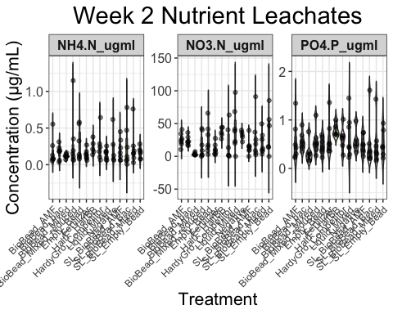

Correlation scatterplots
QQ plots were generated to assess the correlations between nitrate and phosphate and ammonium.
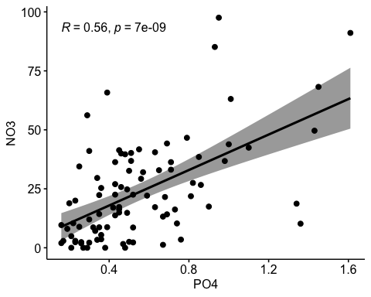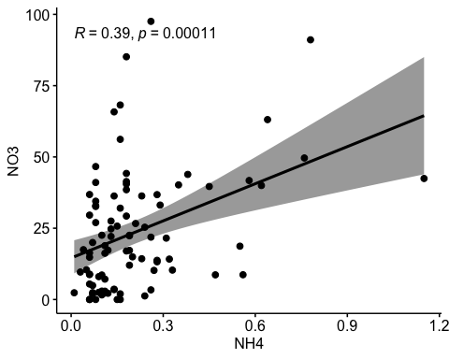

One Way ANOVA
summary(anova_NH4_wk2)
## Df Sum Sq Mean Sq F value Pr(>F)
## Treatment_Category 13 0.2583 0.01987 0.517 0.908
## Residuals 77 2.9601 0.03844
summary(anova_NO3_wk2)
## Df Sum Sq Mean Sq F value Pr(>F)
## Treatment_Category 13 9209 708.4 1.821 0.0544 .
## Residuals 77 29947 388.9
## ---
## Signif. codes: 0 '***' 0.001 '**' 0.01 '*' 0.05 '.' 0.1 ' ' 1
summary(anova_PO4_wk2)
## Df Sum Sq Mean Sq F value Pr(>F)
## Treatment_Category 13 0.868 0.06675 0.653 0.801
## Residuals 77 7.866 0.10216
There were no significant differences among treatment groups for ammonium and phosphate concentrations in leachate. Nitrate concentrations different marginally between treatments (0.0544).

Tukey Test
There were no significant differences among treatment groups for ammonium and phosphate concentrations in leachate. Nitrate concentrations different marginally between Liquid_Mixed vs BioBead_Mixed (p = 0.0523), with Liquid_Mixed associated with higher concenrations.

Shapiro Wilk test for normality
##
## Shapiro-Wilk normality test
##
## data: anova_NH4_wk2$residuals
## W = 0.83315, p-value = 9.807e-09
##
## Shapiro-Wilk normality test
##
## data: anova_NO3_wk2$residuals
## W = 0.92787, p-value = 8.344e-05
##
## Shapiro-Wilk normality test
##
## data: anova_PO4_wk2$residuals
## W = 0.86564, p-value = 1.393e-07
Together, the W values for all ANOVA tests (0.83-0.93) indicate deviation from normality. The very low p values indicate that there are significant differences in normality. Therefore, alternative statistical analyses should be considered.

Residuals distribution
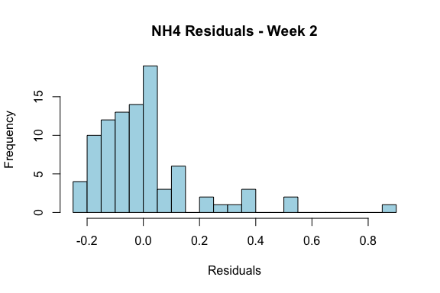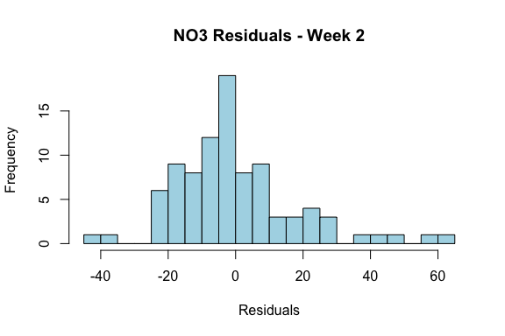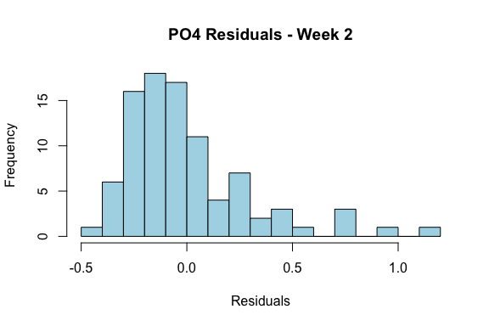

Week 4 Analysis

Faceted violin plot
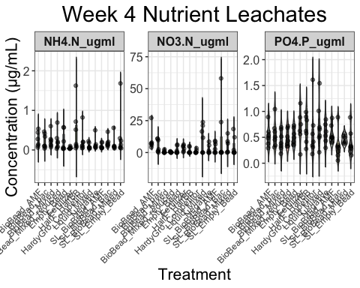

Correlation scatterplots
QQ plots were generated to assess the correlations between nitrate and phosphate and ammonium.
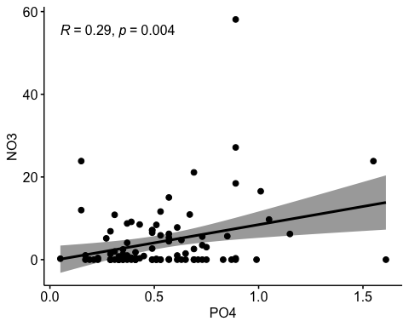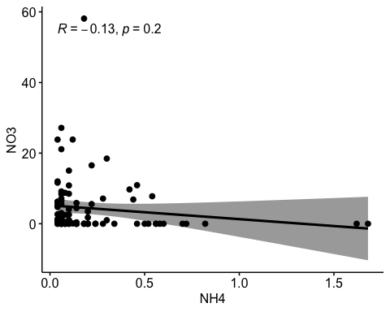

One Way ANOVA
summary(anova_NH4_wk4)
## Df Sum Sq Mean Sq F value Pr(>F)
## Treatment_Category 13 0.986 0.07583 0.968 0.49
## Residuals 80 6.269 0.07836
summary(anova_NO3_wk4)
## Df Sum Sq Mean Sq F value Pr(>F)
## Treatment_Category 13 1271 97.74 1.572 0.111
## Residuals 80 4973 62.16
summary(anova_PO4_wk4)
## Df Sum Sq Mean Sq F value Pr(>F)
## Treatment_Category 13 1.133 0.08716 1.192 0.301
## Residuals 80 5.850 0.07312
There were no significant differences among treatment groups for ammonium, nitrate, or phosphate concentrations in leachate.

Tukey Test
tukey_NH4_wk4 <- TukeyHSD(x=anova_NH4_wk4, ordered=TRUE, conf.level=0.95)
#print(tukey_NH4_wk4)
tukey_NO3_wk4 <- TukeyHSD(x=anova_NO3_wk4, ordered=TRUE, conf.level=0.95)
#print(tukey_NO3_wk4)
tukey_PO4_wk4 <- TukeyHSD(x=anova_PO4_wk4, ordered=TRUE, conf.level=0.95)
#print(tukey_PO4_wk4)
There were no significant differences among treatment groups for ammonium, nitrate, or phosphate concentrations in leachate.

Shapiro Wilk test for normality
##
## Shapiro-Wilk normality test
##
## data: anova_NH4_wk4$residuals
## W = 0.77091, p-value = 8.526e-11
##
## Shapiro-Wilk normality test
##
## data: anova_NO3_wk4$residuals
## W = 0.77616, p-value = 1.19e-10
##
## Shapiro-Wilk normality test
##
## data: anova_PO4_wk4$residuals
## W = 0.92579, p-value = 4.938e-05
Similar to week 2, there are similarly high W values (0.77091, 0.77616, 0.92579) and very low p values. This indicates that the data are not normal.

Residuals distribution
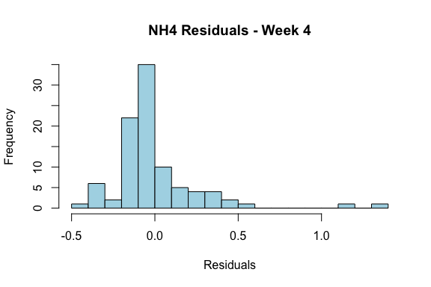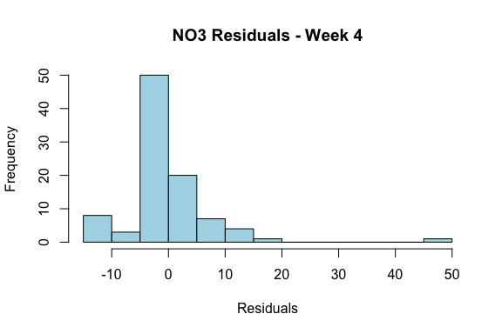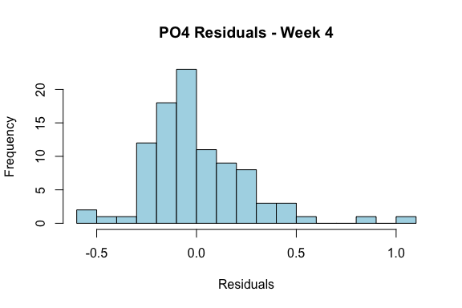

Week 6 Analysis

Faceted violin plot
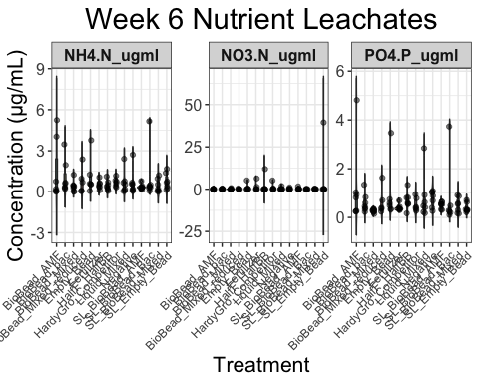

Correlation scatterplots
QQ plots were generated to assess the correlations between nitrate and phosphate and ammonium.
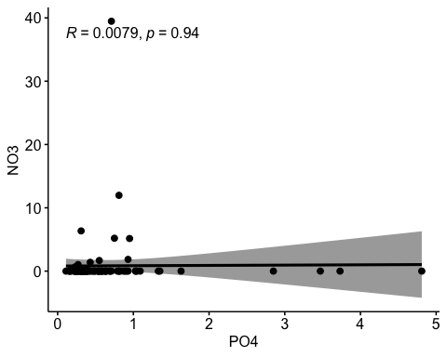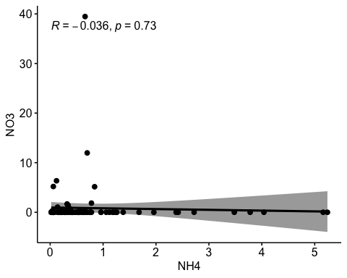

One Way ANOVA
summary(anova_NH4_wk6)
## Df Sum Sq Mean Sq F value Pr(>F)
## Treatment_Category 13 9.80 0.754 0.685 0.772
## Residuals 78 85.87 1.101
summary(anova_NO3_wk6)
## Df Sum Sq Mean Sq F value Pr(>F)
## Treatment_Category 13 200.1 15.39 0.78 0.679
## Residuals 78 1540.3 19.75
summary(anova_PO4_wk6)
## Df Sum Sq Mean Sq F value Pr(>F)
## Treatment_Category 13 5.52 0.4245 0.758 0.701
## Residuals 78 43.70 0.5603
There were no significant differences among treatment groups for ammonium, nitrate, or phosphate concentrations in leachate.

Tukey Test
There were no significant differences among treatment groups for ammonium, nitrate, or phosphate concentrations in leachate.

Shapiro Wilk test for normality
##
## Shapiro-Wilk normality test
##
## data: anova_NH4_wk6$residuals
## W = 0.80185, p-value = 8.809e-10
##
## Shapiro-Wilk normality test
##
## data: anova_NO3_wk6$residuals
## W = 0.3975, p-value < 2.2e-16
##
## Shapiro-Wilk normality test
##
## data: anova_PO4_wk6$residuals
## W = 0.68731, p-value = 1.064e-12
Similar to week 2, there are similarly high W values (0.80185, 0.3975, 0.92579) and very low p values. This indicates that the data are not normal.

Residuals distribution
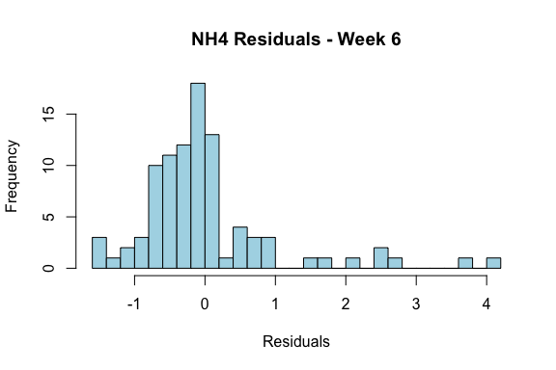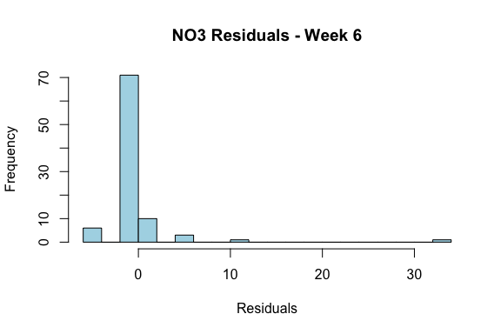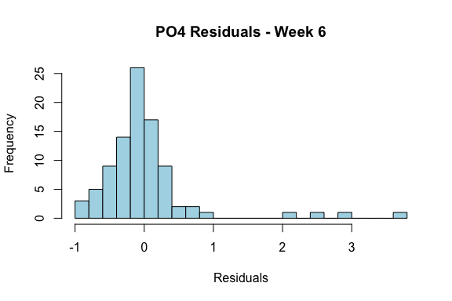

Week 8 Analysis

Faceted violin plot
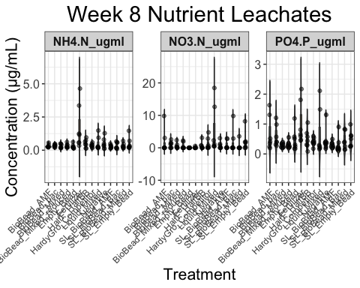

Correlation scatterplots
QQ plots were generated to assess the correlations between nitrate and phosphate and ammonium.
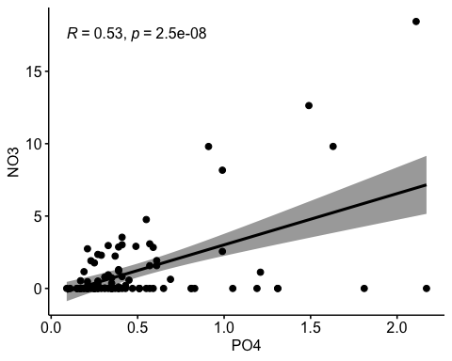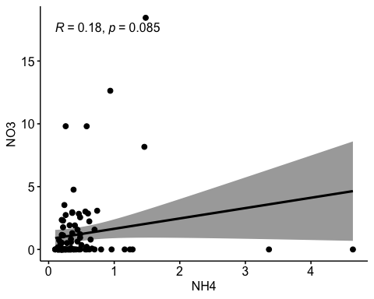

One Way ANOVA
summary(anova_NH4_wk8)
## Df Sum Sq Mean Sq F value Pr(>F)
## Treatment_Category 13 12.11 0.9313 3.524 0.000213 ***
## Residuals 84 22.20 0.2643
## ---
## Signif. codes: 0 '***' 0.001 '**' 0.01 '*' 0.05 '.' 0.1 ' ' 1
summary(anova_NO3_wk8)
## Df Sum Sq Mean Sq F value Pr(>F)
## Treatment_Category 13 151.6 11.662 1.612 0.098 .
## Residuals 84 607.8 7.236
## ---
## Signif. codes: 0 '***' 0.001 '**' 0.01 '*' 0.05 '.' 0.1 ' ' 1
summary(anova_PO4_wk8)
## Df Sum Sq Mean Sq F value Pr(>F)
## Treatment_Category 13 3.401 0.2616 1.642 0.0899 .
## Residuals 84 13.389 0.1594
## ---
## Signif. codes: 0 '***' 0.001 '**' 0.01 '*' 0.05 '.' 0.1 ' ' 1
There were no significant differences among treatment groups for nitrate or phosphate concentrations in leachate. However ammonium shows highly significant differences among treatments.

Tukey Test
There were no significant differences among treatment groups for nitrate or phosphate concentrations in leachate.
For ammonium, there were significant concentration differences between the following treatments (along with p adj values):
- Fertilizer-SL_Empty_Bead 0.0020809
- Fertilizer-SL_BioBead_AMF 0.0001264
- Fertilizer-SL_BioBead_Mixed 0.0002748
- Fertilizer-Liquid_Mixed 0.0027988
- Fertilizer-Negative 0.0027988
- Fertilizer-Empty_Bead 0.0001212

Shapiro Wilk test for normality
##
## Shapiro-Wilk normality test
##
## data: anova_NH4_wk8$residuals
## W = 0.72636, p-value = 3.185e-12
##
## Shapiro-Wilk normality test
##
## data: anova_NO3_wk8$residuals
## W = 0.74704, p-value = 1.064e-11
##
## Shapiro-Wilk normality test
##
## data: anova_PO4_wk8$residuals
## W = 0.87171, p-value = 1.038e-07
Similar to previous weeks, there are similarly very low p values. This indicates that the data are not normal.

Residuals distribution
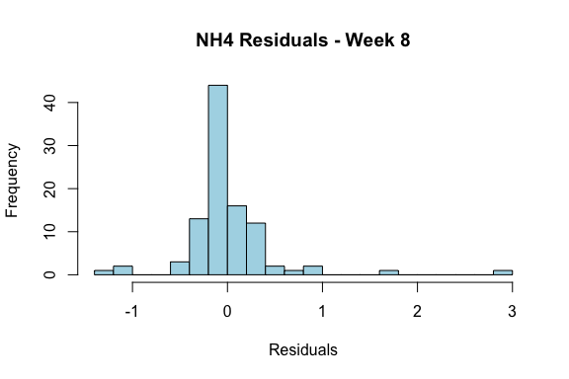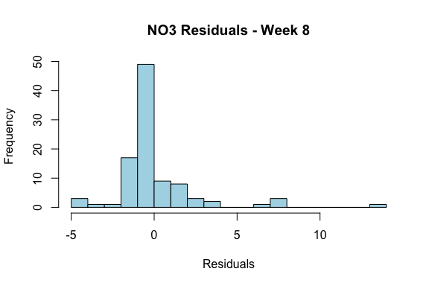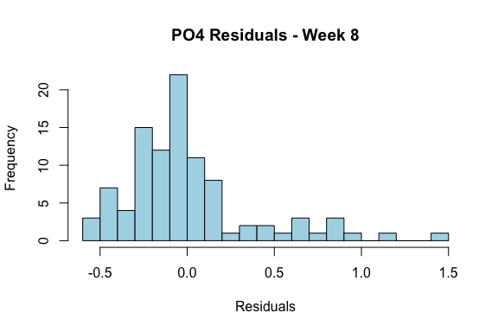

Discussion
Leachate data is not normally distributed, hence ANOVA is not the appropriate statistical approach. Regardless, we start to see signal at week 8 with ammonium concentrations. These are mostly comparisons to synthetic fertilizer, which is expected.

Next steps
- Use alternative to ANOVA, like Non-Parametric Tests (Kruskal-Wallis) or Linear Mixed Effects Model
- Consider data transformation (e.g. relativizing to max) to address normality issues
- Consider multivariate approaches to connect with other data (soil moisture, greenhouse gases, soil ions)

