Renee Ammerman

ITON1748

9/22/20

Lab 5

1. Yum- I used the commands “yum search httpd” and “yum list |grep httpd”. The search command shows the package name and description for the Apache Web Server, the grep command shows the available installs for the package.

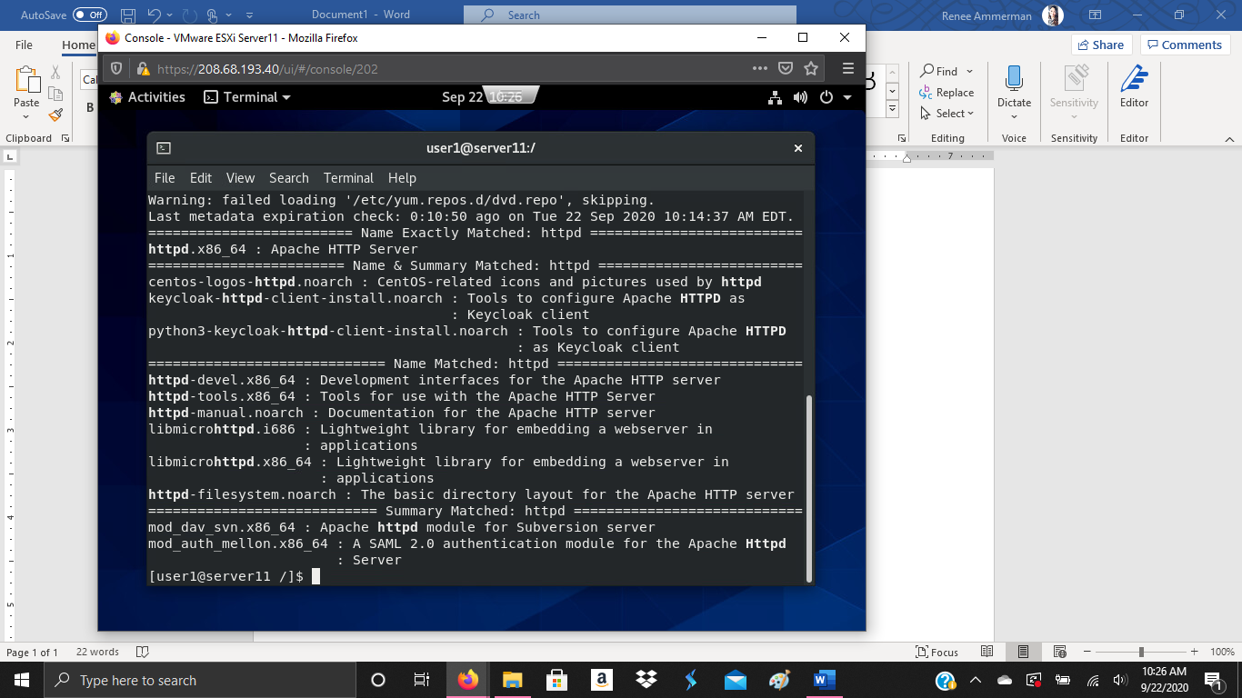

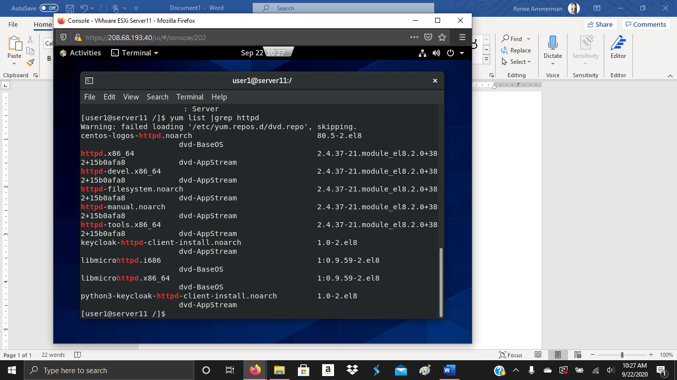

1. Installing package- I typed “yum install httpd” to install the Apache server. To run the package I typed “systemctl start httpd” and to ensure it was running I typed “systemctl status httpd”.

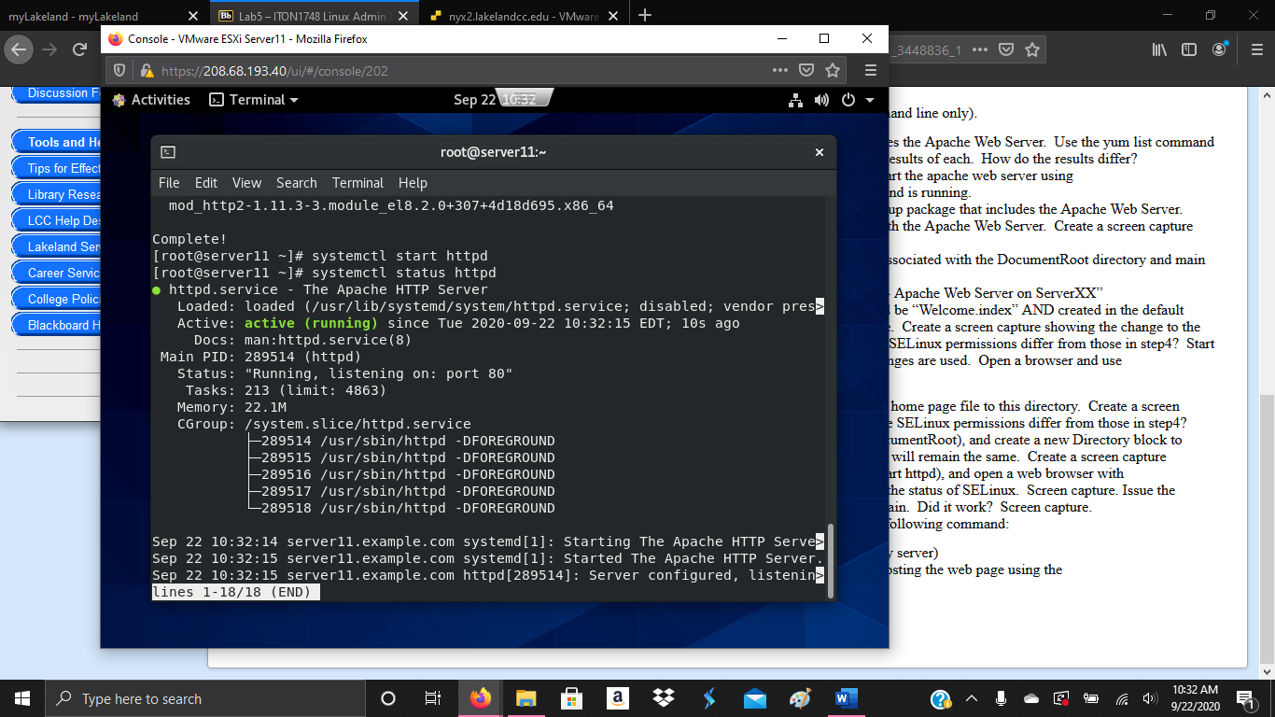

1. Using Yum- I used the command “yum groups list hidden”, I then typed “yum info ‘basic web server’. After ensuring Apache was a part of this package, I typed “yum groupinstall ‘basic web server’.

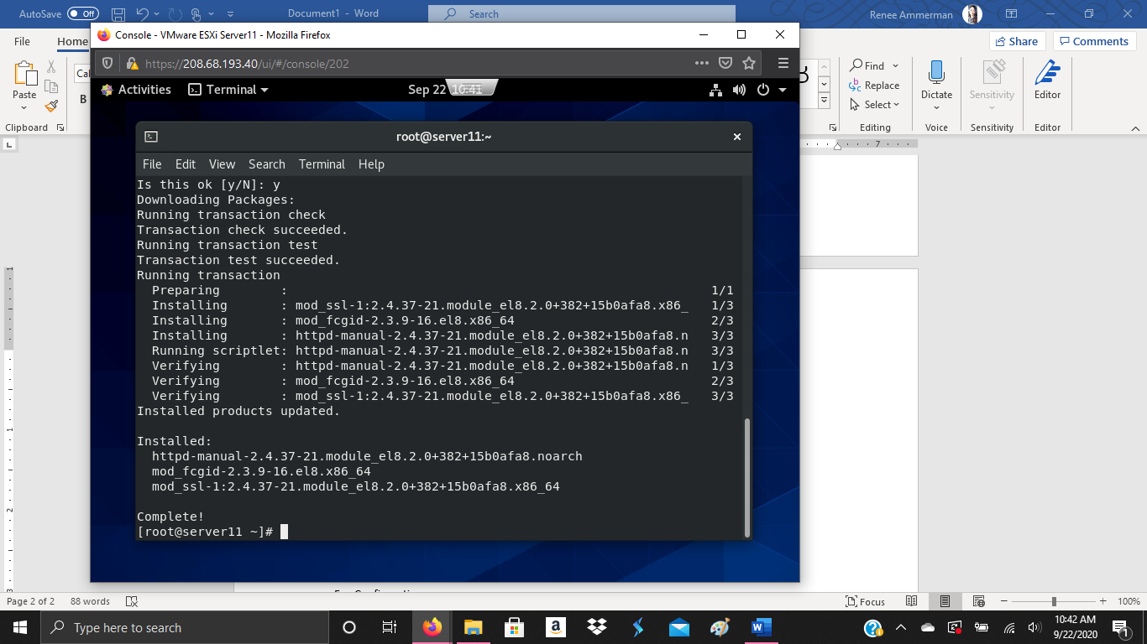

1. Permissions- I used the command “ls -laZd” to view the permissions and the SELinux associated with the Apache main config file and the document root.

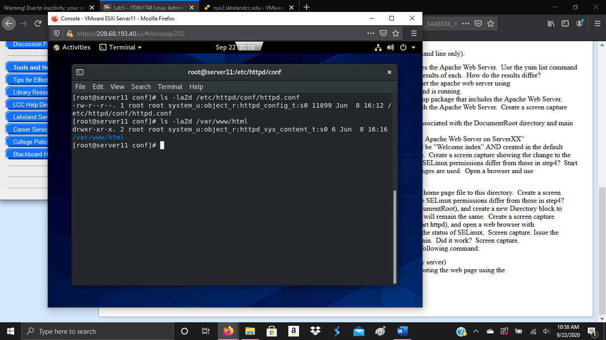

1. Configuration- By using “vi httpd.conf” I was able to edit the configuration file. I added welcome.index to the Directory Index field. After this is typed the command “ls -laZd wlcome.index” to view the permissions/SELinux. The file was changed to from “system” to “unconfined”.

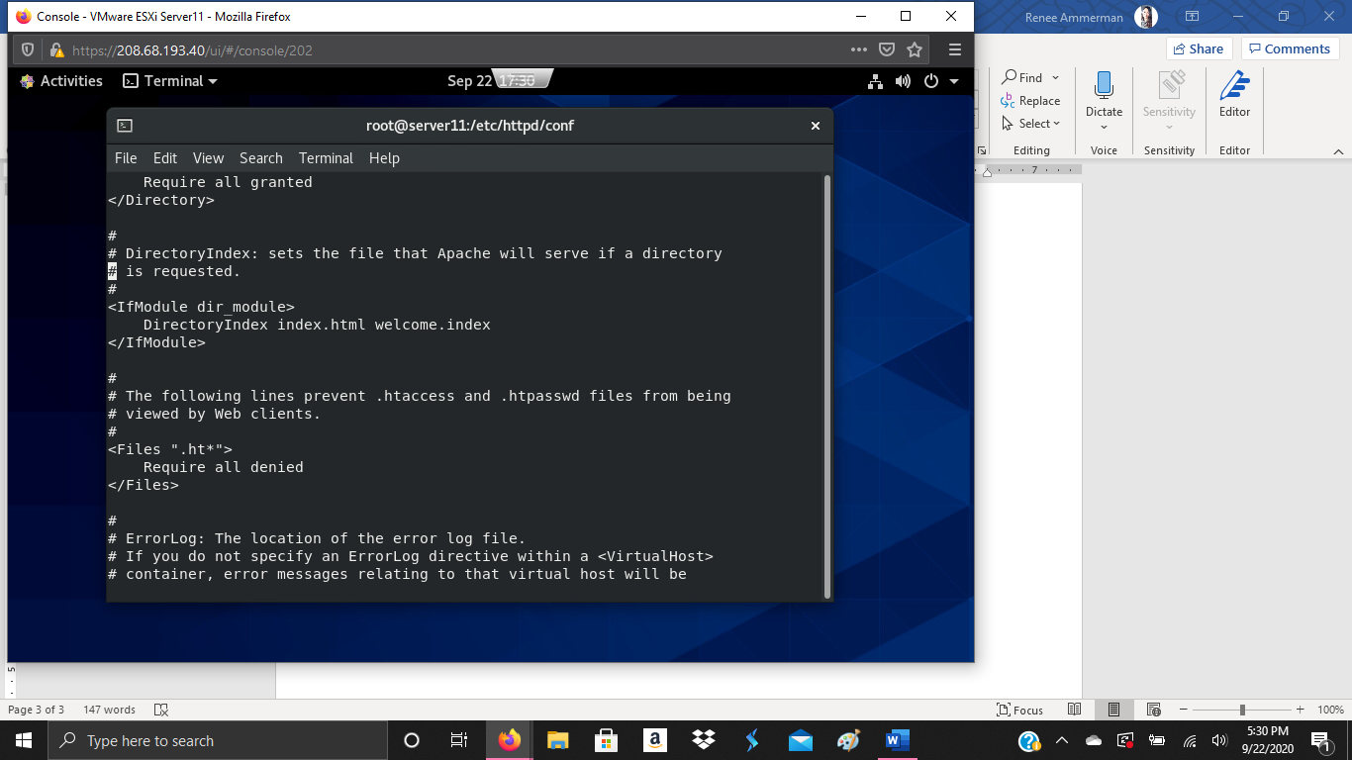

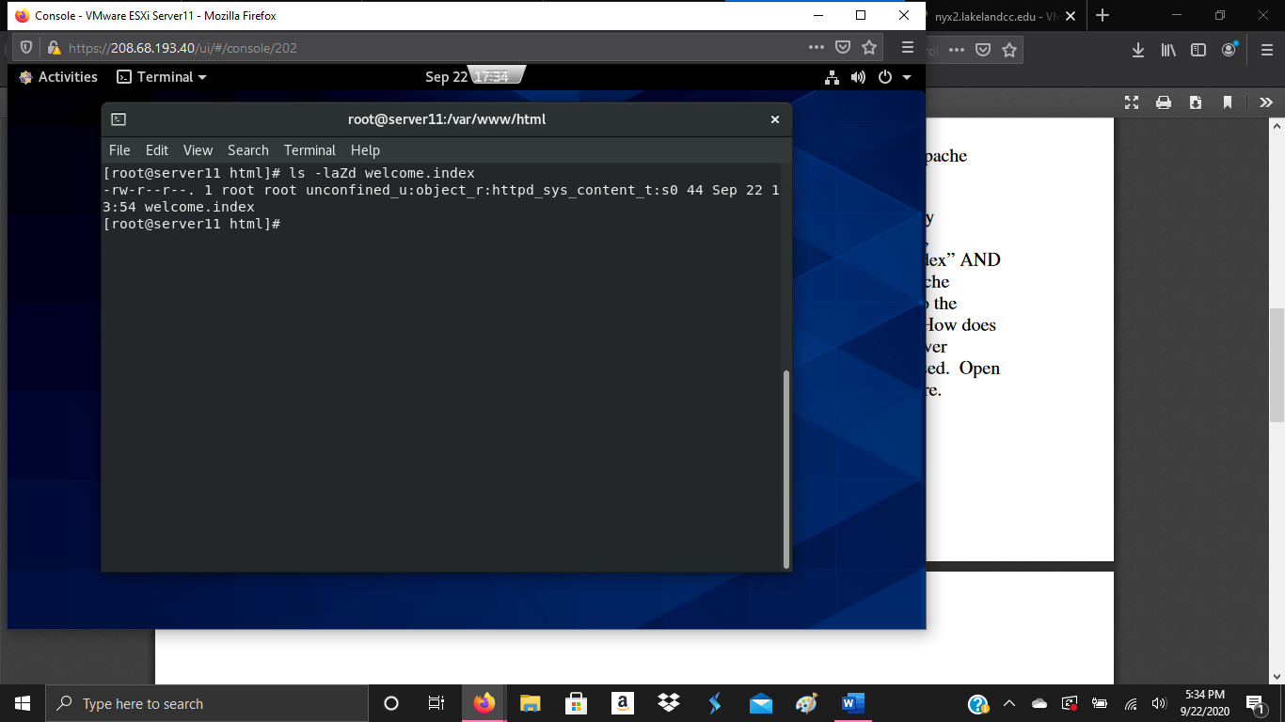

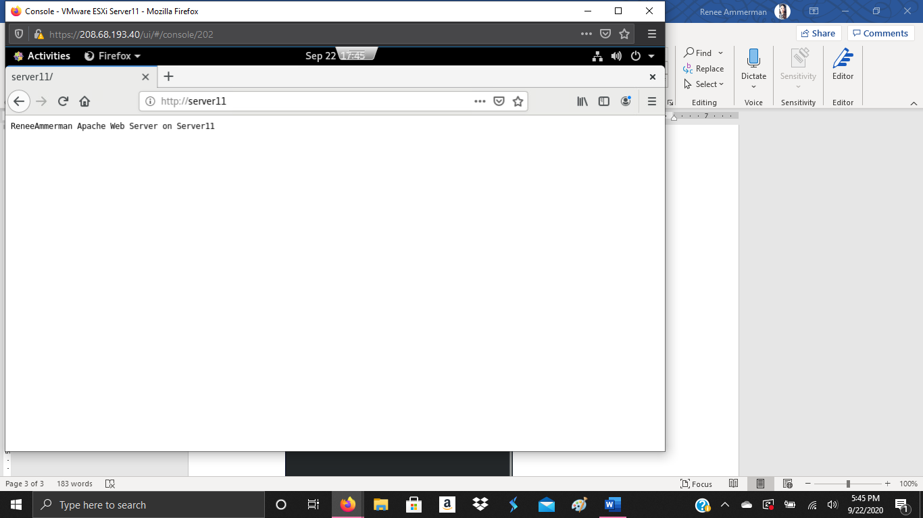

1. Configuration- I created the “/web” directory using “mkdir /web”, I copied the “welcome.index” file to the /web directory using “cp /var/www/html/welcome.index /web”. The SELinux is different than step 4 because it has changed the type to default. The /web directory has the same permissions as the /var/www/html directory. I went back to the configuration file and added /web to the Document root, and added a directory block for /web. I went back to the web browser and it did display the home page. I used “getenforce” to get the SELinux status. I displayed the homepage again in the web browser.

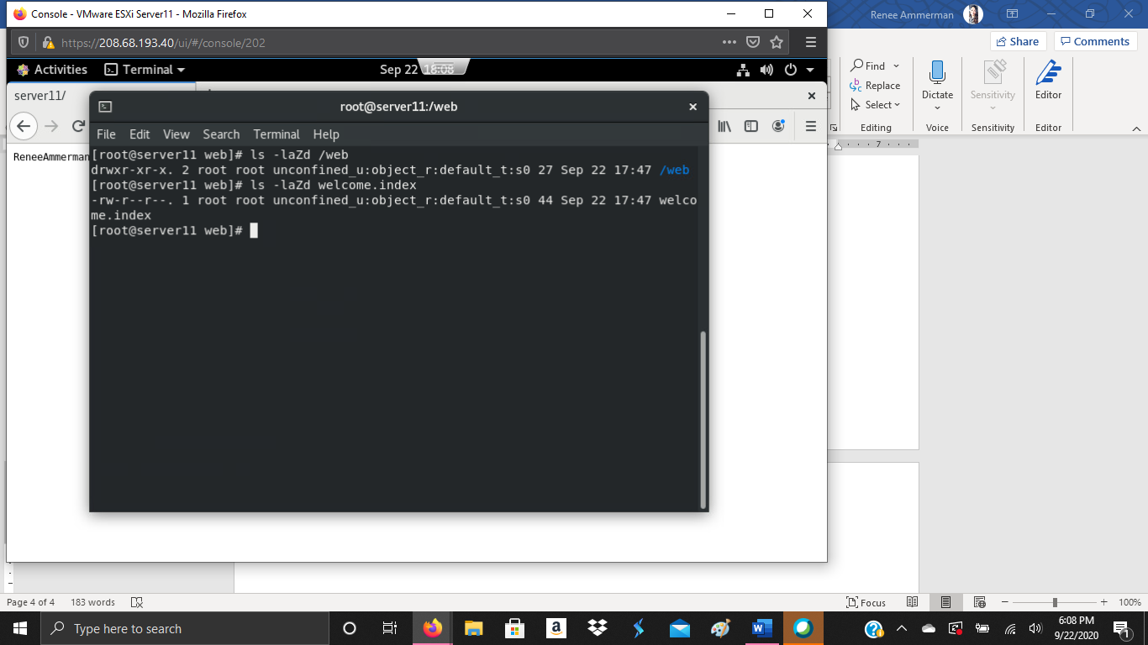

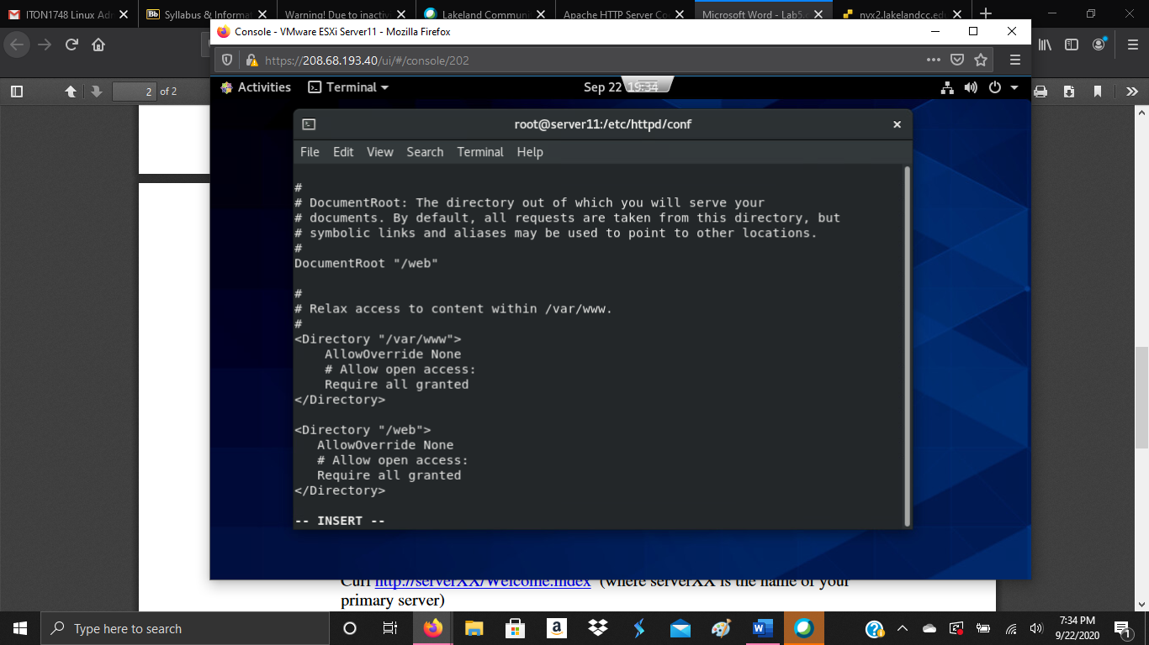

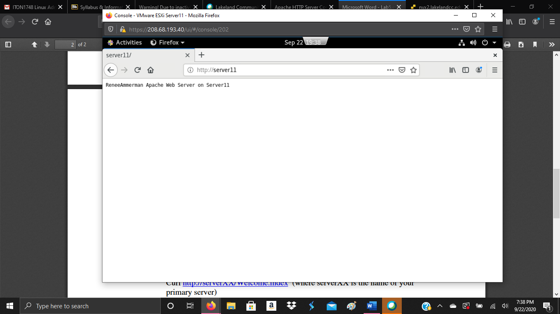

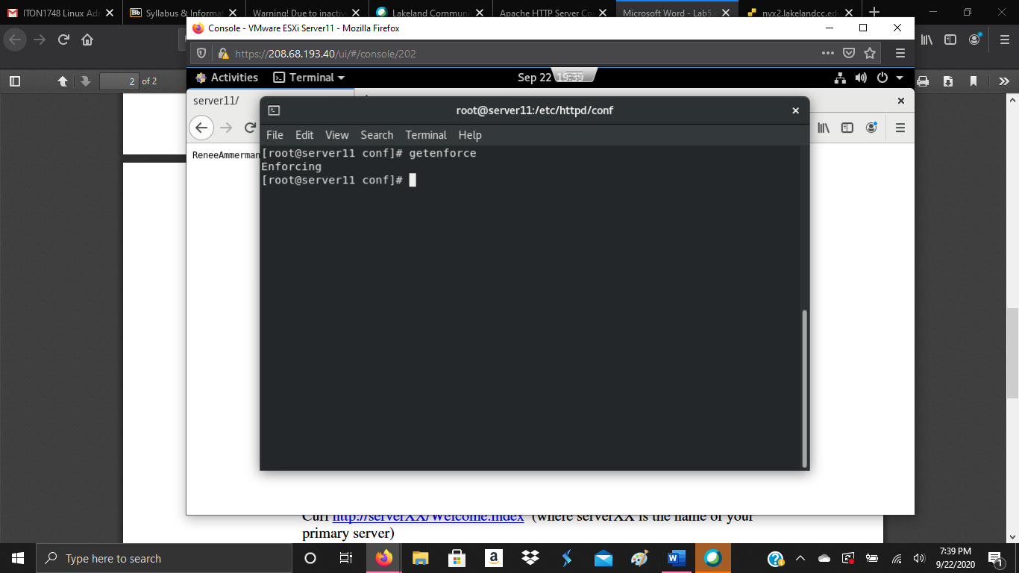

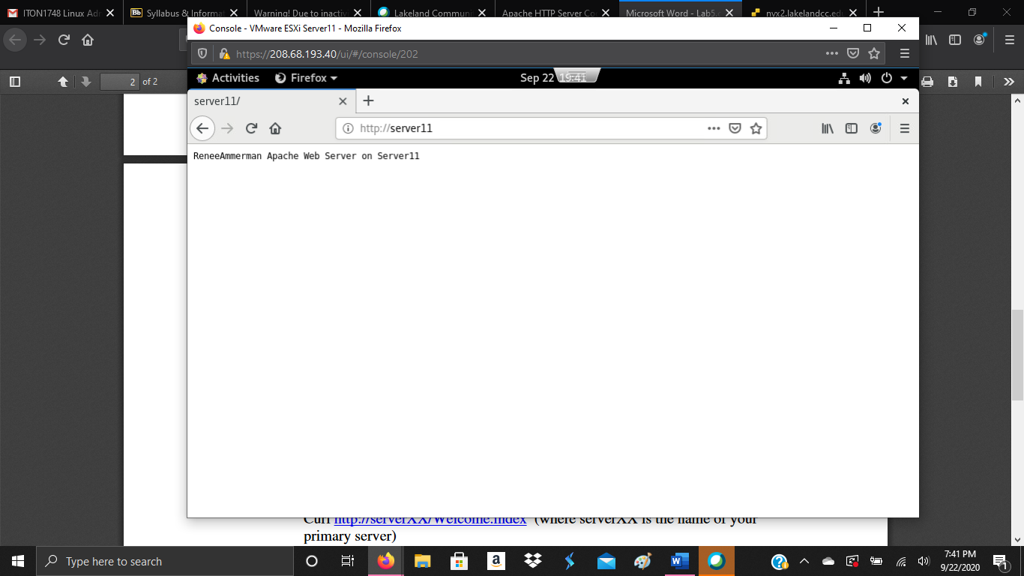

1. Client- I typed “curl http://server11/welcome.index” , It returned the contents of the welcome.index file.

