# Executable code (command for execution)

There are few roles in the system, they are manager (the system administrator) and the user. The different role in the system responsible for different actions. A client could become the system user through the registration process. For the “registration” command, the system requires user enter account name and password for the registration process. There are few require input for the registration process because we don’t want the registration process too complicate and it is not the main focus of the system.

A system user could perform several commands, they are “show all plan”, “display shopping cart” and “show order” commands. The “show all plan” command would be displayed all telephone service plans, after the command executed, the system would display “filter” command for user perform a filter action to the telephone service plan. There few filter options for a user, they are filter by name, filter by price, filter by data usage and filter by extra officer. The filter by name option just like its name, it performs a filter action with inputted keyword. Besides, the filter by price would require the user enter minimum plan price and maximum plan price, the system would return a filtered plan list, the price range would within the minimum and maximum prices. Moreover, the filter by data usage option is that it filters based on the data plan (e.g 5G, 4G data plan). Filter by extra officer options would list all plan service by specify officer. In addition, user could enter plan id to retrieve the detail description of the service plan, an add to shopping cart command would display with the plan detail. User could add specify service plan to his/her shopping cart.

For the “display shopping cart” command, it would be displayed all service plan users has been added into the shopping cart. The checkout and remove item from cart functions would be displayed after the user performs “display shopping cart” command. User could perform check out shopping cart function with the keyboard button “c”. Also, a user could enter the plan id to remove the item from her/his shopping cart. You may find that the result of “show order” command is similar to “display shopping cart” command. The difference between them is that the “show order” command display user’s purchase history. On the other hand, the “display shopping cart” command displayed the items which are pending to checkout.

Compare to the user, the manager could perform the user’s action since the manager extends from user role. In addition, the manager has extra operation commands to the system, they are “add service plan”, “update service plan”, “delete service plan” and “check user plan” commands. Concerning the “update service plan” command, this command requires the manager to enter the basic information about a service plan such as the plan type, plan title and monthly fee. A placeholder would be displayed to remind the manager. The summary information of the plan would be displayed after the creation successful. Furthermore, the “update service plan” command requires manger to enter the plan ID which he/she want to modify. The program would ask manager enter the updated plan info when a valid plan ID was entered. Also, the manager could skip the input filed by press “s”. The progress of the update is similar to “add service plan” command and It is another usage of “add service plan” command. In addition, the manager could delete the service plan through the “delete service plan” command, this command would ask manager enter plan ID. The service plan would be deleted when the plan ID is valid. Lastly, the “check user plan” command would display a list of client who are the member of the system. To display the user’s plan info, the manager needs to enter the user’s name. The user’s purchase history would be displayed after this command executed.

# Executable code structure

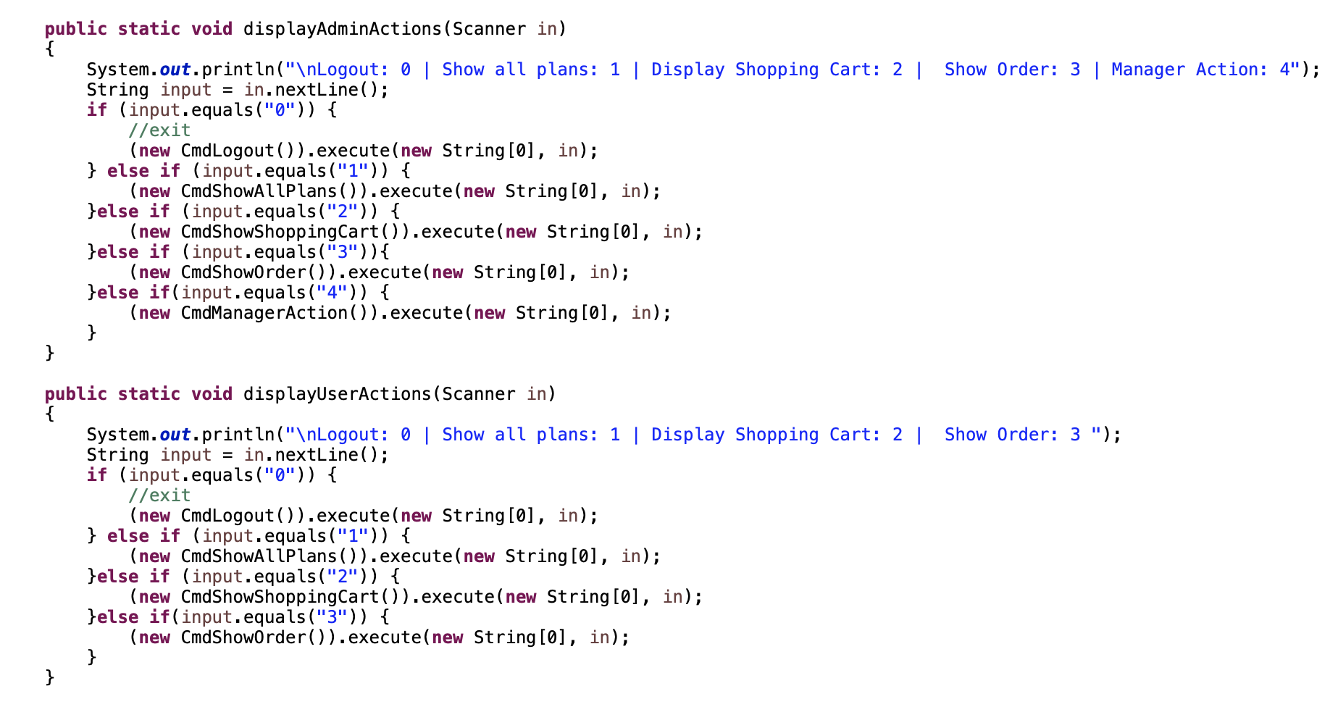The follow code shows the commands execution structure:

Above code shows the command pattern design, each class response to a command. The different user responsible for the different commands, we mentioned that before. Also, this structure is good for program extension. The program would ask user login when the program executed. The program will check the user role and display responsible commands when the user login success. We can find that the difference between user and admin role is “manager action” command. Each command would execute with relative number.