Technical Report: Frequency of Accidental Introduction for Livestock and Crop Pathogens
Emma Mendelsohn, Renee Klann, Ernest Guevarra, and Noam Ross
EcoHealth Alliance
June 2024

Introduction
As part of the Food and Agriculture Sector Risk Analytics Capabilities (FASRAC) project, EcoHealth Alliance (EHA) developed models to estimate the probability of unintentional introduction of livestock and crop pathogens into the U.S. to support risk assessments in the food and agriculture sector. EHA leveraged prior research funded by DHS S&T on the Rapid Evaluation of Pathogens to Prevent Epidemics in Livestock (REPEL) model, a predictive machine-learning approach for assessment of animal disease threats. As a proof-of-concept, REPEL predicted the probability of new veterinary disease outbreaks at the country level due to import via trade and cross-border contact, as well as country endemic factors.
In this effort, we redesigned REPEL for continuous deployment. We structured the REPEL pipeline to ingest new data as it becomes available, enabling predictions in the early stages of outbreaks, and refined the model pipeline design to improve predictive performance, computational performance, and reproducibility. The updated model can be regularly re-fit to adjust to new patterns of disease emergence and spread as new data becomes available. We also adapted the REPEL pipeline to generate the Crop Accidental Frequency Model (CAFM), a predictive machine-learning approach for rapid assessment of crop disease threats. This report describes the REPEL and CAFM modeling effort, including data sources, methods, results, guidelines for reproducibility, and suggestions for future directions.

Data Sources

Livestock Outbreaks
We sourced animal disease outbreak data from the World Organization for Animal Health (WOAH) World Animal Health Information Database (WAHIS) which contains data from local country veterinary reporting agencies of WOAH member countries. REPEL is trained on WAHIS disease outbreak reports, which contain detailed location and case data for individual outbreak events and monthly follow-ups until outbreaks are suppressed or become endemic. Disease outbreak reports are continuously released by country reporting agencies to report new cases and disease locations as disease outbreaks evolve. As of March 2024, the WAHIS database contains 5,490 outbreak reports of 92 terrestrial diseases from 183 countries and territories since 2005. Of these reports, 3,385 are for DHS priority diseases (Figure 1). 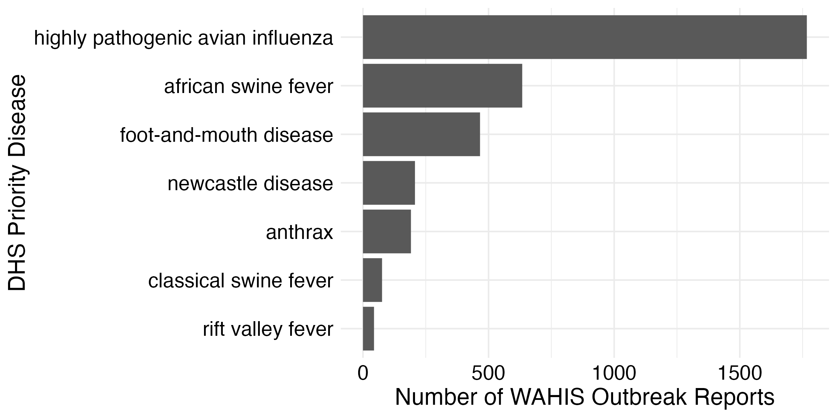
Figure 1. Livestock outbreak report records for DHS priority diseases

Crop Outbreaks
We sourced crop disease outbreak data from the European and Mediterranean Plant Protection Organization (EPPO) Reporting Service, the International Plant Protection Convention (IPPC) official pest reports, and the North American Plant Protection Organization (NAPPO) official pest reports.

EPPO
The EPPO Reporting Service is a monthly newsletter on events of phytosanitary concern, including official pest reports from EPPO member countries as well as information from the scientific literature. A cumulative index contains data from articles dating back to 1967, and the full text of articles dating back to 1974 is available in the EPPO Global Database. The index contains the pest name, country, publication year, issue number, article title, and keywords (e.g. new record, detailed record, absence). EPPO is the largest data source we used, with 7,676 total articles as of March 2024. After preprocessing to remove irrelevant records such as observations of invasive plants, taxonomic revisions, and conference announcements, there are 4,296 articles containing 9,626 unique disease records. The number of records per year increased substantially in the 1990s, and since 1994 it has ranged from 216 to 402. EPPO reports on disease outbreaks worldwide, but about half of the records are from Europe. There are 1,023 reports of DHS priority diseases (Figure 2).

IPPC
The International Plant Protection Convention (IPPC) is a treaty signed by 185 countries that aims to prevent the introduction and spread of plant pests. Official pest reports from contracting parties are available on the IPPC website. The structured data includes the pest name, country, publication date, host plant(s), status of the pest in the country, and report title. There are 1,006 total reports, spanning from 2005 to March 2024. After preprocessing to exclude reports that overlap with NAPPO, there are 656 reports. IPPC has the most even geographic coverage of the sources, with 90-157 reports per continent. There are 45 reports of DHS priority diseases (Figure 2).

NAPPO
The North American Plant Protection Organization (NAPPO) is a regional plant protection organization established in 1976 in accordance with the IPPC. Official pest reports provided by the member countries are available through NAPPO's Phytosanitary Alert System. The structured data consists of the country, publication date, and report title. There are 836 total reports, all from North America, spanning from 2002 to March 2024. There are 101 reports of DHS priority diseases (Figure 2).
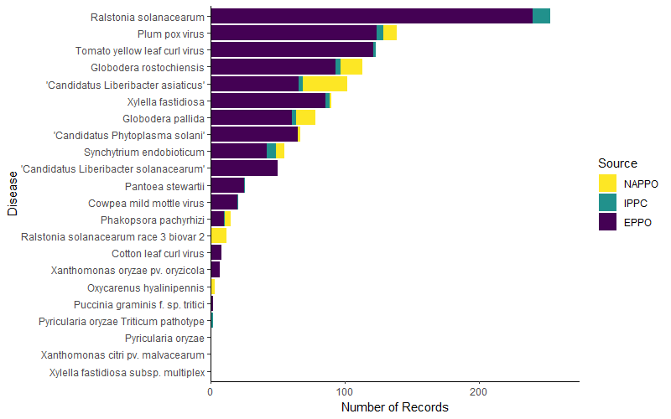
Figure 2. Crop outbreak report records for DHS priority diseases

PestLens
In addition to the previous sources, we evaluated the possibility of including PestLens, an early-warning system developed for USDA’s Animal and Plant Health Inspection Service Plant Protection and Quarantine (APHIS-PPQ) program, as a data source. However, we found that the PestLens website is not readily amenable to scraping or other forms of data ingest. PestLens administrators were willing to sharing raw data but did not provide within the time frame of the project. See Appendix 2 (Future Steps) for suggestions for adding this source in future work.

Covariates
We sourced data from OIE, FAO, World Bank, and United Nations to develop predictive covariates of disease outbreaks. These consisted of two categories – country characteristics (generally measures of disease “attack surface” or capacity to respond to outbreaks), and strength of network connections (trade and contact vectors along which diseases can spread). Table 1 summarizes these predictor data.

Table 1. Covariate data used in REPEL and CAFM models.
Name | Frequency | Dimension | Source | Model
Animal disease events and outbreaks | yearly | per country | World Organisation for Animal Health (https://wahis.woah.org/#/home) | livestock
Country shared borders | static | bilateral | CIA World Factbook archive (https://www.cia.gov/about/archives/download/factbook-2020.zip) | both
Wildlife migration | static | bilateral | International Union for Conservation of Nature (https://www.iucnredlist.org/) and Global Register of Migratory Species (http://groms.de/groms_neu/view/order_stat_patt_spanish.php?search_pattern=) | both
Livestock trade | yearly | bilateral | Food and Agriculture Organization (https://www.fao.org/faostat/en/#data/QCL) | livestock
Agricultural Product Trade | yearly | bilateral | United Nations Comtrade Database (https://comtradeplus.un.org/) | both
Gross Domestic Product (GDP) | yearly | per country | World Bank (https://data.worldbank.org/indicator/NY.GDP.MKTP.CD) | both
Human population | yearly | per country | World Bank (https://data.worldbank.org/indicator/SP.POP.TOTL) | both
Taxa population | yearly | per country | Food and Agriculture Organization (https://www.fao.org/faostat/en/#data/QCL) | livestock
Veterinarian population | yearly | per country | World Organisation for Animal Health (https://wahis.woah.org/#/home) | livestock
Plant pest reports | yearly | per country | European and Mediterranean Plant Protection Organization - EPPO (https://gd.eppo.int/reporting/) | crop
Plant pest reports | yearly | per country | International Plant Protection Convention - IPPC (https://www.ippc.int/en/countries/all/pestreport/) | crop
Plant pest reports | yearly | per country | North American Plant Protection Organization - NAPPO (https://www.pestalerts.org/nappo/official-pest-reports/) | crop
Crop production | yearly | per country | Food and Agriculture Organization (https://www.fao.org/faostat/en/#data/QCL) | crop
Crop trade | yearly | per country | Food and Agriculture Organization (https://www.fao.org/faostat/en/#data/TCL) | crop

We also evaluated bird migration (BirdLife International), human migration (UN Population Division), and tourism (UN Worlds Tourism Organization) as potential bilateral data sources. We did not include them in our model due to data sparsity.

Methods

Crop Data Extractions
Because the crop data sources provide data in free-text format, we used natural language processing (NLP) to extract data required for the CAFM model. For each report, we extracted the disease name, year and month of the outbreak or latest observation, host plant(s), and status in the country (present or absent). We used the OpenAI GPT-4 large-language model (LLM) (specifically, gpt-4-1106-preview), accessed via Web API, to perform extractions with the “function calling” feature that constrains results to a JSON format matching a user-provided schema. We used the openai R client package to interface with the API.
We developed prompts for each data source to account for differences in the free text and reduce common errors identified in test output. For example, for IPPC we used the status prompt "Is the disease or pest present or absent from [country name]? This information often follows the phrases 'Pest Status' and 'ISPM 8'.” This directs the model to the part of the report that is likely to contain the information. We flagged reports that had improbable values of year and presence, and manually reviewed flagged reports of priority diseases. We also manually reviewed all reports of Ralstonia solanacearum and Xylella fastidiosa to ensure that priority subtypes were extracted correctly. After integrating the manually reviewed data into the full dataset, we aggregated priority disease subtypes, so that an outbreak of Xylella fastidiosa subsp. multiplex is also an outbreak of Xylella fastidiosa. For reports without a year extracted, we used the report publication date as the outbreak date.
Because the largest data source prioritizes Europe, one limitation of the crop data is under-reporting of outbreaks in Africa and Asia. In addition, we extracted the host plant(s) for each outbreak, but the field is not sufficiently cleaned to use production of the host crop (analogous to target taxa population for livestock) as a predictor in the model. There are also relatively few instances of reported eradications, leading to uncertainty of whether outbreaks are ongoing.

Disease and Taxonomy Standardization
For the livestock model, we standardized disease names from the WAHIS database using the Animal Disease Ontology (ANDO), and we manually standardized disease names that were not represented in ANDO. We removed veterinary diseases that only affect fish, insects, or reptiles.
For the crop model, there were 1,769 unique disease names in the aggregated data from EPPO, IPPC, and NAPPO. We used the R package pestr to standardize disease names to EPPO Data Services, and manually standardized disease names that were not represented in the database. Taxonomic data for each disease was retrieved from the EPPO Global Database. We removed 746 non-priority diseases that were each reported once, producing a final dataset with 760 diseases. There were no reports of the priority diseases Clavibacter nebraskensis, Coniothyrium glycines, Groundnut rosette virus, Peronosclerospora maydis, and Thecaphora frezii.

Feature Engineering

Outbreaks
We developed parallel pipelines to transform livestock and crop outbreak reports into monthly time series for all combinations of disease and countries, starting from beginning of digital reporting (2005 for livestock and 1993 for crops). For each month, we used the historical outbreak data to indicate whether a disease was present or absent within the country. For livestock data, we explored supplementing this with reporting from WAHIS on endemic diseases not reported in regular outbreak reports, but found that it did not improve model performance and ultimately removed it from the model (see Appendix 1 NowCast). Outbreaks were assumed to be ongoing between the reported starting month and when the outbreak was reported as resolved or endemic. If an outbreak was never reported as resolved or endemic, and the last report was over 12 months in the past, we assumed the outbreak's end month to be the month of the last report of the outbreak. If an outbreak was not marked as resolved and the last report was within the previous 12 months, we assumed the outbreak was ongoing through to the current month.
Following processing at the monthly scale, we aggregated the data into 12-month windows. We created a field indicating if an outbreak started (i.e., switched from absent to present) within the window, and another field indicating if an outbreak was ongoing but not started within the window. The former field is the model outcome variable, while the combination of the two fields was used to inform the network representation of connectivity between countries with outbreaks (see Augmented Data).

Covariates
For time-varying country-attribute variables (e.g., GDP, population), we used linear interpolation for missing data imputation, given at least a single variable existed for the country. If no data was available for a country, we imputed a value well below the range of the rest of the data.
For connectivity variables (e.g., migration, trade), we replaced missing values with zeros, unless it was the most recent year in the data (missingness due to reporting lags), in which case we assumed the most recent values as the present value.
To estimate wildlife migration between countries, we first filtered International Union for Conservation of Nature (IUCN) species distribution data for species listed by the Global Register of Migratory Species (GROMS). We then counted the number of shared species for each country combination.
To estimate agricultural product and live animal trade between countries, we processed Comtrade and FAO data, respectively, to calculate the sum of imports into all countries by year. In cases where both exports and imports were reported between countries (e.g., U.S. reports imports from Canada and Canada reports exports to U.S.), we assumed the highest of the two values. Re-imports and re-exports were included in total values.

Augmented Data
We joined predictor covariates with the outcome data into a single dataset for model training and prediction. Each row in the dataset represents a unique combination of country, disease, and year, with the outcome field indicating if an outbreak started (TRUE/FALSE). Country attribute data (e.g., GDP) was joined with the identifying data by country and year. For taxa population in the REPEL model, we identified the most relevant taxa for each disease (e.g., pigs for African Swine Fever) before joining in time-varying population data specific to the disease and country.
To incorporate the network variables, we first identified which countries had a disease present in each year, either due to a new or ongoing outbreak. Then, for each country and disease combination, we summed the network values from countries with the disease present. This produced variables of infective pressure from all potential disease source countries for each network connection type. For example, for livestock trade, we calculated the total number of animal heads imported into a country from other countries that had the disease present in the given month. For shared borders, we totaled the number of land borders a country shares with other countries that had the disease present in the given month.
For the REPEL livestock model, we used outbreak data to generate two predictive variables representing potential force of infection outside the effects of migration and trade: whether the disease is present anywhere in the world for a given time window, and whether there has been a previous outbreak of the disease within the given country. This step was not incorporated into the CAFM crop model but can be added as part of future efforts.

Under Phase I REPEL work, we tested including trade data in various disaggregated forms, including using principal component analysis (PCA) on the disaggregated trade variables (e.g., individual trade product groupings), but found that it did not improve model performance, and therefore used total livestock heads/total crop production and total trade dollars as predictive features.

Model Design and Fitting
Prior to model fitting, we filtered out data with disease status marked as outbreak ongoing, so that the model was trained to represent the probability of an outbreak starting in a location that does not currently have the disease present. We log transformed continuous variable and standardized (Z-score normalized) all numeric predictors. We split the data into a training set (80%) and validation set (20%).
We modeled outbreak start (binomial outcome), as a function of the predictor variables, with random effects for each disease and a fixed intercept. This allows each predictor variable to have disease-specific slopes, so that the effect of the predictor on the outcome varies by disease.
We used the following model formula for livestock:
livestock_outbreak_start ~ (0 + continent | disease) +
(0 + shared_borders_from_outbreaks | disease) +
(0 + log_comtrade_dollars_from_outbreaks | disease) +
(0 + log_fao_livestock_heads_from_outbreaks | disease) +
(0 + log_n_migratory_wildlife_from_outbreaks | disease) +
(0 + log_gdp_dollars | disease) +
(0 + log_human_population | disease) +
(0 + log_target_taxa_population | disease) +
(0 + log_veterinarians | disease) +
(0 + disease_present_anywhere | disease) +
(0 + outbreak_previous | disease)

and for crops:

crop_outbreak_start ~ (0 + continent | disease) +
(0 + taxonomic_kingdom | disease) +
(0 + shared_borders_from_outbreaks | disease) +
(0 + log_comtrade_dollars_from_outbreaks | disease) +
(0 + log_fao_crop_quantity_from_outbreaks | disease) +
(0 + log_n_migratory_wildlife_from_outbreaks | disease) +
(0 + log_gdp_dollars | disease) +
(0 + log_human_population | disease) +
(0 + log_crop_production | disease)

We used the lme4 package in R to fit the generalized linear mixed-effects model to the training data (n = 1,656,869 for livestock, n = 3,578,080 for crop. We estimated the effect of all network connector variables on the marginal change in risk of each disease (n = 58 livestock diseases, n = 760 crop diseases), penalizing these variables to reduce the high variability of rare diseases. We used the Gauss-Hermite quadrature to approximate the integral used in the calculation of the log likelihood.

Pipeline Architecture
Computer code to acquire and process data, fit models and assess performance was written in the R language. The project GitHub repository is available at: https://github.com/ecohealthalliance/repel2-battelle. Full instructions for re-creating and updating the model-fitting and prediction pipeline are in the code documentation vignette (and included in this report as Appendix 3).
We used the targets build system framework to orchestrate and cache steps in the process, and the renv framework to record software dependencies and versions used in the workflow. The pipeline includes discrete steps for data downloading, data processing, data augmentation, model fitting, model validation, and prediction generation. These steps can be run separately or as a full pipeline in serial.
Data ingest steps are fully functionalized to be able to access and process data from the sources described in previous sections. Some of these steps require API tokens for data access, and the code documentation includes full detail on how to acquire and set these tokens as environment variables. The data download process includes checks on upstream sources to ensure fields and content are as expected. Download times and resources needed are also described in the code documentation.
The crop pipeline uses NLP processes from OpenAI for data extraction from free text reports. The code documentation includes instructions to use OpenAI for data updates, and also offers instructions to perform all data updates manually.
All model, validation, and prediction steps are functionalized and described within model documentation. To preserve model objects, and prevent unnecessary model refitting, we have cached versions of model objects and associated inputs and outputs available on GitHub. See data documentation for how to use these cached objects for running predictions on new data.

Results
We generated predictions of probability of new disease outbreaks on validation holdout data (n = 57,280 for livestock, n = 975,840 for crop). We generated calibration curves by grouping predictions into optimized bins for isotonic regression using pool-adjacent violators algorithm, as implemented in the reliabilitydiag package in R, and comparing forecasted probability bins to actual outbreak rates, represented as binomial probabilities and confidence intervals for each bin. Each prediction represents the expectation of an outbreak of a given disease in a country in a 12-month window. This assessment evaluates the reliability of predictions for rare events: given a predicted probability of a rare outbreak, how well is that probability borne out as a fraction of times that outbreaks actually occurred in the validation data? Across the range of predictions, the average predicted probability matched the observed fraction of events (by falling within binomial confidence intervals) in 24 of 29 bins for the livestock model (Figure 3), and 21 of 32 bins for the crop model (Figure 4). These results indicate that the models are well calibrated, with the crop model having tendency to conservatively overestimate risk at the higher end of the prediction range. Performance statistics for binary prediction are provided in Table 2. These performance statistics reflect the fact that in the vast majority of conditions the predicted probability of outbreaks is below 50%, and no outbreak occurs. Conditions indicating greater than 50% probability of outbreak are very rare, and this high threshold is insensitive to the majority of outbreaks. The calibration curves provide a more nuanced assessment of model performance, and continuous probabilistic predictions, or consequence-based thresholds for the probability of outbreak, should be used when using these models for decision-making.
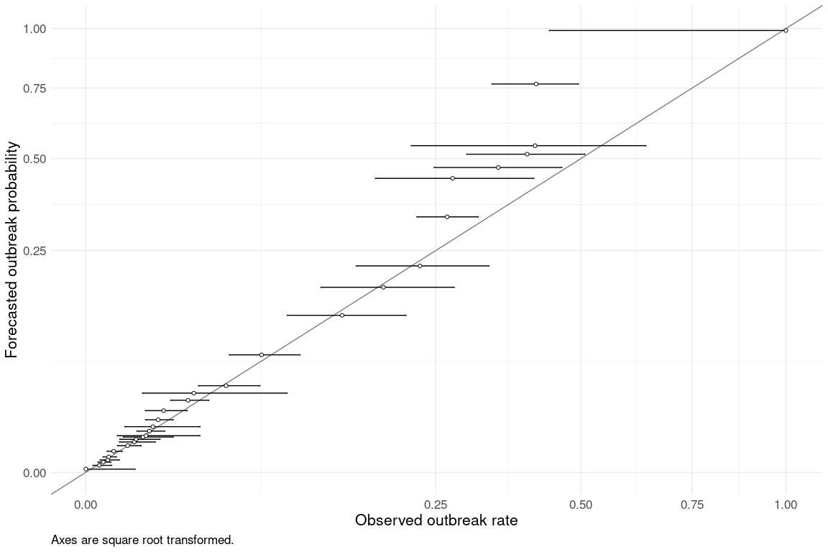
Figure 3. REPEL livestock model calibration curve.

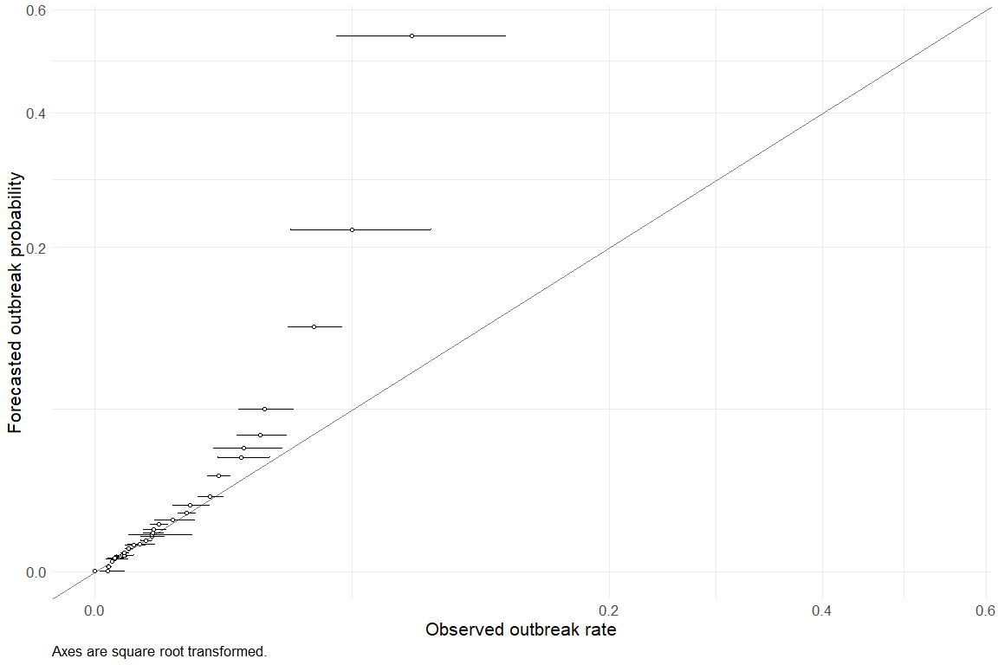
Figure 4. CAFM crop model calibration curve

Table 2. Model performance statistics
Metric | REPEL (livestock) | CAFM (crop)
Accuracy | 0.99 | 1.0
KAP | 0.25 | 0.0038
Sensitivity | 1.0 | 1.0
Specificity | 0.19 | 0.0020
Positive Predictive Value | 0.99 | 1.0
Negative Predictive Value | 0.40 | 0.063
MCC | 0.27 | 0.011
j index | 0.18 | 0.0020
Bal accuracy | 0.59 | 0.50
Detection prevalence | 1.0 | 1.0
Precision | 0.99 | 1.0
Recall | 1.0 | 1.0
f meas | 1.0 | 1.0

Appendix 1. Nowcast
Under Phase I REPEL work, we had developed a machine learning approach, called NowCast, to provides current and next-year estimates of livestock disease status (i.e., presence or absence) and case counts at the country level. This model was designed to enhance situational awareness of disease status globally, which is often underreported or subject to long reporting lags or gaps, especially in low-resource settings. NowCast model predictions were used in the original REPEL travel model to identify countries where a disease is endemic and may not be reported in the outbreak reports.
Under the current effort, we recreated the NowCast model using updated WAHIS data. However, we found that including NowCast endemic disease status in the main REPEL travel model did not increase model performance, and therefore we did not include it in the final model. Here we document the NowCast methods and results. Instructions for reproducibility for in Appendix 3.
The NowCast model is based on the WAHIS six-month disease summary reports, which provide epidemic and endemic disease status (present, absent, or unreported), summary metrics (e.g., total six-month case counts), and disease control measures at the country level. The model predicts country-level disease status, providing a current estimate for status as raw reported data often lags for periods ranging from six months to several years.
Prior to modeling, we implemented a series of model-specific data augmentation steps to generate predictive features that would support prediction of disease emergence, growth and suppression. First, to capture temporal dependence and patterns in disease status, we generated features of lagged disease status from previous three reporting intervals (i.e., status from previous 6, 12, and 18 months) to capture. We also included disease outbreak history - whether the disease had ever occurred in the country or continent. We captured disease infection pressure from neighboring countries by indicating whether the disease was present in a neighboring country in the previous three reporting intervals. We represented the effects of mitigation efforts on disease occurrence with a multi-response field indicating which control measures had been applied during the previous three reporting intervals.
Disease and capacity reporting quality varies widely across OIE-reporting countries, and we standardized data with a series of assumptions designed to minimize reporting biases. We assumed diseases reported as suspected to be present. We assumed diseases with unreported status (i.e., diseases included in country reports but listed as unreported) to be absent. For other variables, we created separate features to mark missingness in these fields, so as to use under-reporting as a bias-adjusting predictor. We used country attributes as covariates to adjust for country vulnerability, creating fields for GDP per capita and veterinarians per taxa population (Table 1). For these fields, we replaced missing values with a value well below the range of the rest of the data and we also created separate columns to mark missingness. We made a feature to indicate the first reporting period (i.e. length of reporting history) for the country. We filtered out data from territories and regions without reported GDP values. Prior to model fitting, we converted nominal fields into binary dummy variables and log transformed numeric fields. We then split the data into a training set (80%) and validation set (20%).
We used gradient boosted decision trees, implemented with the xgboost package in R to fit a classification model for disease status and a regression model for case counts. Gradient boosted decision trees are a powerful machine-learning approach in which decision trees are iteratively fit to reduce the value of a loss function. We used 10-fold cross validation followed to tune all model parameters.
On holdout validation data, the NowCast model had 97% accuracy, with a positive predictive value of 98% and negative predictive value of 92%. When used in the REPEL travel model, performance did not improve relative to the model without endemic status specific (figure 3; table 2). We tested multiple formulations of the nowcast, including different assumptions around handling and predicting unreported diseases, and did not find any improvement in the travel model.

Appendix 2. Future Steps
EcoHealth Alliance (EHA) has developed unintentional introduction probability models for livestock and crop diseases in collaboration with Battelle as part of the FASRAC project. Here we summarize support tasks for ongoing maintenance, improvement, and extension of these modules for future phases of work that would enhance FASRAC and related initiatives.

Maintenance
The modeling pipelines for livestock and crop introduction models have been designed to maximize automation and have been documented to minimize the effort required to update data for future forecasting. However, we anticipate the following tasks will require ongoing maintenance effort:
- Maintaining the WAHIS animal disease outbreak data source. WAHIS disease outbreak data is not available in a format conducive to automatic updates. EHA has an agreement with WOAH to access static data extracts, which we process into a public, machine-readable database for use in the REPEL model. While much of this process is functionalized, it does require regular manual steps. In the future, WOAH plans to release a public-facing application program interface (API), which will facilitate automatic data extraction. When this is available (timeline TBD), the data extraction pipeline will need to be adapted accordingly. WOAH can be contacted for status updates and to obtain access to the static data releases.
- Maintaining the crop disease database. Because there is no centralized database like WAHIS for crop disease outbreak data, EHA has developed a database for the crop model (CAFM) based on multiple sources of text-based outbreak data, leveraging a mix of manual and NLP curation. This database will need to be updated to enable future forecasts, and we have provided documentation for performing the updates entirely manually or with NLP assistance. With NLP, we estimate that updates can occur in about a tenth of the time of a manual review, including the time needed for quality assurance. Support for this process may be provided.
- Upstream data source changes to predictor variables. Historically, the providers of key model inputs (e.g., WOAH-WAHIS, UN COMTRADE, FAO), have changed the format and distribution channels for their data, requiring refactoring of data engineering pipelines. Based on the number of data sources used in the models, we anticipate a need for such updates every 1-2 years.

Crop model improvements
The CAFM model for crop disease was developed for FASRAC based on previous work on the REPEL model for unintentional introduction of livestock diseases. REPEL has had the benefit of iteration through several generations: since the start of the FASRAC effort, we have improved rare event prediction accuracy nearly 7-fold, and overall model calibration by 25%. We would expect similar performance improvements in CAFM through further iterations that address the following tasks:
- Incorporating additional sources of crop disease outbreaks. PestLens is high-quality source of crop disease outbreak data from USDA’s Animal and Plant Health Inspection Service Plant Protection and Quarantine (APHIS-PPQ) program, containing nearly disease 3,000 records (equal to 26% of our current full dataset). Because PestLens data is not readily accessible for extraction, we were not able to use PestLens the FASRAC effort, but APHIS has confirmed they are willing to provide data access for future efforts. Incorporating this data source into our model is likely to increase coverage of priority diseases and improve performance.
- Incorporating additional predictors. The following predictors are likely to improve model forecast accuracy and contribute to interpretation of variable importance in disease introduction.
  - Static bioclimatic and/or dynamic seasonal variables to capture the seasonality of crop outbreaks.
  - Crop host information extracted from free outbreak reports. We currently have this data available but additional effort is needed to improve data hygiene and standardization.
  - Vector populations within countries to better predict vector-borne crop disease risks.
  - Agricultural investment values (FAO) and agricultural production indicators (World Bank) to better capture country “attack surface” vulnerability.
  - Human travel data to better capture spread mechanisms. We have not yet identified a data source with sufficient coverage of country-to-country travel patterns. If DHS has this type of information available, we can incorporate it into the crop and livestock models.
  - Global and historical disease status: whether the disease is present anywhere in the world for a given time window, and whether there has been a previous outbreak of the disease within the given country.
- NLP improvements. Our current NLP-based approach for extracting data from free text is a successful proof-of-concept that establishes a performance baseline. This process can be improved by providing additional training to large language models (LLMs) to fine-tune extractions to the specific use case, and we can evaluate performance accuracy across multiple LLM models, which are rapidly improving. In addition, we can generate performance rate curves to understand the impacts of NLP-extraction accuracy on overall model performance.

General extensions
- More robust and granular uncertainty and performance metrics. The current model structure does not include disease-specific uncertainty estimates due to limitations of the model structure. We can develop non-parametric approaches for better estimating uncertainty in predictions and scenario/disease-specific performance estimates.
- Real-time outputs in response to changing events. Workflow for FASRAC has been developed around the 12-month prediction cycle, but crop and livestock pipelines can be modified to provide real-time updates based on outbreaks abroad that modify the global risk profile, or hypothetical outbreaks for scenario planning, and incorporate shorter timescale predictions and incorporation of seasonality.
- Consequence-specific model-tuning: The crop and livestock models have been developed to be highly general but can be tuned so their prediction performance is optimized based on consequence-specific rules, such as the relative cost of true and false positives, or focus on specific diseases.
- Focus on ports of entry and domestic outbreak locations: Current models predict outbreaks anywhere in the United States based on import risk from countries with current disease status. Decomposing this data to better specify likely ports of entry and model domestic location of outbreak is a possible extension.

Appendix 3. Reproducibility Manual
This vignette is an overview of the full pipeline for the livestock and crop REPEL models, from data ingest and processing to model fitting and predictions.

Project setup

Downloading the repository
The project GitHub repository is available at https://github.com/ecohealthalliance/repel2-battelle.
In the terminal, the repository can be cloned using HTTPS:
git clone https://github.com/ecohealthalliance/repel2-battelle
or using SSH:
git clone git@github.com:ecohealthalliance/repel2-battelle.git
You also have the option of downloading a zipped version of the repository from GitHub. Unzip the file into a preferred directory on your machine.

Setting environment variables
Environment variables are used to store authentication keys for data sources and to specify model settings.
Variables can be set manually before running the data ingest pipeline. For example, in R:
Sys.setenv(VARIABLE_NAME = YOUR_VARIABLE_VALUE)
However, we suggest storing environment variables in an .env file in the root directory of the repository. This way, environment variables will always be loaded prior to running the pipeline.

Authentication keys
Some of the data sources require authentication keys to access the data programmatically. The following keys should be saved as environment variables.
IUCN_REDLIST_KEY=YOUR_IUCN_REDLIST_KEY_HERE
COMTRADE_PRIMARY=YOUR_COMTRADE_PRIMARY_KEY_HERE
COMTRADE_SECONDARY=YOUR_COMTRADE_SECONDARY_KEY_HERE
DOLT_TOKEN=YOUR_DOLTHUB_TOKEN_HERE
EPPO_TOKEN=YOUR_EPPO_TOKEN_HERE
Below we provide instructions for obtaining these keys.

The International Union for Conservation of Nature (IUCN) Red List of Threatened Species API token
The IUCN provides an API to programmatically access the IUCN Red List of Threatened Species. The required API token can be generated by making a request at https://apiv3.iucnredlist.org/api/v3/token detailing reason for API use. Request is sent to IUCN and approval along with the API token is provided to the email address used during registration. This may take several days.
Due to delays in obtaining IUCN tokens, the IUCN data file is now saved as part of this data repository. It is no longer necessary to obtain a token to be able to run the pipeline.

United Nations Comtrade Database API token/key
The UN Comtrade Database can be accessed programmatically using its API. The API token/key can be obtained as follows:
- Create a UN Comtrade Database account at this link
- Sign in to the UN Comtrade Database API portal and then proceed to the Products tab (https://comtradedeveloper.un.org/products)
- From the Products page, select the Free APIs option (https://comtradedeveloper.un.org/product#product=free)
- In the text entry dialog box, enter comtrade-v1 and then click the Subscribe button
After these steps, the page should now show you two subscription keys called primary and secondary which are the API tokens/keys needed for API access.

World Animal Health Information System (WAHIS) data via EcoHealth Alliance’s DoltHub repository
EcoHealth Alliance routinely curates animal health information on animal disease events and outbreaks from WOAH’s WAHIS website using DoltHub. The curated database is found here and is openly accessible. Programmatically, access can be gained using a DoltHub API key. A DoltHub API key can be created as follows:
- Create a DoltHub account
- Log in to your DoltHub account
- Create an API token in your settings on DoltHub

European and Mediterranean Plant Protection Organization (EPPO) Data Services
EPPO Data Services provides an API to programmatically access the database used for plant disease name standardization. An API token can be generated by registering for an account at https://data.eppo.int/user/register. Immediately after registration, the token can be copied from the user dashboard, under the Tokens API header.

Project settings
In addition to authentication keys, environment variables can be used to store project settings. For example, the user can set the following variables to use AWS for object storage:
AWS_REGION=YOUR_AWS_REGION_HERE
AWS_BUCKET_ID=YOUR_AWS_BUCKET_ID_HERE
AWS_ACCESS_KEY_ID=YOUR_AWS_ACCESS_KEY_ID_HERE
AWS_SECRET_ACCESS_KEY=YOUR_AWS_SECRET_ACCESS_KEY_HERE
Additional settings related to model fitting and prediction are described in their respective sections below.

R dependencies
This pipeline was created using R version 4.3.2 (2023-10-31 ucrt). This project uses the {renv} framework to record R package dependencies and versions. Packages and versions used are recorded in renv.lock and code used to manage dependencies is in renv/ and other files in the root project directory. On starting an R session in the working directory, install R package dependencies:
renv::restore()
or using the following command in Terminal
Rscript -e 'renv::restore()'

Targets workflow
This pipeline uses the targets package as a build system to resolve dependencies and cache results. This is similar conceptually to make, with the _targets.R file being the equivalent of a Makefile. With targets, the user can build individual parts of the pipeline and they will be cached when running in the future.

Docker
We have assembled a Docker image with necessary dependencies to run the pipeline, and a convenience shell script (tar_make.sh) for building pipeline steps in the console. To build the image locally and use it to run the pipeline, run the following
docker build . -t ecohealthalliance/repel2
docker run -v "$(pwd):/repel2" ecohealthalliance/repel2 ./tar_make.sh '<TARGET_NAME>'
<TARGET_NAME> can be any target and can also be everything() or other selection commands such as tidyr::contains(c("woah", "wahis", "iucn")).
In addition, we have provided a tarball of the Docker image. Instead of building it, you can load it with
docker load < repelcontainer_vXXX.tar.gz

Data ingest and processing
The data ingest pipeline retrieves the datasets used by the REPEL model from their various sources.
The entire data ingest and processing pipeline can be run using the following command in the R console.
targets::tar_make(c(augmented_livestock_data_aggregated, augmented_crop_data_aggregated))
or using the following command in Terminal
Rscript -e 'targets::tar_make(c(augmented_livestock_data_aggregated, augmented_crop_data_aggregated))'
The augmented_livestock_data_aggregated or augmented_crop_data_aggregated target endpoint is the full model dataset, which combines all predictor and outcome data sources, used for training and validation. Note that these may take over a day to run due to the data download steps (particularly Comtrade). Below we provide guidance for testing subsets of the data ingest pipeline with faster run times. Note, running tar_make() without specifying a target will run all livestock and crop targets.

Pipeline testing
Given specific requirements (such as API tokens) and length of run times described above, we recommend the following steps for someone trying out this data ingest and processing pipeline for the first time or for someone reproducing the outputs:
- Test that the pipeline works as described by running a data source pipeline that doesn’t require any tokens
For the livestock pipeline, we recommend the pipelines for data retrieved from the FAO, UN Statistics Division, CIA World Factbook, and the World Bank. We would expect this pipeline to complete in ~20 minutes. To run these, the following command can be used in the R console:
targets::tar_make(c(country_yearly_human_population, country_yearly_gdp, connect_static_shared_borders, country_yearly_taxa_population, connect_yearly_fao_trade_livestock, country_yearly_vet_population))
For the crop pipeline, we recommend the pipelines for data retrieved from the FAO, UN Statistics Division, CIA World Factbook, the World Bank, EPPO, IPPC, and NAPPO. We would expect this pipeline to complete in ~4 hours. To run these, the following command can be used in the R console:
targets::tar_make(c(country_yearly_human_population, country_yearly_gdp, connect_static_shared_borders, country_yearly_crop_production, connect_yearly_fao_trade_crop, eppo_index_processed, ippc_table_processed, nappo_table_processed))
Note that source("tar_plans/_targets_data_downloads_crop.R") and source("tar_plans/_targets_data_processing_crop.R") are currently commented out in the _targets.R file. This needs to be changed in order to run the crop data ingest and processing pipeline.
This step will give an indication that the general pipeline works as expected if the run completes without errors. For a faster test, you could run the world bank GDP data pipeline, which should complete in seconds: targets::tar_make(country_yearly_gdp).
- Test the pipeline for the steps requiring authentication keys/tokens
For the livestock pipeline, the steps requiring authentication keys/tokens that complete fast are for data retrieved from the IUCN and WOAH (via EcoHealth Alliance’s DoltHub database). We would expect this pipeline to complete in ~10 minutes. To run these, the following command can be used in the R console:
targets::tar_make(c(connect_static_wildlife_migration, connect_livestock_outbreaks))
For the crop pipeline, the step requiring authentication keys/tokens that completes fast is for disease name standardization using the EPPO Global Database. We would expect this pieline to complete in ~30 minutes. To run this, the following command can be used in the R console:
targets::tar_make(pest_names_standardized)
This step will test whether you have set up your authentication keys appropriately.
- Run the pipeline for the UN Comtrade database
The remaining source, the UN Comtrade database, requires authentication and also runs the longest (Based on API call limits and depending on server traffic, it could be 2-4 days). We recommend running this last, using this command in the R console:
targets::tar_make(connect_yearly_comtrade_livestock)
targets::tar_make(connect_yearly_comtrade_crop)

Addressing server errors with the UN Comtrade download pipeline
The download pipeline for the trade data through the UN Comtrade data API uses authentication keys for a basic individual free subscription. This type of subscription has specified rate limits which has been taken into account in the pipeline. However, performing bulk download with a basic individual free subscription is known to infrequently produce HTTP 500 Internal Server Error. To avoid this, UN Comtrade recommends a premium individual or premium institution subscription which allows access to UN Comtrade’s bulk API (click here for details on the subscription packages).
The user can prevent these infrequent errors from stopping the full pipeline by setting an environment variable
TARGETS_ERROR="null"
Because the Comtrade download pipeline uses dynamic targets branching, this setting allows the pipeline to skip over any failed branches and continue to run subsequent steps using only the data that has been successfully downloaded. Then, a subsequent call to re-run the pipeline will run the downloads only for the remaining data that have not been downloaded yet. We recommend re-running the download pipeline at a later time after an HTTP 500 Internal Server Error, particularly at less busy times (e.g. evenings, weekends).

Detecting changes in data sources
The workflow has been set up to detect that the data from source has changed and these steps will re-run. For the Comtrade data and the FAO production and trade data specifically, we have noted that during the period of developing this pipeline these data sources changed field names, which caused errors. We have now put in place a check system that will detect these changes and provide a more informative error message regarding this during the data processing step and recommend that data processing functions be updated/refactored to adjust for the new field names. For Comtrade, we have put in place a check in the pipeline that runs prior to the start of the Comtrade download step and provides a warning that Comtrade field names have changed. Because the Comtrade download step takes the most time in the pipeline, the data check doesn’t stop the pipeline from performing the download but instead gives the warning in advance to allow for updating/refactoring of functions while the download is progressing. For all other data, the same checks are performed in case any change happens, but for the most part we expect these to remain the same.

Data storage
All raw data from the various data sources are downloaded and then stored before any processing or standardization inside the data-raw/ directory.
Unless the user has enabled AWS object storage (see Project settings above), all processed data are stored as qs files in the _targets/objects/ directory.
Data objects can be viewed using the targets package. For example, to view GDP data:
targets::tar_read(country_yearly_gdp)
Data schemas and descriptions are available as csv files in the inst/ directory.
- inst/data_dictionary_raw.csv contains schemas for the raw downloaded data files, and
- inst/data_dictionary.csv contains schemas for the processed data
In the crop pipeline, several intermediate data products are stored in the repository to allow the user to skip the step of regenerating resource-intensive steps. These files are automatically incorporated into the pipeline, and the code to generate these files is currently commented out in _targets.R.
- data-raw/comtrade-crop/connect_yearly_comtrade_crop.csv
- data-raw/crop-data-extracted/extracted_data_complete.csv
- data-raw/crop-disease-lookup/crop_report_index.csv

Crop disease data extraction
The crop pipeline uses OpenAI GPT-4 large-language model (LLM) (specifically, gpt-4-1106-preview), accessed via Web API to extract data from free text crop disease outbreak reports. The extraction was run with EPPO reports through December 2023, and IPPC and NAPPO reports through February 2024. The output is saved as parquet files in the data-raw/crop-data-extracted/ directory. The complete output, including manually reviewed data, is saved as extracted_data_complete.csv in the same directory.
Future updates can be performed with NLP or manually.

NLP approach
To run the extractions with NLP, you need an OpenAI account with an API key, saved as
OPENAI_API_KEY=YOUR_OPENAI_API_KEY_HERE
Currently, source("tar_plans/_targets_data_extraction_crop.R") is commented out in the _targets.R file, to bypass the extraction pipeline and use the csv file of extracted data in subsequent targets. This needs to be uncommented for the extraction pipeline to rerun.
Make a backup of extracted_data_complete.csv, then run
targets::tar_make(extracted_data_complete)

Manual approach
To perform manual updates, run
targets::tar_load(extracted_data)
extracted_data <- read.csv(extracted_data)
extracted_data <- extracted_data |> dplyr::mutate(date_published = lubridate::as_date(date_published))
targets::tar_make(crop_report_index)
targets::tar_load(crop_report_index)
crop_report_index <- crop_report_index |> dplyr::mutate(issue = as.integer(issue))
new_reports <- dplyr::anti_join(crop_report_index, extracted_data, by = dplyr::join_by(source, pest, preferred_name, country, date_published, year_published, issue, eppo_unique_id, url))
write.csv(new_reports, "data-raw/crop-data-extracted/data_update_manual_extraction.csv")
This will create a csv of new records since the pipeline was last run. Add the columns disease_manual, year_manual, month_manual, presence_manual, and manually_extracted.
Then read each report and record:
- The scientific name of the disease or pest in the column disease_manual. Refer to the EPPO Global Database for the preferred name.
- The year of the outbreak in the column year_manual. The year should be in YYYY format, or NA if not mentioned in the report.
- The month of the outbreak in the column month_manual. Use the full English name of the month, or NA if not mentioned in the report.
- The disease status in the country in the column presence_manual. The status can be “present”, “absent”, or NA if it is unclear from the report.
Note that some EPPO reports include multiple diseases and/or countries, so double-check the preferred_name and country columns to make sure the data is recorded in the right place. After reading each report, enter TRUE in the column manually_extracted.
Then make a backup of data-raw/crop-data-extracted/extracted_data_complete.csv and run the following
extracted_data_complete_old <- read.csv("data-raw/crop-data-extracted/extracted_data_complete.csv")
data_update_manual_extraction <- read.csv("data-raw/crop-data-extracted/data_update_manual_extraction.csv")
extracted_data_complete_new <- dplyr::bind_rows(extracted_data_complete_old, data_update_manual_extraction)
write.csv(extracted_data_complete_new, "data-raw/crop-data-extracted/extracted_data_complete.csv")

Model fitting
Data are aggregated to the yearly time scale, such that we are predicting outbreak probabilities using 12-month windows. For example, we predict disease outbreak probability for Jan-Dec 2022 based on conditions in Jan-Dec 2021.
The full dataset is randomly split into training (80%) and validation (20%) data. The training data are scaled and used to fit a linear mixed effects model, with random effects for each disease.
The full pipeline including data ingest, fitting, and prediction can be run with the following code. The model fitting step takes ~1 hr for the livestock model and ~24 hrs for the crop model.
targets::tar_make(repel_full_pipeline)
targets::tar_make(repel_full_crop_pipeline)
All elements of the model pipeline can be inspected. This may be especially useful to view the model dataset:
targets::tar_read(augmented_livestock_data_aggregated)
targets::tar_read(augmented_crop_data_aggregated)
Or the model object:
targets::tar_read(repel_model)
targets::tar_read(repel_model_crop)

Model reports
- reports/comparison_repel_models.html was developed to confirm that our Phase II pipeline can reproduce the dataset and model from the previous Phase I pipeline. Note that to match the Phase I approach, this report represents the Phase II model on the monthly time scale.
- reports/repel_model_updates.html presents livestock model results with a high-level list of the changes that have been made to the model since reproducing the Phase I pipeline.
- reports/repel_crop_model_updates.html presents crop model results.

Model cache and retraining
The model was trained and validated on data ending in September 2022. This version and associated input data and validation steps are preserved in the Data Cache GitHub version release. To avoid unnecessarily refitting the model when data is updated for predictions, the pipeline can be run with cached data. This allows new data downloads, processing, and predictions to run with a fixed version of the model. Set the following environment variable:
LIVESTOCK_MODEL_USE_CACHE=TRUE
CROP_MODEL_USE_CACHE=TRUE
If/when there is a need to refit the model with more recent data, the user can set the maximum training date as an environment variable, with the date in the format yyyy-mm.
LIVESTOCK_MODEL_MAX_TRAINING_DATE="2022-09"
CROP_MODEL_MAX_TRAINING_DATE="2022-09"
To invalidate and refit the model:
- targets::tar_invalidate(repel_full_pipeline) invalidates the full livestock pipeline including the model. targets::tar_invalidate(repel_full_crop_pipeline) invalidates the full crop pipeline including the model.
- Set an environment variable to specify that the model should not be pulled from the cache.
LIVESTOCK_MODEL_USE_CACHE=FALSE
CROP_MODEL_USE_CACHE=FALSE
- targets::tar_make(repel_full_pipeline) refits the livestock model, which takes ~1 hr, and updates predictions and reports. targets::tar_make(repel_full_crop_pipeline) refits the crop model, which takes ~24 hrs, and updates predictions and reports.
- Run the script inst/cache_data_objects.R to cache the new data objects. Within the script, you can specify a new GitHub version release to stash the data.
- Set LIVESTOCK_MODEL_USE_CACHE or CROP_MODEL_USE_CACHE to TRUE to prevent the model from refitting when there are future data changes. With this setting, predictions can be updated with new data (see below), but not the model.

Model predictions
The targets repel_predictions and repel_predictions_crop provide model predictions for the full dataset, including 12 months ahead from when the data was last updated.
The targets repel_predictions_priority_diseases_usa and repel_predictions_priority_diseases_usa_crop are the output of this function for priority diseases entering the US.
The target repel_predictions_crop_new_diseases provides model predictions for priority crop diseases that were not reported in the data sources.
The targets repel_variable_importance_priority_diseases_usa and repel_variable_importance_priority_diseases_usa_crop contain two data frames pertaining to priority diseases entering the US. variable_importance is the importance of each bilateral predictor variable for each month-country-disease prediction. variable_importance_by_origin disagreggates the variable importance by outbreak origin countries.

Updating model predictions
The model can generate predictions for 12 months ahead from when the data was last updated. To update the data, we suggest the following steps:
- Make a backup of your existing data-raw directory.
- Create an environment variable to allow Comtrade data to be redownloaded. This overrides the default time-saving behavior of skipping over files that have already been downloaded.
OVERWRITE_COMTRADE_LIVESTOCK_DOWNLOADED=TRUE
OVERWRITE_COMTRADE_CROP_DOWNLOADED=TRUE
- Run source("inst/invalidate_livestock_pipeline.R") or source("inst/invalidate_crop_pipeline.R").
- Set an environment variable for the current month, as follows. This tells the prediction function how far ahead it can make predictions.
LIVESTOCK_MODEL_LAST_DATA_UPDATE="2023-12"
CROP_MODEL_LAST_DATA_UPDATE="2023-12"
- Run targets::tar_make(repel_full_pipeline) or targets::tar_make(repel_full_crop_pipeline) to rerun the full data download and processing pipeline. Note that this will not refit the model unless the user has LIVESTOCK_MODEL_USE_CACHEor CROP_MODEL_USE_CACHE environment variable set to FALSE (see above).

NowCast
The NowCast model estimates current and next-year livestock disease status (i.e., presence or absence) at the country level. It was previously developed under Phase I REPEL work, and was recreated under the current effort using updated WAHIS data. However, we found that including NowCast endemic disease status in the current REPEL travel model does not increase model performance, and therefore we did not include it in the final model. Here we document the code and reproducibility for this NowCast model.
NowCast steps are entirely in tar_plans/_targets_nowcast.R, which is currently commented out in the main _targets.R pipeline. The pipeline to run the NowCast consists of steps to process WAHIS six month disease status reports, augment with predictor variables that are also represented in the travel model (e.g., GDP, population), fit a boosted regression tree model, calculate validation statistics on holdout data, and generate predictions.
To incorporate the NowCast model into the travel pipeline, the user must a) uncomment tar_plans/_targets_nowcast.R in _targets.R, and b) specify repel_nowcast_predictions into the nowcast argument in the function process_wahis_outbreaks() within the file tar_plans/_targets_data_processing_livestock.R.

https://wahis.woah.org/
https://gd.eppo.int/reporting/
https://www.ippc.int/en/countries/all/pestreport/
https://www.pestalerts.org/nappo/official-pest-reports/
https://pestlens.info/
We selected agricultural products relevant to each model. For livestock, we included live animals, animal meat, dairy and animal products, animal oil, fur, leather, animal skins, textiles of animal origin, commodities related to animal blood, and machinery used for preparing animal products. For crops, we included vegetable products, wood products, and machinery used in crop agriculture.
https://platform.openai.com/docs/models/gpt-4-turbo-and-gpt-4
https://platform.openai.com/docs/guides/function-calling
https://CRAN.R-project.org/package=openai
http://agroportal.lirmm.fr/ontologies/ANDO/?p=summary
https://cran.r-project.org/web/packages/pestr/
https://gd.eppo.int/
R Core Team (2023). _R: A Language and Environment for Statistical Computing_. R Foundation for Statistical Computing, Vienna, Austria. <https://www.R-project.org/>.
https://cran.r-project.org/web/packages/targets/index.html
https://cran.r-project.org/web/packages/renv/index.html
https://github.com/ecohealthalliance/repel2-battelle/releases/tag/data-cache
Dimitriadis et al., (2021) Stable reliability diagrams for probabilistic classifiers. https://doi.org/10.1073/pnas.2016191118
https://CRAN.R-project.org/package=reliabilitydiag
https://cran.r-project.org/web/packages/xgboost/index.html
https://www.dolthub.com/repositories/ecohealthalliance/wahisdb
EHA’s contacts have been Gregorie Hermann Bazimo, Data Manager (g.bazimo@woah.org), and Peter Melens, WAHIS Business lead (p.melens@woah.org).
https://platform.openai.com/docs/models/gpt-4-turbo-and-gpt-4

