**Renee Thomas**

**CIS170C_Lab02**

**1/14/14**

**Lab # CIS CIS170C-A2 (Part A)**

// ---------------------------------------------------------------

// Programming Assignment: LAB2A

// Developer: Renee Thomas

// Date Written: 1/14/14

// Purpose: Smallest Number Game

// ---------------------------------------------------------------

#include<iostream>

using namespace std;

int main(){

// output intro to program

cout << "***************************************" << endl;

cout << "Welcome to the \"Smallest Number\" game!"<< endl;

cout << "***************************************"<< endl<< endl<< endl;

// define varables

int num1, num2, smallest;

// get numbers from users and input into variables

cout <<"Enter a number between 0 and 9(then press the enter key): ";

cin>>num1;

cout<<"\nEnter another number between 0 and 9(then press the enter key): ";

cin>>num2;

// code calculations

if (num1 == num2)

{

cout<< "\n \nBoth numbers are the same."<<endl;

}

else if (num1 < num2)

{

smallest = num1;

cout<< "\n \nThe smallest number is " <<smallest<<"."<<endl;

}

else

{

smallest = num2;

cout<< "\n \nThe smallest number is " <<smallest<<"."<<endl;

}

cin.ignore(2);

}

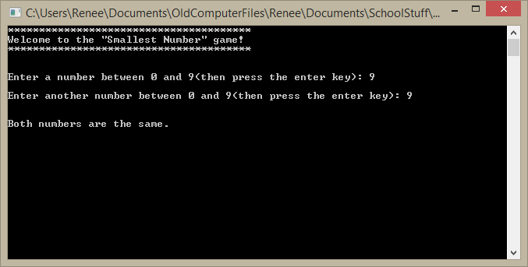

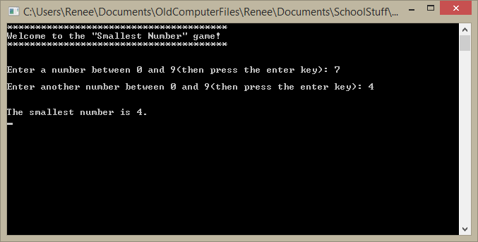

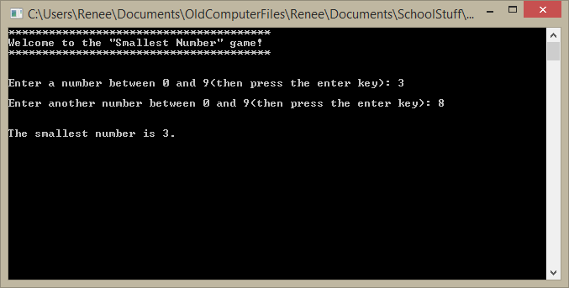

**Lab # CIS CIS170C-A2(Part B)**

// ---------------------------------------------------------------

// Programming Assignment: LAB2B

// Developer: Renee Thomas

// Date Written: 1/14/14

// Purpose: Shipping Charges

// ---------------------------------------------------------------

// add libraries

#include <iostream>

#include <iomanip>

using namespace std;

// add main function

void main()

{

//initialize variables as doubles

double sales, shipping;

// Introduce program

cout<< "**************************"<< endl;

cout<< "Shipping Charge Calculator"<< endl;

cout<< "**************************"<< endl<< endl;

// get sales from user

cout << "Enter Total Sales Amount: $";

cin >>sales;

//calculate shipping charges

if (sales >= 5000)

{

shipping = 20.00;

}

else if ((sales >= 1000) && (sales < 5000))

{

shipping = 15.00;

}

else if ((sales >= 500) && (sales < 1000))

{

shipping = 10.00;

}

else if ((sales >= 250) && (sales < 500))

{

shipping = 8.00;

}

else if ((sales > 0) && (sales < 250))

{

shipping = 5.00;

}

else

{

shipping = 0;

}

cout<<fixed<<showpoint<<setprecision(2); // use to make two floating points

if (shipping != 0)

{

cout<<"\n\nTotal Sales: $" <<sales << endl;

cout<<"Shipping Charges: $" <<shipping<< endl;

}

else

{

cout<<"Error incorrect input"<<endl;

}

//add cin.ignore(2); to stop the console widow from closing

cin.ignore(2);

}

