**Screen Shot:**

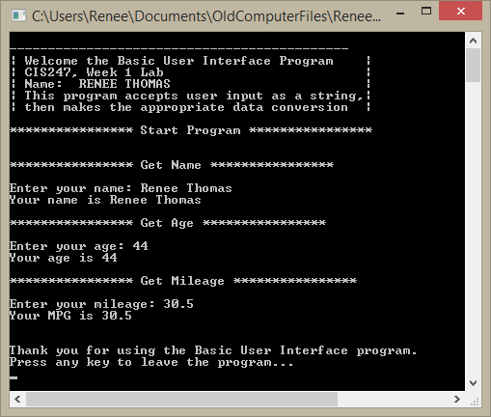

**Code:**

// ---------------------------------------------------------------------------

//Program Header

//Program Name: Basic User Interface

//Programmer: Renee Thomas

//CIS247, Week 1 Lab

//Program Description: Using four separate functions, create a user interface

// ---------------------------------------------------------------------------

# include <iostream>

# include <string>

using namespace std;

// create prototypes for functions

void DisplayApplicationInformation();

void DisplayDivider(string);

string getInput(string);

void TerminateApplication();

int main(){

//***********************Header************************

// call function for header information

DisplayApplicationInformation();

//***********************Start Program************************

// call function for divider for start program

DisplayDivider("Start Program");

//***********************Get Name************************

// call function for divider for "Get Name"

DisplayDivider("Get Name");

// set variable name

string name;

// set name to equal the getInput function with "name: "

name = getInput("name: ");

// print out the user's name

cout<<"Your name is "<<name<<endl;

//***********************Get Age************************

// call function for divider for "Get Age"

DisplayDivider("Get Age");

// set variable input

string input;

// set input to equal the getInput function with "age: "

input = getInput("age: ");

// set age to equal converted input to integer

int age = atoi(input.c_str());

// print out the user's age

cout<<"Your age is "<<age<<endl;

//***********************Get Mileage************************

// call function for divider for "Get Mileage"

DisplayDivider("Get Mileage");

// set input to equal the getInput function with name:

input = getInput("mileage: ");

// set mileage to equal converted input to double (float)

double mileage = atof(input.c_str());

// print out the user's mileage

cout<<"Your MPG is "<<mileage<<endl;

//***********************End Program************************

// call function to leave program

TerminateApplication();

// keep page open until user hits any key

cin.ignore();

return 0;

}

//***********************Functions************************

// create header function

void DisplayApplicationInformation(){

// create header to introduce the program

cout<<"\n--------------------------------------------"<<endl;

cout<<"| Welcome the Basic User Interface Program |"<<endl;

cout<<"| CIS247, Week 1 Lab |"<<endl;

cout<<"| Name: RENEE THOMAS |"<<endl;

cout<<"| This program accepts user input as a string,|"<<endl;

cout<<"| then makes the appropriate data conversion |"<<endl;

}

// create divider string function

void DisplayDivider(string outputTitle){

cout<<"\n**************** "<<outputTitle<< " ****************"<<endl<<endl;

}

// create function to get information from user

string getInput(string inputType){

// declare variable strInput

string strInput;

// get information from user

cout<<"Enter your " <<inputType;

//put user input into variable strInput

getline(cin, strInput);

//output user input

return strInput;

}

// create good bye message

void TerminateApplication(){

cout<<"\n\nThank you for using the Basic User Interface program."<<endl;

cout<<"Press any key to leave the program..."<<endl;

}