**Screen Shot:**

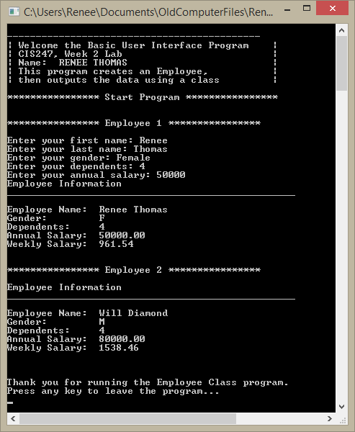

**Code:**

// ---------------------------------------------------------------------------

//Program Header

//Program Name: Employee Class

//Programmer: Renee Thomas

//CIS247, Week 2 Lab

//Program Description: Employee Class

// ---------------------------------------------------------------------------

# include <iostream>

# include <string>

# include <iomanip>

using namespace std;

// create prototypes for functions

void DisplayApplicationInformation();

void DisplayDivider(string);

string getInput(string);

void TerminateApplication();

// create Employee Class

class Employee{

private:

string firstName;

string lastName;

char gender;

int dependents;

double annualSalary;

public:

Employee();

Employee(string fn, string ln, char gen, int dep, double sal);

double calculatePay(double sal);

void displayEmployee();

string getFirstName();

void setFirstName(string fn);

string getLastName();

void setLastName(string ln);

char getGender();

void setGender(char gen);

int getDependents();

void setDependents(int dep);

double getAnnualSalary();

void setAnnualSalary(double sal);

};

int main(){

// call function for header information

DisplayApplicationInformation();

//***********************Start Program************************

// call function for divider for start program

DisplayDivider("Start Program");

DisplayDivider("Employee 1");

// First Name code

// set variable fname

string fname;

// set name to equal the getInput function with "fname: "

fname = getInput("first name: ");

//Last Name code

// set variable lname

string lname;

// set name to equal the getInput function with "lname: "

lname = getInput("last name: ");

//Gender code

// set variable gender

char gender;

// set name to equal the getInput function with "gender: "

gender = getInput("gender: ")[0];

//Dependents code

// set variable input

string input;

// set input to equal the getInput function with "dependents: "

input = getInput("dependents: ");

// set age to equal converted input to integer

int dep = atoi(input.c_str());

//Salary code

// set input to equal the getInput function with "Annual Salary: "

input = getInput("annual salary: ");

// set age to equal converted input to integer

double sal = atof(input.c_str());

//create Employee 1 from user input above

Employee obj1(fname, lname, gender, dep, sal);

obj1.displayEmployee();

//create Employee 2 by inputtinng parameters into the constuctor

DisplayDivider("Employee 2");

Employee obj2("Will", "Diamond", 'M', 4, 80000);

obj2.displayEmployee();

//***********************End Program************************

// call function to leave program

TerminateApplication();

// keep page open until user hits any key

cin.ignore();

return 0;

}

//***********************Class Functions************************

// default constructor

Employee::Employee(){

firstName = "Not Given";

lastName = "Not Given";

gender = 'U';

dependents = 0;

annualSalary = 20000;

}

// constructor with multi arguements

Employee::Employee(string fn, string ln, char gen, int dep, double sal)

{

firstName = fn;

lastName = ln;

gender = gen;

dependents = dep;

annualSalary = sal;

}

double Employee:: calculatePay(double sal){

double wsal = sal/52;

return wsal;

}

void Employee::displayEmployee()

{

cout<<"Employee Information"<<endl;

cout<<"__________________________________________________"<<endl<<endl;

cout<<"Employee Name: \t"<<firstName<<" "<<lastName<<endl;

cout<<"Gender: \t"<<gender<<endl;

cout<<"Dependents: \t"<<dependents<<endl;

cout<<"Annual Salary: \t"<< setprecision(2) << showpoint << fixed << annualSalary<<endl;

cout<<"Weekly Salary: \t"<< setprecision(2) << showpoint << fixed <<calculatePay(annualSalary)<<endl<<endl;

}

string Employee::getFirstName(){return firstName;}

void Employee::setFirstName(string fn){firstName=fn;}

string Employee::getLastName(){return lastName;}

void Employee::setLastName(string ln){firstName=ln;}

char Employee::getGender(){return gender;}

void Employee::setGender(char gen){gender=gen;}

int Employee::getDependents(){return dependents;}

void Employee::setDependents(int dep){dependents=dep;}

double Employee::getAnnualSalary(){return annualSalary;}

void Employee::setAnnualSalary(double sal){annualSalary=sal;}

//***********************Functions************************

// create header function

void DisplayApplicationInformation(){

// create header to introduce the program

cout<<"\n--------------------------------------------"<<endl;

cout<<"| Welcome the Basic User Interface Program |"<<endl;

cout<<"| CIS247, Week 2 Lab |"<<endl;

cout<<"| Name: RENEE THOMAS |"<<endl;

cout<<"| This program creates an Employee, |"<<endl;

cout<<"| then outputs the data using a class |"<<endl;

}

// create divider string function

void DisplayDivider(string outputTitle){

cout<<"\n**************** "<<outputTitle<< " ****************"<<endl<<endl;

}

// create function to get information from user

string getInput(string inputType){

// declare variable strInput

string strInput;

// get information from user

cout<<"Enter your " <<inputType;

//put user input into variable strInput

getline(cin, strInput);

//output user input

return strInput;

}

// create good bye message

void TerminateApplication(){

cout<<"\n\nThank you for running the Employee Class program."<<endl;

cout<<"Press any key to leave the program..."<<endl;

}